Cover (berisi judul dan nama penulis)

# Aprroval (lembar persetujuan dari dosen pembimbing yang menunjukkan bahwa skripsi tersebut layak untuk dicetak)

# Statement (berisi lembar pernyataan bahwa skripsi tersebut benar dibuat oleh anda dan tidak plagiat)

# Dedication (lembar persembahan)

# Motto (moto hidup anda)

# Acknowledgment (ucapan terima kasih

# Table of content

# List of tables, charts, figures, etc.

# Abstract (penjelasan singkat mengenai isi skripsi tersebut)

# Introduction (background, problem, objective, Uses, Scope, Definition of terms)

## Background

## Problem

## Objective

## Uses

## Scope

## Definition of Term

# Literature review (landasan teori)

### Society Organization

### Violin

### Information Systems

An Information System has not always involve computer. An Information System which uses computer called Computer Based Information System (CBIS). There are definitions about Information Systems. The conclusion of it is Information System include components (human, computer, Information Technology, and work procedures), something to process and build to archive goals (Abdul, 2014).

### System Development Life Cycle(SDLC)

System Development Life Cycle is a classic methodology to develop, maintain, and use an Information System. The methodology has steps and **fase.** Table 2.1 illustrated name of the steps in SDLC.

Although the mount of SDLC’s steps in some literatures are different, but all the process are same. Waterfall model in SDLC illustrated in Image 2.1 (Abdul, 2014).

### Tools

Tools are softwares which use to build model or other components of project (John, 2005). In this essay, use Ubuntu as the Operating System, Astah to design the system, Atom as programming editor and Django as the Framework.

### Unified Modeling Languange (UML)

Unified Modeling Language is a graphic notation supported by single meta model to describe and design a software system , specially for system built with Object Oriented Programming. Here are few model diagrams in UML (Henderi, 2007) :

#### Use Case Diagram

Use Case Diagram is a model or illustration of object’s behavior in a system.

#### Activity Diagram

Activity Diagram is a diagram that modeling flow of activities in a system.

#### Class Diagram

Class Diagram collects objects with general structure, behavior, relations, and semantic.

### Data Modeling

Data modeling is reintegration concepts to elaborate data, relation of data, and restriction of data that use to maintain consistency, which is called by Logical Data Structure. Relational Data Modeling use two dimension tables. This model is not supported many to many relation. This model use to make many to one or one to many relation.

MySQL is an implementation of relational database management system distributed by General Public License (GPL). Each user can use freely MySQL to create uncommercial software. MySQL is derivative of SQL (Structured Query Language). SQL is a operational database concept specially to choose or selecting and including data which allows to operate data automatically (Hendry, 2015).

### Object Oriented Programming

The idea of object oriented programming is to combine data and procedures to access data into one unit. This unit known by object (Abdul, 2014).

Python is a high level language developed by Guido ban Rossum in 1989 and published in 1991. Python was born to help programmers finish their jobs quickly. Python designed to make programmer ease to manage time and develop compatibility with system. Python can be use for create standalone program or scripting programming (Hamzah W, 2015). Features and advantages of Pyhton (Santoso, 2010) :

Python is powerful and fast. Python has libraries that ready to use. Python is simple collected modules to handle each domain problem. Python has features advanced programming language such as meta-classes, duck typing and decorators.

Python plays well with others. Python can integrate with Component Object Model (COM), NET and objects of Common Object Request Broker Architecture (COBRA). SWIG and Boost Python wrap unsupported Python code. The module is ready to use and integrate.

Python runs everywhere. Python available for Windows, Unix/Linux, OS/2 Mac, Amiga and others operating systems.

Python is friendly and easy to learn. Python built wiski, manage local and international conferences, develop and contribute source code in cloud repository. Full documentation is included on Python installation.

### MVC Design Pattern

### Navigation Structure

Navigation structure is combinations of information reference structure of website and link mechanism which support to explore the site. There are four forms of navigation structure, Linear, non-Linear, hierarchy and combination (Binanto, 2010).

#### Linear Navigation Structure

Linear Navigation Structure direct user sequentially, from frame or byte information to others.



#### Non-Linear Navigation Structure

Navigation with free navigate to all content of the project without related with previous track.

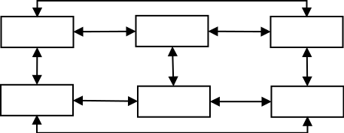

#### Hierarchy Navigation Structure

This structure is also called “linear with branching” structure, cause the structure direct user at all branch of tree structure from website content logic.

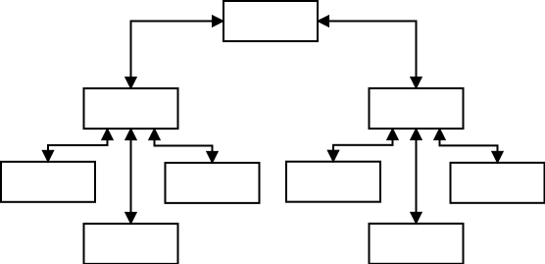

#### Combination Navigation Structure

User direct non-linear way but in condition will track some sequential process and organized in a hierarchy logically.

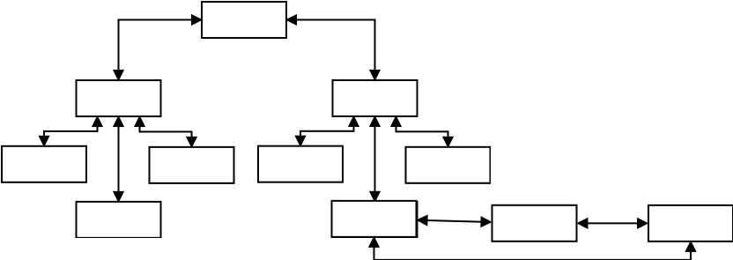

# Research Methods (berisi kerangka penelitian)

## Community Profile

### About Alliance Violin Community

Alliance Violin Community (AVC) is a music community with string instruments there are violin, viola, and violoncello. AVC is a place for society to learn about music specially violin. Begin with intention to sharing, AVC established in 2010 at 2nd Floor Depok Baru Station. Generally, people know that music as a knowledge only for certain people who has financial ability to learn in informal music school, but AVC expected to change this public perception and can be a solution to learn and explore about music without spending big cost.

### AVC’s Goals

AVC as an organization have goals, which are :

AVC could make ability to play music use for good.

AVC could educate children with play a music instrument.

AVC would produce independent people with competence to play a music instrument.

AVC could give chance to society specially marginalized with music ability can improve the lives.

AVC would produce potential and anti-drugs young generation.

### AVC’s Vision

AVC could spread name of town where there are and educate people with develop their abilities.

### AVC’s Missions

AVC consummate musical skills through community forum.

AVC participate in various positive events.

AVC give education about music specially string instruments.

AVC develop a sense of togetherness and kinship.

### AVC’s Organization Structure

AVC have a founder, chief and vice chief with six divisions which for each division hold by one or two people. The divisions are Secretary, Chamberlain, Human Resources Development (HRD), Event, All of the committee have their own responsibilities.

# Result and discussion

# Conclusion and suggestion