**READINESS OF MALAYSIA TOWARD IR 4.0**

Table 2.3 shows the rankings of nations regarding competitiveness for the fourth industrial revolution. Malaysia is ranked at 23rd and this ranking should be considered to be quite low when compared to other countries. This ranking measure the national competitiveness in terms of set of institution, policies and factor. The initiative of introducing Industry4WRD is helping Malaysia to be in the high place compared to other countries. It also shows Malaysia is n the right direction and managed to set a place in the competitiveness rankings for the fourth industrial revolution. From the ranking, only two Southeast Asia countries (Singapore and Malaysia) managed to be in the list. If Malaysia don’t work at it, other countries in the region like Indonesia, Thailand and Vietnam will easily overtake and leave Malaysia behind.

Table 2.4 :Global competitiveness rankings for the fourth industrial revolution

Source: UBS (2016), WEF (2017), IMD (2017) as cited in Sung (2018).

|  |  |  |  |  |  |
| --- | --- | --- | --- | --- | --- |
| Rank | Nation | UBS | WEF | IMD | Average |
| 1 | Singapore | 2 | 1 | 1 | 1.3 |
| 2 | Finland | 4 | 2 | 4 | 3.3 |
| 3 | U.S.A | 5 | 5 | 3 | 4.3 |
| 4 | Netherland | 3 | 6 | 6 | 5.0 |
| 5 | Switzerland | 1 | 7 | 8 | 5.3 |
| 6 | Sweden | 11 | 3 | 2 | 5.3 |
| 7 | Norway | 8 | 4 | 10 | 7.3 |
| 8 | United Kingdom | 7 | 8 | 11 | 8.3 |
| 9 | Denmark | 9 | 11 | 5 | 8.3 |
| 10 | Hong Kong | 7 | 12 | 7 | 8.7 |
| 11 | Canada | 15 | 14 | 9 | 12.7 |
| 12 | New Zealand | 10 | 17 | 14 | 13.7 |
| 13 | Germany | 13 | 15 | 17 | 15.0 |
| 14 | Taiwan | 16 | 19 | 12 | 15.7 |
| 15 | Japan | 12 | 10 | 27 | 16.3 |
| 16 | Australia | 17 | 18 | 15 | 16.7 |
| 17 | Austria | 18 | 20 | 16 | 18 |
| 18 | Israel | 21 | 21 | 13 | 18.3 |
| 19 | Korea | 25 | 13 | 19 | 19.0 |
| 20 | Ireland | 14 | 25 | 21 | 20.0 |
| 21 | Belgium | 19 | 23 | 22 | 21.3 |
| 22 | France | 20 | 24 | 25 | 23.0 |
| **23** | **Malaysia** | **22** | **31** | **24** | **25.7** |
| 24 | Portugal | 23 | 30 | 33 | 28.7 |

**ECONOMY CONTRIBUTION**

Behind the scenes of the world’s leading industrial and manufacturing companies, a profound digital transformation is now underway. The engineering and construction sector is no exception in this matter. The engineering and construction sector have a great impact on the economy of any nation. Although, some might argue that the extent of its contribution is not important and not as powerful as the other sectors. However, it has direct and significant contribution to gross domestic product (GDP) and it does not in any way invalidate the importance of the construction industry in regards to providing the necessary infrastructures that stimulate economic development. Indirectly, construction creates intersectoral linkage with other sectors and contribute to the economy as whole (Giang & Pheng, 2011). For an instance, the strong linkages stem from the fact that all other sectors of the economy use the flow of services generated by infrastructure, which in turn can lead to growth in the production of other economic sectors in two ways: through the reduction in costs of intermediate inputs from infrastructure services such as transport, water and electricity; and through the increase in the productivity of other factors of production (Giang & Pheng, 2011).

As such, the industry is required for national development. It has been argued that for a country to have meaningful and sustained development, it urgently requires that it indigenize its construction industry, because if the construction industry is inefficient, it will be difficult for such a country to attain meaningful development (Olanrewaju & Abdul-Aziz, 2015). Among the major economic sectors, the importance of the construction industry is unique regardless of whether the country is underdeveloped, developing or developed.

Changes brought about by the introduction of information technology into production, services, construction and all sectors of the economy bring a great impact called as Fourth Industrial Revolution. Implementation of new technologies and the substitution of labour by capital is a process taking place in all industries in order to reduce costs, increase productivity, and facilitate the provision of individual customer solutions. Malaysia’s economy grew 4.4 per cent in the third quarter of 2018 (Department of Statistics Malaysia, 2018) and lead by sector of services and manufacturing (refer table 2.2).

The statistic shown in Table 2.4 is the previous or current contribution on the economy development but how about in the future. In five years, the sector that once lead the economy might fall behind and the economy control by the other sector. Thus, PricewaterhouseCoopers (PwC) had conducted a survey among 2,000 companies from 26 countries in the industrial production sectors, including aerospace and defence; automotive; chemicals; electronics; engineering and construction; forest products, paper, and packaging; industrial manufacturing; metals; and transportation and logistics. The result of the survey is shown in .

Table 2.5 : Share of specific industries in total value added, in %, data

Source: OECD STAN as cited in (Fuchs, 2018); Department of Statistics Malaysia (2018)

|  |  |  |  |  |
| --- | --- | --- | --- | --- |
| Industry: | USA (2015) | UK (2015) | Germany (2015) | Malaysia (2018) |
| Agriculture | 1.1% | 0.7% | 0.6% | 8.2% |
| forestry and fishery | 12.3% | 9.8% | 23.1% | - |
| Manufacturing | 4.2% | 6.2% | 4.6% | 23.0% |
| **Construction** | **6.1%** | **6.5%** | **4.7%** | **4.7%** |
| Information and communication | 7.3% | 7.2% | 4.1% | - |
| Finance and insurance | 12.5% | 13.0% | 10.9% | - |
| Real estate | 19.7% | 20.2% | 15.0% | - |
| FIRE Services | 78.9% | 79.9% | 68.9% | 56.0% |

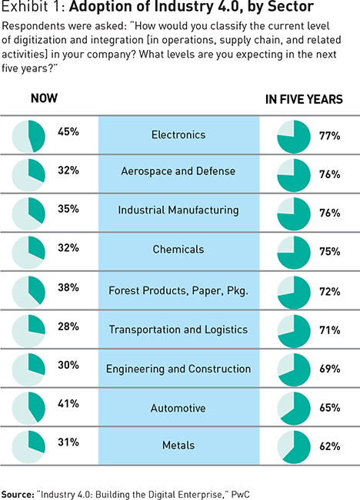

: Adoption if Industry by Sector (Geissbaue et al., 2016)

**BENEFITS OF INDUSTRY 4.0**

There are numerous benefits that can be attained with the adoption of industry 4.0 especially for organizations in which, it has a significant contribution to improving their existing level of competitiveness, to increase value and to minimize risks due to the adoption of more efficient production systems and utilizing innovative technologies (Fonseca, 2018). Haslinda *et al*. (2018) have identified several benefits when leveraging the technologies in industry 4.0 which classified into six categories: productivity, agility, innovation, customer experience, cost and revenue. For productivity, it able to establish the smart working relationship between people and machines and thus lead to increases in capacity production, reduction with human errors and mass customization. Agility offer improvement with the existing version of products through speeding up the product innovation and variation with the customer base. Whilst, innovation is focused on introducing new product and to have experimentation with the design. For customer experience, it provides thorough information of the product in delivering a better service for customers. For costs benefit, despite the requirement for high initial investment, the intelligent system which built in the products and processes helps to reduce the personnel and operating cost since there has been fewer quality problems and less wastage of materials. Furthermore, the speed level and ability in handling product will also contribute to lower the costs. Lastly, for revenue, it helps to create a path for businesses for being preferred by customers since industry 4.0 offer for better quality, lower cost, and well ability to serve customers through utilizing the new technologies. It able to steer benefits to the next level due to the businesses have intensive monitoring, controlling and optimizing the product, able to make a prediction and avoiding impending issues with the utilization of intelligent technology. Thus, it will make the businesses to compete with profitability in the most demanding global markets.

Muller (2018) added the benefits of industry 4.0 can be received in terms of environmental and social. Industry 4.0 is one of the enablers to reduce the greenhouse gas emissions since its core technologies is an opportunity to reduce waste, resource and energy consumption such as through data-centred, reduction in using physical transport and logistics processes. For social benefits, industry 4.0 offer for flexibility, to improve the process and decisions from management. Besides, with the use of digitalization, the models of working time becoming more susceptible and adaptable for an individual.

**ISSUE AND CHALLENGES OF INDUSTRY 4.0**

When conversation drifted towards Construction 4.0, it has to be connected about whether the engineering and construction (E&C) industry was ready for a new evolution or what are the challenges faced by the industry to catch up with the technology advancements currently available. It cannot be denied that in a connected era, digitalization and other disruptive technologies will enable construction firms to improve their efficiency. Chen et al., (2018) emphasizes that construction 4.0 can help to improve the productivity by enhancing the collaboration between different stakeholders and shortens the length of time required to complete the activity.

However, changing from highly automated system to smart factory and IOT is a challenging process as it requires people to leave their comfort zone (Lange, Bähre, Finetti-imhof, Klamma, & Oppermann, 2017). Employee already get used to conventional system and new technologies demanding them to picks up new processes and new technology fast. There are a variety of different issues facing construction in the context of Industry 4.0. depicted in Table 2.3. Each issue has also its own challenges.

Table 2.3: Challenges on the Way of Construction 4.0 Adoption

| Issue | Challenges | 1 | 2 | 3 | 4 | 5 | 6 |
| --- | --- | --- | --- | --- | --- | --- | --- |
| Politics (P) | The absence of a digital culture and the right training |  | / |  |  |  |  |
| Lack of a clear digital operations vision |  | / |  |  |  |  |
| Lack of support/leadership from top management |  | / |  |  |  |  |
| Economic (E) | Economic factor affecting the price, demand and availability of engineering services | / |  |  |  |  |  |
| Unclear economic benefit of digital investments |  | / |  |  |  |  |
| High financial investment requirements |  | / |  | / | / |  |
| High cost of implementation |  |  |  |  | / |  |
| Social (S) | Insufficient talent |  | / |  |  | / |  |
| Loss of unskilled job |  |  |  | / |  |  |
| Require retraining or further training in operating these new applications if they want to make full use of them |  |  | / |  |  |  |
| Process-dependent systems that make greater use of technology may prove to be a major challenge for existing employees |  |  | / |  |  |  |
| The in-house technical staff are not ready to be trained |  |  |  |  | / |  |
| Pressure to improve services while raising quality and lowering costs. | / |  |  |  |  |  |
| Technology (T) | Requires new modeling techniques and data formats |  |  | / |  |  |  |
| Changes over time and has to be adapted constantly |  |  | / |  |  |  |
| Do not have the technology |  |  |  |  | / |  |
| Environmental (E) | Unknown potential impact on sustainability and environment |  |  |  |  |  | / |
| Double the production of metal (lithium, dysprosium, rhenium) due to technological change |  |  |  |  |  | / |
| The infrastructure to maintain and provide secure data transfer will concentrate a large amount of resources and energy |  |  |  |  |  | / |
| Disregard responsible consumption, motivated by the availability of on-demand customized product |  |  |  |  |  | / |
| Legal (L) | Managing these large quantities of data |  |  | / |  |  |  |
| Lack of digital standards, norms and certification |  | / |  | / |  |  |
| Industry 4.0 will need to comply with the law, existing legislation will  also need to adapt to take new innovations into account |  |  | / |  |  |  |
| Unresolved questions around data security and data privacy in connection with the use of external data |  | / |  | / |  |  |
| Data theft, industrial espionage and attacks by hackers |  |  | / | / |  |  |
| Cyber-attacks and viruses can have a devastating impact |  |  | / |  |  |  |
| Concerns around loss of control over your company’s intellectual property |  | / |  |  |  |  |

1: (Autodesk, 2017); 2: (Global Industrial Products Industry 4.0, 2016); 3:(Lange et al., 2017); 4: (Alaloul et al., 2018); 5:(Anuar & Zainal Abidin, 2015); 6: Bonilla et al. (2018)

Finally, from literature review can be concluded that concluded that there are six major issues that block the way of construction adoption. All the challenges have been categories into **Politic (P), Economic (E), Social (S), Technology (T), Environmental (E) and Legal (L**). Addressing Malaysia’s issues and challenges on Construction 4.0 is a crucial step to ensure better suggestions provided to help advance the uptake of automation in construction.

**PROCESS OF DEVELOPING ROADMAP**

Several papers have outlined the roadmapping process. Based on three approaches listed in Figure 3, generally it started by reviewing the related literature, technology and application. Past research on the direction of new technologies, products and markets are used to help national plan the technological development in different fields and to provide a tool for technology prediction. Next, expert classification based on maturity. To give precise definitions of the a fore mentioned key technologies and to gain insight into the market maturity and technology maturity conditions, experts help needed. Technology development predictions are used to establish the causal relationship between a technology and the timing of its application. Last step is developing the integrated roadmap using the data collected during the previous steps.

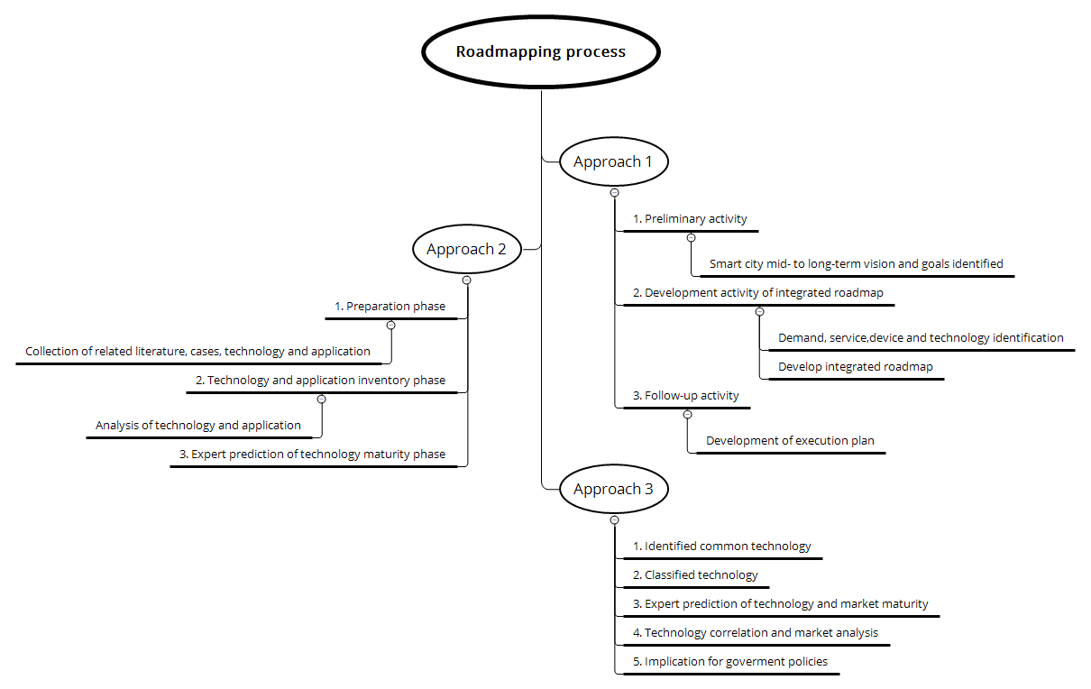

Figure 2.5: Roadmapping process (Lu & Weng, 2018; Lu, Chen, & Yu, 2019; Hoon, Phaal, & Lee, 2013)

Figure 2.6 shows an example of a technology development roadmap. The methodology is to construct a three-step technology development roadmap strategy; which is to be developed

by taking into account stakeholders and future relevant planned actions.

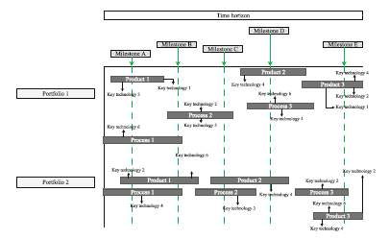

Figure 2.6: Exemplary schedule Industry 4.0 roadmap by (Sarvari, Ustundag, Cevikcan, & Cebi, 2018)