IT Security
High level design documents
2017 Spring



Lillebaelt Academy of
University of applied sciences

IT Technology

Authors
Martin B. K. Grønholdt mart80c7@edu.eal.dk
Michal Stanislaw Skorczewski mich74p0@edu.eal.dk
Mikkel Juel Johansen mikk4972@edu.eal.dk

2017-05-22
Table of Contents
1. Introduction 1
2. Overview 1
3. Performance 3
4. Hardware 4
4.1. Logged machines 4
4.2. Elastic stack. 4
5. Protocols 4
6. IP layout 4
6.1. Chinanet 4
6.2. Test 4
7. Naming convention 5

Introduction
We have been tasked with doing an implementation of security related principles in a project that relates to Chinanet.

Overview
Logging is crucial for keeping track of what happens to the machines in a network. Going through page after page of log lines is not the way. We are proposing an automated installation using Ansible to get an Elastic stack up and running that can present these logs in a nice graphical web interface.
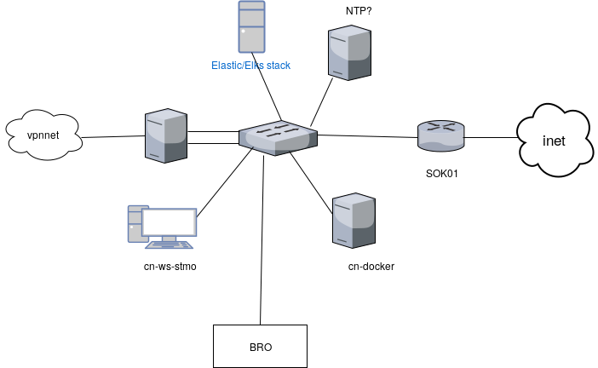 Illustration 1: Elastic stack in Chinanet
This is the layout of Chinanet, since we are not going be the ones installing it in that system, the illustration contains most of the data we have on that system. We are working from the assumption that machines in that network are running either Debian or OpenBSD.

The Ansible play books will perform two main tasks.
- Setup machines that should be logged to send them to the Elastic stack machine.
- Setup a machine running the Elastic stack

To test the system before being deployed on the machines in Chinanet, we have made a local test setup using Vagrant, that spins up the machines in Illustration 2.
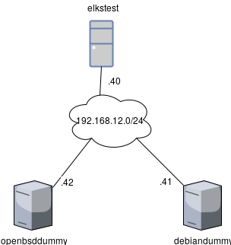
Illustration 1: Elks stack test network with an a Debian and an OpenBSD sending log.
- openbsddummy - 192.168.12.42 - an OpenBSD machine to gather log data from.
- debiandummy - 192.168.12.41 - a Debian machine to gather log data from.
- elkstest - 192.168.12.40 - a Debian machine running the full ELKS stack including Kibana.

The dummy VM’s are used to test the Ansible rsyslog setup and the elkstest machine with the Elastic stack.

Performance
The Elastic stack runs in the VM using 4Gb of RAM, but would run better with at least 8Gb of RAM. The machine that contains the Elastic stack will also have to store the log data.

Hardware

Logged machines
Any machine that is able to run Debian or OpenBSD.

Elastic stack.
- Minimum 8Gb of RAM.
- Storage to accommodate the log data.

Protocols
- Rsyslog for sending log messages.

IP layout

Chinanet
The IP layout of Chinanet is as follows:

- Chinanet: 10.100.200.0/24
  - SOK01: .1
  - cn-vpn: .5
  - cn-vpn: .6
  - cn-docker: .103
  - cn-ws-stmo: .104
- vpnet: 10.0.8.0/24

Test
- Test network: 192.168.12.0/24
  - elkstest: 192.168.12.40
  - debiandummy: 192.168.12.41
  - openbsddummy: 192.168.12.42

Naming convention
In chinanet every host has the prefix “cn-”, in keeping with this convention a host name like “cn-elks or “cn-elastic” seems appropriate.

http://ittech.eal.dk/chinanet/

