**User Manual**

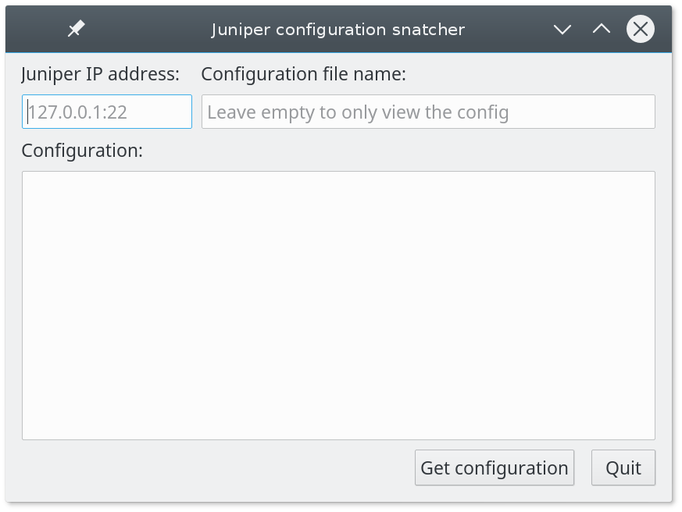  
The program is quite simpel it works by inserting the IP address of the router and in the next row entering what you want the file to be named.

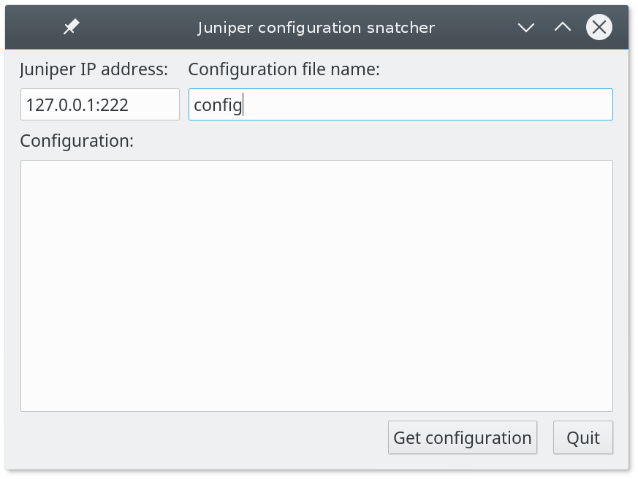

Then press the button “Get configuration” and the program will via SSH access the router and ask for the login information.

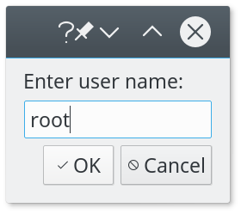

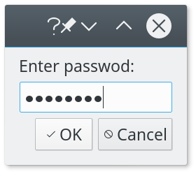

After that the program will pull the configuration file from the juniper SRX router and name the file whatever you decided and leave on your pc it will also be shown in the box in the program.

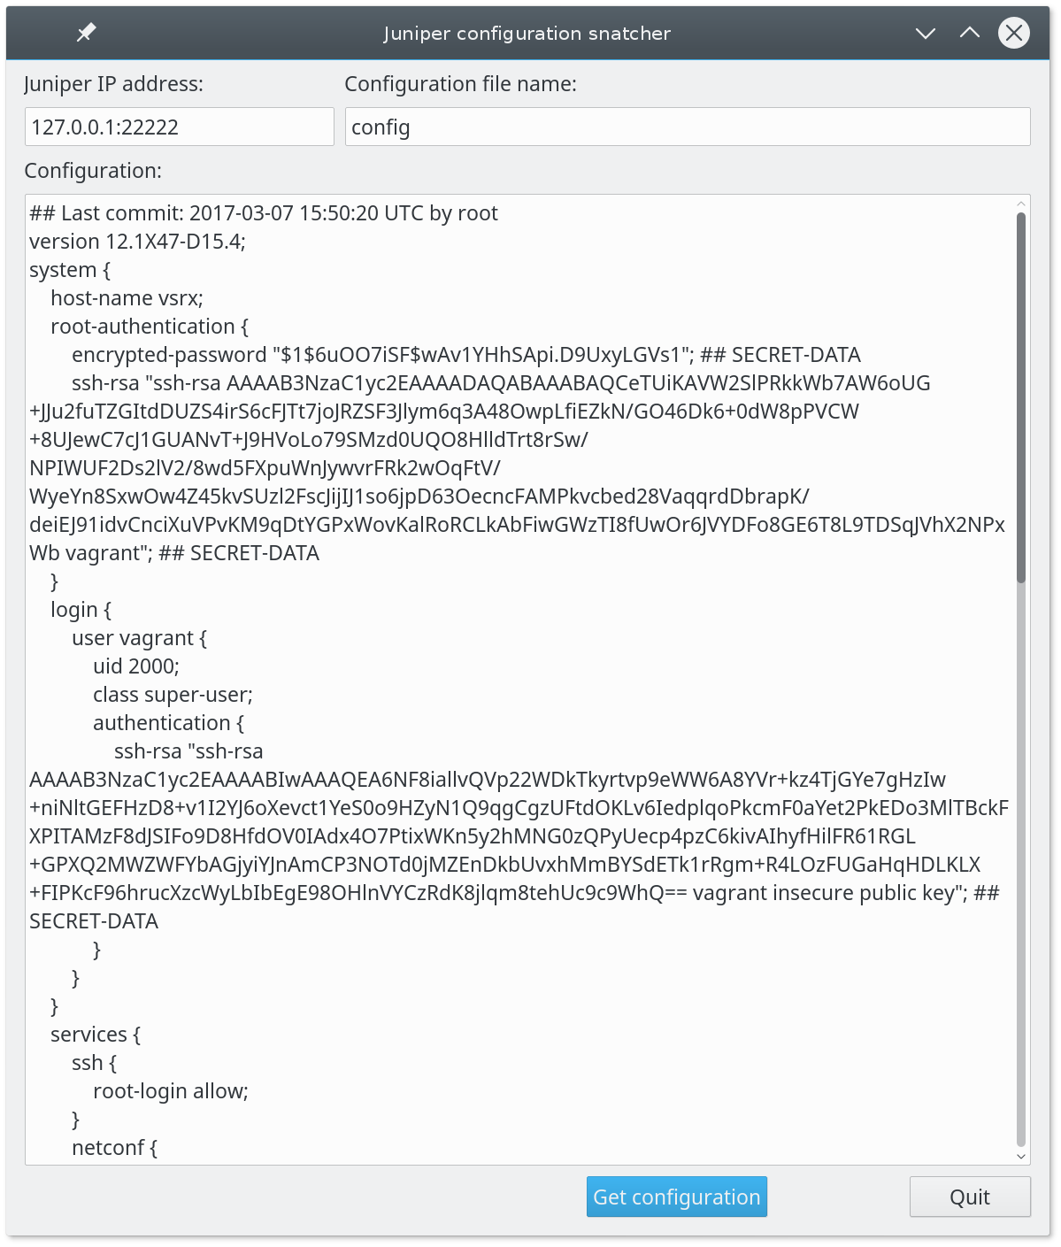

If there is a problem while running the program you will see one of the following error boxes which will specify what went wrong.

