Juniper configuration snatcher

User manual

v1.0

Introduction
This manual describes the use of the “Juniper configuration snatcher” program. The purpose of this program is to download the configuration from a Juniper device to a local file.

Instructions
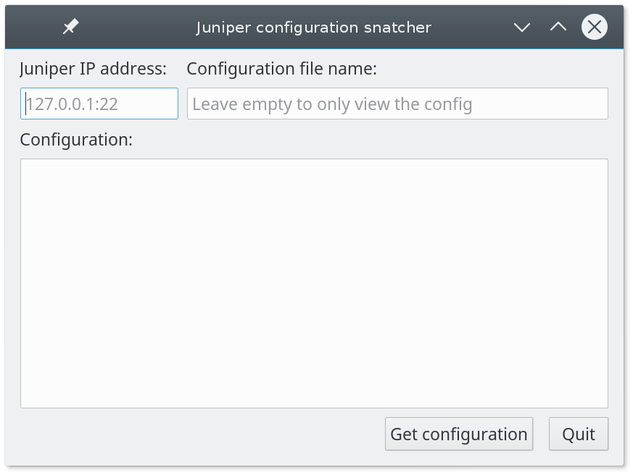
Illustration 1: The main window at program start.
The program is quite simple it works by inserting the IP address of the router, possibly followed by the port number assigned to the SSH service in the first text box (referring to Illustration 1). A default port of 22 is assumed if no port is entered. The next text box is for entering the file name used to save the configuration file locally. If no file name is entered, the program will still show the configuration, but not save it.
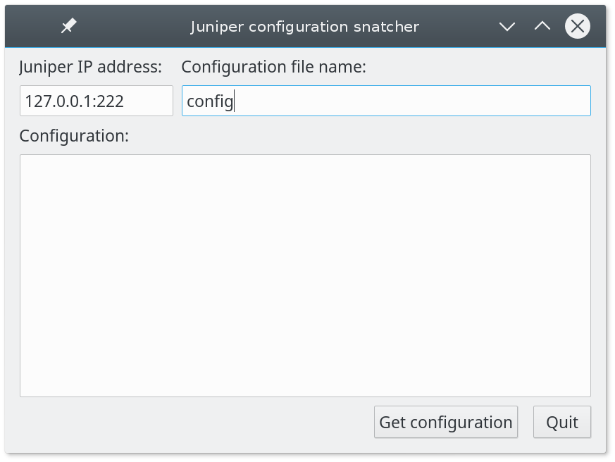
Illustration 2: Main window with the values entered.

When the information has been entered, as seen in Illustration 2, pressing the button “Get configuration” will access the router via SSH and ask for the login information as shown in Illustration 3.
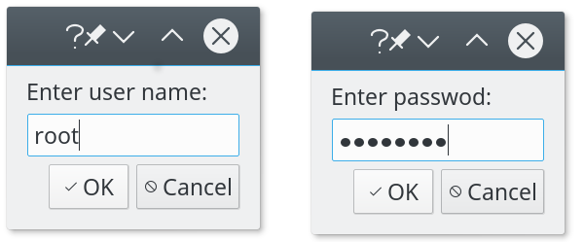
Illustration 3: Entering the user name and password.

After that the program will pull the configuration file from the juniper device and save it to a file if a name was given earlier, in any case the configuration is also be shown in the box in the program.

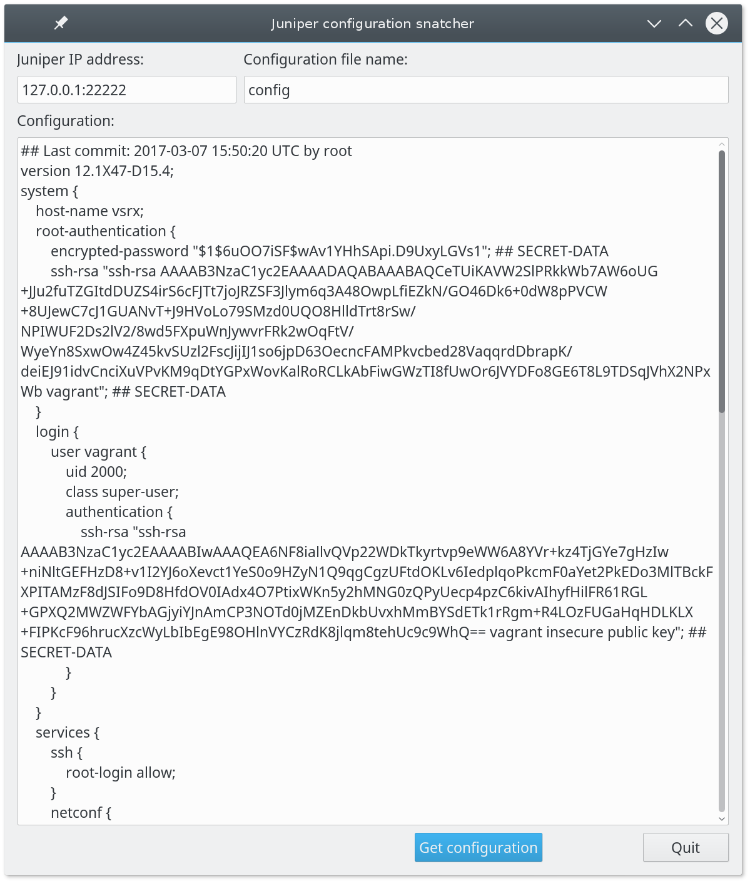
Illustration 4: The main window after the configuration is fetched

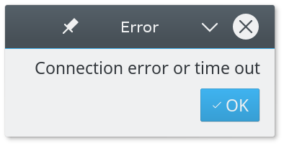
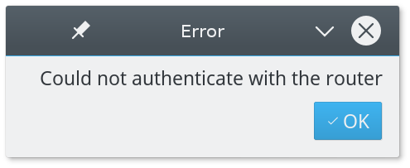
Errors
If there is a problem while running the program you will see one of the following error boxes which will specify what went wrong.

