What is a VLAN? (Virtual Local Area Network)

Ethernet LANs were originally designed for small networks that primarly carried text, over years the type of data carried by LANs grew to include voice, graphics, and video. This complex data, when combined with the speed of transmission became too much of a load for the original Ehernet LAN design, packet collisions were slowing down larger LANs. The IEEE 802.1D-2004 standard helped evolve LANs to cope with the higher data and transmission requirements by defining the concept of bridging.

* Bridging divides a single physical LAN (now broadcast domain) into two or more virtual LANs
* By default, system on one VLAN don’t see the traffic associated with systems on other VLANs on the same network

IEEE 802.1Q is the standard defining VLANs. Each VLAN is identified by a unique 802.1Q ID, only IDs 1 through 4094 can be assigned to VLANs during configuration, IDs 0 and 4095 are reserved by Junos OS and cannot be assigned.

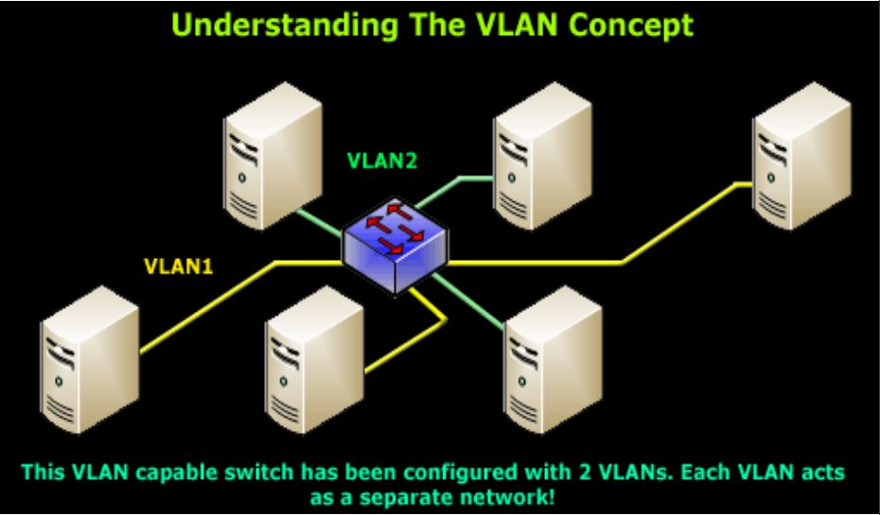

Ethernet packets includes:

* Tag protocol identifier
* EtherType field, which identidies the protocol being transported. When a device within a VLAN generates a packet, this field includes a value of 0x8100, which indicates that the packet is a VLAN-tagged packet.
* The packet also has a VLAN ID field that includes the unique 802.1Q ID, which identifies the VLAN to which the packet belongs

The Ethernet Frame + 802.1q Tag

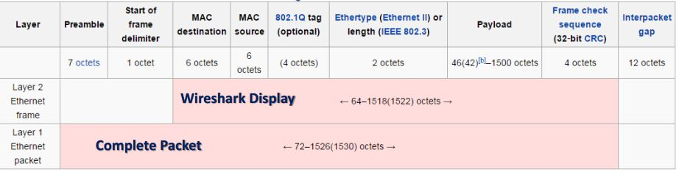

The “layer 1 Ethernet Packet” is what is transmitted over the wire, bit-by-bit.  
The “layer 2 Ethernet Frame” is the display on monitor interface.

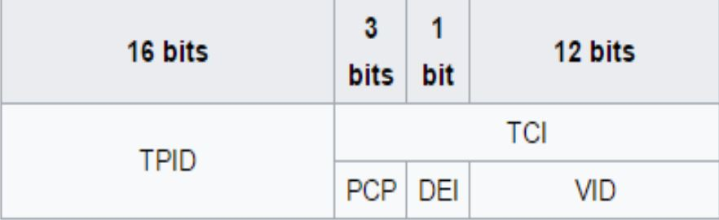

The 802.1q tag:

Tag protocol ID (TPID): a 16 bit field set ro a value of 0x8100

Tag control information (TCI)

* Priority code point (PCP): 3 bit field which refers to the IEEE 802.1p class of service and maps to the frame priority
* Drop eligible indicatior (DEI): 1 bit field, may be used separately or in conjunction with PCP to indicate frames eligible to be dropped in the presence of congestion
* VLAN identifier (VID) a 12 bit field specifying the VLAN to which the frame belongs

**Implementing VLANs:**

Step 1: Create a layer 2 vlan

*set vlans <vlan-name> vlan-id <vlan-id>*

Step 2: Create a logical layer 3 VLAN interface:

*set interfaces vlan unit <unit> family inet address <ip address/mask>*

Step 3: Link the layer 2 VLAN to the layer 3 VLAN interface:

*set vlans <vlan-name> l3-interface vlan.<unit mentioned above>*

The result in project after implementing vlans can be displayed using command: *show vlans.*

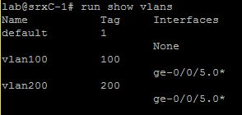

Other command that can be used to display configured vlans is: *show vlans summary.*

In the display, untagged and tagged vlans are shown.

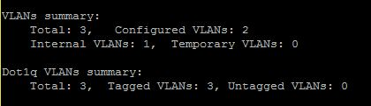

**VLAN Trunking:**

Trunk mode interfaces are used to connect switches to one another. Traffic sent between switches can then consist of packets from multiple VLANs, with those packets multiplexed so they can be sent over the same physical connection.

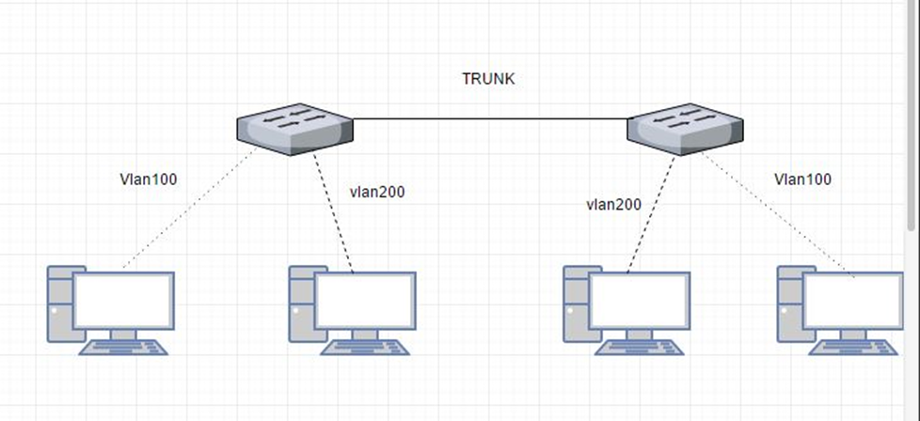

The trunk interface is a switched interface, have to have a corresponding interface on a second switch.

QUICK CONFIGURATION:

*set interfaces <interface> unit <unit number> family ethernet-switching port-mode access vlan members <vlan-name>*

Only VLANs named in members <vlan-name> have access over the Trunk.

**L3 interface:**

In order to configure the switch to perform L3 switching it is necessary to assign VLAN interface to VLAN using command:

*Set vlans <vlan name> l3-interface vlan.<vlan number>*

SHOW VLANS BRIEF/SHOW INTERFACES VLAN TERSE SCREENSHOT

**VIRTUAL ROUTERS**

In Junos Software, a virtual router is a routing instance type. It is a collection of routing tables, interfaces and routing option settings. Routing instance virtual router can act like a normal router, with policies and routing options. It allows to isolate traffic without using multiple routing devices to segment network.

To establish a virtual router it is necessary to follow few steps.

* Create a virtual router
* Assign an interface to a virtual router
* Assign an interface to a zone

It is possible to assign other routing option to virtual router.

To share routes in more than one routing instance it is optional to select physical or logical connection.

Physical connection is a normal interface (for example ge-0/0/0 or so-0/0/0) it can be established using cables or VMNets in VMware.

Logical Tunnels (lt0 interfaces) can be used only on SRX Juniper devices.

To connect two routing instances with a logical connection logical tunnel interface should be configured for each instance. Then, it is mandatory to configure a peer relationship between the logical tunnel interfaces, thus creating a point-to-point connection. To create a point-to-point connection logical tunnel has to configured using the lt-fpc/pic/port format.

Each logical tunnel interface should be configured with a proper encapsulation type.

It is important to configure only one peer unit for each logical interface. (Unit 0 cannot peer with both unit 1 and unit 2.)

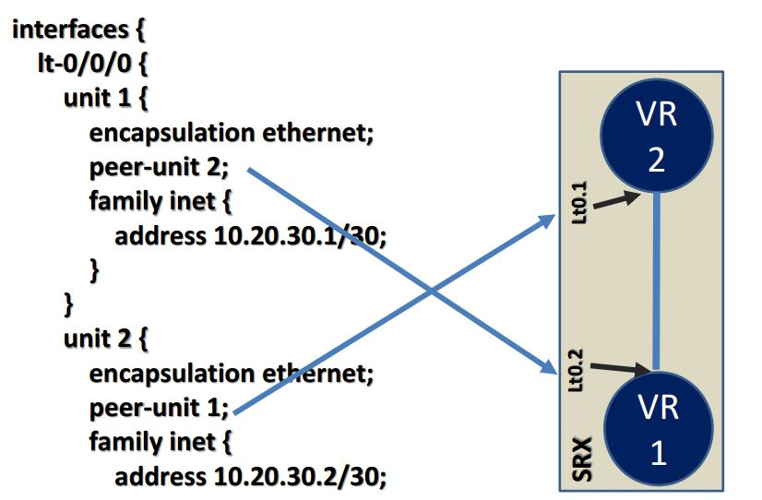

**Ethernet OAM**

Ethernet Operations, Administration, and Maintenance

Ethernet OAM is a set of tools that network manager use to know the way how Ethernet links are working. Ethernet OAM should:

* Rely only on the media access control (MAC) address or virtual local area network (VLAN) identifier for troubleshooting
* Work independently of the actual Ethernet transport and function over physical Ethernet ports, or a virtual service such as pseudowire, and so on.
* Isolate faults over a flat (or single operator) network architecture or a nested or hierarchical (or multi-provider) networks.

**Troubleshooting and monitoring**

Juniper SRX device provides set of commands that can be used for troubleshooting. Mostly it is giving an opportunity to view log files, environment of router and alarms.

Few troubleshooting commands:

* show chassis environment

Command above allows to display temperatures, fans and power supply on SRX device.

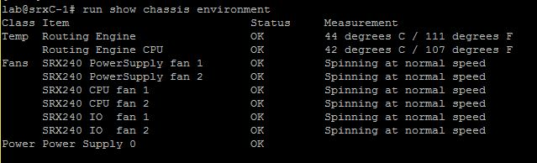

* show chassis hardware

Using command above causes display hardware informations like serial numbers, part numbers and version.

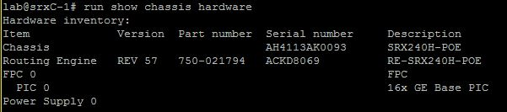

* show chassis alarms

This command is used for displaying information about alarms in real time.



Troubleshooting commands above were used on Juniper SRXC-1 in schools lab.

**Monitoring**

Except troubleshooting Juniper gives command to monitor interfaces, traffic and routes on device.

Most common command for monitoring routes in router is: *show route.*

Where next-hops, routes, preferences and protocols.

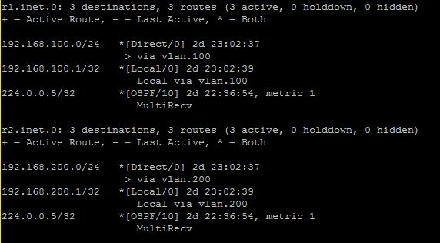

*show interfaces terse* allows to see admin and link state of interfaces as well as protocol its using and addresses.

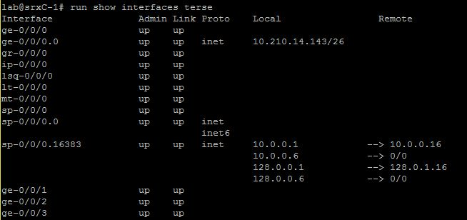

In Juniper Devices it is possible to monitor traffic inside the router, using *monitor traffic.*

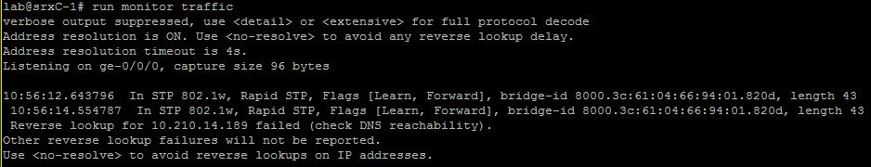

Source:

Vlan presentation from Peter

<http://searchnetworking.techtarget.com/definition/virtual-LAN>

<https://kb.juniper.net/InfoCenter/index?page=content&id=KB11000>

<https://www.juniper.net/documentation/en_US/junos/topics/reference/configuration-statement/l3-interface-bridging.html>

<https://www.juniper.net/documentation/en_US/junos/topics/task/configuration/bridging-vrf-qfx-series-cli.html>

<https://kb.juniper.net/InfoCenter/index?page=content&id=KB21260>

https://www.juniper.net/documentation/en_US/junos12.3/topics/concept/layer-2-802-1ag-ethernet-oam-overview-mx-solutions.html