Firewall filters
Firewall filters control the traffic entering and leaving a networking device in a stateless fashion. Stateless means that the firewall filters uses static values like protocol, source, and destination address it cannot interpret traffic patterns or data flows. The firewall filters processes each packet individually.
Firewall filters can perform the following actions:

- Restrict traffic destined for the Routing Engine based on its source, protocol, and application.
- Limit the traffic rate of packets destined for the Routing Engine.
- Process fragmented packages by configuring the filter to support this.

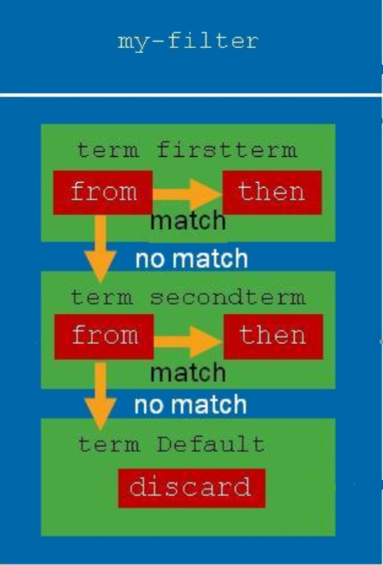
In Juniper devices firewall filters are build of a list of terms. Each “term” has a from statement that is used for matching the package. If this term is true the “then” statement of that term takes effect. The terms are matched sequentially starting from the first, which means that the order they are appear in will determine the order that the terms are matched.

The from statements describes the match condition. Some common match criteria are:
- Match most header field in the package.
- Match conditions include
  - Numeric range
  - Address
  - Bit field

Actions can terminate (while accepting, discarding or rejecting) the sequence of terms. They may also modify the flow, perform monitoring task, modify the forwarding class or perform rate limiting.
Common firewall filter actions are as follows:
- Terminating actions:
  - accept
  - discard
  - reject
- Flow control:
  - next term
- Action modifiers:
  - count , log , and syslog
  - forwarding-class and loss-priority policer

Everything that is not explicitly allowed will be discarded.

Configuration.
Firewall filters are configured in the “firewall” hierarchy.
Firewall {

The next line limits the filters to IPv4 packages.

family inet {
filter filter1 {

This is an example of filtering by protocol, traffic except TCP and UDP is accepted.

term term1 {
from {
protocol-except [tcp udp];
}
then {
accept;
}
}

Taking into account the above term, the next term is only reached for TCP and UDP traffic since all other types are accepted above. The next term will reject packages from the 192.168.0.0/16 network.

term term2 {
from {
address 192.168/16;
}
then {
reject;
}
}

Again taking into account the above rules all packages that are TCP or UDP and not coming from the 192.168.0.0/16 network are accepted by the next term, after increasing the counter “pkts_remote_man”. This count feature is used for monitoring.

term term3 {
from {
destination-port [ssh telnet];
}
then {
count pkts_remote_man;
accept;
}
}

The last term is the default term, that rejects everything that did not match any of the terms above.

term term4 {
then {
reject;
}
}
}
}

Firewall filters play a role in Class of Service, to classify the traffic as will be discussed in the “Class of Service” chapter and as mentioned earlier can also limit the amount of traffic according to the condition of the terms.

