IT Technology
Final Report – Project Network



LILLEBAELT ACADEMY
UNIVERSITY OF APPLIED SCIENCE

Authors
Martin Grønholdt
Michal Skorczewski

Friday 19 May 2017

Table of Contents

1.1.1 Introduction 3
1.1.2 Project Plan 3
1.1.3 Responsibilities 4
2.1.1 Ethernet L2 & L3 Switching 4
2.1.2 VLAN Implementation 4
2.1.3 VLAN L3-Interface 4
2.1.4 Virtual Routers 4
2.1.5 Ethernet OAM 4
2.1.6 Troubleshooting & Monitoring 4
3.1.1 Intermediate Routing 5
3.1.2 IPv6 5
3.1.3 OSPF 5
3.1.4 IS – IS 5
3.1.5 Route Re-Distribution (OSPF/IS-IS) 5
3.1.6 BGP 5
3.1.7 Re-distribution BGP/OSPF 5
4.1.1 Security 5
4.1.2 Routing Policies 5
4.1.3 Route Redistribution 5
4.1.4 RE/PFE 5
4.1.5 Firewall Filters 5
4.1.6 Class of Service 5

Introduction

Project Plan

Task Name | Duration | Start | Finish
Project Network 2. Semester | 31.14 days? | Mon 1/9/17 | Mon 5/8/17
Stage-1: Ethernet L2 & L3 Switching | 9 days | Mon 1/9/17 | Tue 2/14/17
VLAN Implementation | 1 day | Mon 1/9/17 | Tue 1/10/17
Vlan Trunking (802.1q) | 1 day | Tue 1/10/17 | Mon 1/16/17
VLAN L3-Interface | 1 day | Mon 1/16/17 | Tue 1/17/17
Virtual Routers (SRX & EX) | 2 days | Tue 1/17/17 | Tue 1/24/17
Ethernet OAM | 1 day | Tue 1/24/17 | Mon 1/30/17
Troubleshooting & Monitoring | 1 day | Mon 1/30/17 | Tue 1/31/17
Stage-2: Intermediate Routing | 15 days | Tue 1/31/17 | Mon 4/3/17
IPv6 | 2 days | Tue 1/31/17 | Tue 2/14/17
OSPF | 2 days | Tue 2/14/17 | Tue 2/21/17
IS-IS | 2 days | Tue 2/21/17 | Tue 2/28/17
Route Re-Distribution (OSPF/IS-IS) | 3 days | Tue 2/28/17 | Tue 3/7/17
BGP (iBGP & eBGP w. OSPF) | 3 days | Tue 3/7/17 | Mon 3/20/17
Route Redistribution (BGP/OSPF) | 3 days | Tue 3/21/17 | Mon 4/3/17
Stage-3: Security | 12 days | Mon 4/3/17 | Tue 5/16/17
Routing Policies | 2 days | Mon 4/3/17 | Mon 4/10/17
Route Redistribution | 2 days | Mon 4/10/17 | Mon 4/17/17
RE/PFE | 2 days | Mon 4/17/17 | Tue 4/25/17
Firewall Filters | 3 days | Tue 4/25/17 | Mon 5/8/17
CoS | 3 days | Mon 5/8/17 | Tue 5/16/17
Finalize Report | 4 days | Tue 5/16/17 | Mon 6/5/17
Project End/Hand-in | 0 days | Mon 6/5/17 | Mon 6/5/17

Responsibilities
Vlan Implementation | Michal Skorczewski
Vlan Trunking (802.1q) | Michal Skorczewski
Vlan L3- Interface | Michal Skorczewski
Vurtual Routers | Michal Skorczewski
Ethernet OAM | Michal Skorczewski
Troubleshooting & Monitoring | Michal Skorczewski
Ipv6 | Martin Gronholdt
OSPF | Martin Gronholdt
IS-IS | Martin Gronholdt
Route Re-distribution OSPF/IS-IS | Martin Gronholdt
BGP | Michal Skorczewski
Router Redistribution BGP/OSPF | Michal Skorczewski
Routing Policies | Michal Skorczewski
Route Redistribution | Martin Gronholdt
RE/PFE | Michal Skorczewski
Firewall Filters | Martin Gronholdt
CoS | Michal Skorczewski

    - 2.1.1 Ethernet L2 & L3 Switching

    - 2.1.2 VLAN Implementation

    - 2.1.3 VLAN L3-Interface

    - 2.1.4 Virtual Routers

    - 2.1.5 Ethernet OAM

    - 2.1.6 Troubleshooting & Monitoring

    - 3.1.1 Intermediate Routing

    - 3.1.2 IPv6

    - 3.1.3 OSPF
    - 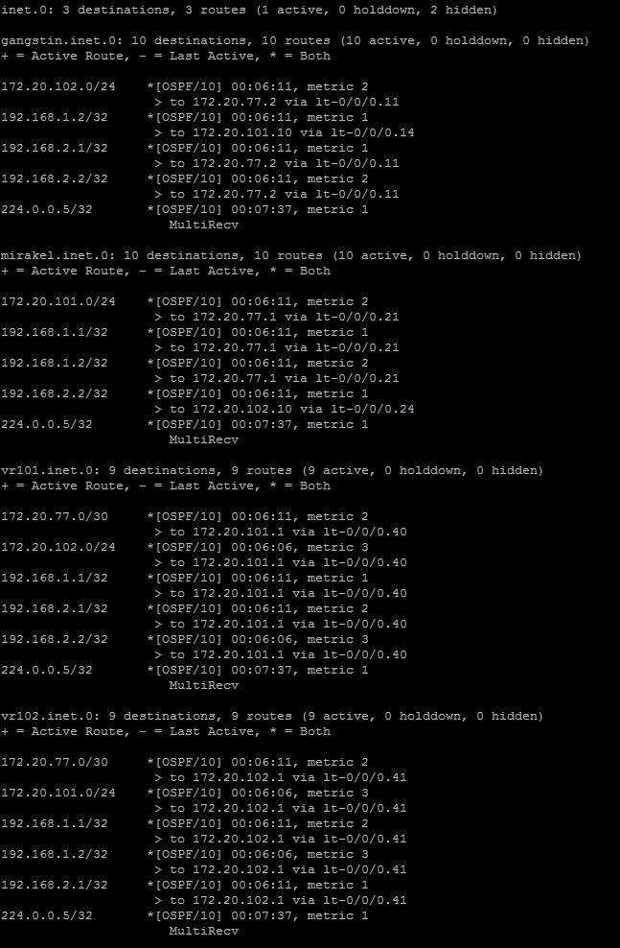

    - 3.1.4 IS – IS

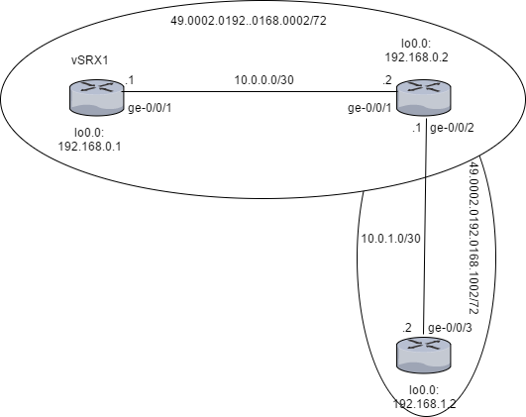
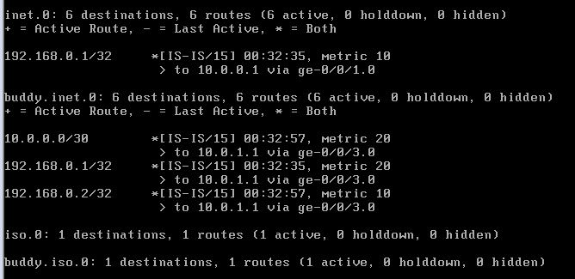

    - 3.1.5 Route Re-Distribution (OSPF/IS-IS)
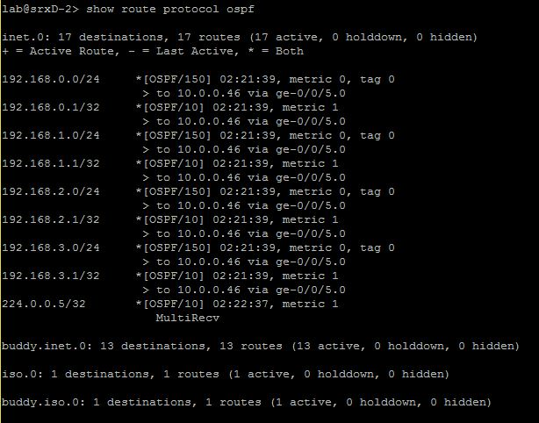
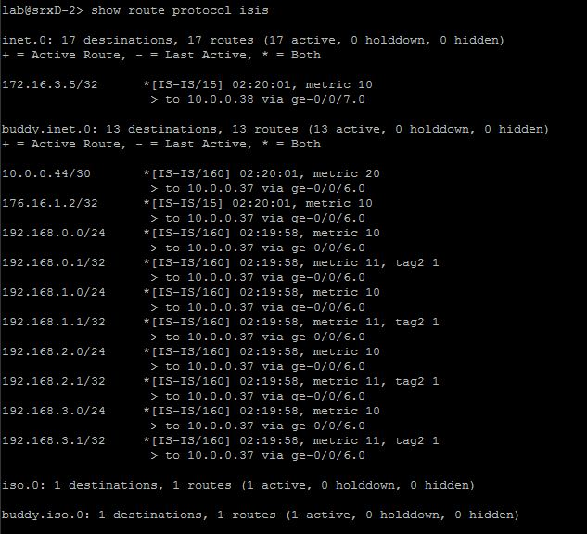

    - 3.1.6 BGP

    - 3.1.7 Re-distribution BGP/OSPF

    - 4.1.1 Security

    - 4.1.2 Routing Policies

    - 4.1.3 Route Redistribution

    - 4.1.4 RE/PFE

    - 4.1.5 Firewall Filters

    - 4.1.6 Class of Service

