Route Re-distribution OSPF/IS-IS
This chapter is about re-distributing OSPF to IS-IS and visa verse. Since each routing protocol has its own chapter this is mainly summarising the configuration on the Juniper SRX series router.

Configuring the Juniper SRX
(The full configuration is available in the appendix)
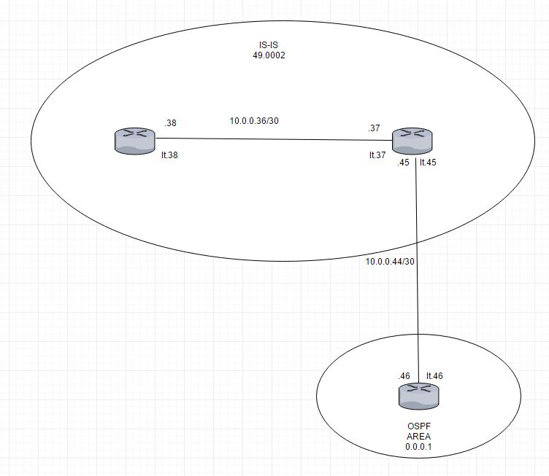
Illustration 1: The network diagram of the network where OSPF - IS-IS redistrubution is configured
The OSPF router has a standard OSPF configuration but the loopback interface has multiple addresses used to simulate routing destinations.

Interfaces {

The ge-0/0/9 interface is connected to the router doing redistribution.
ge-0/0/9 {
unit 0 {
family inet {
address 10.0.0.46/30;
}
}
}

The lo0 interface is configured to have several addresses to simulate route destinations.

lo0 {
unit 0 {
family inet {
address 192.168.1.1/32;
address 192.168.2.1/32;
address 192.168.3.1/32;
address 192.168.0.1/32;
}
}
}
}

Packages to the simulated destination are discarded.

routing-options {
static {
route 192.168.0.0/24 discard;
route 192.168.1.0/24 discard;
route 192.168.2.0/24 discard;
route 192.168.3.0/24 discard;
}
autonomous-system 22;
}

The loopback interface and the interface connected to the IS-IS router is added to OSPF area 1 and the static routes are exported into OSPF using the “ospf” policy.

protocols {
ospf {
export ospf;
area 0.0.0.1 {
interface ge-0/0/9.0;
interface lo0.0 {
passive;
}
}
}
}

policy-options {
policy-statement ospf {
term 1 {
from protocol static;
then accept;
}
}
}
security {
forwarding-options {
family {
mpls {
mode packet-based;
}
}
}
}

The router that does redistributiuon has both OSPF and IS-IS configured on it.

interfaces {

The first interface connected to the router running OSPF configured above.

ge-0/0/5 {
unit 0 {
family inet {
address 10.0.0.45/30;
}
}
}

These interfaces connects the router doing OSPF/IS-IS redistribution (ge-0/0/6), the routing instance that does IS-IS shown at the far left side of the network diagram. Notice that “family iso” is included as described in the IS-IS chapter.

ge-0/0/6 {
unit 0 {
family inet {
address 10.0.0.38/30;
}
family iso;
}
}
ge-0/0/7 {
unit 0 {
family inet {
address 10.0.0.37/30;
}
family iso;
}
}
Set the routers ISO addresses on the loopback interface. The router is in a private area (49) with an ID of 2. The redistributing router has an system id of 0172.0016.0907 and the pure IS-IS router has an ID of 0172.0016.0305.

lo0 {
unit 0 {
family inet {
address 176.16.1.2/32;
}
family iso {
address 49.0002.0172.0016.0907.00;
}
}
unit 1 {
family inet {
address 172.16.3.5/32;
}
family iso {
address 49.0002.0172.0016.0305.00;
}
}
}
}

All routers are in AS17.

routing-options {
autonomous-system 17;
}

Allow export of IS-IS into OSPF and OSPF into the IS-IS and allow the IS-IS routers to talk to each other.

protocols {
isis {
export [ ospf-isis send-direct-to-isis-neighbors ];
interface ge-0/0/7.0;
interface lo0.0;
}
ospf {
export send-direct-to-ospf-neighbors;
area 0.0.0.1 {
interface ge-0/0/5.0;
interface lo0.0 {
passive;
}
}
}
}
policy-options {

Allow traffic from the dummy routing destinations set up in the OSPF router.

policy-statement ospf-isis {
term 1 {
from {
protocol ospf;
route-filter 192.168.0.0/22 longer;
}
then accept;
}
}

Allow traffic between IS-IS and OSPF and visa versa.

policy-statement send-direct-to-isis-neighbors {
from {
protocol direct;
route-filter 10.0.0.44/30 exact;
}
then accept;
}
policy-statement send-direct-to-ospf-neighbors {
from {
protocol direct;
route-filter 10.0.0.36/30 exact;
}
then accept;
}
}

This is the routing instance that does only IS-IS.

routing-instances {
buddy {
instance-type virtual-router;
interface ge-0/0/6.0;
interface lo0.1;
protocols {
isis {
interface ge-0/0/6.0;
interface lo0.1;
}
}
}
}

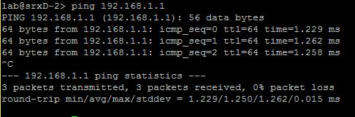
Illustration 2: Pinging the router running OSPF and getting an answer back.
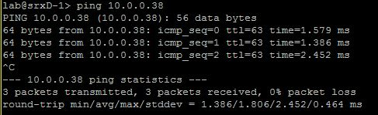
Illustration 3: Pinging the virtual router buddy and getting an answer back.

The OSPF routing table contains routes to all the dummy destinations.
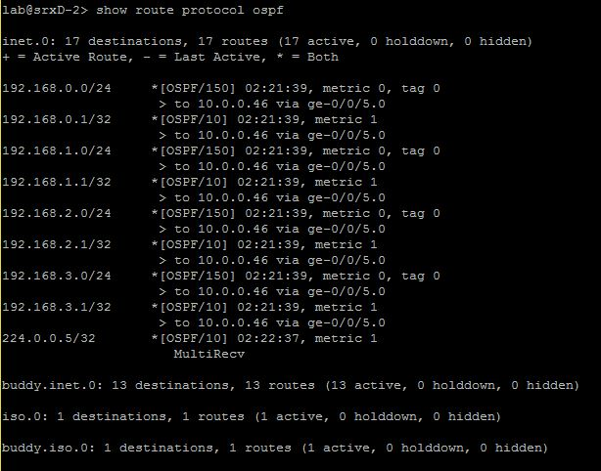
Illustration 4: The OSPF routing table in the redistributing router.

Connections between the routers are clearly working, looking at the routing table the OSPF system there is in fact a route that says 10.0.0.36/30 that is the network where buddy the virtual router is at.
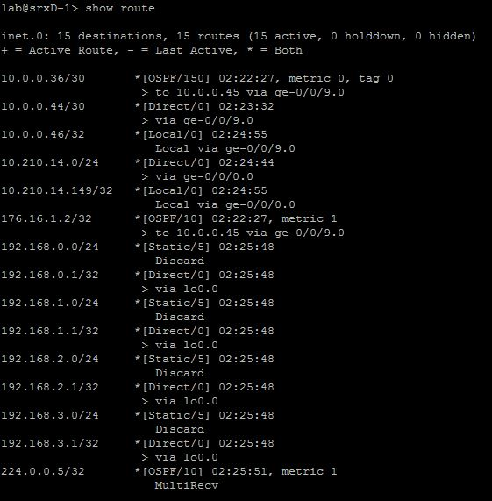
Illustration 5: The routing table of the router running purely OSPF.
The the virtual router buddy has an IS-IS routing table that includes the network of the OSPF router 10.0.0.44/30 and the dummy routes on the loopback interface.
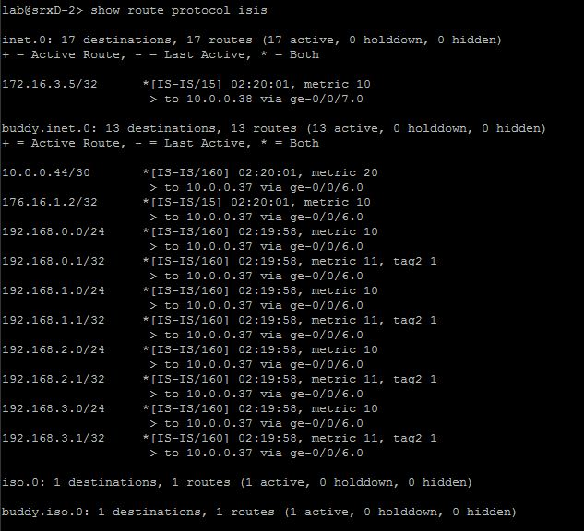
Illustration 6: IS-IS routing table of the redistributing router

