RE/PFE

All platform running the JunosOS share a common design goal: clean separation of control and forwarding functions.

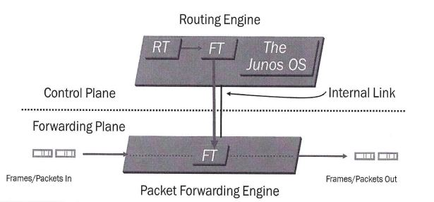

Routing Engine is located in control plane, it is the brain of the Juniper Device, responsible for performing protocol updates and system management, it runs various deamons that reside inside a protected memory environment. The Routing Engine maintains the routing tables, bridging table and forwarding table and conntects to the Packet Forwarding Engine through an internal link. The RE provides the CLI in addition to the J-Web GUI.

The Packet Forwarding Engine is responsible for forwarding transit traffic through the device. In many Juniper platforms the PFE uses application-specific integrated circuits (ASICs) for increased performance.

The PFE receives the layer 2 and layer 3 forwarding table (FT) from Routing Engine. FT updates are a high priority for the Junos OS kernel and are performed incrementally. It implements various services such as policing, stateless firewall filtering, and class of service

Transit Traffic consists of all traffic that enters an ingress network port, is compared against the forwarding table entries, and is forwarded out an egress network port toward its destination.

Exception Traffic does not pass through the local device but rather requires some form of special handling. Examples of exception traffic:

* Packets addressed to the chassis (telnet, pings traceroutes)
* Traffic that requires the generation of ICMP messages

Exception traffic is rare-limited on the internal link to protect the RE from potential DoS attacks

Source: Introduction to the Junos Operating System – Student Guide Revision V-15.a