# IS-IS

IS-IS is an interior gateway protocol designed for routing traffic in an administrative domain it is published as ISO/IEC 10589:2002. Each router floods link state information through the network and independently builds its own database of the networks topology by collecting this information. IS-IS has similarities with OSPF but is a layer 2 protocol and does not use the IP protocol to communicate routing information. As with OSPF, IS-IS uses Dijkstra's algorithm to compute the best path to the network. This algorithm is further described in the OSPF section.

|  |  |  |
| --- | --- | --- |
| Data Link Header | IS-IS Header | IS-IS Data |

|  |  |  |  |
| --- | --- | --- | --- |
| Data Link Header | IP Header | OSPF Header | OSPF Data |

Illustration 1: IS-IS (top) and OSPF (bottom) encapsulation.

The difference between the OSPF Layer 3 encapsulation and that of the Layer 2 IS-IS is shown above. IS-IS is easy to extend by using TLV (Type-Length-Value) field. For instance IS-IS did not originally support IPv4 and later IPv6 but they were added using TLVs.

|  |  |  |
| --- | --- | --- |
| 1 Byte | 1 Byte | *“Length”* bytes |
| Type | Length | Value |

Illustration 2: Format of the TLVs used by IS-IS

The format of a TLV is shown above. Each TLV contain information concerning routing of a certain type as by the first byte. The length of this information is variable and specified in the second byte. The actual information is type dependant but spans the number of bytes given in the previous field.

## Terminology and OSPF differences

An IS-IS network is a single autonomous system (AS) or routing domain consisting of:

* End systems are network entities that send and receive packets.
* Intermediate systems send and receive packets and relay packets, also known as a router.
* ISO packages are called network PDUs (See Protocol Data Unit below).
* A single AS can be divided into smaller groups called areas.
* Routing between areas is organized hierarchically, allowing a domain to be administratively divided into smaller areas.
  + Level 1 Intermediate System: Route within the same area or towards Level 2 systems
  + Level 2 Intermediate System: Route between areas and towards other ASs.
* There is no Area 0 like OSPF.
* IS-IS is neutral with regards to the type of network addresses it can route.
* OSPF areas are tied to interfaces making it possible for a the Area Border Routers (ABRs) to be in more than one area at once. An IS-IS router is only in one area and the border is between the routers.

## Protocol Data Units

IS-IS exchanges information in Protocol Data Units (PDUs) here are the different types:

* IS-IS hello (IIH) PDUs
  + Broadcast to discover identity of neighbouring IS-IS routers.
  + Determine whether neighbours are Level 1 or Level 2 intermediate systems.
* Link-state PDUs (LSPs)
  + Describes the state of adjacencies in neighbouring IS-IS systems.
  + Flooded periodically throughout an area to keep information up to date between IS-IS systems.
* Sequence Number Packets (SNP)
  + Complete sequence number PDUs (CSNPs)
  + Partial sequence number PDUs (PSNPs)

### PDU Format

|  |  |  |  |  |  |  |  |
| --- | --- | --- | --- | --- | --- | --- | --- |
| **1 byte** | **1 byte** | **1 byte** | **1 byte** | **1 byte** | **1 byte** | **1 byte** | **1 byte** |
| Protocol Identifier | Header Length | Version | ID Length | PDU type | Version | Reserved | Maximum Area Address |
| PDU Length | | Remaining lifetime | | LSP ID | | | |
| LSP ID cont. | | | | Sequence number | | | |
| Checksum | | P, ATT, and IS Type bits | TLVs (variable length) | | | | |

*Illustration 3: The Protocol Data Unit.*

Field details

* Protocol Identifier
  + Always 0x83
* Version
  + Always 1.
* ID Length
  + 0 means 6.
* PDU Type
  + 15: LAN Level-1 Hello
  + 16: LAN Level-2 Hello
  + 17: Point-to-point Hello
  + 18: Level-1 LSP
  + 20: Level-2 LSP
  + 24: Level-1 Complete SNP
  + 25: Level-2 Complete SNP
  + 26: Level-1 Partial SNP
  + 27: Level-2 Partial SNP
* Version
  + Always 1
* Maximum Area Addresses
  + 0: indicates the IS only supports three area addresses (by default).
  + Others: up to 254 indicates the number of areas allowed.
* PDU Length, Remaining lifetime, LSP ID, Sequence number, and Checksum are PDU specific.
* P, ATT, and IS type bits.
  + ATT bit is set if IS is connected to another area
  + OL bit is set is the link-state database is overloaded
  + IS Type bits determine a L1 or L2 router
    - Level 1 router: 1
    - Level 2 router: 3
* TLVs
  + Level 1 PDU: 1, 2, 10, 22, 128, 129, 132, 134, 135, 137, 222, 229, 232, 235, 236
  + Level 2 PDU: 1, 2, 10, 22, 128, 129, 130, 132, 134, 135, 137, 222, 229, 232, 235, 236

#### PDU TLV types

* 1: Area Address
* 2: IS reachability
* 10: Authentication
* 22: Extended IS reachability
* 128: IP internal reachability
* 129: Protocols supported
* 130: IP external reachability
* 132: IP interface address
* 134: TE IP router ID
* 135: Extended IP reachability
* 137: Dynamic host name resolution
* Multiple topologies (routing instances) supported
  + TLVs 222, 229, and 235
* 232 and 236: IPv6 is support

## IS-IS configuration on the Juniper SRX

(The full configuration is available in the appendix)

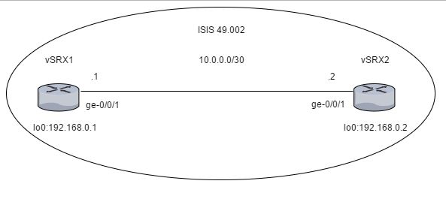  
Illustration 4: The example IS-IS network on the Juniper SRXs.

The IS-IS configuration needs an ISO network address and it is configured on the lo0 interface:

interfaces {

lo0 {

unit 0 {

family inet {

address 192.168.0.1/32;

}

family iso {

address 49.0002.0192.0168.0001.00;

}

}

}

}

|  |  |  |  |  |  |
| --- | --- | --- | --- | --- | --- |
| 49 | 00002 | 0192 | 0168 | 0001 | 00 |
| AFI (1 byte) |  | | | | |
| Area ID (variable 1-13 bytes) | | System ID (6 bytes) | | | NSEL (1 byte) |

* Area ID:
  + Variable part of the NET address.
    - The first byte is the AFI (Address Family Identifier), 49 means private addressing.
    - The following bytes of the AREA ID can be arbitrary filled to represent the Area number and is useful for Level 1 adjacency.
* System ID:
  + This is a unique id for the router like the OSPF router-id. In this case it is derived from the loopback IP address.
* NSEL:
  + The NSEL is like the Protocol field of the IP header. It must be set to 0x00 in order to for adjacency comes up.

Interfaces that are to handle IS-IS PDUs needs to have the “famliy iso” statement added.

interfaces {

ge-0/0/1 {

unit 0 {

description to-vSRX2;

family inet {

address 10.0.0.1/30;

}

family iso;

}

}

}

The interfaces must be added in the “protocols” hierarchy under “isis” and any optional IS-IS parameters configured.

protocols {

isis {

interface ge-0/0/1.0;

interface lo0.0;

}

}

In the security hierarchy enable packet-based processing for the “mpls” and “iso” family.

security {

forwarding-options {

family {

mpls {

mode packet-based;

}

iso {

mode packet-based;

}

}

}

}

As shown in the network diagram above two machines are connected using the above configuration, with individual addresses.

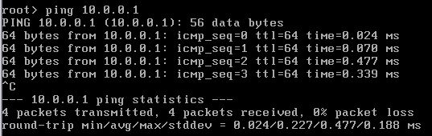  
Illustration 5: Pining vSRX1 to test the connection.

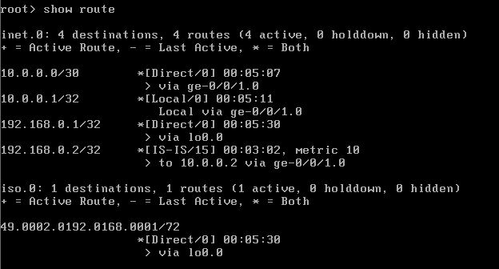  
Illustration 6: Showing that IS-IS routes are in the routing table.

## Sources:

EAL – IS-IS Intermediate System to Intermediate System.