# OSPF

OSPF is short for Open Shortest Path First and is the name of a routing protocol. OSPF is an interior gateway protocol which means that it is used to exchange routing information within an autonomous system. IOSPF Version 2 was defined in RFC2328 in 1998 and Version 3 in RFC5340 in 2008. Version 3 is an update to support IPv6.

OSPF forms IP datagrams directly and packages them using protocol number 89 and implements its own transport layer error detection and correction functions. OSPF uses multicast addressing for distributing routing information within a broadcast domain.

Routers running OSPF communicate with neighbouring routers on connected interfaces to establish the state of connections:

* **Down:** Initial state of the connection indicating that no resent communication has been received.
* **Init:** A HELLO packet has been received from a neighbour but the routers have not established two-way communication.
* **Exchange:** The router is sending its link state database to the neighbour in database description packets. Each packet has a sequence number that is explicitly acknowledged.
* **Loading:** The router requests the most recent link-state advertisements from its neighbor discovered in the Exchange state.
* **Full:** The end state when all adjacent routers has reached the Full state and the link state database of o the neighbours are fully synchronized.

## OSPF areas

Areas in OSPF are used to administratively group networks and host in an AS together, areas are identified by 32-bit numbers. The topology of an area is unknown outside that area

An example of a network split into areas are shown in Illustration 1. The routers fully inside the areas (circles) are called internal routers, these are all connected to devices inside the same area. The routers on the borders between to areas are called area border routers or ABRs. Area 0 has a special role as the backbone area that distributes routes between areas. All ABRs are connected to the backbone, and the backbone area most be contiguous, if not physically, by using virtual links. The backbone has no ABRs and the routers in area 1 has to go through area 0 to talk to routers in area 2. It is the backbones job to redistribute routing information between the other areas.

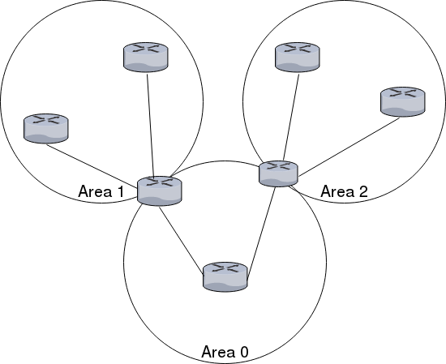  
Illustration 1: OSPF areas

## Designated Router

To not load down the network with routing traffic in large networks, OSPF uses designated routers. Routers in the same network sends their link state information to the designated router. The designated router send the link advertisements on behalf of the network and participates in synchronising the link state database by establishing adjacencies. The designated router is found through election.

* The router priorities are evaluated and the router with the highest priority is selected as the designated router.
* If there is more than one router with the same priority, the one with the highest router identifier is chosen.
* If the no router ids are configured the election will go by the IP address of the first interface that comes online. This is usually the loopback interface.
* If nothing of the above, the first hardware interface with an IP address will be used for the election.

By default routing devices has a priority of 128. The priorities work like this:

* 0: the router will not e considered in the election.
* 1: the router has the least chance of being elected.

## Dijkstra's algorithm

OSPF ( and IS-IS described later) uses Dijkstra’s algorithm to calculate the shortest path between to nodes. The algorithm works as follows:

1. Set the first node as the current node. Assign a distance to each node, the value is zero for the current node and infinity for all others. Create a set of all unvisited nodes.
2. Calculate the distance to all neighbours of the current node and compare to this distance to the current value. Assign the new distance if it is smaller.
3. When distances to all neighbours have been calculated, mark the current node as visited and remove it from the set of unvisited nodes.
4. When the destination node is marked as visited, if looking for a route between specific nodes, the path has been found. When doing a complete traversal of the graph there is is no nodes in the unvisited set that has a lower distance than infinity, there is no connection between the initial node, and the the unvisited nodes and the algorithm has finished.
5. If none of the above is the case, select the node from the unvisited set that has the lowest distance value as the current node, and repeat from step 2.

## Quick configuration example

(The full configurations are located in Appendix)

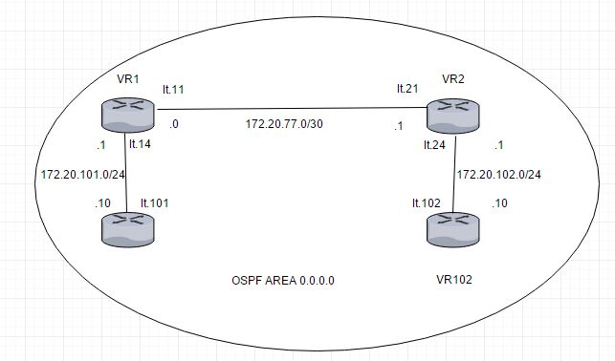  
Illustration 2: Network diagram of the OSPF example configuration.

The above diagram illustrates an example configuration of virtual router to use OSPF. Connection between the virtual routers are connected using logical tunnels.

This is the routing instance designated “VR1” in the illustration above:

routing-instances {

gangstin {

The logical tunnel interfaces and loopback interface are set up according to the illustration above.

instance-type virtual-router;

interface lt-0/0/0.11;

interface lt-0/0/0.14;

interface lo0.1;

Next comes the actual OSPF configuration. This configuration includes all interfaces in area 0, the backbone area.

protocols {

ospf {

area 0.0.0.0 {

interface lt-0/0/0.11;

interface lt-0/0/0.14;

interface lo0.1;

}

}

}

}

}

This configuration is mirrored on each virtual router, except of course the interfaces change according to the digram above.

## Sources:

Wikipedia - Open Shortest Path First - <https://en.wikipedia.org/wiki/Open_Shortest_Path_First>

Wikipedia - Dijkstra's algorithm - <https://en.wikipedia.org/wiki/Dijkstra's_algorithm>

Juniper website - Understanding OSPF Areas - <https://www.juniper.net/documentation/en_US/junos/topics/concept/ospf-routing-understanding-ospf-areas-overview.html>

EAL - OSPF/Open Shortest Path First presentation