# Route Re-distribution OSPF/IS-IS

This chapter is about re-distributing OSPF to IS-IS and visa verse. Since each routing protocol has its own chapter this is mainly summarising the configuration on the Juniper SRX series router.

## Configuring the Juniper SRX

(The full configuration is available in the appendix)

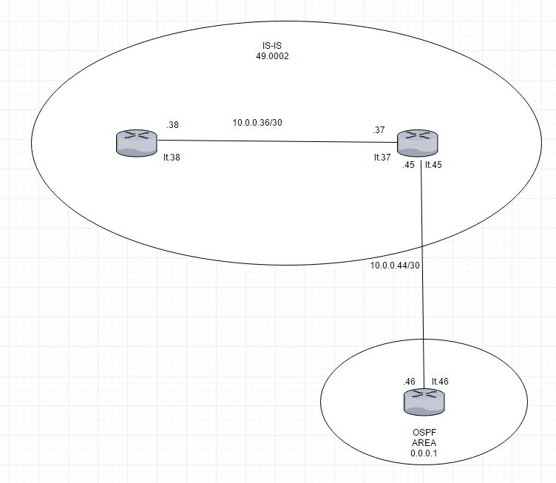  
Illustration 1: The network diagram of the network where OSPF - IS-IS redistrubution is configured

The OSPF router has a standard OSPF configuration but the loopback interface has multiple addresses used to simulate routing destinations.

Interfaces {

The ge-0/0/9 interface is connected to the router doing redistribution.

ge-0/0/9 {

unit 0 {

family inet {

address 10.0.0.46/30;

}

}

}

The lo0 interface is configured to have several addresses to simulate route destinations.

lo0 {

unit 0 {

family inet {

address 192.168.1.1/32;

address 192.168.2.1/32;

address 192.168.3.1/32;

address 192.168.0.1/32;

}

}

}

}

Packages to the simulated destination are discarded.

routing-options {

static {

route 192.168.0.0/24 discard;

route 192.168.1.0/24 discard;

route 192.168.2.0/24 discard;

route 192.168.3.0/24 discard;

}

autonomous-system 22;

}

The loopback interface and the interface connected to the IS-IS router is added to OSPF area 1 and the static routes are exported into OSPF using the “ospf” policy.

protocols {

ospf {

export ospf;

area 0.0.0.1 {

interface ge-0/0/9.0;

interface lo0.0 {

passive;

}

}

}

}

policy-options {

policy-statement ospf {

term 1 {

from protocol static;

then accept;

}

}

}

security {

forwarding-options {

family {

mpls {

mode packet-based;

}

}

}

}

The router that does redistributiuon has both OSPF and IS-IS configured on it.

interfaces {

The first interface connected to the router running OSPF configured above.

ge-0/0/5 {

unit 0 {

family inet {

address 10.0.0.45/30;

}

}

}

These interfaces connects the router doing OSPF/IS-IS redistribution (ge-0/0/6), the routing instance that does IS-IS shown at the far left side of the network diagram. Notice that “family iso” is included as described in the IS-IS chapter.

ge-0/0/6 {

unit 0 {

family inet {

address 10.0.0.38/30;

}

family iso;

}

}

ge-0/0/7 {

unit 0 {

family inet {

address 10.0.0.37/30;

}

family iso;

}

}

Set the routers ISO addresses on the loopback interface. The router is in a private area (49) with an ID of 2. The redistributing router has an system id of 0172.0016.0907 and the pure IS-IS router has an ID of 0172.0016.0305.

lo0 {

unit 0 {

family inet {

address 176.16.1.2/32;

}

family iso {

address 49.0002.0172.0016.0907.00;

}

}

unit 1 {

family inet {

address 172.16.3.5/32;

}

family iso {

address 49.0002.0172.0016.0305.00;

}

}

}

}

All routers are in AS17.

routing-options {

autonomous-system 17;

}

Allow export of IS-IS into OSPF and OSPF into the IS-IS and allow the IS-IS routers to talk to each other.

protocols {

isis {

export [ ospf-isis send-direct-to-isis-neighbors ];

interface ge-0/0/7.0;

interface lo0.0;

}

ospf {

export send-direct-to-ospf-neighbors;

area 0.0.0.1 {

interface ge-0/0/5.0;

interface lo0.0 {

passive;

}

}

}

}

policy-options {

Allow traffic from the dummy routing destinations set up in the OSPF router.

policy-statement ospf-isis {

term 1 {

from {

protocol ospf;

route-filter 192.168.0.0/22 longer;

}

then accept;

}

}

Allow traffic between IS-IS and OSPF and visa versa.

policy-statement send-direct-to-isis-neighbors {

from {

protocol direct;

route-filter 10.0.0.44/30 exact;

}

then accept;

}

policy-statement send-direct-to-ospf-neighbors {

from {

protocol direct;

route-filter 10.0.0.36/30 exact;

}

then accept;

}

}

This is the routing instance that does only IS-IS.

routing-instances {

buddy {

instance-type virtual-router;

interface ge-0/0/6.0;

interface lo0.1;

protocols {

isis {

interface ge-0/0/6.0;

interface lo0.1;

}

}

}

}

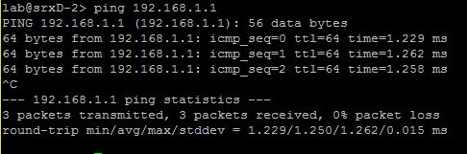  
Illustration 2: Pinging the router running OSPF and getting an answer back.

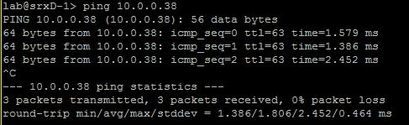  
Illustration 3: Pinging the virtual router buddy and getting an answer back.

The OSPF routing table contains routes to all the dummy destinations.

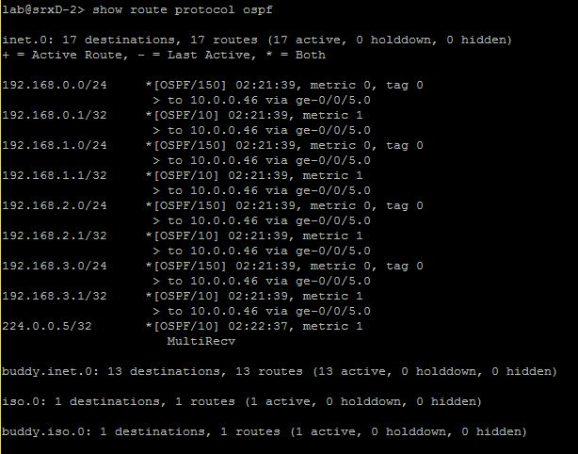  
Illustration 4: The OSPF routing table in the redistributing router.

Connections between the routers are clearly working, looking at the routing table the OSPF system there is in fact a route that says 10.0.0.36/30 that is the network where buddy the virtual router is at.

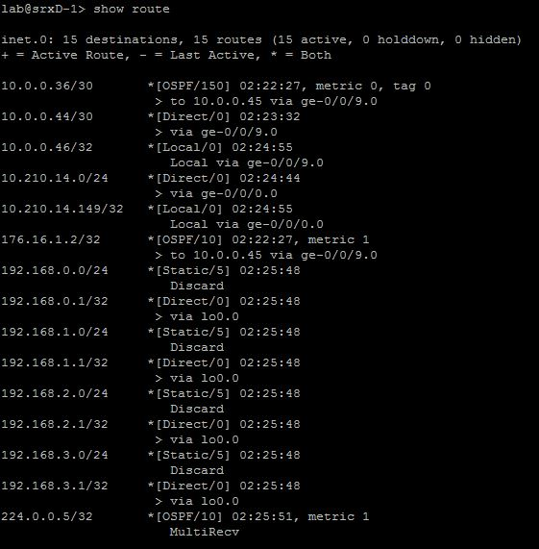  
Illustration 5: The routing table of the router running purely OSPF.

The the virtual router buddy has an IS-IS routing table that includes the network of the OSPF router 10.0.0.44/30 and the dummy routes on the loopback interface.

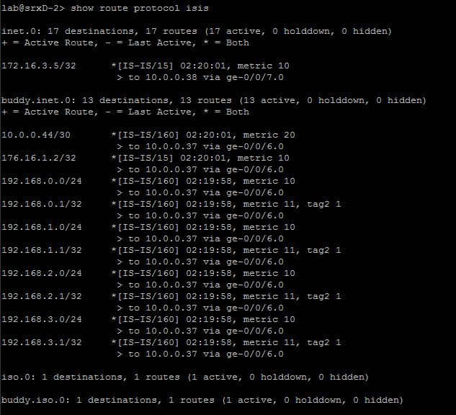  
Illustration 6: IS-IS routing table of the redistributing router