Recovery documentation
Project network
Autumn 2016



Lillebaelt Academy of
University of applied sciences

IT Technology

Author
Cristian Iacobanu cris0691@edu.eal.dk
Kasper Soelberg kasp062e@edu.ael.dk
Martin B. K. Grønholdt mart80c7@edu.eal.dk
2016-11-24

Table of Contents
1 Introduction 1
2 Overview 1
3 Software sources: 1
4 Creating the Virtual Machines and install their OSs 2
4.1 CLIENT-USRLAN (Kali client) 2
4.2 SERVER-SRVLAN-DNS & SERVER-DMZ-WEB (Debian netinst) 5
4.3 ROUTER-EXT & ROUTER-INT (JunOS SRX VM) 5
5 Configuring the virtual machines 6
5.1 General setup of the Debian servers 6
5.1.1 Setup SSH for root logins over the network 6
5.1.2 Add another network card to the virtual machine 6
5.2 General SSH setup of the routers 8
5.2.1 Configuring the router for SSH 8
5.3 CLIENT-USRLAN (Kali client) 9
5.4 ROUTER-INT 9
5.5 ROUTER-EXT 10
5.6 SERVER-SRVLAN-DNS 10
5.7 SERVER-DMZ-WEB 10
5.8 Network setup 11

Introduction
This document describes the steps needed to create project network. The latest version of this document is available at https://github.com/deadbok/project_network.
Since this project is available on GitHub, basic git usage skills are expected for this guide.
This is a test/teaching setup, there are some configuration details in here that should NEVER be allowed in a production environment.
- Root logins from remote machines, instead create an unprivileged user for remote access.
- Leaving unused interface configurations in the routers, they could be exploited and should be removed.

Overview
This are the overall steps in recreating the system from scratch.
- Software sources
- Create virtual machines and install OSs if needed
- Define the interfaces on each machine and link them together
- Configure internal router
- Configure internal server for DHCP
- Configure the external router
- Configure the external server for HTTP services
- Configure internal machine for local DNS resolution

Software sources:
These are the links to the external resources that has been downloaded to get things working:

- VMWare Workstation 12 Pro:
http://www.vmware.com/products/workstation/workstation-evaluation.html
- JunOS SRX VMWare virtual machine:
https://fronter.com/eal/links/files.phtml/2080432588$548107012$/1st+Semester/Data+Communication/Software/junos-vsrx-12.1X47-D15.4-domestic.ovf
and
https://fronter.com/eal/links/files.phtml/2080432588$548107012$/1st+Semester/Data+Communication/Software/junos-vsrx-12.1X47-D15.4-domestic-disk1.vmdk
- Debian net installer ISO file:
http://cdimage.debian.org/debian-cd/8.6.0/amd64/iso-cd/debian-8.6.0-amd64-netinst.iso
- Kali Linix 64-bit ISO file:
http://cdimage.kali.org/kali-2016.2/kali-linux-2016.2-amd64.iso

Creating the Virtual Machines and install their OSs
When creating the virtual machines do not bother with the network configuration at this time.

CLIENT-USRLAN (Kali client)
The Kali client is a Live CD and is run directly from the ISO image, with no persistent storage. When setting up this machine in VMWare, create a custom machine (as shown in Illustration 1) with no emulated hard drive.
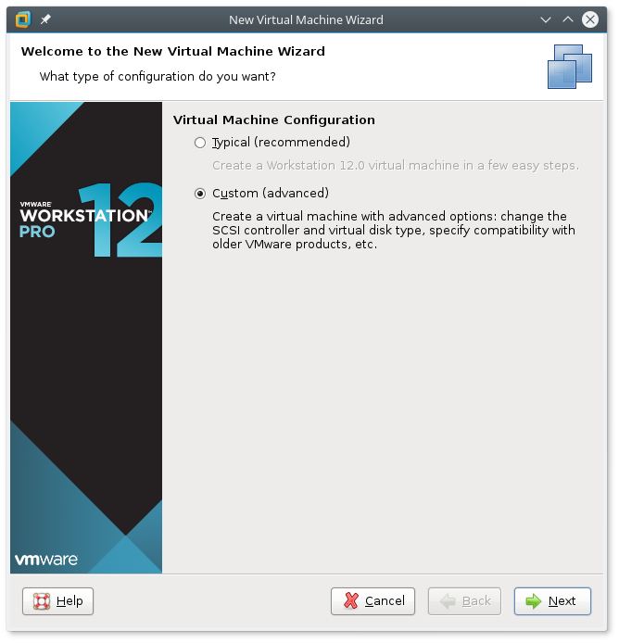
Illustration 1: Creating a custom virtual machine
Add the ISO image to the virtual machine in the screen after that, and on the next screen select the OS as shown in Illustration 2.
On the following screen enter the name CLIENT-USRLAN. Set the amount of memory to no less than 1024MB or Kali will complain. VMWare insists on creating a virtual hard drive, but since Kali is running from a live image, you are free to delete this virtual drive when the machine is created (see Illustration 3)
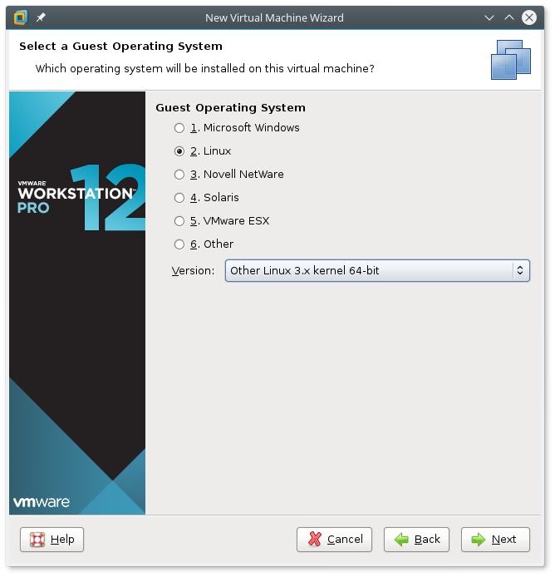
Illustration 2: OS selection for the Kali Client
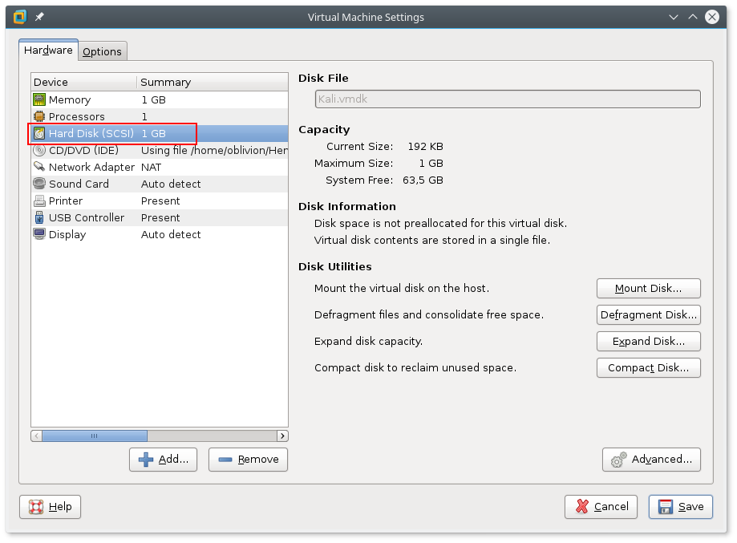
Illustration 3: You can delete the Hard Disk image since Kali is booted from the ISO image.

SERVER-SRVLAN-DNS & SERVER-DMZ-WEB (Debian netinst)
To create the virtual machines for the Debian server, just click through the guided VM creation, in VMWare. There are only three changes, remember to select the debian-8.6.0-amd64-netinst.iso, for the installation media, set the correct machine name, and decrease the virtual hard drive to 2GB, to not waste space.
When installing the Debian GNU/Linux remember to have a working Internet connection in the VM, because the netinst image fetches most of the Debian packages from the Internet. When the Debian installation asks for the hostname, use the name from the naming convention. Set the domain to “localnet”.

ROUTER-EXT & ROUTER-INT (JunOS SRX VM)
The downloaded files has a VMWare “.ovf” file that you can open from the VMWare file menu. Rename the machine “ROUTER-EXT”. Create a full clone of the “ROUTER-EXT” machine and name that one “ROUTER-INT”. The JunOS operating system is all ready installed on the image, so for these machines there are no OS installation step.

Configuring the virtual machines
When an SSH connection is made for the first time, the client will ask if the connection is to the right machine by showing the following:
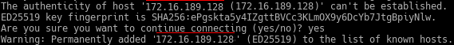
Illustration 4: Confirming the SSH connection at first connection.
If the IP looks correct answer “yes”.

General setup of the Debian servers
To login to the server to install the configuration files an SSH connection to the virtual machine has to be established. To do this follow these steps:

Setup SSH for root logins over the network
Login as root and edit /etc/ssh/sshd_config, find the following line:
PermitRootLogin without-password
and change it to:
PermitRootLogin yes
Save the file and then restart SSH service:
service ssh restart

Add another network card to the virtual machine
Open the properties for the virtual machine, and add another network card with a Host-only connection.
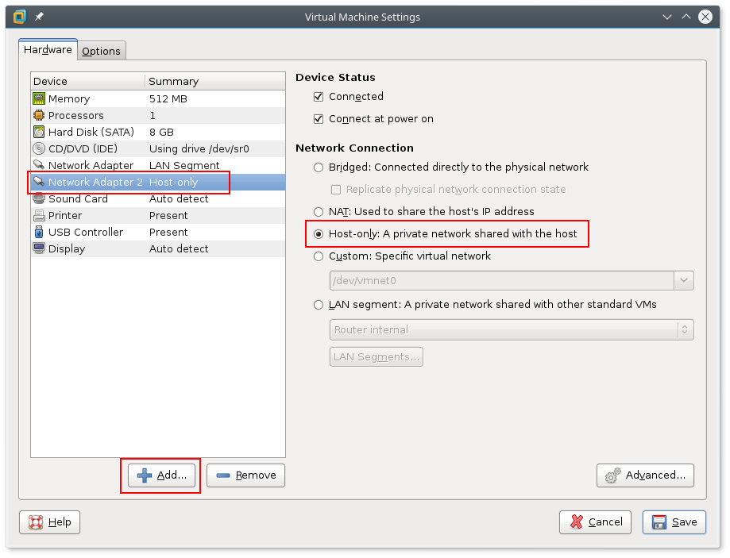
Illustration 5: Adding a network card using Host-only to allow connecting from the host.
After these steps get an address for the new interface on the server vm. There is no need to make any more changes to configuration files since this is a temporary management connection.
To get an IP address for eth1 (assuming this is the name of the new network device) in the server vm run the following as root:
dhclient eth1
When the command finishes run ip addr, to learn the address assigned by DHCP:
ip addr
The output looks like this:
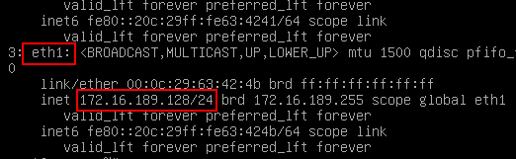
Illustration 6: The IP address of the new interface (eth1) as shown by running "ip addr".
To ssh from the host to the vm server use the following command (with the actual IP address of the server):
ssh root@172.16.189.128
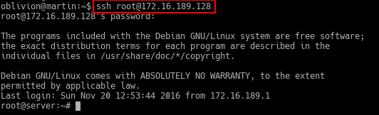
Illustration 7: Logging into the vm server using the Host-only connection and ssh.

General SSH setup of the routers
As with the server, and ssh connection is needed to copy the configuration to the routers. To have a Host-only connection refer to section “Add another network card to the virtual machine“.

Configuring the router for SSH
To set up the router for SSH access the following configuration has to be set for the Host-only interface:
#Enter the cli
cli

#Enter edit mode
edit

# Set the root password
set system root-authentication plain-text-password
New Password: type password here
Retype new password: retype password here

# Set the interface to DHCP
set interfaces ge-0/0/3 unit 0 family inet dhcp

# Delete the interface from the untrusted zone.
delete security zones security-zone untrust interfaces \
ge-0/0/3.0

# Put the interface in the trusted zone and allow all services
set security zones security-zone trust interfaces \
ge-0/0/3.0 host-inbound-traffic system-services all

# Allow all protocols
set security zones security-zone trust \ interfaces ge-0/0/3.0 host-inbound-traffic protocols all

# Commit the changes
commit

CLIENT-USRLAN (Kali client)
The client boots of the ISO image and does not need any configuration.

ROUTER-INT
To copy the configuration file onto the router when configured for SSH access do like this:

scp router-int.conf root@172.16.189.133:~/.

Then on the router login and load the configuration:
# Enter the cli
cli

# Enter edit mode
edit

# Load the configuration that has just been copied to the
# router.
load override router-int.conf

# Commit the new configuration
commit

ROUTER-EXT
To copy the configuration file onto the router when configured for SSH access do like this:

scp router-ext.conf root@172.16.189.133:~/.

Then on the router login and load the configuration:
# Enter the cli
cli

# Enter edit mode
edit

# Load the configuration that has just been copied to the
# router.
load override router-ext.conf

# Commit the new configuration
commit

SERVER-SRVLAN-DNS
- Copy the configuration files into the server
- Install dnsmasq
- Enable the dnsmasq service

SERVER-DMZ-WEB
- Copy the configuration files into the server
- Install apache
- Enable

Network setup

