Recovery documentation
Project network
Autumn 2016



Lillebaelt Academy of
University of applied sciences

IT Technology

Author
Cristian Iacobanu cris0691@edu.eal.dk
Kasper Soelberg kasp062e@edu.ael.dk
Martin B. K. Grønholdt mart80c7@edu.eal.dk
2016-11-16

Table of Contents
1. Introduction 1
2. Overview 1

Introduction
This document describes the steps needed to create project network. The latest version of this document is available at https://github.com/deadbok/project_network

Overview
This are the overall steps in recreating the system from scratch.
- Software sources
- Create virtual machines and install OSs if needed
- Define the interfaces on each machine and link them together
- Configure internal router
- Configure internal server for DHCP
- Configure the external router
- Configure the external server for HTTP services
- Configure internal machine for local DNS resolution

Software sources:
These are the links to the external resources that has been downloaded to get things working:

- VMWare Workstation 12 Pro:
http://www.vmware.com/products/workstation/workstation-evaluation.html
- JunOS SRX VMWare virtual machine:
https://fronter.com/eal/links/files.phtml/2080432588$548107012$/1st+Semester/Data+Communication/Software/junos-vsrx-12.1X47-D15.4-domestic.ovf
and
https://fronter.com/eal/links/files.phtml/2080432588$548107012$/1st+Semester/Data+Communication/Software/junos-vsrx-12.1X47-D15.4-domestic-disk1.vmdk
- Debian net installer ISO file:
http://cdimage.debian.org/debian-cd/8.6.0/amd64/iso-cd/debian-8.6.0-amd64-netinst.iso
- Kali Linix 64-bit ISO file:
http://cdimage.kali.org/kali-2016.2/kali-linux-2016.2-amd64.iso

Creating the Virtual Machines and install their OSs
When creating the virtual machines do not bother with the network configuration at this time.

CLIENT-USRLAN (Kali client)
The Kali client is a Live CD and is run directly from the ISO image, with no persistent storage. When setting up this machine in VMWare, create a custom machine (as shown in Illustration 1) with no emulated hard drive.
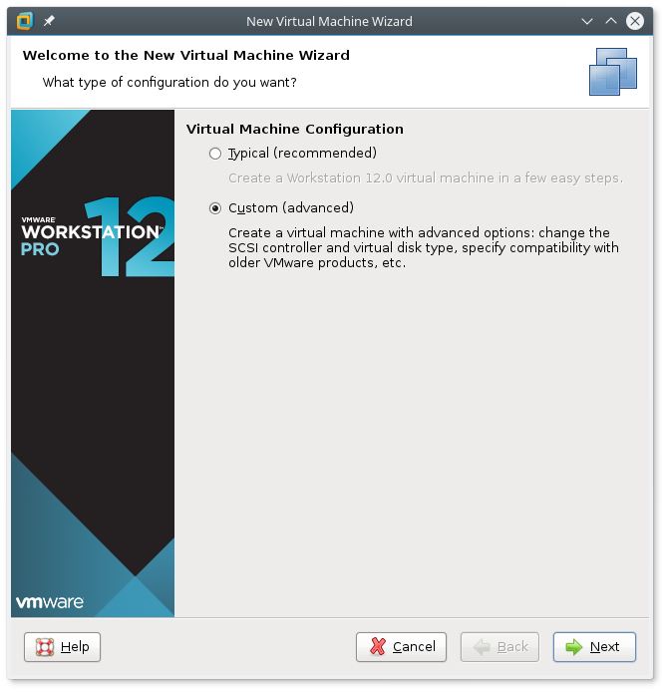
Illustration 1: Creating a custom virtual machine
Add the ISO image to the virtual machine in the screen after that, and on the next screen select the OS as shown in Illustration 2.
On the following screen enter the name CLIENT-USRLAN. Set the amount of memory to no less than 1024MB or Kali will complain. VMWare insísts on creating a virtual hard drive, but since Kali is running from a live image, you are free to delete this virtual drive when the machine is created (see Illustration 3)
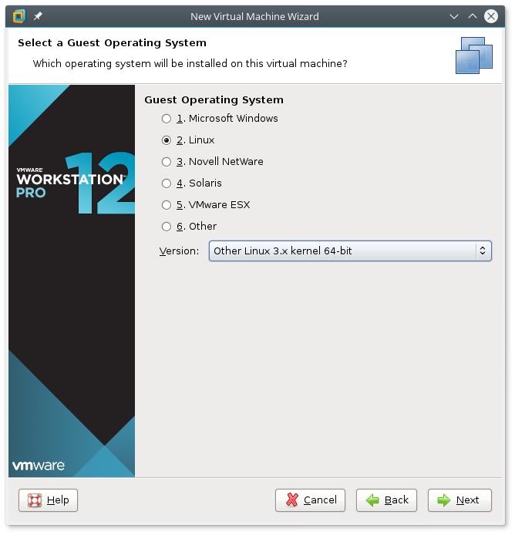
Illustration 2: OS selection for the Kali Client
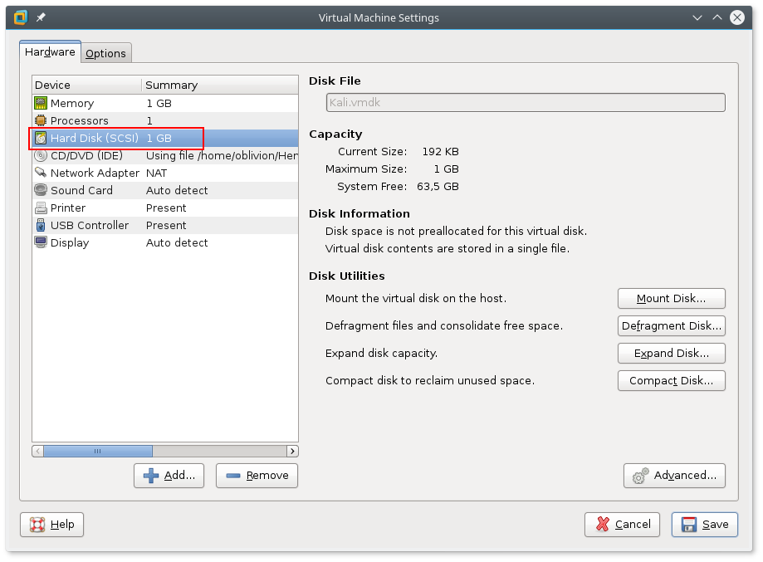
Illustration 3: You can delete the Hard Disk image since Kali is booted from the ISO image.

SERVER-SRVLAN-DNS & SERVER-DMZ-WEB (Debian netinst)
To create the virtual machines for the Debian server, just click through the guided VM creation, in VMWare. There are only three changes, remember to select the debian-8.6.0-amd64-netinst.iso, for the installation media, set the correct machine name, and decrease the virtual hard drive to 2GB, to not waste space.
When installing the Debian GNU/Linux remember to have a working Internet connection in the VM, because the netinst image fetches most of the Debian packages from the Internet. When the Debian installation asks for the hostname, use the name from the naming convention. Set the domain to “localnet”.

