Name : Sum, Sub, Multi, Div, Modulus of 2 variables in JAVA.

Source Code :

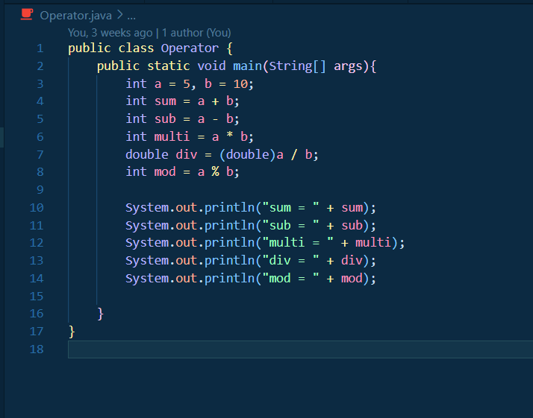

Output :

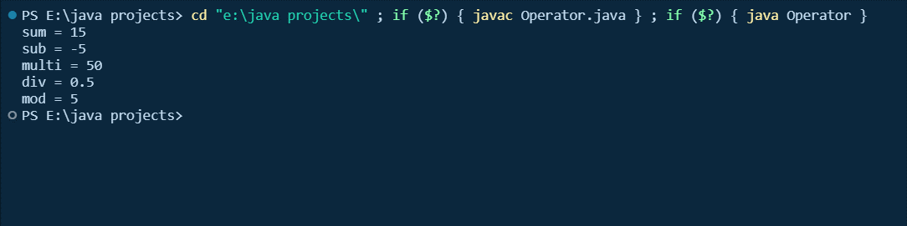

Name : Using different types of variable in JAVA.

Source Code :

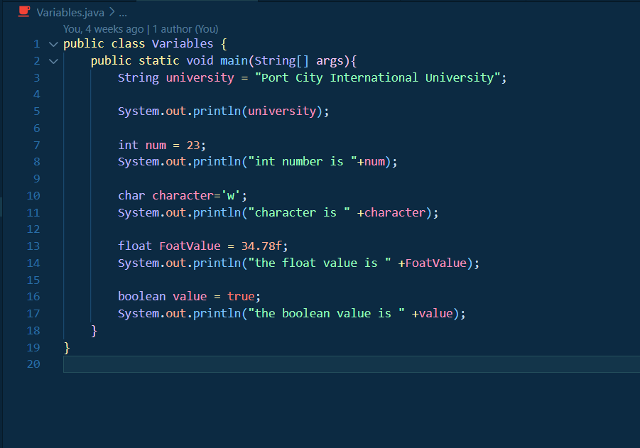

Output :

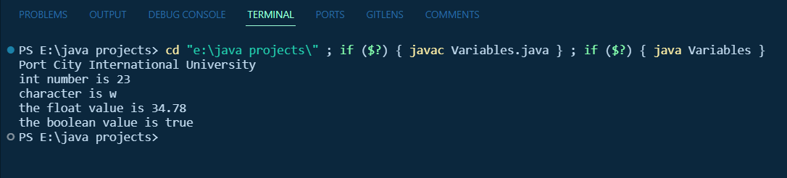

Name : Using variables and operators in JAVA.

Source Code :

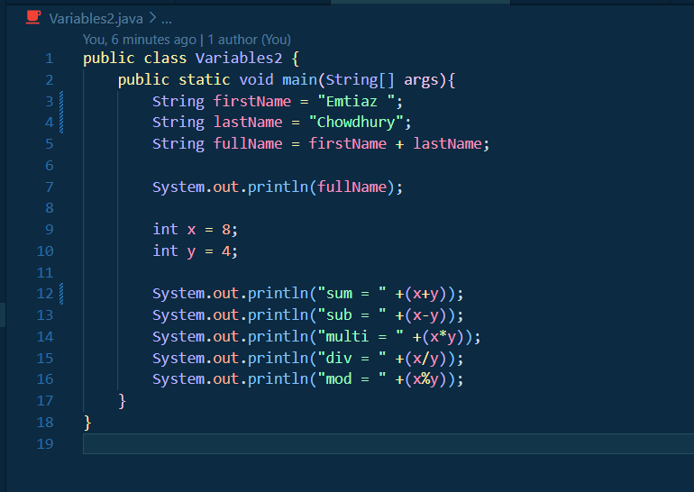

Output :

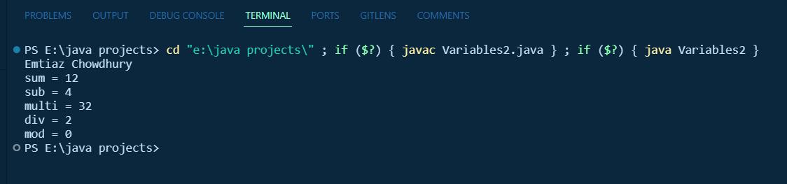

Name : Auto and manual type conversion in JAVA.

Source Code :

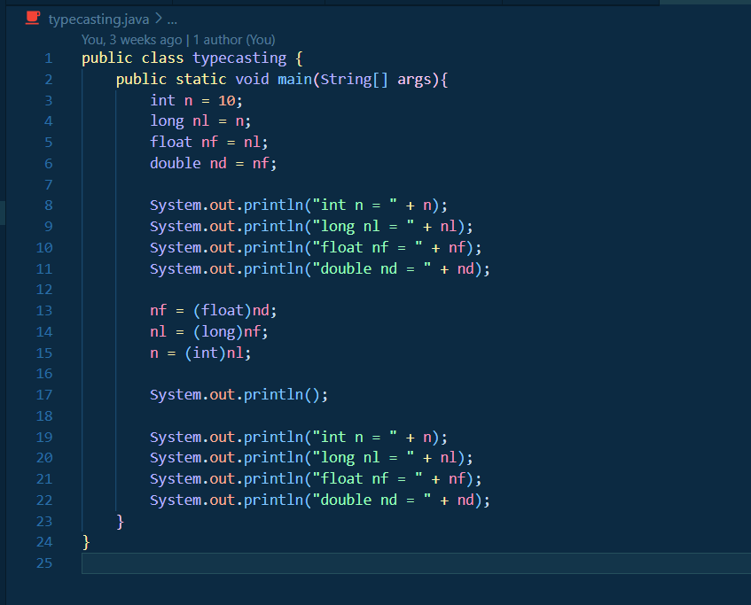

Output :

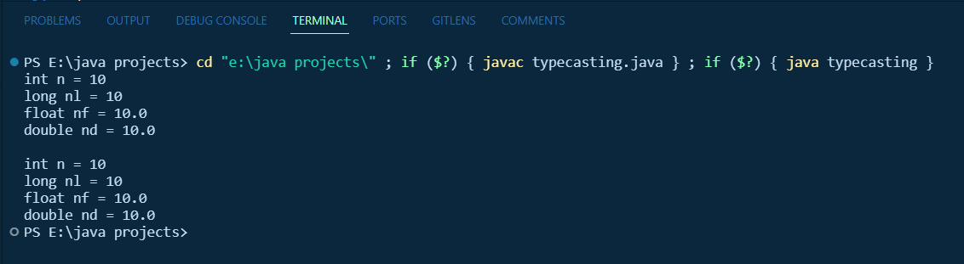

Name : Pre increment and post increment in java.

Source Code :

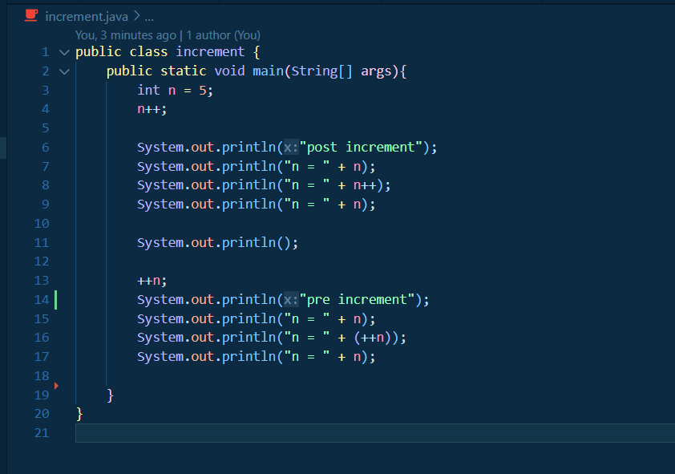

Output :

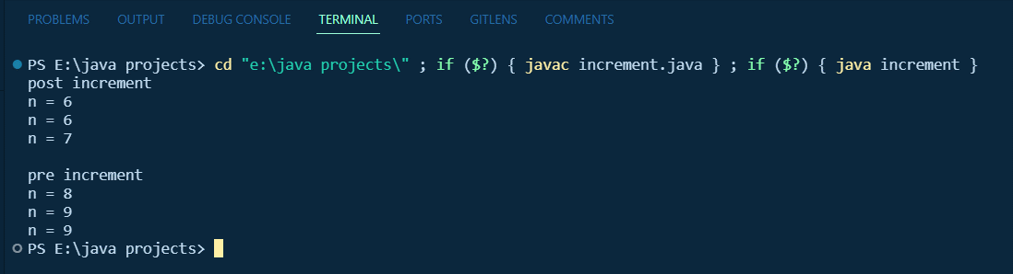

Name : pre decrement and post decrement in JAVA.

Source Code :

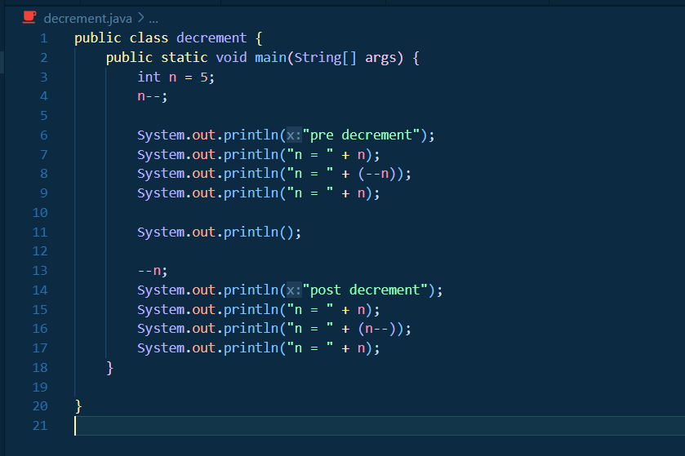

Output :

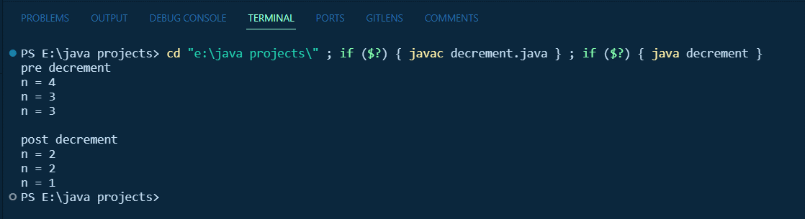

# INDEX

|  |  |  |
| --- | --- | --- |
| **SERIAL NUMBER** | **NAME** | **PAGE** |
| 1 | Sum, Sub, Multi, Div, Modules of 2 variables in JAVA. | 1 |
| 2 | Using different types of variable in JAVA. | 2 |
| 3 | Using variables and operators in JAVA. | 3 |
| 4 | Auto and manual type conversion in JAVA. | 4 |
| 5 | Pre increment and post increment in java. | 5 |
| 6 | pre decrement and post decrement in JAVA. | 6 |