Type of the Paper(Article)
SRDFNet: A Network with Semantic Interaction Refinement and Differential Feature Enhancement for Semantic Change Detection in High-Resolution Remote Sensing Images
Wenbo Zhao^{a, 1}, Yingjun Zhao^{a,1}, Keyue Chen^{a,2} and Donghua Lu^{a,*}
ªBeijing Research Institute of Uranium Geology, Beijing 100029, China
¹zhaowenbo@briug.cn; zhaoyingjun@briug.cn
²chenkeyue@briug.cn
*Correspondence: ludonghua@briug.cn
Abstract
To address uneven ground object distribution and variable sizes in remote sensing images, this paper improves BGSNet and proposes a new change detection network SRDFNet (Semantic Refinement and Enhanced Difference). Based on BGSNet’s framework, it introduces three complementary modules: (1) a Hierarchical Graph Module (HGM) that converts multi-scale feature maps into compact semantic graph nodes, using graph attention for intra-layer and cross-level semantic interaction to enhance topological relationship perception; (2) a Difference Enhancement (DE) module that extracts multi-receptive-field difference information from bi-temporal concatenated features via multi-scale parallel convolution branches; (3) a Semantic Refine (SR) module that performs lightweight residual refinement on bi-temporal semantic features to improve segmentation accuracy. Trained and tested with BGSNet and three other models on SECOND and HRSCD datasets, SRDFNet outperforms BGSNet in F1, Sek, and mIoU, and surpasses other models in identifying various semantic changes on HRSCD.
Keywords: Remote Sensing; Deep Learning; Semantic Change Detection; Feature Refinement; Multi-Task Learning

1. Introduction
In the field of remote sensing, change detection research refers to the process of obtaining surface change information by analyzing two images of the same area acquired at different times [1]. In applications such as land use, resource exploration, and disaster monitoring, the use of remote sensing technology for dynamic monitoring of surface cover is an extremely important technical means [2]. In recent years, with the rapid development of technologies such as artificial intelligence, neural networks, and large language models, deep learning has also been widely applied to task scenarios such as target recognition and change detection in the remote sensing field [3-5]. Due to its strong learning ability and deep mining ability of complex features, compared with other change detection methods, deep learning can more accurately capture change information in remote sensing images, improve the accuracy of interpretation, and reduce the time of feature extraction [6-8].
The Transformer model is an important innovation in the field of deep learning, which mainly realizes the parallelization of sequence processing through its unique self-attention mechanism [9], [10]. A classic method of applying Transformer to change detection is ChangeFormer proposed by Bandara et al. [11], which uses a hierarchical Transformer encoder and a lightweight MLP decoder to process bi-temporal images in a Siamese architecture. To reduce model complexity, Zhang et al. [12] combined Swin Transformer with UNet to propose SwinSUNet. Teng et al. [13] proposed SFCD, which uses Swin Transformer instead of traditional CNN as the encoder in the feature extraction stage, exerting the advantages of Swin Transformer in small target and local area change detection. Guo et al. [14] proposed an iterative difference enhancement method (IDET), which enhances differential features in an iterative manner to improve change detection accuracy. Yang et al. [15] proposed a Siamese encoder-decoder network based on graph context attention (GCA-SEDN).In recent years, multi-task learning and multi-scale fusion have become research hotspots in the field of Semantic Change Detection (SCD), Traditional CNN models and their extended networks, such as LeNet-5 [16], AlexNet [17], VGG [18], ResNet [19], and DenseNet [20], which are dedicated to binary change detection tasks, have gradually failed to meet the requirements. Chen et al. [21] combined the Siamese network with the U-Net model and introduced Atrous Spatial Pyramid Pooling (ASPP) to enhance the multi-scale feature detection capability. Pang et al. [22] proposed the SCA-CDNet, a robust Siamese correlation and attention change detection network. Cui et al. [23] proposed MTSCD-Net, which adopts a Swin Transformer-based Siamese semantic perception encoder to extract bi-temporal multi-scale features. Wang et al. [24] proposed a cross-difference semantic consistency network, which improves SCD performance by enhancing the collaboration between binary change detection and semantic segmentation subtasks and using modeled difference features to solve the limitation of consistency in the bi-temporal feature space. Some studies focus on improving SCD performance through semantic enhancement and change consistency strategies. For example, methods based on SAM2 are used to extract global features to address the problems of insufficient semantic extraction and inconsistent change features [25]. To better capture surface cover features in complex scenarios, Liu et al. [26] proposed an SCD model based on spatiotemporal attention perception and multi-scale fusion to solve the problems of spatial detail loss and insufficient global feature modeling capability. Although such methods have achieved good results, how to effectively utilize the correlation between tasks and promote the overall performance of the model remains a challenge.
To address the above dilemma of insufficient multi-task collaboration and achieve high-precision semantic change detection of bi-temporal remote sensing images, we propose three collaborative improvement modules for different subtasks based on BGSNet, and construct a semantic change detection network SRDFNet (Semantic Refinement and Enhanced Difference) oriented to multi-task joint optimization. Our research contributions are summarized as follows:
(1) We design a Hierarchical Graph Module (HGM) to enhance the semantic structured representation in the multi-scale feature fusion stage. This improvement provides more discriminative shared feature representations for both downstream semantic segmentation and change detection subtasks, improving the collaborative effect of multi-tasks from the source.
(2) We also propose a Difference Enhancement (DE) module to bridge the feature gap between the change detection branch and the semantic segmentation branch. Compared with the simple pixel-wise absolute difference operation, DE can capture richer multi-scale change patterns and achieve mutual improvement between change detection and semantic segmentation tasks.
(3) In addition, we introduce a Semantic Refine (SR) module specifically for end-to-end optimization of the semantic segmentation subtask. It suppresses the noise interference introduced by temporal cross-attention in the process of enhancing change information, and improves the accuracy of semantic segmentation for each temporal phase.

2. Methods

2.1. BGSNet
On the basis of its existing three branches(i.e., bilingual semantic change detection and binary change detection tasks), the BGSNet model adds a new boundary detection branch [27], and establishes the association between boundary and change features through boundary-contextual guided (BCG), which is the key design that distinguishes BGSNet from all comparison methods, as shown in Figure 1. In this model structure, a Siamese feature extractor with shared weights acquires robust semantic features; the temporal correlation of bi-temporal features is modeled through the "Query-Key-Value" attention mechanism to enhance the feature consistency of invariant regions and initially suppress false changes; the Multi-Scale Decoder (MSD) enhances the semantic representation of boundaries at different scales through continuous convolution; the BCG module generates refined features with boundary constraints by introducing boundary guidance.
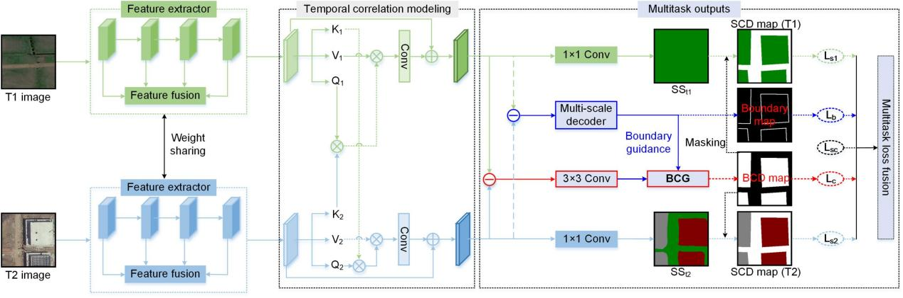
Figure 1. The Structure of BGSNet^{[27]}

2.2. SRDFNet
SRDFNet takes the BGSNet model as its basic framework and constructs a more targeted architecture for semantic change detection, whose overall structure is shown in Figure 2. SRDFNet mainly adds three core functional modules on the basis of BGSNet, namely the HGM, DE module, and SR module. Among them, the HGM module focuses on addressing the core pain point that the multi-scale feature interaction process in existing models lacks in-depth semantic-level modeling. Through the construction of semantic graph nodes, the introduction of graph attention mechanism, and the design of cross-hierarchy feature interaction, it realizes the enhancement of semantic correlation and effective fusion of multi-scale features; the DE module is mainly responsible for capturing multi-scale change information and can accurately mine feature differences at different scales; while the SR module focuses on solving the problem that the cross-attention mechanism is prone to introducing noise during the feature fusion process, which leads to a decline in semantic accuracy, and effectively reduces noise interference through targeted semantic refinement operations. These three modules systematically enhance the feature complementarity between semantic change detection tasks from three key aspects: feature fusion, difference modeling, and semantic refinement, thereby significantly improving the detection performance of the entire model.
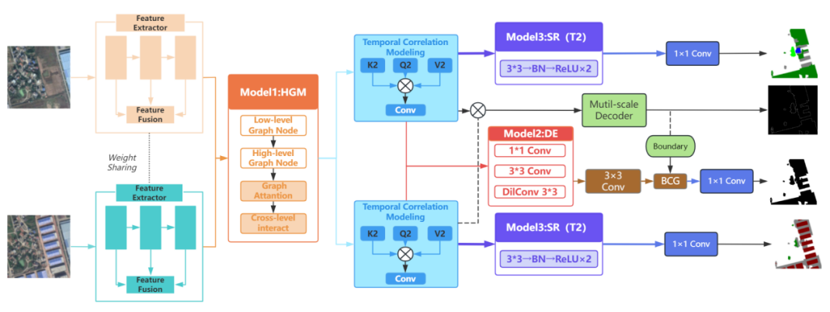
Figure 2. The Structure of SRDFNet

2.2.1. HGM Module
In the BGSNet model, low-level features and high-level features are fused through simple CBAM attention and concatenation, lacking explicit modeling at the semantic level. The spatial distribution relationships between different semantic categories (such as buildings, vegetation, and water bodies) are not fully utilized. HGM converts the feature map $\text{F∈}{\text{R}}^{\text{C×H×W}}$ into N semantic graph nodes $\text{V∈}{\text{R}}^{\text{N×C}}$, and performs cross-level information interaction in the graph space:
$$\begin{aligned}\text{A=Softmax(BN(}{\text{W}}_{\text{a}}\text{F))}\#\text{(1)}\end{aligned}$$
$$\begin{aligned}\text{V=}\frac{\text{A⋅}{\text{F}}^{\text{T}}}{\sum_{\text{j=1}}^{\text{HW}}{\text{A}}}\#\text{(2)}\end{aligned}$$
Where ${\text{W}}_{\text{a}}\text{F}$ indicates 1×1 convolutional learnable parameter, A denotes a soft assignment matrix representing the probability that each spatial position belongs to each semantic node.Then, multi-head self-attention is performed on the low-level nodes ${\text{V}}^{\text{low}}$ and high-level nodes ${\text{V}}^{\text{high}}$ respectively, and the high-level semantic nodes query complementary information from the low-level nodes to realize cross-level graph interaction.

2.2.2. DE Module
BGSNet uses a simple absolute difference $\left|{{\text{F}}_{\text{T1}}\text{-F}}_{\text{T2}}\right|$ to detect change regions. This method only captures pixel-wise amplitude differences, ignoring multi-scale contextual change information and the differences in change patterns between channels. The DE module enhances differential features through multi-scale convolution and residual fusion. First, three convolution branches with different receptive fields are used:
$$\begin{aligned}{\text{D}}_{\text{1}}\text{=ReLU(BN(}{\text{Conv}}_{\text{1×1}}\text{(F)))}\#\text{(3)}\end{aligned}$$
$$\begin{aligned}{\text{D}}_{\text{3}}\text{=ReLU(BN(}{\text{Conv}}_{\text{3×3}}\text{(F)))}\#\text{(4)}\end{aligned}$$
$$\begin{aligned}{\text{D}}_{\text{5}}\text{=ReLU(BN(}{\text{DilConv}}_{\text{3×3,d=2}}\text{(F)))}\#\text{(5)}\end{aligned}$$
Where ${\text{DilConv}}_{\text{3×3,d=2}}$ indicates 3×3 dilated convolution with a dilation rate of 2, which is equivalent to a receptive field of 5×5. For residual fusion, the scaling factor $\text{β}$ is initialized to 0, and it degrades to an absolute difference in the early stage of training to ensure the original performance of the baseline.
$$\begin{aligned}{\text{D}}_{\text{out}}\text{=}\left|{{\text{F}}_{\text{T1}}\text{-F}}_{\text{T2}}\right|\text{+β⋅}{\hat{\text{D}}}_{\text{out}}\#\text{(6)}\end{aligned}$$

2.2.3. SR Module
The features after bi-temporal cross-attention are used for semantic segmentation prediction. However, cross-attention mainly focuses on the difference alignment between temporal phases, which may introduce noise while enhancing change information, affecting the accuracy of the semantic information of each temporal phase itself. The SR module performs local refinement on the semantic features of T1 and T2 respectively to improve the quality of semantic segmentation. For the feature ${\text{F}}_{\text{t}}\text{(t∈(}{\text{T}}_{\text{1}}\text{,}{\text{T}}_{\text{2}}\text{))}$ of each temporal phase:
$$\begin{aligned}{\text{R}}_{\text{t}}\text{=ReLU(BN(}{\text{Conv}}_{\text{3×3}}\text{(ReLU(BN(}{\text{Conv}}_{\text{3×3}}\text{(}{\text{F}}_{\text{t}}\text{))))))}\#\text{(7)}\end{aligned}$$
$$\begin{aligned}{\text{F}}_{\text{t}}^{\text{refined}}\text{=}{\text{F}}_{\text{t}}\text{+}{\text{γ}}_{\text{t}}\text{⋅}{\text{R}}_{\text{t}}\#\text{(8)}\end{aligned}$$
Where the scaling factor ${\text{γ}}_{\text{t}}$ is initialized to 0, and the parameters of the SR modules for the two temporal phases are independent of each other (without sharing weights), enabling them to learn semantic refinement strategies tailored to the characteristics of their respective temporal phases.

2.2.4. Loss Fuctions
In this paper, multi-task loss functions are used as the loss function for the corresponding tasks in the bi-temporal semantic segmentation task, change detection task, and boundary detection task [21]. The formula of the bi-temporal semantic segmentation loss function Lt（t=1,2）is as follows:
$$\begin{aligned}{\text{L}}_{\text{t}}\text{=-}\frac{\text{1}}{\text{N}}\sum_{\text{i=1}}^{\text{N}}{\sum_{\text{C=1}}^{\text{C}}{{\text{y}}_{\text{i}}^{\text{C}}\text{log(}{\hat{\text{y}}}_{\text{i}}^{\text{C}}\text{)}}}\#\text{(9)}\end{aligned}$$
Where N indicates the number of image pixels, ${\text{y}}_{\text{i}}$ and ${\hat{\text{y}}}_{\text{i}}$ separately represent the categories of the ground truth and the actual predicted value respectively where $\text{i∈(0,1,2,...C)}$ and C represents the number of semantic categories. Then, the loss function L3 for calculating the change detection region :
$$\begin{aligned}{\text{L}}_{\text{3}}\text{=-}\frac{\text{1}}{\text{N}}\sum_{\text{i=1}}^{\text{N}}{\text{(W×}{\text{y}}_{\text{c}}\text{log}{\text{(}{\hat{\text{y}}}_{\text{c}}\text{)}}\text{+(1-W)×(1-}{\hat{\text{y}}}_{\text{c}}\text{)}\text{log}{\text{(1-}{\hat{\text{y}}}_{\text{c}}\text{)}}\text{)}}\#\text{(10)}\end{aligned}$$
where W indicates the weight of unchanged pixels (the proportion of negative samples to the total samples), ${\text{y}}_{\text{c}}$ and ${\hat{\text{y}}}_{\text{c}}$ are the change probabilities of the ground truth and the predicted region respectively, with values ranging from 0 to 1. For the boundary detection task, the same loss function as the change detection task is used (${\text{L}}_{\text{4}}$=${\text{L}}_{\text{3}}$). In addition, to enhance the consistency between the change detection task and the semantic segmentation task, a semantic change loss function ${\text{L}}_{\text{5}}$ is used, which adopts the cosine function [22,][23].
$$\begin{aligned}{\text{L}}_{\text{5}}\text{=}\left\{\begin{aligned}\text{1-}\text{cos}{\text{(}{\text{s}}_{\text{1}}\text{,}{\text{s}}_{\text{2}}\text{)}}\text{, }{\text{y}}_{\text{c}}\text{= 0} \\ \underset{}{\text{max}}{\text{(0,cos(}{\text{s}}_{\text{1}}\text{,}{\text{s}}_{\text{2}}\text{))}}\text{, }{\text{y}}_{\text{c}}\text{= 0}\end{aligned}\right.\#\text{(11)}\end{aligned}$$
where s₁ and s₂ are the feature vectors of the semantic segmentation results of the previous and subsequent temporal phases, respectively. Finally, based on the uncertainty-weighted multi-task learning loss function of the baseline model, by setting the minimum weight ${\text{w}}_{\text{min}}$ = 0.2, the basic weight of each task is guaranteed, and the adaptive balance ability of the optimizer is maintained:
$$\begin{aligned}{\text{L}}_{\text{total}}\text{=}\sum_{\text{i=1}}^{\text{5}}{\text{(max(}\frac{\text{1}}{\text{2}{\text{σ}}_{\text{i}}^{\text{2}}}\text{,}{\text{w}}_{\text{min}}\text{)}{\text{L}}_{\text{i}}\text{+log(1+}{\text{σ}}_{\text{i}}^{\text{2}}\text{))}}\#\text{(12)}\end{aligned}$$

3. Experiments

3.1. Datasets
This method was tested on two public semantic change detection datasets, namely the SECOND and HRSCD datasets.
The SECOND dataset collects 4662 pairs of aerial images from multiple platforms and sensors, which are distributed in cities such as Hangzhou, Chengdu and Shanghai. Each image has a size of 512×512 pixels with a spatial resolution between 0.5 and 3 meters, and is annotated at the pixel level [28]. It includes 6 main land cover categories, namely non-vegetated surface, trees, low vegetation, water, buildings, and playgrounds.
The HRSCD dataset contains 291 pairs of images with a spatial size of 10,000 pixels × 10,000 pixels [29]. All image pairs have a spatial resolution of 0.5 meters and were collected in multiple cities in France in 2006 and 2012. The dataset includes five types of semantic changes, namely wetlands, agricultural areas, forests, water bodies, and artificial surfaces.

3.2. Experimental Environment Configuration
All experiments in this paper were trained and run on a server. The server operating system is Linux, equipped with two Intel(R) Xeon(R) Gold 6326 CPUs @ 2.90GHz, an NVIDIA A100 GPU. The PyTorch 2.0.0 deep learning framework was used, configured with CUDA 12.4 for model training. The optimizer for all experiments is set to AdamW, the learning rate set to 1e-4, the number of training epochs set to 100 for both datasets, and the batch size set to 6.

3.3. Accuracy evaluation
For the change detection task, the prediction results of the model can be divided into four basic scenarios: True Positive (TP), where the true category is consistent with the predicted category; True Negative (TN), where pixels are correctly predicted as other non-target categories; False Positive (FP), where non-target categories are incorrectly predicted as target categories; and False Negative (FN), where target categories are incorrectly predicted as other categories. To comprehensively evaluate the model performance, this study adopts a corresponding set of evaluation metrics for different types of semantic change detection tasks:
Pre(Precision): It measures the proportion of pixels predicted as changed that are actually changed. The formula is as follows:
$\begin{aligned}\text{Pre=}\frac{\text{TP}}{\text{TP+FP}}\#\text{(13)}\end{aligned}$
Rec(Recall): It measures the proportion of actually changed pixels that are correctly detected among all truly changed pixels. The formula is as follows:
$$\begin{aligned}\text{Rec=}\frac{\text{TP}}{\text{TP+FN}}\#\text{(14)}\end{aligned}$$
F1(F1-Score): It is the harmonic mean of precision and recall, which comprehensively evaluates the model performance by integrating the two indicators. The formula is as follows:
$$\begin{aligned}\text{F1=}\frac{\text{2×}\left(\text{Pre×Rec}\right)}{\left(\text{Pre+Rec}\right)}\#\text{(15)}\end{aligned}$$
IoU(Intersection over Union): It measures the overlap degree between the predicted change region and the true change region. The formula is as follows:
$$\begin{aligned}\text{I}\text{oU=}\frac{\text{TP}}{\text{TP+FP+FN}}\#\text{(16)}\end{aligned}$$
mIoU(Mean Intersection over Union): Calculate the average of the non-change IoU (IoUnc) and the change IoU (IoUc) to obtain the mIoU value:
$$\begin{aligned}\text{mIoU=}\frac{{\text{IoU}}_{\text{c}}\text{+}{\text{IoU}}_{\text{nc}}}{\text{2}}\#\text{(17)}\end{aligned}$$
OA(Overall Accuracy): Evaluates the overall proportion of all pixels (changed and unchanged) that are correctly classified:
$$\begin{aligned}\text{OA=}\frac{\text{TP+TN}}{\text{TP+FP+TN+FN}}\#\text{(18)}\end{aligned}$$
Sek(Separated Kappa): Used to measure the consistency between classification results and ground truth labels. First, the Kappa coefficient for a single class i:
$$\begin{aligned}\text{K}\text{appa}\text{=}\frac{{\text{ρ}}_{\text{i}}−{\hat{ρ}}_{\text{i}}}{\text{1-}{\text{p}}_{i}}\#\text{(19)}\end{aligned}$$
where ${\text{ρ}}_{\text{i}}$ and ${\hat{ρ}}_{\text{i}}$ represent the observed agreement rate and expected agreement rate for class i, respectively. Sek is the average Kappa value across all classes:$\begin{aligned}\text{Sek=}{\text{e}}^{{\text{IoU}}_{\text{c}}−1}\text{⋅K}\text{appa}\#\text{(20)}\end{aligned}$

3.4. Performance Comparison
To evaluate the semantic change detection performance of the proposed SRDFNet in this paper, comparative experiments were conducted on the SECOND dataset between this model and three other semantic change detection models, namely BGSNet, BiSRNet [22], and HGINet. The accuracy metrics of the four models on the test dataset were calculated, as shown in Table 1. It can be seen from Table 1 that SRDFNet achieves the highest overall accuracy and recall rate among the four models. SRDFNet obtains the highest OA value of 87.64%, indicating its optimal performance in global pixel classification accuracy. SRDFNet also achieves the best result on the Recall metric, reaching 65.27%, which demonstrates that the model can detect more real change regions with the lowest missed detection rate. Other metrics including mIoU, SeK, and F1 are improved by 0.73%, 1.44%, and 0.81% respectively compared with the baseline model BGSNet.

Table 1. Performance Comparison of Different SCD Methods on the SECOND Dataset (the best metric values are marked in bold)
Method | OA(%) | mIoU(%) | SeK(%) | F1(%) | Recall(%)
BGSNet | 85.30 | 69.58 | 18.92 | 59.44 | 62.55
BiSRNet^{[30]} | 87.35 | 71.46 | 20.12 | 60.46 | 56.73
HGINet^{[31]} | 87.11 | 71.25 | 20.68 | 60.90 | 58.56
SRDFNet | 87.64 | 70.31 | 20.36 | 60.25 | 65.27

Figure 3 illustrates the detection results of different methods on the SECOND dataset. The proposed SRDF-Net accurately identifies the changed categories and regions, demonstrating the model's capability in perceiving local semantic details. Especially in terms of geometric features, the model shows greater advantages over other methods in extracting boundaries and shapes.
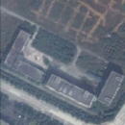 | 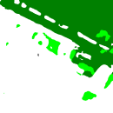 | 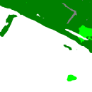 | 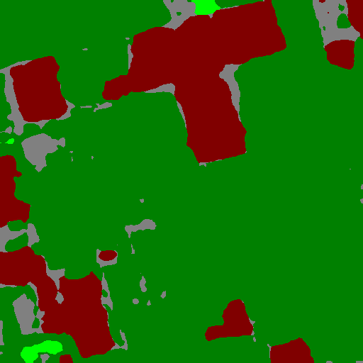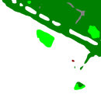 | 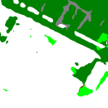 | 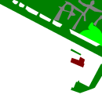
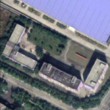 | 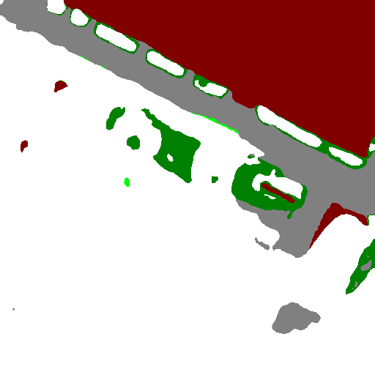 | 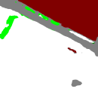 |  |  | 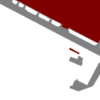
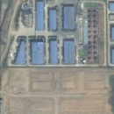 | 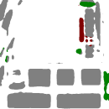 |  |  |  | 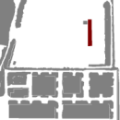
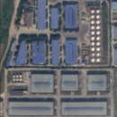 |  |  |  |  | 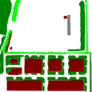
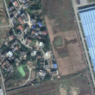 |  | 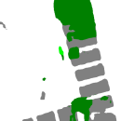 | 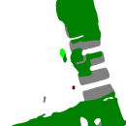 | 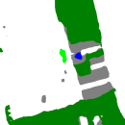 | 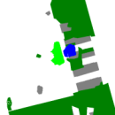
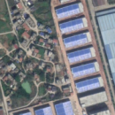  BGSNet  Images  BiSRNet  HGINet  SRDFNet  GT | 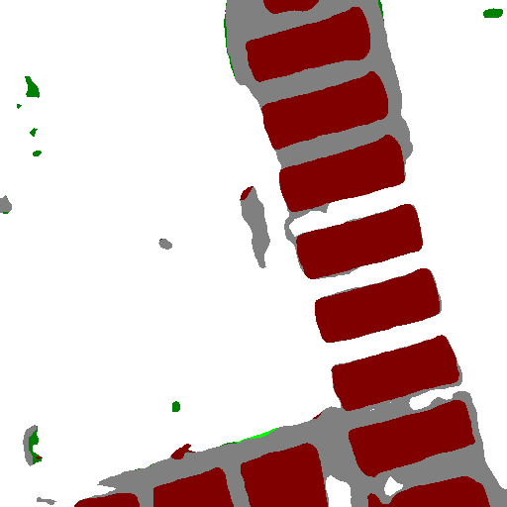 |  |  |  | 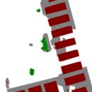


Figure 3. Semantic change detection result maps of various methods on the SECOND dataset
To verify the generalization ability of the proposed semantic change detection model SRDFNet, this model was also compared with the other three methods on the HRSCD dataset. As can be seen from Table 2, our method achieves the best performance in all five metrics: OA, mIoU, SeK, F1, and Recall. Especially in the SeK metric, it outperforms BGSNet, BiSRNet, and HGINet by 9.69%, 41.81%, and 29.65% respectively.
Table 2. Performance Comparison of Different SCD Methods on the HRSCD Dataset (the best metric values are marked in bold)
Method | OA(%) | mIoU(%) | SeK(%) | F1(%) | Recall(%)
BGSNet | 94.17 | 48.74 | 64.08 | 86.53 | 84.18
BiSRNet^{[30]} | 60.75 | 49.73 | 31.96 | 60.85 | 60.98
HGINet^{[31]} | 72.70 | 49.80 | 44.12 | 72.85 | 73.00
SRDFNet | 98.13 | 52.67 | 73.77 | 88.86 | 88.18

We also present the comparative results of SCD by the four models on the HRSCD dataset, as shown in Figure 4. Our method effectively identifies various 'from-to' change information. Meanwhile, compared with other models, our model significantly reduces missed detections and false detections, achieving the best accuracy performance and the highest semantic segmentation precision. The results intuitively demonstrate that the semantic segmentation masks obtained by SRDFNet are more accurate, with fewer omissions and clearer boundaries.
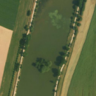 | 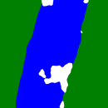 |  |  |  | 
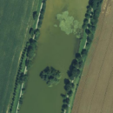 | 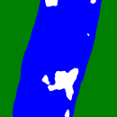 |  |  |  | 
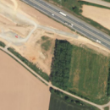 |  |  |  |  | 
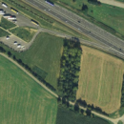 |  |  |  |  | 
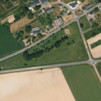 |  |  |  | 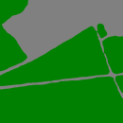 | 
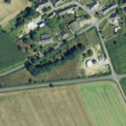 |  |  |  |  | 
BGSNet
Images
BiSRNet
HGINet
SRDFNet
GT
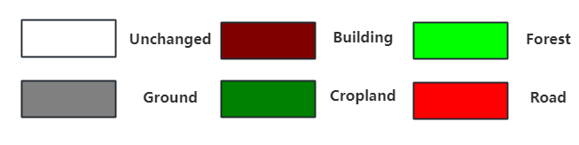
Figure 4. Semantic Change Detection Results of Various Methods on the HRSCD Dataset
3.5 Ablation studies
To evaluate the effectiveness of the three constructed modules (HGM, DE, and SR) in SRDFNet, we selected the SECOND dataset for ablation experiments. To ensure reliability, all experiments were conducted under consistent settings, including the same learning rate and pre-trained weight file (pvt_v2_b2.pth). The final results are shown in Table 3. The combination of HGM+DE+SR achieves the best performance in OA, SeK, and F1, and is only slightly lower than the DE+SR combination in mIoU. Meanwhile, other combinations also show certain improvements over the baseline, which verifies the effectiveness of the three modules.
Table 3. Ablation Results of the Three Modules HGM, DE and SR on the SECOND Dataset (the best metric values are marked in bold)
HGM | DE | SR | OA(%) | mIoU(%) | SeK(%) | F1(%)
 |  |  | 84.18 | 68.85 | 18.69 | 58.55
√ |  |  | 84.13 | 69.38 | 19.74 | 58.99
 | √ |  | 85.12 | 70.21 | 20.16 | 59.89
 |  | √ | 84.57 | 69.73 | 19.83 | 59.41
√ | √ |  | 84.80 | 69.99 | 20.18 | 59.82
 | √ | √ | 85.08 | 70.36 | 20.23 | 59.90
√ |  | √ | 85.22 | 70.08 | 19.68 | 59.57
√ | √ | √ | 85.29 | 70.31 | 20.36 | 60.25

4. Conclusions
This paper proposes SRDFNet, a change detection network model for semantic interaction refinement and differential feature enhancement. Based on the collaborative cooperation of three modules: HGM, DE, and SR, the model operates in feature encoding, difference modeling, and semantic decoding stages respectively, ensuring that multiple subtasks are effectively optimized throughout the entire training process.
Extensive experiments were conducted on the SECOND and HRSCD datasets, and the conclusions are as follows:
(1) The three constructed modules (HGM, DE, and SR) significantly improve the performance of the baseline model. The SeK metric is increased by 1.44% and 9.69% on the SECOND and HRSCD datasets respectively, and other metrics also show considerable improvements compared with the baseline model.
(2) The model demonstrates adaptability to multi-task loss optimization. On both the SECOND and HRSCD datasets, SRDFNet exhibits strong generalization ability, especially on the HRSCD dataset, where all metrics outperform other models except OA.
Looking ahead, the fusion of multi-source data has gradually become a mainstream research direction. Meanwhile, multi-source data fusion can also provide richer feature representations. We plan to apply our model to change detection using multi-source remote sensing data—for example, fusing optical images with Synthetic Aperture Radar (SAR) images. We will design cross-modal feature alignment and fusion modules to perform semantic change detection in a unified feature space and explore cross-domain generalization.
Author Contributions: Conceptualization, WB.Z.; methodology, WB.Z.; validation, WB.Z.; resources, WB.Z. and DH.L.; writing—original draft preparation, WB.Z. and DH.L.; writing—review and editing, WB.Z., YJ.Z. and KY.C.; supervision, YJ.Z. All authors have read and agreed to the published version of the manuscript.
Funding: This research received no external funding.
Institutional Review Board Statement: Not applicable.
Informed Consent Statement: Not applicable.
Data Availability Statement: The data presented in this study are available upon request from the corresponding author.
Conflicts of Interest: The authors declare no conflicts of interest.

Abbreviations
The following abbreviations are used in this manuscript:
BGSNet Boundary-guided Siamese Network
SRDFNet Semantic Refinement and Enhanced Difference Network
HGM Hierarchical Graph Module
DE Difference Enhancement
SR Semantic Refine
MLP Multilayer Perceptron
SCD Semantic Change Detection
BCG Boundary-Contextual Guided
IDET Iterative Difference Enhancement

5. References
- Sui Haigang, Feng Wenqing, Li Wenzhuo, et al. A Review of Change Detection Methods for Multi-Temporal Remote Sensing Images[J]. Geomatics and Information Science of Wuhan University, 2018, 43(12): 1885-1898. DOI:10.13203/j.whugis20180251.
- Cheng Qi, Qin Sixian. Application of Deep Learning Technology in Intelligent Change Detection of Land Cover[J]. Urban Geotechnical Investigation & Surveying, 2025, (05): 10-14.
- SINGH, A. (1989). Review Article Digital change detection techniques using remotely-sensed data. International Journal of Remote Sensing, 10(6), 989–1003. DOI:10.1080/01431168908903939.
- Jiang Kaiyue, Zhao Zhuxin, Ma Lu, et al. Review of Progress in Remote Sensing Image Change Detection Methods Based on Deep Learning[J]. Radio Engineering, 2025, 55(2): 343-356.
- Kirillov A, Mintun E, Ravi N, et al. Segment Anything[A/OL]. arXiv, 2023[2025-09-27]. http://arxiv.org/abs/2304.02643. DOI:10.48550/arXiv.2304.02643.
- Ding L, Zhu K, Peng D, et al. Adapting Segment Anything Model for Change Detection in VHR Remote Sensing Images[J/OL]. IEEE Transactions on Geoscience and Remote Sensing, 2024, 62: 1-11. DOI:10.1109/TGRS.2024.3368168.
- Ye Pingping, Tong Xin. Research on Building Change Detection Technology Based on Deep Learning[J]. Henan Science and Technology, 2024, 51(19): 104-107. DOI:10.19968/j.cnki.hnkj.2024.19.021.
- Li C. COMIC: An unsupervised change detection method for heterogeneous remote sensing images based on copula mixtures and Cycle-Consistent Adversarial Networks[J]. Information Fusion, 2024.
- JIANG H, PENG M, ZHONG Y, et al. A Survey on Deep Learning-Based Change Detection from High-Resolution Remote Sensing Images[J/OL]. Remote Sensing, 2022, 14(7): 1552. DOI:10.3390/rs14071552.
- Liu B, Chen H, Li K, et al. Transformer-based multimodal change detection with multitask consistency constraints[J/OL]. Information Fusion, 2024, 108: 102358. DOI:10.1016/j.inffus.2024.102358.
- BANDARA W G C, PATEL V M. A Transformer-Based Siamese Network for Change Detection[A/OL]. arXiv, 2022[2025-11-10]. DOI:10.48550/arXiv.2201.01293.
- ZHANG C, WANG L, CHENG S, et al. SwinSUNet: Pure Transformer Network for Remote Sensing Image Change Detection[J/OL]. IEEE Transactions on Geoscience and Remote Sensing, 2022, 60: 1-13. DOI:10.1109/TGRS.2022.3160007.
- TENG Y, LIU S, SUN W, et al. A VHR Bi-Temporal Remote-Sensing Image Change Detection Network Based on Swin Transformer[J/OL]. Remote Sensing, 2023, 15(10): 2645. DOI:10.3390/rs15102645.
- GUO Q, WANG R, HUANG R, et al. IDET: Iterative Difference-Enhanced Transformers for High-Quality Change Detection[A/OL]. arXiv, 2024[2025-11-10]. http://arxiv.org/abs/2207.09240. DOI:10.48550/arXiv.2207.09240.
- YANG Z, WU Y, LI M, et al. Unsupervised change detection in PolSAR images using siamese encoder–decoder framework based on graph-context attention network[J/OL]. International Journal of Applied Earth Observation and Geoinformation, 2023, 124: 103511. DOI:10.1016/j.jag.2023.103511.
- SERMANET P, CHINTALA S, LECUN Y. Convolutional Neural Networks Applied to House Numbers Digit Classiﬁcation[J].
- KRIZHEVSKY A, SUTSKEVER I, HINTON G E. ImageNet classification with deep convolutional neural networks[J/OL]. Communications of the ACM, 2017, 60(6): 84-90. DOI:10.1145/3065386.
- SIMONYAN K, ZISSERMAN A. Very Deep Convolutional Networks for Large-Scale Image Recognition[A/OL]. arXiv, 2015[2025-11-10]. DOI:10.48550/arXiv.1409.1556.
- HE K, ZHANG X, REN S, 等. Deep Residual Learning for Image Recognition[A/OL]. arXiv, 2015[2025-11-10]. http://arxiv.org/abs/1512.03385. DOI:10.48550/arXiv.1512.03385.
- Huang G, Liu Z, Maaten L van der, et al. Densely Connected Convolutional Networks[A/OL]. arXiv, 2018[2025-11-10].
- Chen T, Lu Z, Yang Y, et al. A Siamese Network Based U-Net for Change Detection in High Resolution Remote Sensing Images[J/OL]. IEEE Journal of Selected Topics in Applied Earth Observations and Remote Sensing, 2022, 15: 2357-2369.
- PANG S, ZHANG A, HAO J, et al. SCA-CDNet: a robust siamese correlation-and-attention-based change detection network for bitemporal VHR images[J/OL]. International Journal of Remote Sensing, 2022, 43(15-16): 6102-6123. DOI:10.1080/01431161.2021.1941390.
- CUI F, JIANG J. MTSCD-Net: A network based on multi-task learning for semantic change detection of bitemporal remote sensing images[J/OL]. International Journal of Applied Earth Observation and Geoinformation, 2023, 118: 103294. DOI:10.1016/j.jag.2023.103294.
- WANG Q, JING W, CHI K, et al. Cross-Difference Semantic Consistency Network for Semantic Change Detection[J/OL]. IEEE Transactions on Geoscience and Remote Sensing, 2024, 62: 1-12. DOI:10.1109/TGRS.2024.3386334.
- JIANG Z, WANG B, ZHANG P, et al. Semantic enhancement and change consistency network for semantic change detection in remote sensing images[J/OL]. International Journal of Digital Earth, 2025, 18(1): 2496790. DOI:10.1080/17538947.2025.2496790.
- LIU Y, XU H, CAO W, et al. Semantic Change Detection of Carbon Sources and Sinks via Spatiotemporal Attention and Multiscale Fusion[J/OL]. IEEE Geoscience and Remote Sensing Letters, 2025, 22: 1-5. DOI:10.1109/LGRS.2025.3597281.
- LONG J, LIU S, LI M, et al. BGSNet: A boundary-guided Siamese multitask network for semantic change detection from high-resolution remote sensing images[J/OL]. ISPRS Journal of Photogrammetry and Remote Sensing, 2025, 225: 221-237. DOI:10.1016/j.isprsjprs.2025.04.030.
- Ding L, Guo H, Liu S, et al. Bi-Temporal Semantic Reasoning for the Semantic Change Detection in HR Remote Sensing Images[J]. IEEE TRANSACTIONS ON GEOSCIENCE AND REMOTE SENSING, 2022, 60.
- Long J. Semantic change detection using a hierarchical semantic graph interaction network from high-resolution remote sensing images[J]. ISPRS Journal of Photogrammetry and Remote Sensing, 2024.
- Yang K, Xia G S, Yang W. Asymmetric Siamese Networks for Semantic Change Detection in Aerial Images[J]. IEEE TRANSACTIONS ON GEOSCIENCE AND REMOTE SENSING, 2022, 60.
- Daudt, R.C., Le Saux, B., Boulch, A. and Gousseau, Y., 2019. Multitask learning for large-scale semantic change detection. Computer Vision and Image Understanding, 187, p.102783.

