

Assignment No. 2

Course Title: | Web Technologies
Submitted To: | Sir Usman Akram
Submitted By: | Rumaan Adeel (fa24-bcs-098)
Date: | Monday 26 October 2026

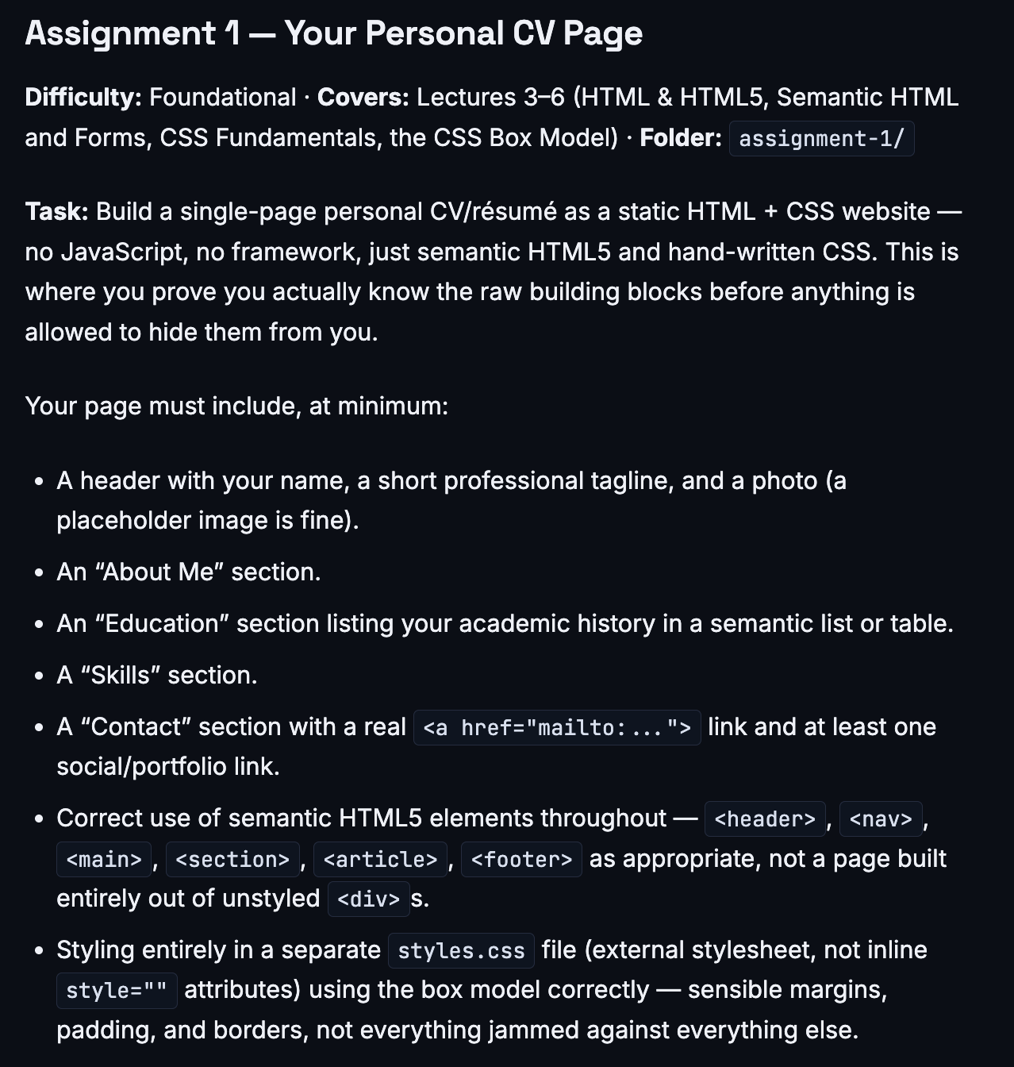
Screenshots:

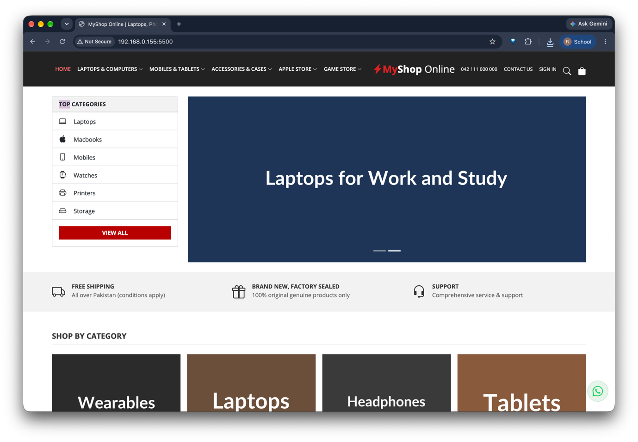
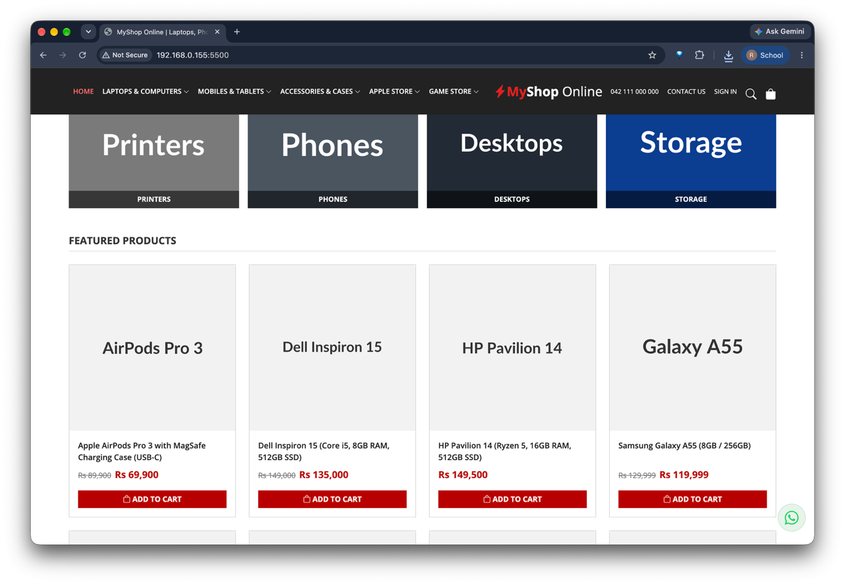
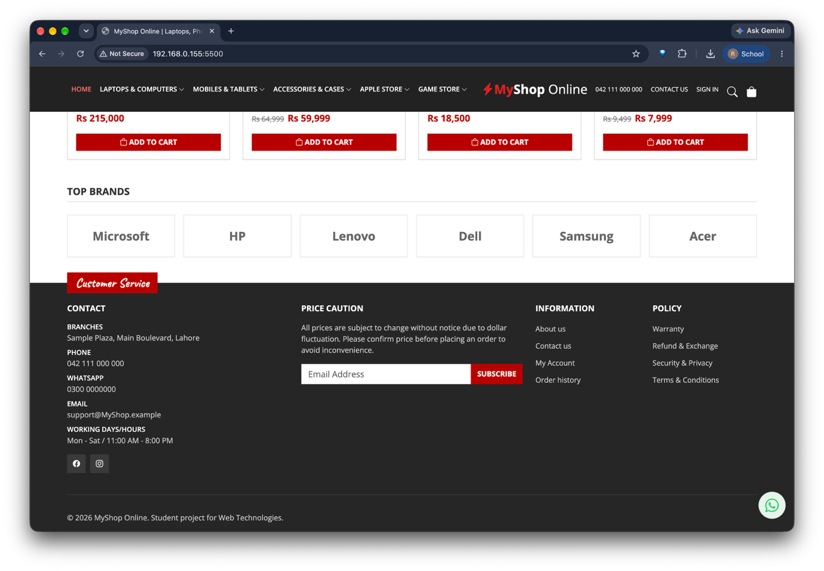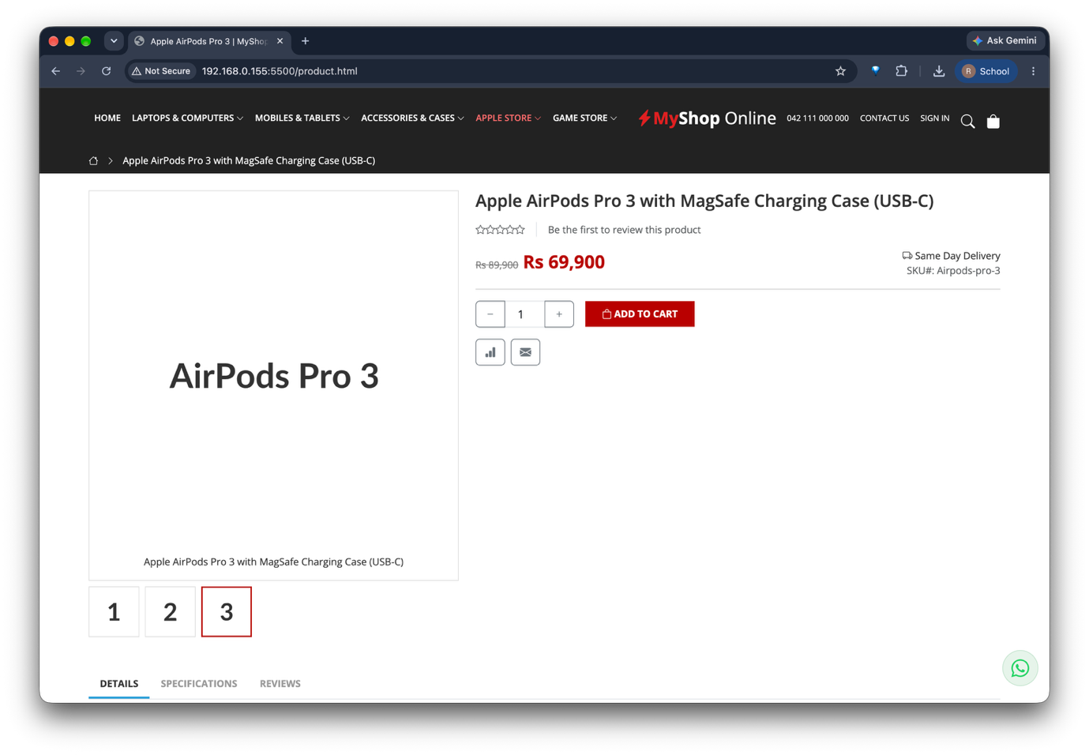
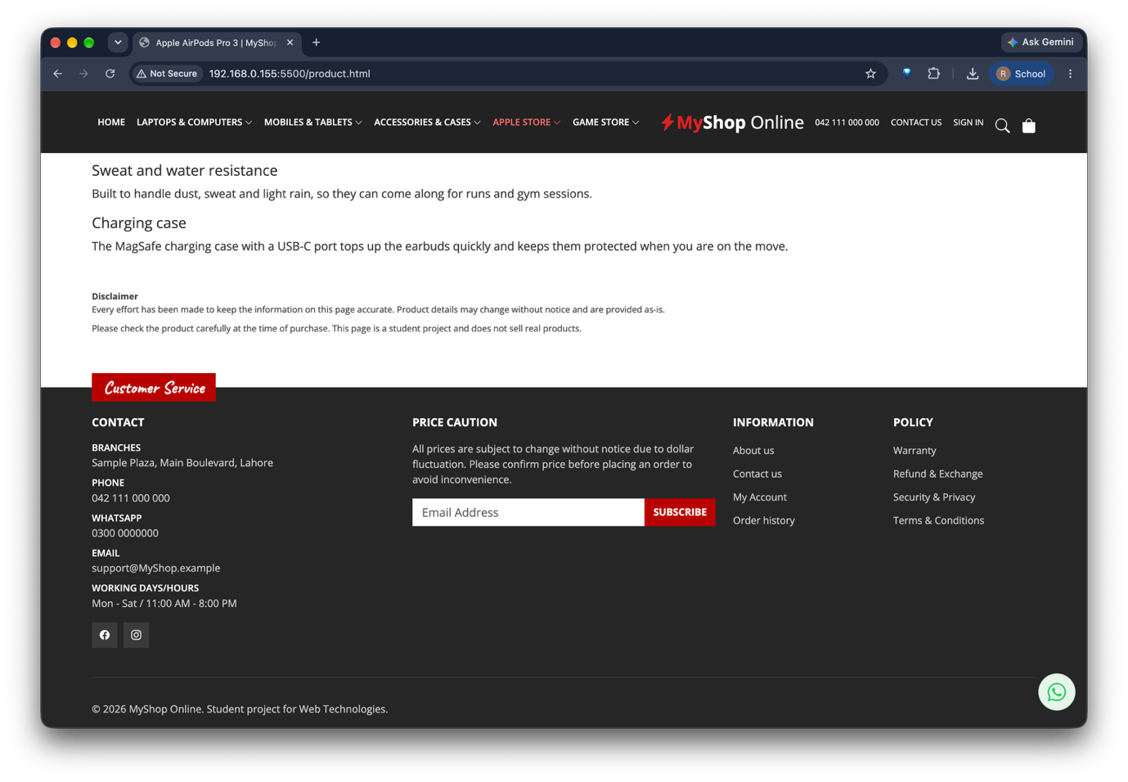
Index.html:

<!DOCTYPE html>
<html lang="en">
<head>
<meta charset="UTF-8">
<meta name="viewport" content="width=device-width, initial-scale=1">
<title>MyShop Online | Laptops, Phones &amp; Gadgets</title>
<link href="https://fonts.googleapis.com/css2?family=Caveat:wght@600&family=Open+Sans:wght@400;600;700&display=swap" rel="stylesheet">
<link href="https://cdn.jsdelivr.net/npm/bootstrap@5.3.3/dist/css/bootstrap.min.css" rel="stylesheet">
<link href="https://cdn.jsdelivr.net/npm/bootstrap-icons@1.11.3/font/bootstrap-icons.min.css" rel="stylesheet">
<link href="style.css" rel="stylesheet">
</head>

<body>

<nav class="navbar navbar-expand-lg navbar-dark site-nav sticky-top">
<div class="container-xl">
<button class="navbar-toggler order-1" type="button" data-bs-toggle="collapse" data-bs-target="#mainNav"
aria-controls="mainNav" aria-expanded="false" aria-label="Toggle navigation">
<span class="navbar-toggler-icon"></span>
</button>

<a class="brand-logo order-2 mx-auto mx-lg-0" href="index.html">
<i class="bi bi-lightning-charge-fill brand-accent"></i><span class="brand-accent">My</span>Shop <span class="fw-normal">Online</span>
</a>

<div class="nav-utils nav-side d-flex align-items-center gap-3 order-3">
<span class="d-none d-xl-inline">042 111 000 000</span>
<a class="d-none d-lg-inline" href="#">Contact Us</a>
<a class="d-none d-lg-inline" href="#">Sign In</a>
<a class="icon-link" href="#" aria-label="Search"><i class="bi bi-search"></i></a>
<a class="icon-link" href="#" aria-label="Cart"><i class="bi bi-bag-fill"></i></a>
</div>

<div class="collapse navbar-collapse nav-side order-4 order-lg-1" id="mainNav">
<ul class="navbar-nav">
<li class="nav-item"><a class="nav-link active" href="index.html">Home</a></li>
<li class="nav-item"><a class="nav-link" href="#products">Laptops &amp; Computers <i class="bi bi-chevron-down small"></i></a></li>
<li class="nav-item"><a class="nav-link" href="#products">Mobiles &amp; Tablets <i class="bi bi-chevron-down small"></i></a></li>
<li class="nav-item"><a class="nav-link" href="#products">Accessories &amp; Cases <i class="bi bi-chevron-down small"></i></a></li>
<li class="nav-item"><a class="nav-link" href="#products">Apple Store <i class="bi bi-chevron-down small"></i></a></li>
<li class="nav-item"><a class="nav-link" href="#products">Game Store <i class="bi bi-chevron-down small"></i></a></li>
</ul>
</div>
</div>
</nav>

<main>
<section class="container-xl mt-4">
<div class="row g-4">
<div class="col-12 col-lg-9 order-1 order-lg-2">
<div id="heroCarousel" class="carousel slide" data-bs-ride="carousel">
<div class="carousel-indicators">
<button type="button" data-bs-target="#heroCarousel" data-bs-slide-to="0" class="active" aria-label="Slide 1"></button>
<button type="button" data-bs-target="#heroCarousel" data-bs-slide-to="1" aria-label="Slide 2"></button>
</div>
<div class="carousel-inner">
<div class="carousel-item active">
<img src="https://placehold.co/1200x500/5b1a2a/ffffff?text=Latest+Smartphones" class="d-block w-100" alt="Latest smartphones banner">
</div>
<div class="carousel-item">
<img src="https://placehold.co/1200x500/1d3557/ffffff?text=Laptops+for+Work+and+Study" class="d-block w-100" alt="Laptops banner">
</div>
</div>
</div>
</div>

<div class="col-12 col-lg-3 order-2 order-lg-1">
<div class="card category-box rounded-0">
<div class="card-header">Top Categories</div>
<ul class="list-group list-group-flush">
<li class="list-group-item"><i class="bi bi-laptop"></i> Laptops</li>
<li class="list-group-item"><i class="bi bi-apple"></i> Macbooks</li>
<li class="list-group-item"><i class="bi bi-phone"></i> Mobiles</li>
<li class="list-group-item"><i class="bi bi-smartwatch"></i> Watches</li>
<li class="list-group-item"><i class="bi bi-printer"></i> Printers</li>
<li class="list-group-item"><i class="bi bi-hdd"></i> Storage</li>
</ul>
<div class="card-body">
<a href="#products" class="btn btn-accent w-100">View all</a>
</div>
</div>
</div>
</div>
</section>

<section class="feature-strip mt-4 py-4">
<div class="container-xl">
<div class="row row-cols-md-3 g-3">
<div class="col d-flex gap-3">
<i class="bi bi-truck"></i>
<div>
<div class="fw-bold text-uppercase small">Free Shipping</div>
<div class="text-muted small">All over Pakistan (conditions apply)</div>
</div>
</div>
<div class="col d-flex gap-3">
<i class="bi bi-gift"></i>
<div>
<div class="fw-bold text-uppercase small">Brand New, Factory Sealed</div>
<div class="text-muted small">100% original genuine products only</div>
</div>
</div>
<div class="col d-flex gap-3">
<i class="bi bi-headset"></i>
<div>
<div class="fw-bold text-uppercase small">Support</div>
<div class="text-muted small">Comprehensive service &amp; support</div>
</div>
</div>
</div>
</div>
</section>

<section class="container-xl mt-5">
<h2 class="section-title">Shop by Category</h2>
<div class="category-grid">
<a class="category-tile" href="#products"><img src="https://placehold.co/600x450/2b2b2b/ffffff?text=Wearables" alt="Wearables"><span>Wearables</span></a>
<a class="category-tile" href="#products"><img src="https://placehold.co/600x450/6b4f3a/ffffff?text=Laptops" alt="Laptops"><span>Laptops</span></a>
<a class="category-tile" href="#products"><img src="https://placehold.co/600x450/3a3a3a/ffffff?text=Headphones" alt="Headphones"><span>Headphones</span></a>
<a class="category-tile" href="#products"><img src="https://placehold.co/600x450/8a5a3c/ffffff?text=Tablets" alt="Tablets"><span>Tablets</span></a>
<a class="category-tile" href="#products"><img src="https://placehold.co/600x450/7a7a7a/ffffff?text=Printers" alt="Printers"><span>Printers</span></a>
<a class="category-tile" href="#products"><img src="https://placehold.co/600x450/4a5560/ffffff?text=Phones" alt="Phones"><span>Phones</span></a>
<a class="category-tile" href="#products"><img src="https://placehold.co/600x450/222a35/ffffff?text=Desktops" alt="Desktops"><span>Desktops</span></a>
<a class="category-tile" href="#products"><img src="https://placehold.co/600x450/0b3d91/ffffff?text=Storage" alt="Storage"><span>Storage</span></a>
</div>
</section>

<section class="container-xl mt-5" id="products">
<h2 class="section-title">Featured Products</h2>

<div class="row row-cols-sm-2 row-cols-lg-4 g-4">

<div class="col">
<div class="card h-100 product-card">
<a href="product.html"><img src="https://placehold.co/600x600/f2f2f2/333333?text=AirPods+Pro+3" class="card-img-top" alt="Apple AirPods Pro 3"></a>
<div class="card-body d-flex flex-column">
<a class="product-title mb-2" href="product.html">Apple AirPods Pro 3 with MagSafe Charging Case (USB-C)</a>
<div class="mt-auto mb-3"><span class="price-old">Rs 89,900</span><span class="price-new">Rs 69,900</span></div>
<button class="btn btn-accent w-100" type="button"><i class="bi bi-bag"></i> Add to Cart</button>
</div>
</div>
</div>

<div class="col">
<div class="card h-100 product-card">
<a href="#"><img src="https://placehold.co/600x600/f2f2f2/333333?text=Dell+Inspiron+15" class="card-img-top" alt="Dell Inspiron 15 laptop"></a>
<div class="card-body d-flex flex-column">
<a class="product-title mb-2" href="#">Dell Inspiron 15 (Core i5, 8GB RAM, 512GB SSD)</a>
<div class="mt-auto mb-3"><span class="price-old">Rs 149,000</span><span class="price-new">Rs 135,000</span></div>
<button class="btn btn-accent w-100" type="button"><i class="bi bi-bag"></i> Add to Cart</button>
</div>
</div>
</div>

<div class="col">
<div class="card h-100 product-card">
<a href="#"><img src="https://placehold.co/600x600/f2f2f2/333333?text=HP+Pavilion+14" class="card-img-top" alt="HP Pavilion 14 laptop"></a>
<div class="card-body d-flex flex-column">
<a class="product-title mb-2" href="#">HP Pavilion 14 (Ryzen 5, 16GB RAM, 512GB SSD)</a>
<div class="mt-auto mb-3"><span class="price-new">Rs 149,500</span></div>
<button class="btn btn-accent w-100" type="button"><i class="bi bi-bag"></i> Add to Cart</button>
</div>
</div>
</div>

<div class="col">
<div class="card h-100 product-card">
<a href="#"><img src="https://placehold.co/600x600/f2f2f2/333333?text=Galaxy+A55" class="card-img-top" alt="Samsung Galaxy A55 smartphone"></a>
<div class="card-body d-flex flex-column">
<a class="product-title mb-2" href="#">Samsung Galaxy A55 (8GB / 256GB)</a>
<div class="mt-auto mb-3"><span class="price-old">Rs 129,999</span><span class="price-new">Rs 119,999</span></div>
<button class="btn btn-accent w-100" type="button"><i class="bi bi-bag"></i> Add to Cart</button>
</div>
</div>
</div>

<div class="col">
<div class="card h-100 product-card">
<a href="#"><img src="https://placehold.co/600x600/f2f2f2/333333?text=iPhone+14" class="card-img-top" alt="Apple iPhone 14"></a>
<div class="card-body d-flex flex-column">
<a class="product-title mb-2" href="#">Apple iPhone 14 (128GB)</a>
<div class="mt-auto mb-3"><span class="price-new">Rs 215,000</span></div>
<button class="btn btn-accent w-100" type="button"><i class="bi bi-bag"></i> Add to Cart</button>
</div>
</div>
</div>

<div class="col">
<div class="card h-100 product-card">
<a href="#"><img src="https://placehold.co/600x600/f2f2f2/333333?text=Galaxy+Tab+A9%2B" class="card-img-top" alt="Samsung Galaxy Tab A9+ tablet"></a>
<div class="card-body d-flex flex-column">
<a class="product-title mb-2" href="#">Samsung Galaxy Tab A9+ (4GB / 64GB)</a>
<div class="mt-auto mb-3"><span class="price-old">Rs 64,999</span><span class="price-new">Rs 59,999</span></div>
<button class="btn btn-accent w-100" type="button"><i class="bi bi-bag"></i> Add to Cart</button>
</div>
</div>
</div>

<div class="col">
<div class="card h-100 product-card">
<a href="#"><img src="https://placehold.co/600x600/f2f2f2/333333?text=Smartwatch" class="card-img-top" alt="AMOLED smartwatch"></a>
<div class="card-body d-flex flex-column">
<a class="product-title mb-2" href="#">Fitness Smartwatch with AMOLED Display</a>
<div class="mt-auto mb-3"><span class="price-new">Rs 18,500</span></div>
<button class="btn btn-accent w-100" type="button"><i class="bi bi-bag"></i> Add to Cart</button>
</div>
</div>
</div>

<div class="col">
<div class="card h-100 product-card">
<a href="#"><img src="https://placehold.co/600x600/f2f2f2/333333?text=Laptop+Backpack" class="card-img-top" alt="Laptop backpack"></a>
<div class="card-body d-flex flex-column">
<a class="product-title mb-2" href="#">Targus 15.6" Laptop Backpack</a>
<div class="mt-auto mb-3"><span class="price-old">Rs 9,499</span><span class="price-new">Rs 7,999</span></div>
<button class="btn btn-accent w-100" type="button"><i class="bi bi-bag"></i> Add to Cart</button>
</div>
</div>
</div>

</div>
</section>

<section class="container-xl mt-5">
<h2 class="section-title">Top Brands</h2>
<div class="row row-cols-2 row-cols-md-3 row-cols-lg-6 g-3">
<div class="col"><div class="brand-chip">Microsoft</div></div>
<div class="col"><div class="brand-chip">HP</div></div>
<div class="col"><div class="brand-chip">Lenovo</div></div>
<div class="col"><div class="brand-chip">Dell</div></div>
<div class="col"><div class="brand-chip">Samsung</div></div>
<div class="col"><div class="brand-chip">Acer</div></div>
</div>
</section>
</main>

<footer class="site-footer">
<div class="container-xl">
<span class="cs-tab">Customer Service</span>

<div class="row g-4 pb-4">
<div class="col-12 col-lg-4">
<h5 class="mb-3">Contact</h5>
<p class="label">Branches</p>
<p class="small mb-2">Sample Plaza, Main Boulevard, Lahore</p>
<p class="label">Phone</p>
<p class="small mb-2">042 111 000 000</p>
<p class="label">WhatsApp</p>
<p class="small mb-2">0300 0000000</p>
<p class="label">Email</p>
<p class="small mb-2">support@MyShop.example</p>
<p class="label">Working days/hours</p>
<p class="small mb-3">Mon - Sat / 11:00 AM - 8:00 PM</p>
<a class="social-btn me-1" href="#" aria-label="Facebook"><i class="bi bi-facebook"></i></a>
<a class="social-btn" href="#" aria-label="Instagram"><i class="bi bi-instagram"></i></a>
</div>

<div class="col-12 col-lg-4">
<h5 class="mb-3">Price Caution</h5>
<p class="small">All prices are subject to change without notice due to dollar fluctuation. Please confirm price before placing an order to avoid inconvenience.</p>
<form class="input-group mt-3">
<input type="email" class="form-control rounded-0" placeholder="Email Address" aria-label="Email address">
<button class="btn btn-accent" type="button">Subscribe</button>
</form>
</div>

<div class="col-6 col-lg-2">
<h5 class="mb-3">Information</h5>
<ul class="list-unstyled">
<li class="mb-2"><a href="#">About us</a></li>
<li class="mb-2"><a href="#">Contact us</a></li>
<li class="mb-2"><a href="#">My Account</a></li>
<li class="mb-2"><a href="#">Order history</a></li>
</ul>
</div>

<div class="col-6 col-lg-2">
<h5 class="mb-3">Policy</h5>
<ul class="list-unstyled">
<li class="mb-2"><a href="#">Warranty</a></li>
<li class="mb-2"><a href="#">Refund &amp; Exchange</a></li>
<li class="mb-2"><a href="#">Security &amp; Privacy</a></li>
<li class="mb-2"><a href="#">Terms &amp; Conditions</a></li>
</ul>
</div>
</div>

<hr class="border-secondary">
<p class="small py-3 mb-0">&copy; 2026 MyShop Online. Student project for Web Technologies.</p>
</div>
</footer>

<a class="whatsapp-float" href="#" aria-label="Chat on WhatsApp"><i class="bi bi-whatsapp"></i></a>

<script src="https://cdn.jsdelivr.net/npm/bootstrap@5.3.3/dist/js/bootstrap.bundle.min.js"></script>
</body>
</html>

Product.html:

<!DOCTYPE html>
<html lang="en">
<head>
<meta charset="UTF-8">
<meta name="viewport" content="width=device-width, initial-scale=1">
<title>Apple AirPods Pro 3 | MyShop Online</title>
<link href="https://fonts.googleapis.com/css2?family=Caveat:wght@600&family=Open+Sans:wght@400;600;700&display=swap" rel="stylesheet">
<link href="https://cdn.jsdelivr.net/npm/bootstrap@5.3.3/dist/css/bootstrap.min.css" rel="stylesheet">
<link href="https://cdn.jsdelivr.net/npm/bootstrap-icons@1.11.3/font/bootstrap-icons.min.css" rel="stylesheet">
<link href="style.css" rel="stylesheet">
</head>
<body>
<nav class="navbar navbar-expand-lg navbar-dark site-nav sticky-top">
<div class="container-xl">
<button class="navbar-toggler order-1" type="button" data-bs-toggle="collapse" data-bs-target="#mainNav"
aria-controls="mainNav" aria-expanded="false" aria-label="Toggle navigation">
<span class="navbar-toggler-icon"></span>
</button>

<a class="brand-logo order-2 mx-auto mx-lg-0" href="index.html">
<i class="bi bi-lightning-charge-fill brand-accent"></i><span class="brand-accent">My</span>Shop <span class="fw-normal">Online</span>
</a>

<div class="nav-utils nav-side d-flex align-items-center gap-3 order-3">
<span class="d-none d-xl-inline">042 111 000 000</span>
<a class="d-none d-lg-inline" href="#">Contact Us</a>
<a class="d-none d-lg-inline" href="#">Sign In</a>
<a class="icon-link" href="#" aria-label="Search"><i class="bi bi-search"></i></a>
<a class="icon-link" href="#" aria-label="Cart"><i class="bi bi-bag-fill"></i></a>
</div>

<div class="collapse navbar-collapse nav-side order-4 order-lg-1" id="mainNav">
<ul class="navbar-nav">
<li class="nav-item"><a class="nav-link" href="index.html">Home</a></li>
<li class="nav-item"><a class="nav-link" href="index.html#products">Laptops &amp; Computers <i class="bi bi-chevron-down small"></i></a></li>
<li class="nav-item"><a class="nav-link" href="index.html#products">Mobiles &amp; Tablets <i class="bi bi-chevron-down small"></i></a></li>
<li class="nav-item"><a class="nav-link" href="index.html#products">Accessories &amp; Cases <i class="bi bi-chevron-down small"></i></a></li>
<li class="nav-item"><a class="nav-link active" href="index.html#products">Apple Store <i class="bi bi-chevron-down small"></i></a></li>
<li class="nav-item"><a class="nav-link" href="index.html#products">Game Store <i class="bi bi-chevron-down small"></i></a></li>
</ul>
</div>
</div>
</nav>

<div class="breadcrumb-bar py-2">
<div class="container-xl">
<a href="index.html" aria-label="Home"><i class="bi bi-house"></i></a>
<i class="bi bi-chevron-right mx-2 small"></i>
<span>Apple AirPods Pro 3 with MagSafe Charging Case (USB-C)</span>
</div>
</div>

<main class="container-xl mt-4">

<div class="row g-4">

<div class="col-12 col-md-5">
<div class="gallery-main">
<img src="https://placehold.co/700x700/ffffff/333333?text=AirPods+Pro+3" class="img-fluid" alt="Apple AirPods Pro 3 with MagSafe Charging Case">
<p class="small mb-0 mt-2">Apple AirPods Pro 3 with MagSafe Charging Case (USB-C)</p>
</div>
<div class="gallery-thumbs d-flex gap-2 mt-2">
<img src="https://placehold.co/150x150/ffffff/333333?text=1" alt="Thumbnail 1">
<img src="https://placehold.co/150x150/ffffff/333333?text=2" alt="Thumbnail 2">
<img src="https://placehold.co/150x150/ffffff/333333?text=3" class="active" alt="Thumbnail 3">
</div>
</div>

<div class="col-12 col-md-7">
<h1 class="h4 fw-semibold">Apple AirPods Pro 3 with MagSafe Charging Case (USB-C)</h1>

<div class="d-flex align-items-center gap-3 text-muted small my-3">
<span><i class="bi bi-star"></i><i class="bi bi-star"></i><i class="bi bi-star"></i><i class="bi bi-star"></i><i class="bi bi-star"></i></span>
<span class="border-start ps-3">Be the first to review this product</span>
</div>

<div class="product-price d-flex flex-wrap justify-content-between align-items-start gap-3 mb-3">
<div><span class="price-old">Rs 89,900</span><span class="price-new">Rs 69,900</span></div>
<div class="small text-end">
<div><i class="bi bi-truck"></i> Same Day Delivery</div>
<div class="text-muted">SKU#: Airpods-pro-3</div>
</div>
</div>

<hr>

<div class="d-flex flex-wrap align-items-center gap-3 my-3">
<div class="input-group qty-group">
<button class="btn btn-outline-secondary" type="button" aria-label="Decrease quantity"><i class="bi bi-dash"></i></button>
<input type="number" class="form-control text-center" value="1" min="1" aria-label="Quantity">
<button class="btn btn-outline-secondary" type="button" aria-label="Increase quantity"><i class="bi bi-plus"></i></button>
</div>
<button class="btn btn-accent px-4 py-2" type="button"><i class="bi bi-bag"></i> Add to Cart</button>
</div>

<div class="d-flex gap-2">
<button class="btn btn-outline-secondary" type="button" aria-label="Compare"><i class="bi bi-bar-chart-fill"></i></button>
<button class="btn btn-outline-secondary" type="button" aria-label="Email a friend"><i class="bi bi-envelope-fill"></i></button>
</div>
</div>
</div>

<div class="mt-5">
<ul class="nav product-tabs border-bottom" id="productTabs" role="tablist">
<li class="nav-item" role="presentation">
<button class="nav-link active" id="details-tab" data-bs-toggle="tab" data-bs-target="#details" type="button" role="tab" aria-controls="details" aria-selected="true">Details</button>
</li>
<li class="nav-item" role="presentation">
<button class="nav-link" id="specs-tab" data-bs-toggle="tab" data-bs-target="#specs" type="button" role="tab" aria-controls="specs" aria-selected="false">Specifications</button>
</li>
<li class="nav-item" role="presentation">
<button class="nav-link" id="reviews-tab" data-bs-toggle="tab" data-bs-target="#reviews" type="button" role="tab" aria-controls="reviews" aria-selected="false">Reviews</button>
</li>
</ul>

<div class="tab-content py-4">
<div class="tab-pane fade show active" id="details" role="tabpanel" aria-labelledby="details-tab" tabindex="0">
<h2 class="h5">Better noise control</h2>
<p>Active noise cancellation quiets the world around you so you can focus on music, calls or work. Switch to transparency mode when you need to hear what is going on nearby.</p>

<h2 class="h5">Clear calls</h2>
<p>Microphones that point toward your voice reduce background noise, so people on the other end hear you clearly on a bus, in a cafe or on the street.</p>

<h2 class="h5">Fit and comfort</h2>
<p>Several ear tip sizes are included to help you find a secure, comfortable fit for long listening sessions and workouts.</p>

<h2 class="h5">Sweat and water resistance</h2>
<p>Built to handle dust, sweat and light rain, so they can come along for runs and gym sessions.</p>

<h2 class="h5">Charging case</h2>
<p>The MagSafe charging case with a USB-C port tops up the earbuds quickly and keeps them protected when you are on the move.</p>

<div class="disclaimer mt-5">
<strong>Disclaimer</strong>
<p class="mb-2">Every effort has been made to keep the information on this page accurate. Product details may change without notice and are provided as-is.</p>
<p class="mb-0">Please check the product carefully at the time of purchase. This page is a student project and does not sell real products.</p>
</div>
</div>

<div class="tab-pane fade" id="specs" role="tabpanel" aria-labelledby="specs-tab" tabindex="0">
<div class="table-responsive">
<table class="table table-striped" style="max-width: 600px;">
<tbody>
<tr><th scope="row">Brand</th><td>Apple</td></tr>
<tr><th scope="row">Model</th><td>AirPods Pro 3</td></tr>
<tr><th scope="row">Connectivity</th><td>Bluetooth</td></tr>
<tr><th scope="row">Charging case</th><td>MagSafe, USB-C</td></tr>
<tr><th scope="row">Noise control</th><td>Active noise cancellation, transparency mode</td></tr>
<tr><th scope="row">Water resistance</th><td>Dust, sweat and water resistant</td></tr>
<tr><th scope="row">Warranty</th><td>As per store policy</td></tr>
</tbody>
</table>
</div>
</div>

<div class="tab-pane fade" id="reviews" role="tabpanel" aria-labelledby="reviews-tab" tabindex="0">
<p class="text-muted">There are no reviews for this product yet.</p>
</div>
</div>
</div>
</main>

<footer class="site-footer">
<div class="container-xl">
<span class="cs-tab">Customer Service</span>

<div class="row g-4 pb-4">
<div class="col-12 col-lg-4">
<h5 class="mb-3">Contact</h5>
<p class="label">Branches</p>
<p class="small mb-2">Sample Plaza, Main Boulevard, Lahore</p>
<p class="label">Phone</p>
<p class="small mb-2">042 111 000 000</p>
<p class="label">WhatsApp</p>
<p class="small mb-2">0300 0000000</p>
<p class="label">Email</p>
<p class="small mb-2">support@MyShop.example</p>
<p class="label">Working days/hours</p>
<p class="small mb-3">Mon - Sat / 11:00 AM - 8:00 PM</p>
<a class="social-btn me-1" href="#" aria-label="Facebook"><i class="bi bi-facebook"></i></a>
<a class="social-btn" href="#" aria-label="Instagram"><i class="bi bi-instagram"></i></a>
</div>

<div class="col-12 col-lg-4">
<h5 class="mb-3">Price Caution</h5>
<p class="small">All prices are subject to change without notice due to dollar fluctuation. Please confirm price before placing an order to avoid inconvenience.</p>
<form class="input-group mt-3">
<input type="email" class="form-control rounded-0" placeholder="Email Address" aria-label="Email address">
<button class="btn btn-accent" type="button">Subscribe</button>
</form>
</div>

<div class="col-6 col-lg-2">
<h5 class="mb-3">Information</h5>
<ul class="list-unstyled">
<li class="mb-2"><a href="#">About us</a></li>
<li class="mb-2"><a href="#">Contact us</a></li>
<li class="mb-2"><a href="#">My Account</a></li>
<li class="mb-2"><a href="#">Order history</a></li>
</ul>
</div>

<div class="col-6 col-lg-2">
<h5 class="mb-3">Policy</h5>
<ul class="list-unstyled">
<li class="mb-2"><a href="#">Warranty</a></li>
<li class="mb-2"><a href="#">Refund &amp; Exchange</a></li>
<li class="mb-2"><a href="#">Security &amp; Privacy</a></li>
<li class="mb-2"><a href="#">Terms &amp; Conditions</a></li>
</ul>
</div>
</div>

<hr class="border-secondary">
<p class="small py-3 mb-0">&copy; 2026 MyShop Online. Student project for Web Technologies.</p>
</div>
</footer>

<a class="whatsapp-float" href="#" aria-label="Chat on WhatsApp"><i class="bi bi-whatsapp"></i></a>

<script src="https://cdn.jsdelivr.net/npm/bootstrap@5.3.3/dist/js/bootstrap.bundle.min.js"></script>
</body>
</html>

Styles.css:

:root {
--accent: #b80000;
--accent-dark: #8f0000;
--nav-bg: #222222;
--footer-bg: #262626;
--tab-blue: #2a9fd8;
--muted-bg: #f2f2f2;
}

body {
font-family: 'Open Sans', sans-serif;
color: #333;
background: #fff;
}

.site-nav {
background: var(--nav-bg);
padding: 0.6rem 0;
}

.site-nav .nav-link {
color: #fff;
font-size: 0.78rem;
font-weight: 600;
text-transform: uppercase;
padding: 0.35rem 0.6rem;
}

.site-nav .nav-link:hover,
.site-nav .nav-link.active {
color: #ff6b6b;
}

.brand-logo {
font-size: 1.5rem;
font-weight: 700;
color: #fff;
text-decoration: none;
padding: 15px;
}

.brand-logo .brand-accent {
color: #e02020;
}

.nav-utils {
color: #fff;
font-size: 0.72rem;
text-transform: uppercase;
white-space: nowrap;
}

.nav-utils a {
color: #fff;
text-decoration: none;
}

.icon-link {
font-size: 1.25rem;
}

@media (min-width: 992px) {
.nav-side {
flex: 1 1 0;
}
.nav-utils {
justify-content: flex-end;
}
}

.btn-accent {
background: var(--accent);
color: #fff;
border: 0;
border-radius: 0;
font-weight: 700;
font-size: 0.85rem;
text-transform: uppercase;
}

.btn-accent:is(:hover, :focus) {
background: var(--accent-dark);
color: #fff;
}

.category-box .card-header {
background: var(--muted-bg);
font-weight: 700;
font-size: 0.85rem;
text-transform: uppercase;
}

.category-box .list-group-item {
font-size: 0.9rem;
border-left: 0;
border-right: 0;
}

.category-box .list-group-item i {
width: 2rem;
display: inline-block;
font-size: 1.1rem;
}

.feature-strip {
background: var(--muted-bg);
}

.feature-strip i {
font-size: 2rem;
}

.section-title {
font-size: 1.15rem;
font-weight: 700;
text-transform: uppercase;
padding-bottom: 0.5rem;
border-bottom: 1px solid #ddd;
margin-bottom: 1.5rem;
}

.category-grid {
display: grid;
grid-template-columns: repeat(2, 1fr);
gap: 1rem;
}

@media (min-width: 768px) {
.category-grid {
grid-template-columns: repeat(4, 1fr);
}
}

.category-tile {
position: relative;
display: block;
overflow: hidden;
background: #111;
}

.category-tile img {
width: 100%;
display: block;
aspect-ratio: 4 / 3;
object-fit: cover;
}

.category-tile span {
position: absolute;
left: 0;
right: 0;
bottom: 0;
padding: 0.4rem;
text-align: center;
color: #fff;
font-size: 0.8rem;
font-weight: 700;
text-transform: uppercase;
background: rgba(0, 0, 0, 0.55);
}

.product-card {
border-radius: 0;
transition: box-shadow 0.2s ease;
}

.product-card:hover {
box-shadow: 0 0.5rem 1.2rem rgba(0, 0, 0, 0.15);
}

.product-card img {
aspect-ratio: 1 / 1;
object-fit: contain;
background: #f6f6f6;
}

.product-title {
font-size: 0.9rem;
font-weight: 600;
color: #222;
text-decoration: none;
}

.price-old {
color: #777;
text-decoration: line-through;
font-size: 0.85rem;
margin-right: 0.4rem;
}

.price-new {
color: var(--accent);
font-weight: 700;
font-size: 1.1rem;
}

.brand-chip {
display: flex;
align-items: center;
justify-content: center;
height: 80px;
font-size: 1.4rem;
font-weight: 700;
color: #666;
border: 1px solid #e3e3e3;
background: #fff;
}

.breadcrumb-bar {
background: var(--nav-bg);
color: #fff;
font-size: 0.85rem;
}

.breadcrumb-bar a {
color: #fff;
text-decoration: none;
}

.gallery-main {
border: 1px solid #ddd;
padding: 1rem;
text-align: center;
}

.gallery-thumbs img {
width: 72px;
height: 72px;
object-fit: contain;
border: 1px solid #ddd;
background: #f6f6f6;
}

.gallery-thumbs img.active {
border: 2px solid var(--accent);
}

.product-price .price-new {
font-size: 1.6rem;
}

.qty-group {
width: 140px;
}

.product-tabs .nav-link {
color: #999;
font-weight: 700;
font-size: 0.85rem;
text-transform: uppercase;
border: 0;
border-bottom: 3px solid transparent;
border-radius: 0;
}

.product-tabs .nav-link.active {
color: #333;
border-bottom-color: var(--tab-blue);
}

.disclaimer {
font-size: 0.75rem;
color: #444;
}

.site-footer {
background: var(--footer-bg);
color: #c9c9c9;
margin-top: 3rem;
}

.site-footer h5 {
color: #fff;
font-size: 0.95rem;
font-weight: 700;
text-transform: uppercase;
}

.site-footer .label {
color: #fff;
font-size: 0.8rem;
font-weight: 600;
text-transform: uppercase;
margin-bottom: 0;
}

.site-footer a {
color: #c9c9c9;
text-decoration: none;
font-size: 0.85rem;
}

.site-footer a:hover {
color: #fff;
text-decoration: underline;
}

.cs-tab {
display: inline-block;
background: var(--accent);
color: #fff;
font-family: 'Caveat', cursive;
font-size: 1.5rem;
padding: 0.1rem 1rem;
transform: translateY(-50%);
}

.social-btn {
display: inline-flex;
align-items: center;
justify-content: center;
width: 2.2rem;
height: 2.2rem;
background: #3a3a3a;
color: #fff !important;
}

.whatsapp-float {
position: fixed;
right: 1rem;
bottom: 1.5rem;
width: 3.2rem;
height: 3.2rem;
border-radius: 50%;
display: flex;
align-items: center;
justify-content: center;
background: #e6f4ea;
border: 1px solid #c3e3cd;
color: #25d366;
font-size: 1.6rem;
z-index: 1030;
}

