ylog handbook
（Tools. TianJin ）
ALL MATERIALS INCLUDED HEREIN ARE COPYRIGHTED AND CONFIDENTIAL UNLESS OTHERWISE INDICATED. The information is intended only for the person or entity to which it is addressed and may contain confidential and/or privileged material. Any review, retransmission, dissemination, or other use of or taking of any action in reliance upon this information by persons or entities other than the intended recipient is prohibited.
This document is subject to change without notice. Please verify that your company has the most recent specification.
Copyright © 2016 Spreadtrum Communications Inc.

1. design architecture 4
1.1 structure design 4
1.1.1 ylog source 4
1.1.2 ydst 5
1.1.3 cache 5
2. ylog module 5
2.1 corresponding list between ylog source and ydst 6
2.2 ylog source 6
2.3 ylog attribute list 9
2.4 ylog function 10
2.4 ylogd 13
3. ylog_cli command line 14
3.1 overview of ylog_cli command line 14
3.2 explanation of ylog_cli command line 14
3.2.1 query class 14
3.2.2 switch class 17
3.2.3 setting class 18
3.2.4 delete class 21
3.2.5 other class 22
3.2.6 modem/wcn log rate statistic 24
4. log analysis methods and techniques. 25
4.1 ylog directory structure 25
4.2 ylog files analysis off line 27
4.2.1 python analyzer.py 27
4.2.2 sgm log analyzer 29
4.2.3 ylog_verify_pc.sh script use help 30
4.3 analytical method of native crash and anr log 31

abbreviation | Description
ylog | your log
Revision | Author | Date | Brief
1.0 | Luther Ge | 2016/02/14 | Initial Draft
1.1 | Yanli Chen | 2016/03/02 | Add ylog use help
1.2 | Yanli Chen | 2016/03/28 | Add ylog_cli at/print2android/print2kernel cmd
1.2e | Yue Zhao | 2016/03/29 | Translate to English
1.3 | Yanli Chen | 2016/04/01 | Add modem/wcn log speed statistics
1.3e | Yue Zhao | 2016/04/03 | Translate to English
1.4 | Yanli Chen | 2016/05/06 | Add snapshot/mtp/screen cmd,capture logcat info when anr/tombstones, add sgm log
1.5 | Yanli Chen | 2016/07/12 | Add ylogd start/stop cmd

1. design architecture
ylog ( your log ) is customizable background resident service, which is used for log collection, intelligent analysis and behaviour statistic,etc.

1.1 structure design
ylog service is designed for three parts : ylog source, ydst and cache.
ylog source ：input data source.
ydst： data output.
cache：cache output data.
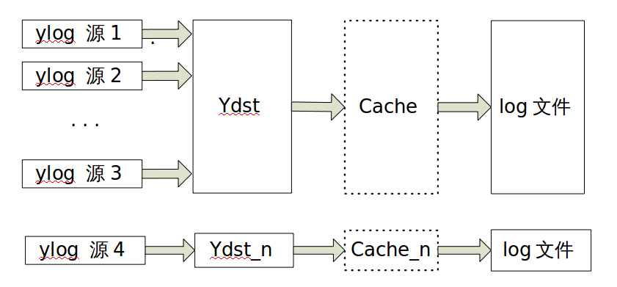

1.1.1 ylog source
ylog source focuses on describing input-data, such as input type, token and restart time.
Currently four input types are supported, which are common file, socket, popen and inotify monitor.
ylog source reference form：
{
.name = "android_main",
.type = FILE_POPEN,
.file = "logcat -v threadtime -b main",
.ydst=&ydst[OS_YDST_TYPE_ANDROID+OS_YDST_TYPE_BASE],
.mode=YLOG_READ_MODE_BLOCK | YLOG_READ_LEN_MIGHT_ZERO | \
YLOG_READ_MODE_BLOCK_RESTART_ALWAYS,
.restart_period = 2000,
.fp_array = NULL,
.id_token = "A0",
.id_token_len = 2,
.id_token_filename = "main.log",
},

1.1.2 ydst
ydst concentrates on output-data that comes from ylog source. ydst is designed for dividing up data and controlling numbers of segments. When there is a large dataflow, much data lose caused by disk transient efficiency occurred. Under this occasion, ydst can be attached to cache for alleviating big data and high throughput.
ydst reference form：
[OS_YDST_TYPE_ANDROID] = {
.file = "android/",
.file_name = "android.log",
.max_segment = 30,
.max_segment_size = 50*1024*1024,
.cache = &os_cacheline[OS_YDST_TYPE_ANDROID],
}

1.1.3 cache
cache focuses on how to cache output-data from ydst, and write them into disk storage at the appropriate time. cache has an attribute named Timeout, which can ensure that output-data can be written to disk as soon as possible. Timeout is used to define an action, where if it doesn't run out of cache line within Timeout, the data in cache line will be flushed to disk with force.
[OS_YDST_TYPE_ANDROID] = {
.size = 512 * 1024,
.num = 4,
.timeout = 1000, /* ms */
.debuglevel = CACHELINE_DEBUG_CRITICAL,
}

2. ylog module
ylog is a a user-space service application started by init.rc, and its default startup behavior after the boot can be aided controlled by attribute value of persist.ylog.enabled . ylog not only supports multiple ylog source parallel inputting, but multiple ydst parallel outputting. It can assign ydst output, set ydst whether attached to cache, define restart time interval, make up whether overwrite when reach the limit of segments numbers, which is based on data structure of ylog source.

2.1 corresponding list between ylog source and ydst
[ylog] android_main
[ylog] android_radio
[ylog] android_system [ydst] android
[ylog] android_events
[ylog] android_crash

[ylog] kernel [ydst] kernel
[ylog] sys_info [ydst] sys_info
[ylog] tcpdump [ydst] tcpdump
[ylog] hcidump [ydst] hcidump
[ylog] ylog_debug [ydst] ylog_debug
[ylog] info [ydst] info
[ylog] journal [ydst] journal
[ylog] tracer [ydst] tracer
[ylog] traces [ydst] traces
[ylog] socket [ydst] socket/open/
[ylog] sys_info_manual [ydst] sys_info_manual

2.2 ylog source
1. Android
It covers five types log , including android_main, android_radio, android_system, android_events, android_crash, which output into a common ydst. Meanwhile, in order to improve disk efficiency, the ydst is attached to a 1M-sized cache by default.
2. kernel
It collects kernel log, and kernel ydst is attached to a 1M-sized cache by default.
3. sys_info
It collects some system-related log in regular time(two minutes). The included specific information is listed as follows.
/proc/slabinfo
/proc/buddyinfo
/proc/zoneinfo
/proc/vmstat
/proc/vmallocinfo
/proc/pagetypeinfo
/sys/module/lowmemorykiller/parameters/adj
/sys/module/lowmemorykiller/parameters/minfree
/proc/wakelocks
/d/wakeup_sources
/sys/class/backlight/sprd_backlight/brightness
/sys/kernel/debug/binder/failed_transaction_log
/sys/kernel/debug/binder/transaction_log
/sys/kernel/debug/binder/transactions
/sys/kernel/debug/binder/stats
/sys/kernel/debug/binder/state
/sys/kernel/debug/sprd_debug/cpu/cpu_usage

4. tcpdump
It collects ap cap log，and tcpdump ydst is attached to a 1M-sized cache by default.
5. hcidump
It collects hci bt log，and hcidump ydst is attached to a 1M-sized cache by default.
6. ylog_debug
It collects debugging information related with log, includes log rate, space usage, running status, etc, usually takes statistics once every 20 minutes.
/system/bin/ylog_cli ylog
/system/bin/ylog_cli speed
/system/bin/ylog_cli space
getprop ylog.killed

7. info
It collects system-related static information, which is captured only once when ylog starts.
/proc/cmdline
/proc/version
/proc/meminfo
/proc/mounts
/proc/partitions
/proc/diskstats
/proc/modules
/proc/cpuinfo
/default.prop
/data/ylog/ylog.conf
ls -l /
ls -l /dev/block/platform/*/by-name/
ls -l /dev/
getprop
cat /*.rc
all the thread pid and tid of ylog

8. journal
It's designed for monitoring ylog running status, monitor switch, and log file deletion,etc.
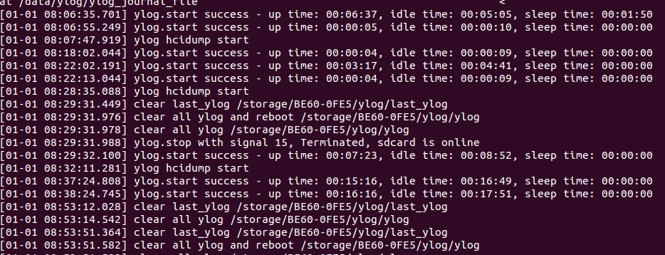
9. tracer
It can make data slice storage read from /d/tracing/trace_pipe, which allows to add debug information, and ajust quota values for time critical drive modules, such as usb.

10. traces
It collects tombstones in the case of native crash, and stack trace in the case of anr.
Besides, traces contain logcat info when the anr or natitive crash occure.The log file name contain
anr/tombstones number and occure time.
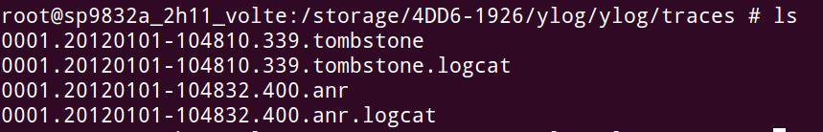
11. socket
It opens ylog socket to receive dataflow from evaluation software called ylog_benchmark, which can search software and system bottleneck.
12. sys_info_manual
It can trigger ylog to capture the execution results of "busybox netstat -ap" and "ps -t" manually.

2.3 ylog attribute list
1.the following attribute values indicate running status of all kinds of log.
[init.svc.ylog]: [running]
[ylog.killed]: [0]
[ylog.svc.android_crash]: [running]
[ylog.svc.android_events]: [running]
[ylog.svc.android_main]: [running]
[ylog.svc.android_radio]: [running]
[ylog.svc.android_system]: [running]
[ylog.svc.benchmark_socket]: [running]
[ylog.svc.cp_5mode]: [stopped]
[ylog.svc.cp_wcn]: [stopped]
[ylog.svc.hcidump]: [running]
[ylog.svc.info]: [stopped]
[ylog.svc.kernel]: [running]
[ylog.svc.sgm.cpu_memory]: [running]
[ylog.svc.snapshot]: [running]
[ylog.svc.socket]: [running]
[ylog.svc.sys_info]: [running]
[ylog.svc.sys_info_manual]: [stopped]
[ylog.svc.tcpdump]: [stopped]
[ylog.svc.tracer]: [running]
[ylog.svc.traces]: [running]
[ylog.svc.ylog_debug]: [running]

2.ylog service master switch control
[persist.ylog.enabled]: [1]
3. TF card unloaded numbers
[ylog.killed]: [0]

2.4 ylog function
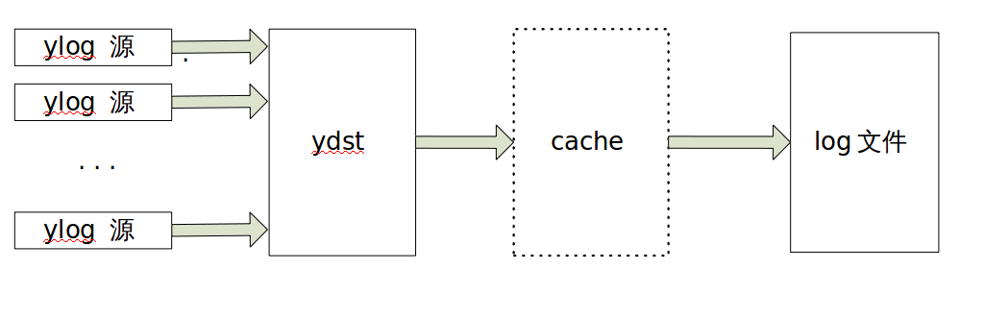
- For purpose of easy to post-maintenance, it abstracts three data model, including ylog ydst and cache.
- cache is used for alleviating disk pressure under normal circumstances, and log loss with high data throughput.
- Keyword filter can retrieve received data, and trigger corresponding action response, which executes shell or other operations to collect much more information, thus to help localize the source of problem. It can make ylog more smart for real-time performance and acquisition for environment.
- The upper limit for log files is distributed by actual free space, realizing dynamic adjustment of quota values.
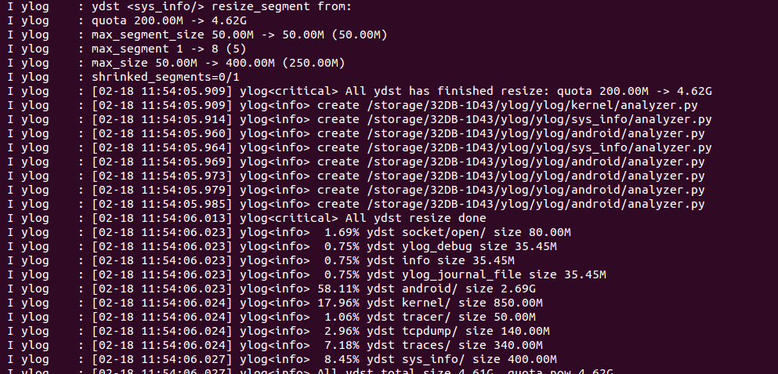
- ylog process can be monitored, and journal is stored into /data/ylog/ylog_journal_file permanently for aided analysis of system behavior.
6. ylog_cli speed can look up the highest ten throughput information since the system started: the productive rate of log.

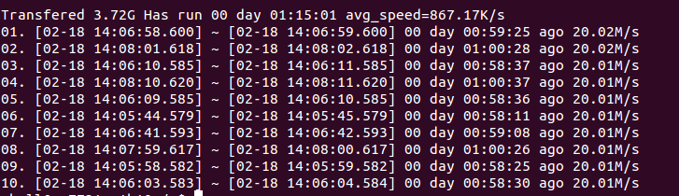
7. Built-in analyzer.py provides for off-line data processing.
8. Multiple data can be output into one ydst, which ensure that log time-stamp are included in the same time form.
9. ylog_cli kernel can capture kernel log in real time, and simultaneous operation of four independent ylog_cli are supported.
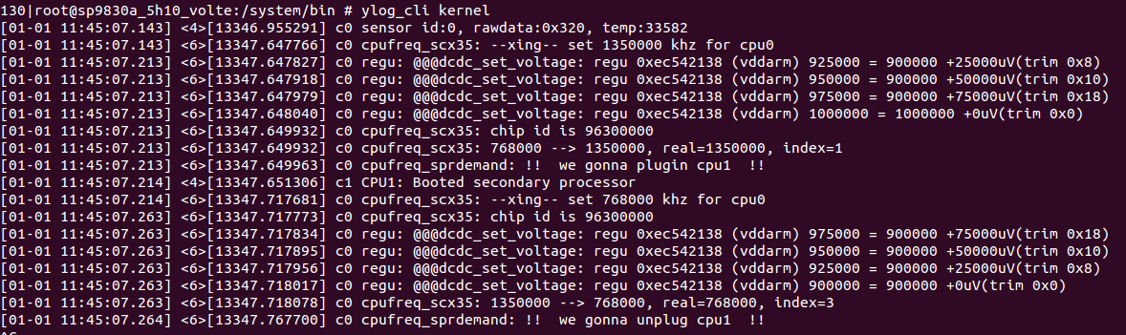
10. It can judge whether log reaches the ceiling by checking the numbers of segments, whether log overwriting has occurred.
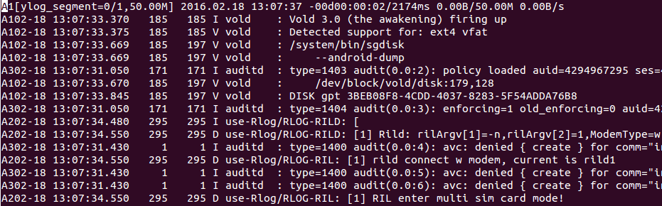
11. sys_info performs system information statistics collection operations, and data will be slice storage.
12. ylog_cli benchmark can evaluate upper limit of read-write rate by disks and ylog.
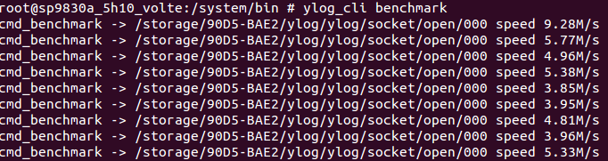
13. It can make data slice storage read from /d/tracing/trace_pipe, which allows adding debug information, and ajust quota values for time critical drive modules, such as usb.

2.4 ylogd
Google native module logd add log prune mechanism to avoid log system effects on power, performance, battery consumption. Logd statiscs log in according to uid, when the certain uid log volume exceeds the safe value, it will drop log. So some module occure miss log phenomenon.Due to some module, such as camera, need abundant log to analyze issue, sprd develop ylogd mechanism to save the complement log.
Ylogd default status is close.After open ylogd ,the log is save in android folder. At the beginning of A in the log entry is captured by logd, t the beginning of Y in the log entry is captured by ylogd. Pull the log to local pc, execute python analyzer.py, there should be main.log and main.ylog, the main.ylog saves the logs from ylogd, it's completely.
Open ylogd cmd:
adb shell ylog_cli ylog ylogd start
return:
[ ylogd ] = running

Open ylogd cmd:
adb shell ylog_cli ylog ylogd stop
return:
[ ylogd ] = stopped

other cmd about ylogd:
adb shell ylog_cli android

adb shell ylog_cli android main
adb shell ylog_cli android system
adb shell ylog_cli android radio

3. ylog_cli command line
Help information of ylog_cli command line can be obtained by “adb shell ylog_cli”.

3.1 overview of ylog_cli command line

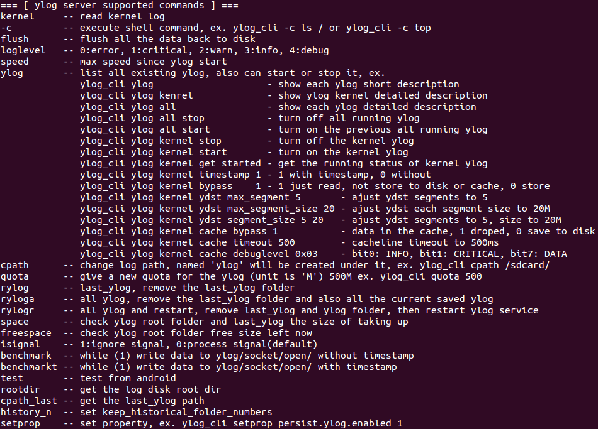
3.2 explanation of ylog_cli command line
ylog_cli connects to ylog process through sockets, and support multi-class command lines, which are queries, switches, settings, deleting, etc.

3.2.1 query class
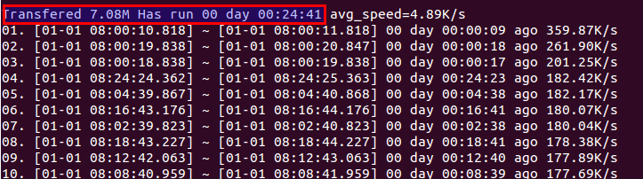
- Look up the top ten read/write rate since ylog boot.
- Look up all kinds of log information, such as switch status, upper limit of segments and single segment's size, log-transfer counter.
Command format： adb shell ylog_cli ylog
Response format：No
Root: display the current log storage path.
Quota : the upper limit of log storage space.
Running：show running time of ylog.

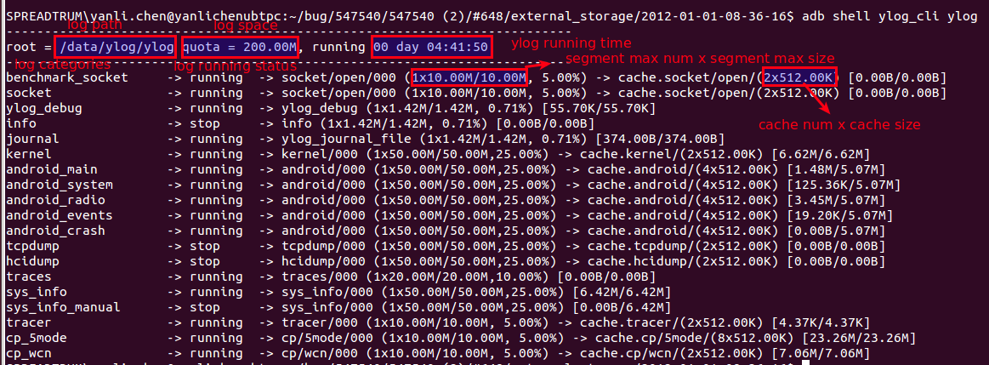
3. Look up switch status of a single log, the same as ylog.svc.xxx
Command format：ylog_cli ylog xxx get started
Response format：No
Opened state： 1\n
Closed state ： 0\n
Note: xxx can be android_main, android_system, android_radio, android_events, android_crash, tcpdump, hcidump, kernel.
4. Look up log storage path
Command format：adb shell ylog_cli cpath
Response format：No
Without TF card： /data/ylog/ylog Note : Internal storage can't support saving history log.
With TF card： /storage/BE60-0FE5/ylog/ylog
/storage/BE60-0FE5/ylog/last_ylog

5. Look up memory space of log
Command format：adb shell ylog_cli space
Response format：No

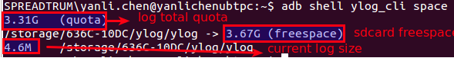
6. Look up free space of disk that log resides on
Command format：adb shell ylog_cli freespace
Response format： /storage/BE60-0FE5/ylog/ylog -> 7.32G

7. Look up disk path that log resides on
Command format：adb shell ylog_cli rootdir
Response format：/storage/BE60-0FE5

8. Look up history log times
Command format：adb shell ylog_cli history_n
Response format：5\n keep five history log by default

9. Look up relevant information of single ylog source
Command format：adb shell ylog_cli ylog xxx
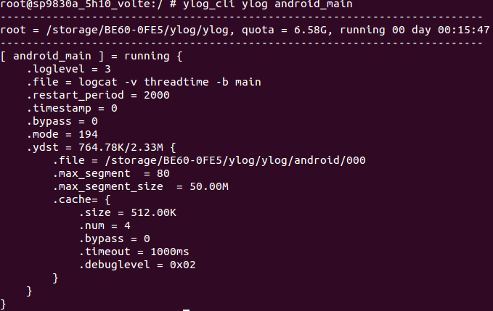
Response format：Output information, including input types of ylog source, storage path, cache size, ect.
Note：xxx can be android_main, android_system, android_radio, android_events, android_crash, tcpdump, hcidump, kernel.
10. Look up all the relevant log information
Command format：adb shell ylog_cli ylog all
Response format：Output all log information, including input types, storage path, cache size, ect.

3.2.2 switch class
1. Main switch settings of ylog
Command format：
start ylog：adb shell setprop persist.ylog.enabled 1 -----> persist.ylog.enabled 1
stop ylog：adb shell setprop persist.ylog.enabled 0 -----> persist.ylog.enabled 0

2. All switch uniform settings of log
Command format：adb shell ylog_cli ylog all start/stop
Response format：Output all log information, including switch status, storage path, cache size, ect.
3. Switch settings of single log
Command format：adb shell ylog_cli ylog xxx start/stop
Response format：output data structure information of the log

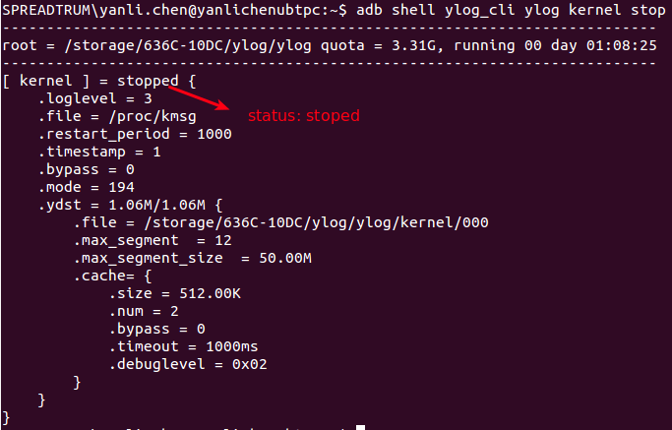
3.2.3 setting class
1. Setting up maximum values of log segments
Command format：adb shell ylog_cli ylog xxx ydst max_segment n
Response format：output data structure information of the log

2. Setting up individual log file size, unit: M
Command format: adb shell ylog_cli ylog xxx ydst max_segment_size 20
Response format：output data structure information of the log
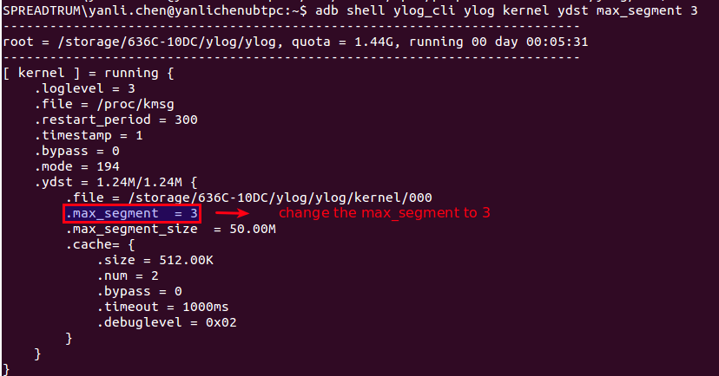
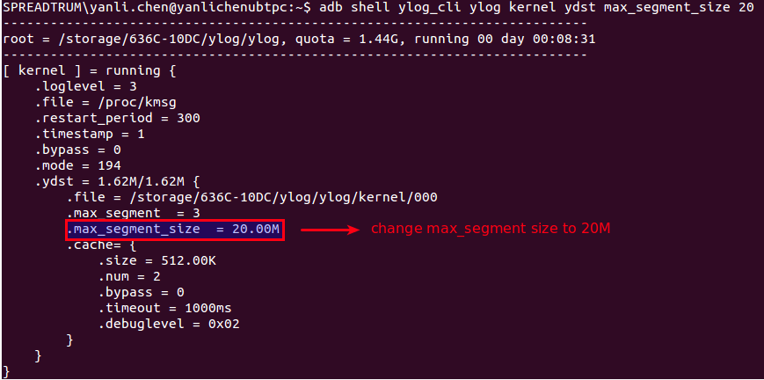
3. Setting up maximum of log segments, upper limit for log size
Command format：adb shell ylog_cli ylog xxx ydst segment_size 5 20
Response format：output data structure information of the log

4. Setting up whether print time stamps during real kernel log printing by ylog_cli.
Command format：adb shell ylog_cli ylog kernel timestamp 1/0 ( yes/no )
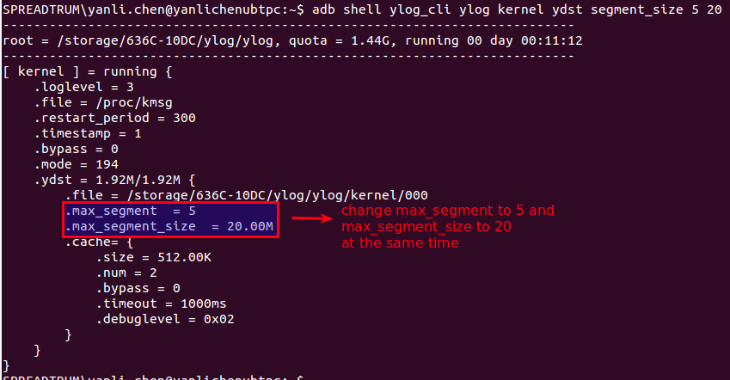
Response format：real printing of kernel log on terminal

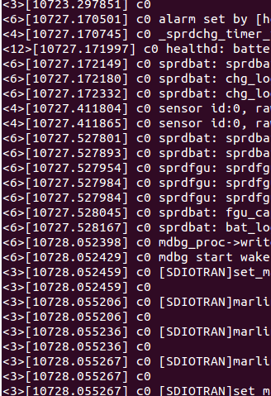
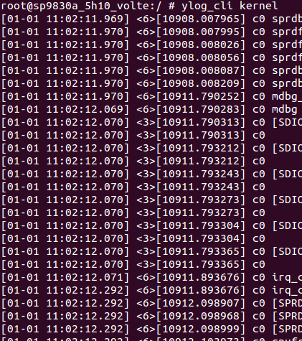

5. Setting up whether writing log back to disk
Command format：adb shell ylog_cli ylog xxx bypass 1/0 ( yes/no )
Response format：output data structure information of the log

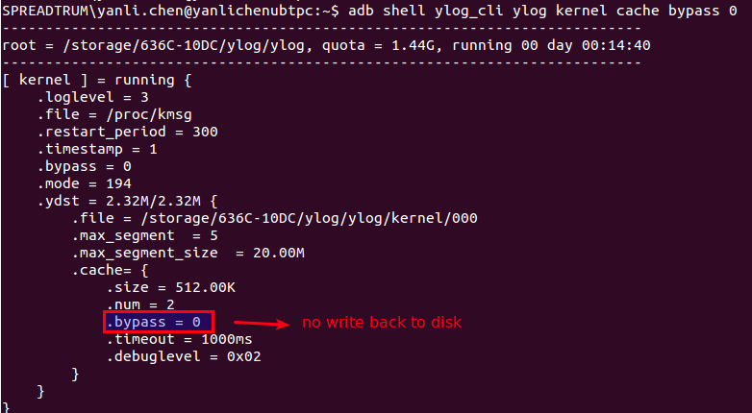
6. Setting up cache timeout
Command format：adb shell ylog_cli ylog xxx cache timeout 500
Response format：output data structure information of the log

7. Setting up number of history log
Command format：adb shell ylog_cli history_n N
Response format：N\n

3.2.4 delete class
1. Deleting last_ylog only
Command format：adb shell rylog
Response format： done\n

2. Deleting folders of ylog, last_ylog
Command format：adb shell ryloga
Response format：done\n

3. Deleting folders of ylog, last_ylog, and restart ylog
Command format：adb shell rylogr
Response format：done\n

3.2.5 other class
1. Get real-time kernel log
Command format：adb shell ylog_cli kernel
Response format： print kernel log in real time

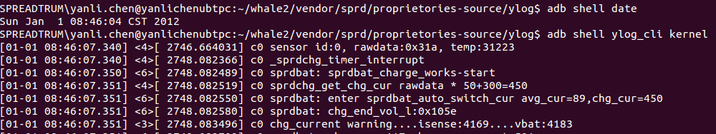
2. Flush cache to disk
Command format：adb shell ylog_cli flush
Response format： None

3. benchmark for evaluating disk read-write rate
a. benchmark test without time stamps.
Command format：adb shell benchmark
Response format：None

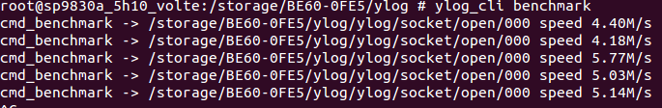
b. benchmark test with time stamps.
Command format：adb shell benchmarkt
Response format：None

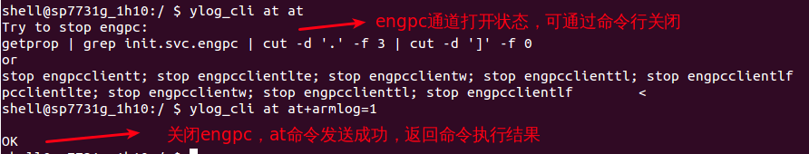
4. use ylog_cli command to save kernel log
Command format: adb shell ylog_cli print2kernel + log content
eg, adb shell ylog_cli print2kernel test

Check whether log is written to “/dev/kmsg” successfully, use the command as follows, adb shell cat /dev/ksmg |grep print2
5. use ylog_cli command to save android log
command format: adb shell ylog_cli print2android + log content
eg, adb shell ylog_cli print2android test

Check whether log is saved successfully, use the command as follows,
adb logcat |grep print2
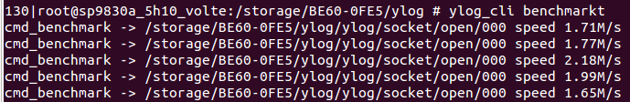
6. capture snapshot info
command format: adb shell ylog_cli snapshot
respond format:
a). adb shell ylog_cli snapshot log
capture dmesg and logcat info when the cmd is executed, the log file is named as the current time.

b). adb shell ylog_cli snapshot mtp
updata mtp file path, default updata ylog file path
c). adb shell ylog_cli snapshot screen
screen , the picture is saved the screen folder
Also, you can set picture save path and name. For example:adb shell ylog_cli snapshot screen /data/screen.png
named as screen.png picture is generated in /data directory

3.2.6 modem/wcn log rate statistic
The rate of modem/wcn log can be counted by ylog, then the corresponding log is stored in folder of cp.
modem log get by ylog is stored in the cache sizeof 8*512*1024, and the log will be written to disk until timeout or cache runs out of the space. Theoretically, modem log stored by ylog can not be lost, in the case that modem log rate can't exceed 4M/s.
1. modem log rate statistic
Various log can be counted by command, which is “adb shell ylog_cli speed”. modem log shows in the following,
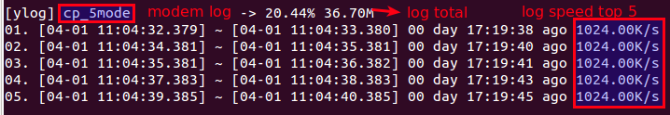
2. wcn log rate statisc
Various log can be counted by command, which is “adb shell ylog_cli speed”. wcn log shows in the following,
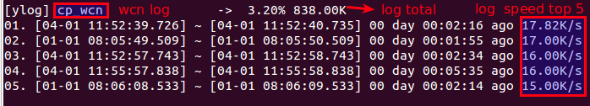
3 . ylog can send AT command
Command format：adb shell ylog_cli at at
Response format:
a. engpc channel is open
Try to stop engpc:
getprop | grep init.svc.engpc | cut -d '.' -f 3 | cut -d ']' -f 0
or
stop engpcclientt; stop engpcclientlte; stop engpcclientw; stop engpcclienttl; stop engpcclientlf
pcclientlte; stop engpcclientw; stop engpcclienttl; stop engpcclientlf

Command to close engpc channel:

adb shell getprop | grep init.svc.engpc | cut -d '.' -f 3 | cut -d ']' -f 0 or
adb shell stop engpcclientt; stop engpcclientlte; stop engpcclientw; stop engpcclienttl; stop engpcclientlf pcclientlte; stop engpcclientw; stop engpcclienttl; stop engpcclientlf

b. engpc channel is closed
Return value of AT command

4. log analysis methods and techniques.

4.1 ylog directory structure
In the case of no TF card, ylog is stored in data partition with default quota value of 200M. Once TF card mounts successfully, quota values will be set as 90% free space of TF card, which calculated by ylog. The free space can be dynamically assigned to each ydst. Meanwhile, log stored in data partition will be moved to TF card, and subsequent log will be stored in append mode. In the condition of a disk-out-of space, ylog can try run smaller to free space for following log. In the another way, ylog can modify disk quotas to set segments numbers or size dynamically.
When TF card mounts abnormally or switch of ylog , current ylog folder is moved to last_ylog, and rename ylog to ylog1. Meanwhile, the exsited ylog1 be renamed to ylog2, and so on. The default history log keeps up to 5 times, this number can be set by command, adb shell ylog_cli history_n N.
ylog directory structure stored in TF card is described as following.
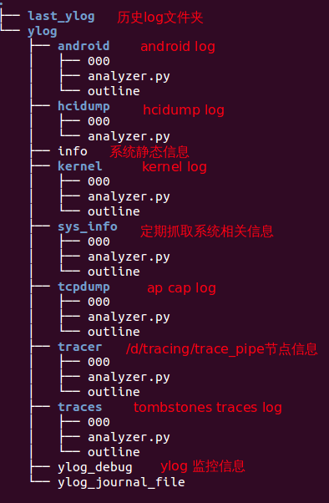
000 is current log file, and when its size reaches the upper limit of single file size, ylog can flip it to 001. At the same time, 000 is created to continue saving log. Obvious, the smaller of file name, the newer log is. When log files reach rollover limit, there are two options, one is saving original log , the other is deleting oldest log for free space, these all depend on the property of ydst.
Analyzer.py is used for parsing log files off line, and support multiple platforms, windows/MAC/linux, etc.
Outline files record log time periods and total time used for filling log. In analyzing problems, the corresponding log segments can be addressed according to point time the problem occurred, where outline files can help to open.
The detailed steps as follows.
vim outline
1. place the cursor on 002
2. input gf
3. open file named 002 directly

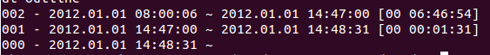
Log information is described as following.
0 stands for files named 000, 54 is the maximum of segments.
50.00M means the maximum data size of each segment.

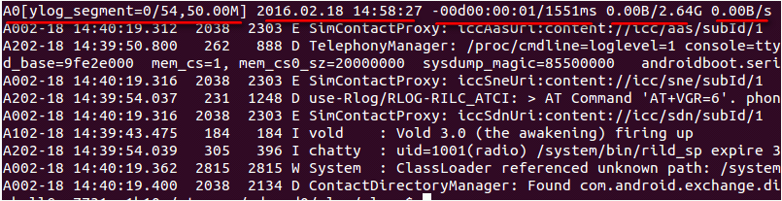
4.2 ylog files analysis off line

4.2.1 python analyzer.py
analyzer.py contains token mapping information
'A0':'main.log',
'A1':'system.log',
'A2':'radio.log',
'A3':'events.log',
'A4':'crash.log',

After pulling ylog to the local, the parsed log can be obtained by executing command “python analyzer.py” in corresponding folder. Analysis supports log resolution and combination, and it can be customized. In addition, it supports for specified segments analysis. For instance, 000 and 001 log can be parsed separately by command that “python analyzer.py 000 001”.
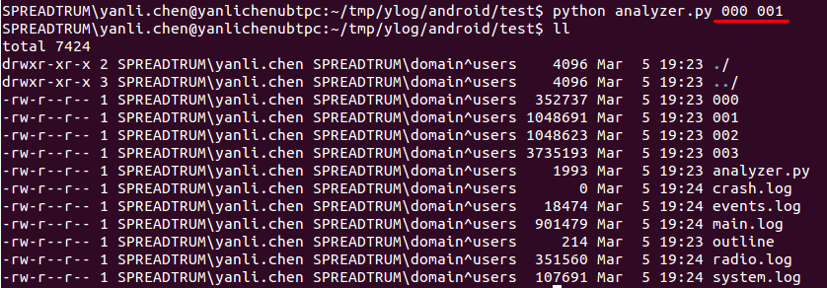
Log parsed directory is shown as follows.
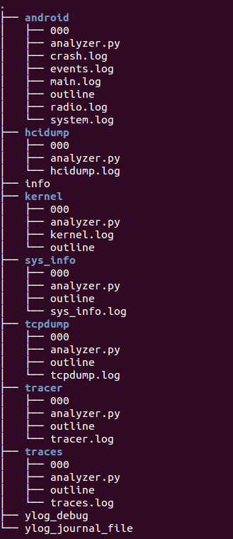

4.2.2 sgm log analyzer
1. obtain sgm.toolkits tool
ubuntu os: git clone git://10.5.2.45/sgm.toolkits
windows os: (make sure adb environment and phone driver is installed)
a. http://10.5.2.45/sync/installer download the matched version: git-for-windows、MobaXterm、Kst2.0
b. git clone git://10.5.2.45/sgm.toolkits
c. operate as steps in 《SGM.toolkits使用手册.pdf》
2. sgm.toolkits help info
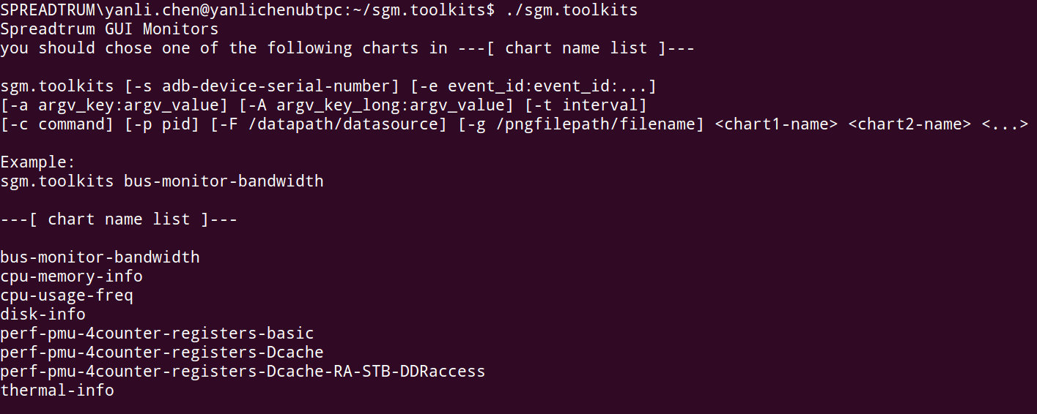
3. how to use sgm.toolkits
pull sgm log to local pc, in sgm folder exec: python analyzer.py, it generage sgm.cpu_memory.log file.
Eg: ./sgm.toolkits -F ~/tmp/sgm/sgm.cpu_memory.log cpu-usage-freq
get cpu usage info and frequency etc.
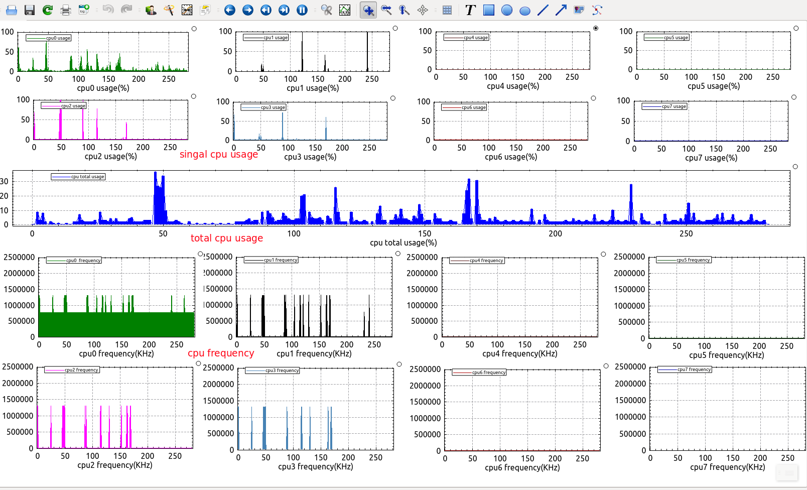
You can also set parameter -g to make chart-name list info to static picture.
Eg: ./sgm.toolkits -F ~/tmp/sgm/sgm.cpu_memory.log -g 1.png cpu-usage-freq
The cpu-usage-freq info is saved as picture named as 1.png

4.2.3 ylog_verify_pc.sh script use help
You can get ylog_verify_pc.sh script frop ylog source code, then copy it to /usr/bin.
cp ylog_verify_pc.sh /usr/bin
Then you can exec ylog_verify_pc.sh directly. In the log folder exec ylog_verify_pc.sh through therminal, you can get the directory tree/run time/end time etc info.
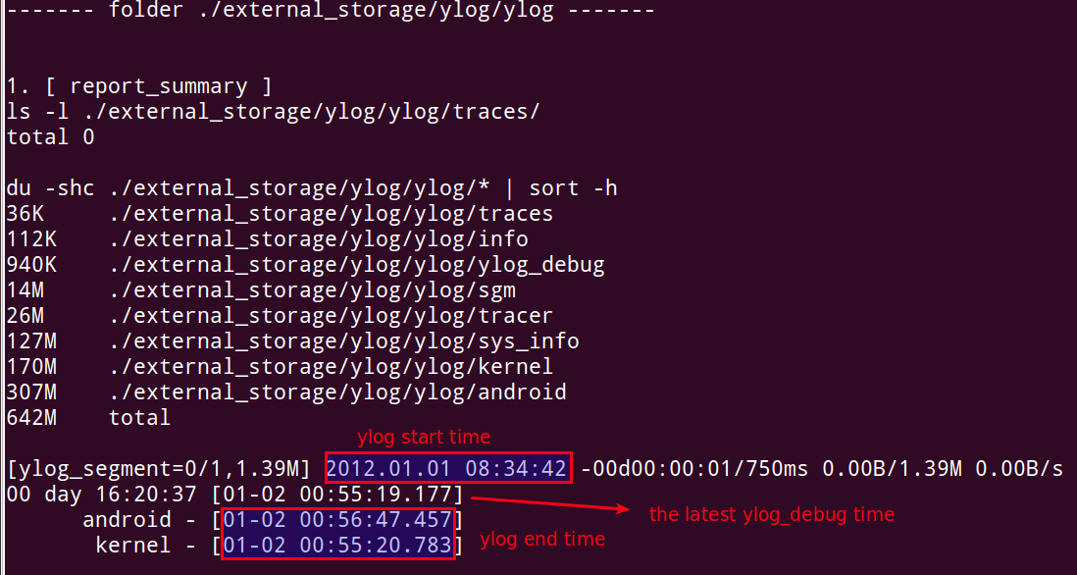

4.3 analytical method of native crash and anr log
1. native crash
a. enter /ylog/ylog/traches, run “python analyzer.py”.
vim traces.log, search “ylog tombstones”.
eg. ylog_tombstones 001 [ cat /data/tombstones/tombstone_00 ] [01-02 02:14:16.785]
time stamp : [01-02 02:14:16.785] presents the time occurred native crash.
b. enter android directory, then vim outline. You can find the segments occurred native crash at that time point.
eg. “01-02 02:14:16.785” is located in the following period, the corresponding log segment is 015.
015 - 2012.01.02 02:12:36 ~ 2012.01.02 02:40:37 [00 00:28:01]
c. obtain log, such as main, system, events, radio, crash contained in this log segment.
command : phthon analyzer.py 015.
generation: crash.log events.log main.log radio.log system.log
d. open corresponding xxx.log, then problems can be analyzed.
2. anr
a. enter /ylog/ylog/traces, run “python analyzer.py”.
vim traces.log, search “ylog traces”.
eg. ylog_traces 001 [ cat /data/anr/traces.txt ] [01-02 04:07:43.903]
Time stamp : [01-02 04:07:43.903] presents the time occurred anr.
b. enter android directory, vim outline. You can find the segments occurred anr at that time point.
eg. “01-02 04:07:43.903” is located in the following period, the corresponding log segment is 011.
011 - 2012.01.02 04:04:04 ~ 2012.01.02 04:29:18 [00 00:25:14]
c. obtain log, such as main, system, events, radio, crash contained in this log segment.
command: phython analyzer.py 011.
generation: crash.log events.log main.log radio.log system.log
d. open corresponding xxx.log, then problems can be analyzed.
3. log analysis related with system status (system-related log can be collected every 2 minitus)
Method One:
enter “ylog/ylog/sys_info”, run “python anlayzer.py”,
generation: sys_info.log ( the total log collected by all the test processing )
Method Two:
a. get time point occurred problems.
b. enter “ylog/ylog/sys_info”, vim outline, you can find the segments occurred anr at that time point.
c. vim the corresponding log segment, analyze the system status about time occurred problems.

