Assignment Submission Report:

Files:

test.cpp

-main file

-all testing is showcased.

-different approaches used for converting the input txt file to correct format

-unsuccessful in converting the triangle.txt file

-successful in converting SampleData.txt && ExampleData.txt file which follows the same format as given triangle.txt file.

-error faced : seg fault (most likely due to stoi() used to convert string to int)

-approaches used to fix it :

1. const char *c = temp_string.c_str(); scanf(c,"%d",&temp_int);using c_str()

2. for(auto ch : temp_string) temp_int = (temp_int*10) + (ch - '0');

test_script.cpp

-test script for running the file.

-two example txt input files given (SampleData.txt and ExampleData.txt)

-output attached and shown here as well

-reading from the file → storing in data structure in correct format → finding the max_sum with answer

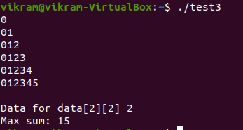

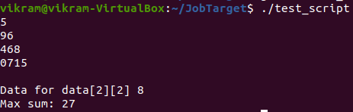Result: SampleData.txt file

Result: ExampleData.txt