Assignment Submission Report:

Files:

test.cpp

-main file
-all testing is showcased.
-different approaches used for converting the input txt file to correct format
-unsuccessful in converting the triangle.txt file
-successful in converting SampleData.txt && ExampleData.txt file which follows the same format as given triangle.txt file.
-error faced : seg fault (most likely due to stoi() used to convert string to int)
-approaches used to fix it :
1. const char *c = temp_string.c_str(); scanf(c,"%d",&temp_int);using c_str()
2. for(auto ch : temp_string) temp_int = (temp_int*10) + (ch - '0');

test_script.cpp

-test script for running the file.
-two example txt input files given (SampleData.txt and ExampleData.txt)
-output attached and shown here as well
-reading from the file → storing in data structure in correct format → finding the max_sum with answer
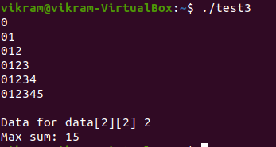
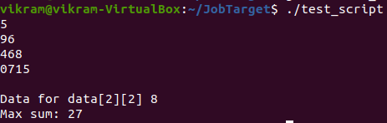
Result: SampleData.txt file

Result: ExampleData.txt

