Elastic Security SIEM – SSH Brute Force Detection & Investigation
Blue Team / SOC Analyst Practical Detection Project

1. Project Overview
This project demonstrates a full SSH brute force attack simulation, detection engineering workflow, SIEM alert investigation, and Linux authentication log analysis using Elastic Security SIEM. The objective was to simulate malicious SSH authentication activity using Hydra, collect telemetry through Elastic Agent, build custom KQL detection rules, investigate generated alerts, and validate attack behavior through event correlation.

2. Lab Environment
- Kali Linux
- Elastic Security (Elastic Cloud)
- Elastic Agent / Fleet
- OpenSSH Service
- Hydra Password Attack Tool
- Linux Authentication Logs (auth.log)
- KQL Detection Rules
- VirtualBox Lab Environment

3. Attack Simulation
A brute force attack was simulated against the SSH service using Hydra. The attack generated multiple failed SSH authentication attempts followed by a successful authentication event. This activity produced Linux authentication telemetry which was ingested into Elastic Security for analysis and detection.

4. Detection Engineering
A custom Elastic Security SIEM detection rule was created to identify failed SSH authentication attempts. The detection rule monitored Linux authentication events and generated alerts for suspicious SSH activity.

5. Custom KQL Detection Logic
event.dataset:"system.auth" and message:*Failed password*
Detection Goal:
- Identify repeated failed SSH logins
- Detect brute force behavior
- Correlate authentication failures with source IP addresses
- Investigate authentication processes and related events

6. Investigation Findings
- Multiple failed SSH authentication attempts detected
- Source IP successfully identified: 172.20.10.2
- Elastic Security generated medium severity alerts
- Authentication failures correlated with sshd-session and unix_chkpwd processes
- Linux auth.log contained detailed PAM authentication events
- Successful authentication observed after repeated failures
- Event correlation confirmed brute force behavior

7. Indicators of Compromise (IoC)
- Multiple failed login attempts within short time period
- Same source IP address
- High-frequency SSH authentication failures
- PAM authentication failures
- Successful authentication after failures
- SSH brute force alert generation in Elastic Security

8. MITRE ATT&CK Mapping
- T1110 – Brute Force
- T1110.001 – Password Guessing
- T1078 – Valid Accounts

9. Event Correlation Analysis
Observed Attack Pattern:
Multiple failed SSH login attempts
→ repeated authentication failures
→ Elastic SIEM alert generation
→ successful authentication event
→ confirmed brute force compromise pattern
This workflow demonstrates practical SOC analysis and attack validation using SIEM telemetry and Linux log analysis.

10. Security Impact Assessment
- Unauthorized access risk
- Potential privilege escalation
- Credential compromise
- Persistence opportunities
- Lateral movement risk
- Increased attack surface exposure

11. Mitigation Recommendations
- Enable Fail2Ban
- Configure account lockout policies
- Enforce strong password policy
- Enable MFA
- Apply SSH rate limiting
- Restrict SSH access by IP
- Continuously monitor authentication logs
- Deploy SIEM correlation rules

12. Conclusion
This project demonstrates practical SOC Level 1 and Blue Team skills including SIEM deployment, detection engineering, KQL rule creation, Linux log analysis, brute force detection, event correlation, and alert investigation inside Elastic Security. The project successfully validated the ability to detect and analyze malicious SSH authentication activity in a realistic monitoring environment.

13. Investigation Evidence & Screenshots
Elastic Security SIEM detection rule overview.
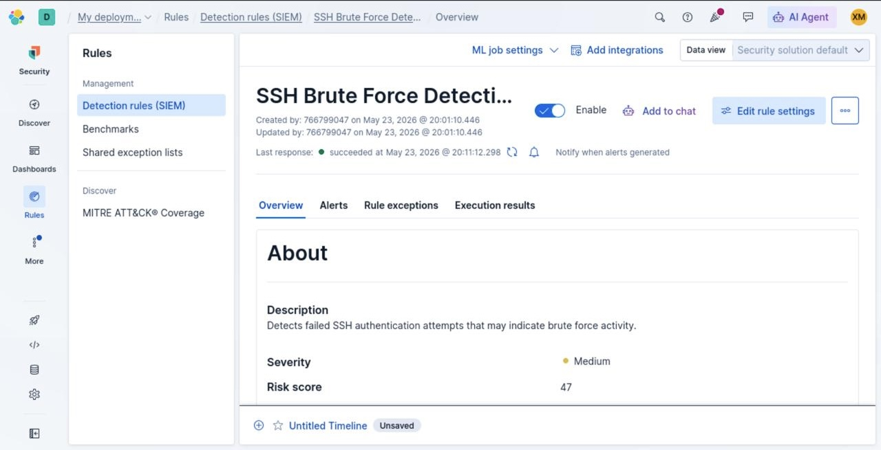
Detection rule configuration and KQL query.
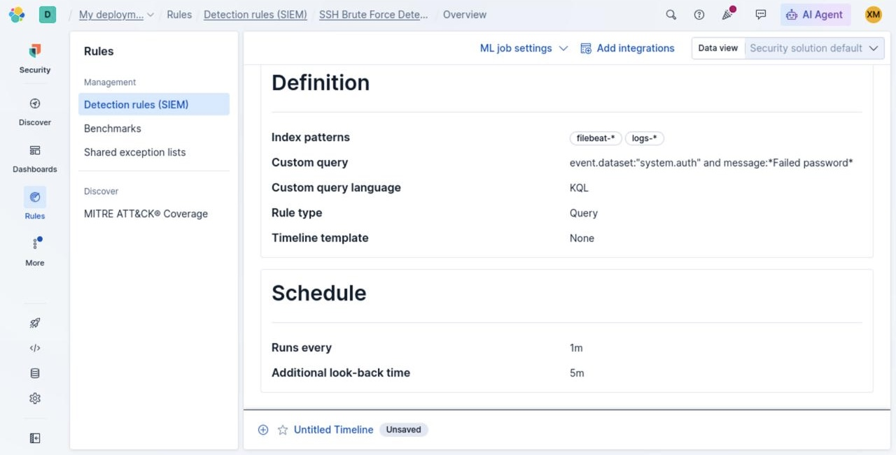
Elastic Security generated SSH brute force alerts.
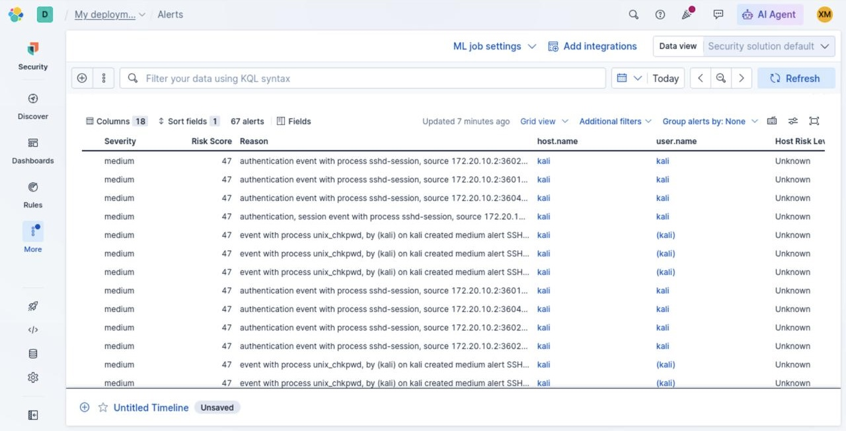
Alert investigation showing correlated events.
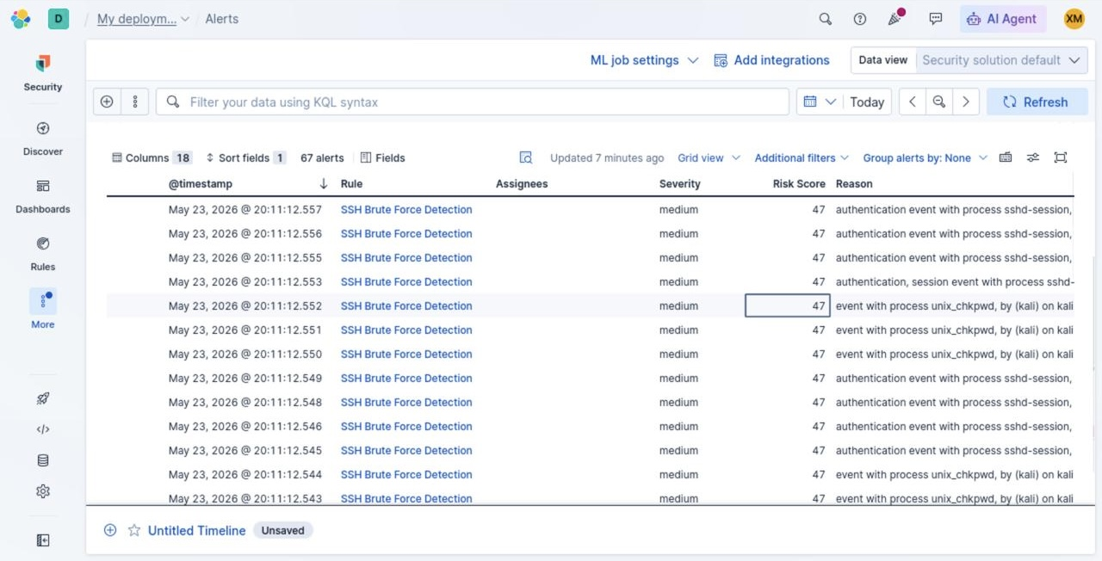
Elastic Fleet agents successfully connected.
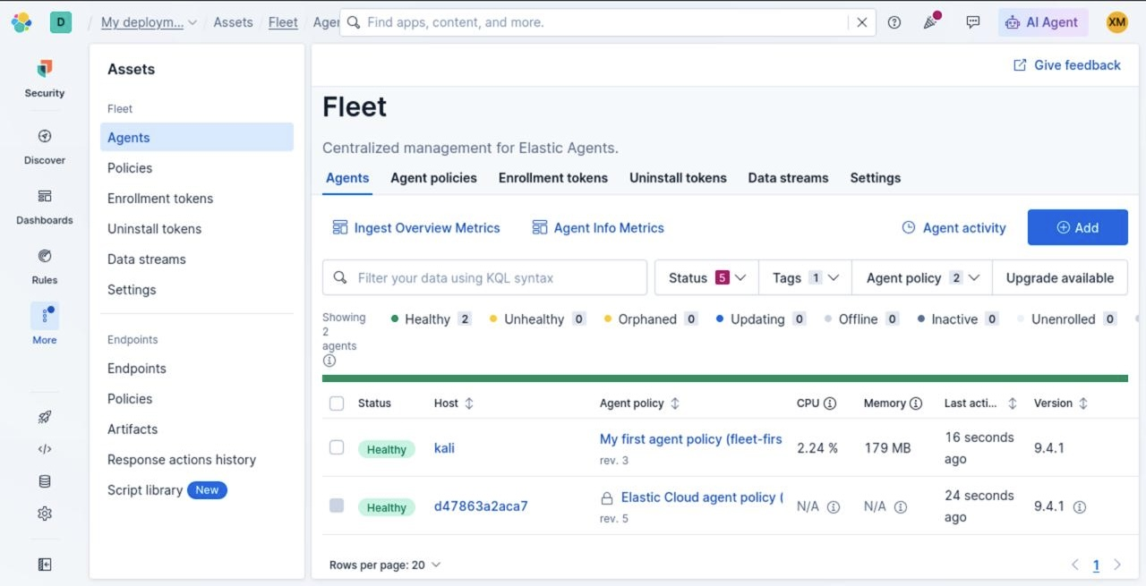
Elastic Security dashboard summarizing alerts.
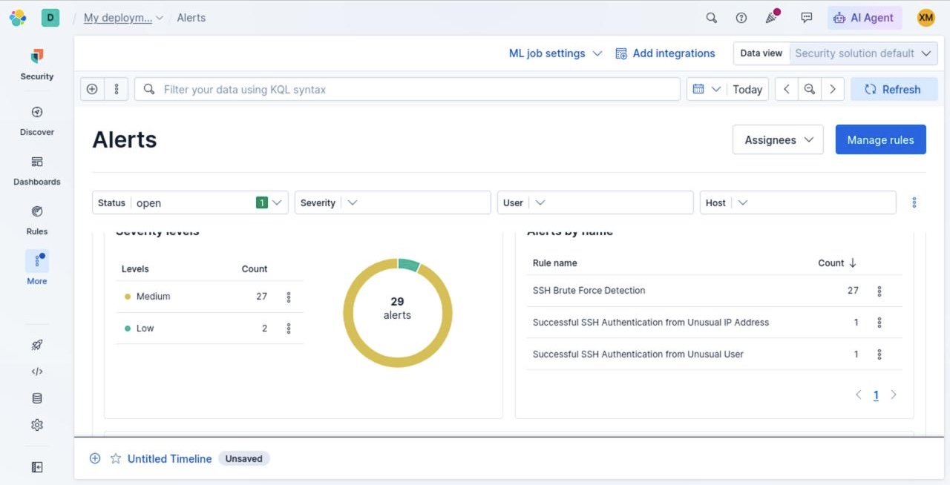
Elastic Discover showing authentication telemetry.
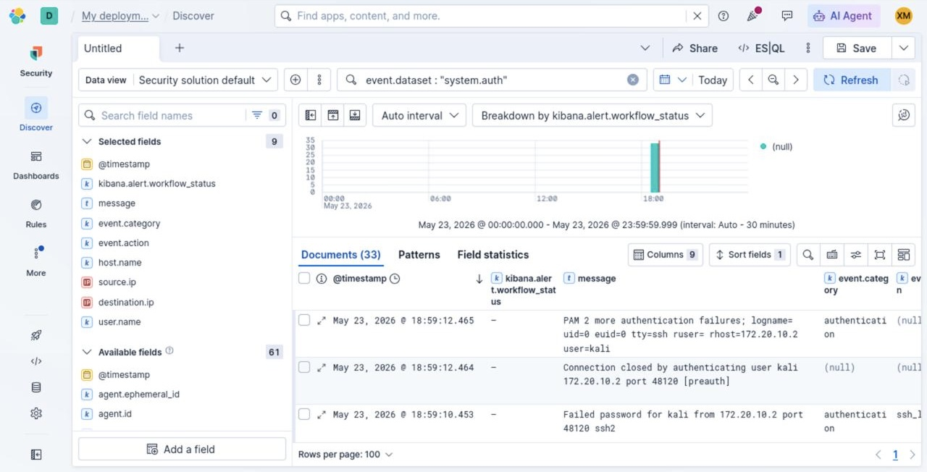
Filtered failed password authentication events.
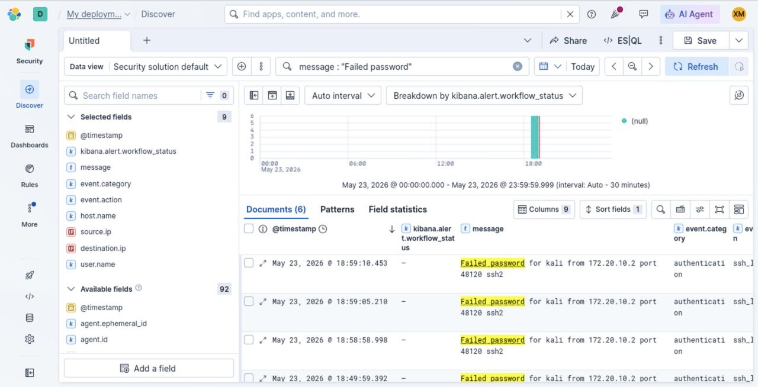
Alert details showing source IP correlation.
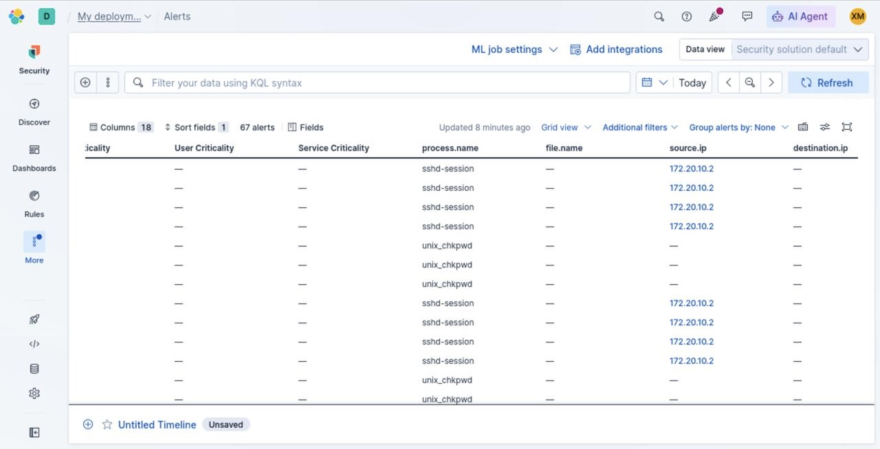
Linux auth.log showing failed SSH authentication events.
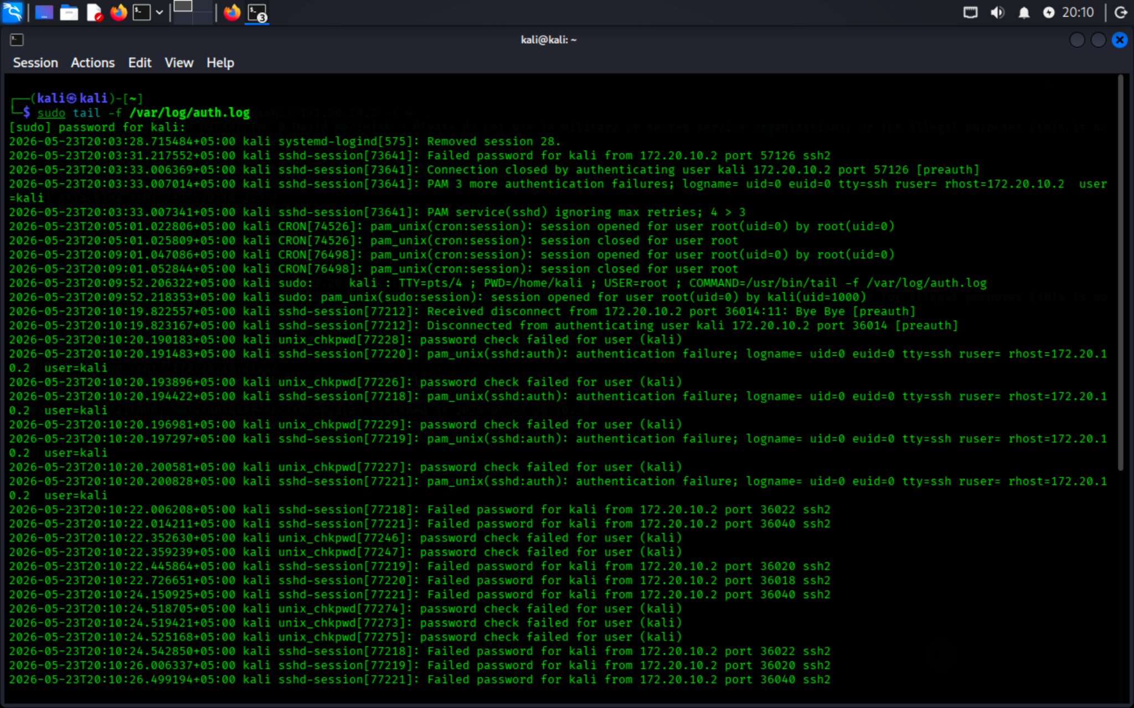
Hydra brute force attack execution against SSH service.
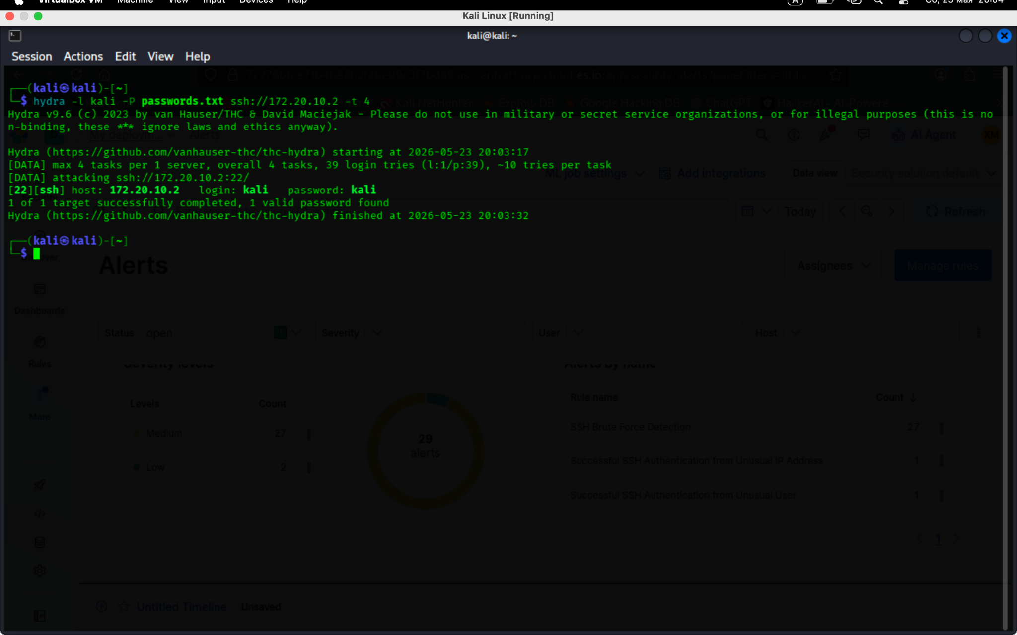
Successful authentication event after brute force attempts.
