Manual for euroduino “sigan” program

Description

sigan software is used for time related operation. It is primarily used for clock / gate / pulse generation with variable and CVable gate length / pulse width. Two channels (DIG OUT1 and DIG OUT2) generates clocks. The first is the master clock. The second is slaved to the first channel and outputs gates ONLY when triggered by a signal in DIG IN2. Master clock can be driven externally if DIG IN1 1 receives a trigger/gate. As we have never enough random, the two CV OUT give you two random channels driven by the master clock. Different parameters are set via POT1 and POT2 (!!! rules of one knob per function is largely broke !!!) and controlled by voltage via CV IN1 and CV IN2. Each parameters are accessible via a combination of switches SW1 and SW2:
- SW1 in high position, clock control
  - SW2 in high position:
    - POT1 control clock frequency of channel1 between 40 and 300 BPM if no clock are detected in DIG IN1. If clock are fed in DIG IN1, POT1 act as external clock divider / multiplier.
    - POT2 control clock frequency of channel2 as a multiplier of channel1 clock
  - SW2 in mid position: POT1 and POT2 attenuate signal from CV IN1 and CV IN2. Incoming CV in CV IN1 and CV IN2 are modulating gate length of channel1 clock and gate length of channel2 clock.
  - SW2 in low position: POT1 and POT2 control respectively gate length of channel1 and channel2 clocks from 0 to 99% of the clock period.
- SW1 in mid position, sync and digital output control
  - SW2 in high position: POT1 and POT2 selects respectively whether channel1 and channel2 clocks are generated on HIGH state (positive voltage) or on LOW state:
    - POT on the left: LOW state
    - POT on the right: HIGH state
  - SW2 in mid position: POT1 and POT2 attenuate signal from CV IN1 and CV IN2. CV IN1 controls channel2 multiplier and CV IN2 modulates gate length of channel2 clock.
  - SW2 in low position: POT1 and POT2 selects respectively whether DIG IN1 and DIG IN2 signaled a clock on rising or falling edge.
    - POT on the left: rising edge
    - POT on the right: falling edge
- SW1 in low position, random control
  - SW2 in high position: POT1 controls frequency (divide/multiply channel 1 clock) and POT2 controls random amplitude or maximum random voltage for random1 (CV OUT1).
  - SW2 in mid position: POT1 and POT2 attenuate signal from CV IN1 and CV IN2 that modulates respectively random frequency of random1 and random2.
  - SW2 in low position: same as SW2 in high position but for random2 (CV OUT2)

About the broken “one knob per function” rule
Tweaking 12 different parameters might be insanely hard because euroduino module has no visual feedback and only two 2 knobs... Not easy but feasible, just remember that SW2 in mid position does not change any parameter (just attenuates the CV in CV IN1 and CV IN2). Selecting the wrong function with SW1 might happen. To avoid overwriting wrong parameters, keep the SW2 in mid position!

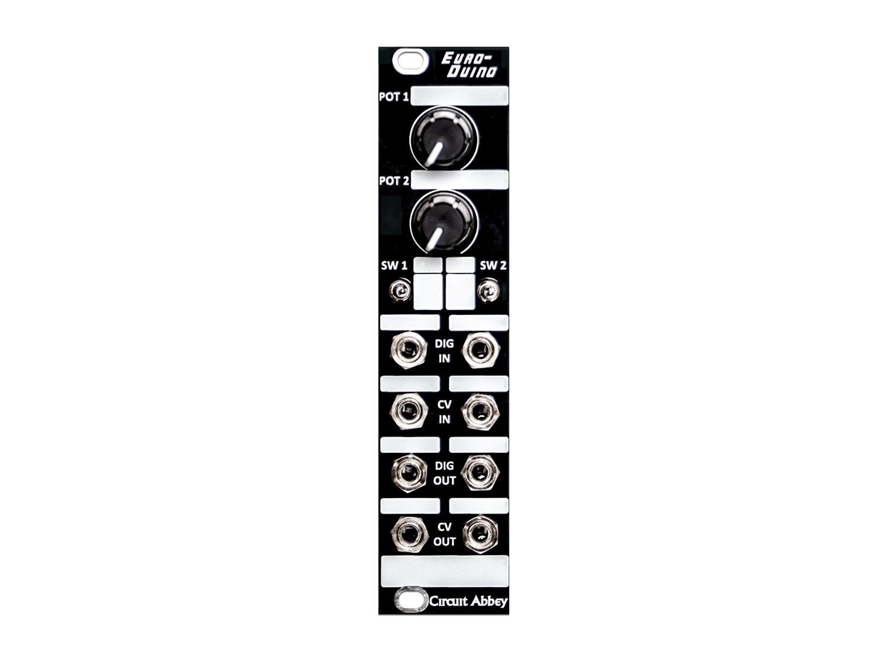
Patch idea

“burst generator”
generates a series of gate signal in DIG OUT2 when DIG IN2 receives a clock:
1. set the frequency of master clock (knob1) and slave clock multiplier (knob2) with SW1 and SW2 in high position
2. send a trig/gate into DIG IN2 and get the succession of trigger/gate from DIG OUT2

“irregular/shuffled clock”
1. set the frequency of master clock (knob1) and set the slave clock multiplier to 1 (SW1 and SW2 in high position)
2. set the pulse width of master clock to around 60% with knob1 (SW1 up and SW2 down)
3. set slave DIG IN2 to be triggered on falling edge with knob2 (SW1 mid and SW2 down)
4. patch the output from DIG OUT1 to input DIG IN2
5. patch DIG IN1 and DIG IN2 in mixer / unity mixer / binary OR module to get the shuffled clock

“clock multiplier”
1. set the frequency of master clock (knob1) and slave clock multiplier (knob2) with SW1 and SW2 in high position
2. patch the output from DIG OUT1 to input DIG IN2

“triggering MS-20 (or any S-Trig synth) with variable pulse width”
1. patch trigger signal in DIG IN1
2. set DIG OUT2 trigger signal to LOW with knob2 (SW1 mid and SW2 up)
3. set slave pulse width to its minimal requested value with knob 2 (SW1 up and SW2 down)
4. patch DIG OUT2 to MS20 trigger in
5. put module in pulse width CV mode with SW1 up/mid and SW2 mid
6. patch CV in CV IN2 and attenuate with knob2
Note: random channel 1 or 2 can be used as CV, just patch CV OUT1 or CV OUT2 in CV IN2!

Compilation
- compile with arduino version ????
- need elapsedMillis.h library

