This Application revolves around the immense matter that we have provided about Geography.

On our website there are many different ways from where you can check and collect information about any part of the world

Information about their cuisine, lifestyle, type of music they hear, travel stories etc are provided on our website.

Now any one can collect as much data as one wants and use our application which is made to make people learn Geography after reading about it.

The application supports a graphically based quiz/learning process.

We can upload any image representing any part of the world and then embedd questions on any thing visible on the image.

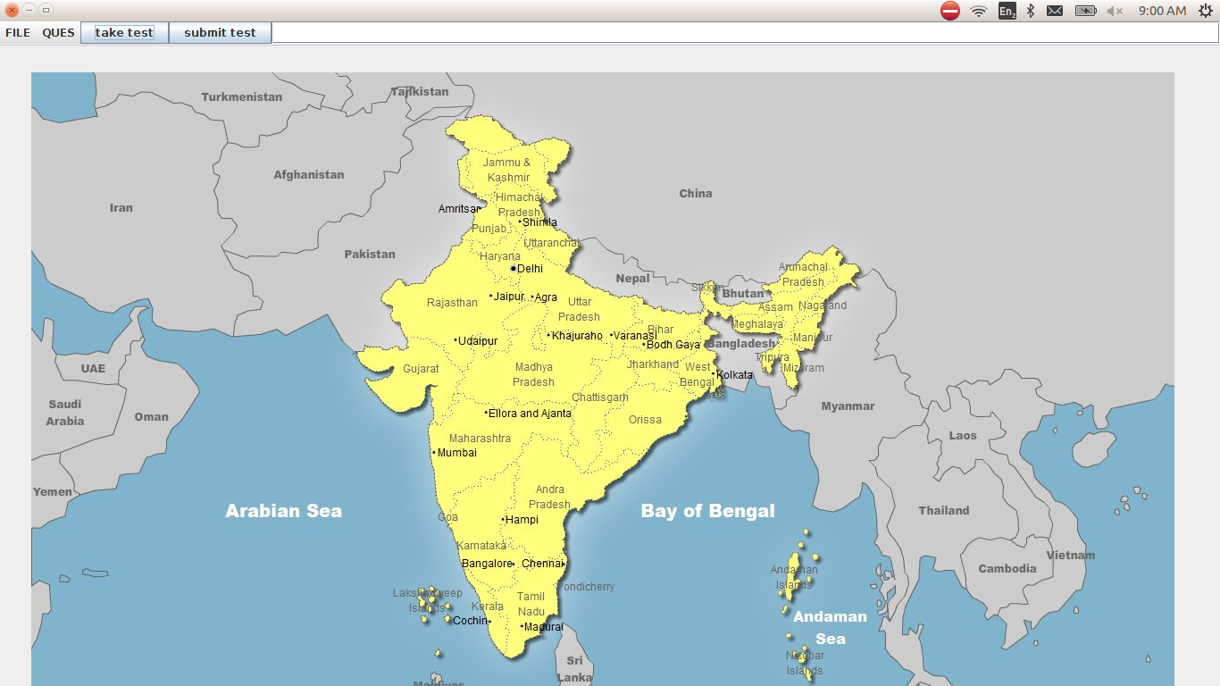

Our app starts with this screen. It contains four options

1. FILE : New, Save, Change Image, Exit

All these options are under the teacher's control.

2. QUES : add ques
The add ques option has a two fold function
a. at the starting of the test it prompts the user to enter the testid
b. after mentioning the testid you can add questions by clicking on the place where you want to create the question shortcut.

3. Take Test and Submit Test are for the Student who takes the test after submitting the test id.

