Technical Design Document — ATE / M1
Project: AI-Assisted Test Plan & Automation Skeleton Generator (POC) — Codevalue PQ 4476 for Exaware Current SOW: ../PQ4476E.pdf Milestone: M1 — Test Plan Generation Status: M1 deliverable Audience: Project owner (Codevalue), reviewer (Exaware)

1. Executive summary (read this first)
Per SOW PQ4476E §5, M1 is "Test Plan Generation" with the following deliverables:
- Test plan generation from input documents (2 Word files + RFC)
- Development environment
- Document parser (PDF, DOCX, TXT)
- Basic text extraction working
- Technical design document (this file)
- Deliverable artifact: Test Plan (single router) xlsx for Exaware review/approval
The implementation pipeline:
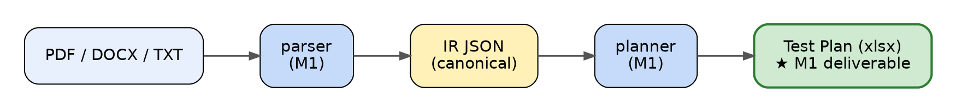
One command for the project owner:
./modular_tools.sh run-tests
Runs every gate (env, corpus, pytest, coverage, scorecard, requirements traceability, lint, performance) and writes a single HTML report.
Generate the M1 deliverable (the xlsx Exaware reviews):
./modular_tools.sh plan_all # writes plans/*.xlsx for every Word spec in references/
Out of scope (per SOW): multi-router topologies (M3), Java/JSystem code generation (M4), IXIA + neighboring-router hooks (M4), web UI (M5).
AI in M1: although the SOW puts "OpenAI/Claude API integration" formally in M3, M1 already integrates Claude (Anthropic SDK) for plan-row enrichment. The committed cache (ate/planner/ai_cache.json) covers 100% of the EVPN System Specification 1.00 rows (382/382) with feature-specific AI-quality content — references real CLI commands, RFC chapters, MUST statements drawn from the source spec. New specs added later are enriched on the fly when ANTHROPIC_API_KEY is set. M3 then expands AI usage to multi-router topologies, prioritization, and coverage tracking per the SOW M3 deliverable list.
Tag-applicability tightening (matrix v4): per-requirement category selection is rule-based (keyword tags from extractor.TAG_KEYWORDS with title-pattern lockouts in TAG_TITLE_LOCKOUTS). Scoring is title-weighted: score = 3 × title_keyword_hits + 1 × description_keyword_hits, threshold 2 (one title hit OR two distinct description hits). This eliminates the v1/v2 false positives where a single passing mention of a keyword in description (e.g. "MAC mobility flag" in REQ#280's route-format description) would falsely apply a tag like HA. Net effect: row count dropped from 543 to 382 (−30%), and the rows that remain are categorically applicable. Reviewer feedback (Q7d) refines this further in M2.

2. Architecture
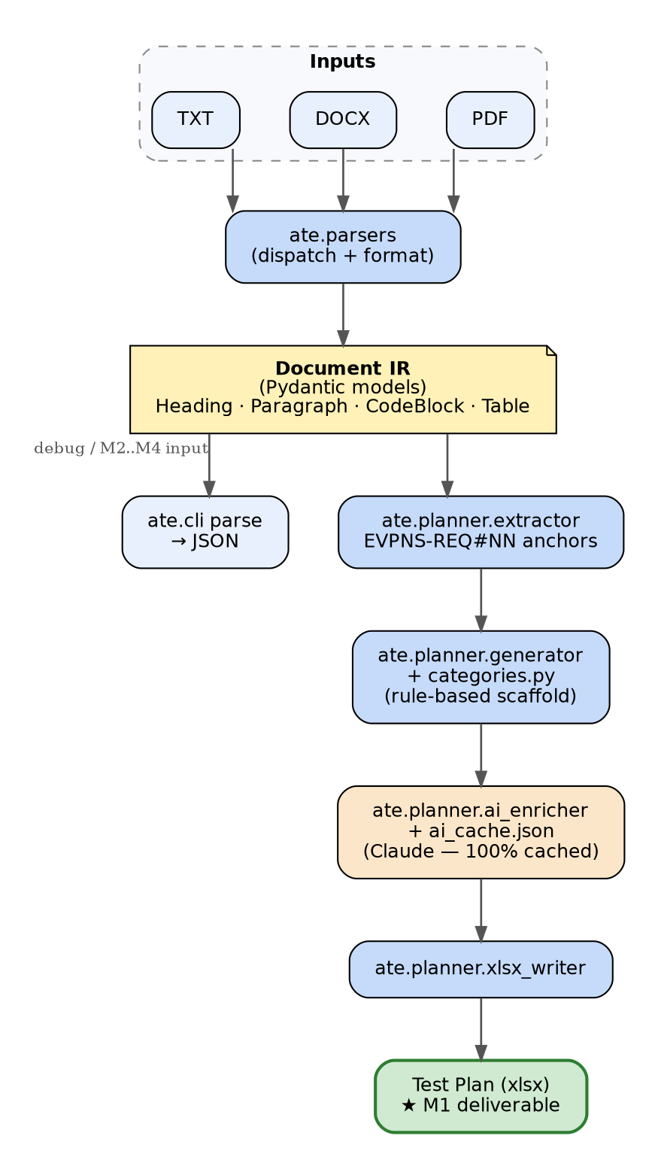{width=5.0in}
The Plan model (ate.planner.model) is the format-neutral artifact. The M1 deliverable is AI-enriched 100% via Claude (Anthropic) — every plan row references real spec content (CLI commands, RFC chapters, MUST statements). The cache (ate/planner/ai_cache.json) is committed so the deliverable is reproducible without an API key. M3 expands AI usage to multi-router topologies, prioritization, and coverage tracking per the SOW M3 deliverable list; M5's web UI reads the same Plan shape.

2.1 Components
Module | Responsibility
ate.ir | Pydantic IR models for parsed documents. Schema versioned (SCHEMA_VERSION = "1.0.0").
ate.errors | Typed exceptions: UnsupportedFormatError, CorruptDocumentError, PasswordProtectedError, EmptyDocumentError, UnsupportedScannedPDFError, EncodingError.
ate.parsers.dispatch | Detect format by magic bytes + suffix; route to the right parser.
ate.parsers.docx_parser | DOCX via python-docx; iterates body in document order; detects code blocks via monospace font / CLI-shape heuristics; tables via direct XML.
ate.parsers.pdf_parser | PDF via pdfplumber; layout-based extraction; heading detection by font-size delta vs. body; table extraction via lattice/stream; rejects scanned PDFs.
ate.parsers.txt_parser | Plain text; RFC numbered headings, setext, markdown #, ALL-CAPS; indented + fenced code blocks.
ate.normalize | Strip format-specific noise (page numbers, soft hyphens, smart quotes, whitespace) for parity comparisons.
ate.planner.model | Plan, PlanRow, Requirement Pydantic models — the format-neutral plan artifact.
ate.planner.extractor | Pulls requirements from IR using anchor regex (default <PREFIX>-REQ#NN).
ate.planner.categories | Test-plan category definitions — categories + per-category sub-test templates from the Exaware xlsx template.
ate.planner.generator | IR → Plan model. Builds a rule-based scaffold then routes through ai_enricher (cache → live Claude API → rule-based fallback).
ate.planner.ai_enricher | Anthropic Claude integration. The committed cache covers 100% of EVPN System Specification rows; live API (ANTHROPIC_API_KEY) extends to new specs on the fly.
ate.planner.xlsx_writer | Plan → xlsx matching the Exaware template column shape.
ate.cli | ate parse <file> -o out.json and `ate plan -o plan.xlsx [--ai

2.2 Why a Pydantic IR (not raw dicts)
- Schema is enforced at parse time; downstream consumers (M2, M3, M4) get typed access.
- Pydantic emits stable, ordered JSON — feeds the determinism gate (M1.f).
- Discriminated union of Block types makes traversal and pattern-matching ergonomic.

2.3 Why the IR is a flat list, not a tree
Section structure is implicit via Heading.level. Consumers that need a tree build one from blocks. Reasons:
- Different parsers produce different heading qualities; flat-list simplifies merging strategies later.
- Tables and code blocks at section boundaries are unambiguous (no "which subsection does this belong to?" debate during parsing).
- Round-tripping is easier (consumer reorders, parser doesn't).

3. Format-specific parsing strategy

3.1 DOCX
- Iterate document.iter_inner_content() so paragraphs and tables stay in document order.
- Heading detection priority: Heading 1..9 style → Title style → fallback heuristic on numbered prefix "2.3.1 Title".
- TOC entries (TOC 1..9 styles) are explicitly rejected to prevent inflating heading counts.
- Code blocks: monospace font on any run, OR style name containing "code"/"preformatted", OR content shape (CLI hints like exaware#, (config)#, lone !, lone config). Adjacent code paragraphs are coalesced into a single block.
- Tables: walk the underlying <w:tbl> XML directly. Each <w:tc> in document order is exactly one cell. Avoids python-docx's r.cells which repeats merged cells across grid positions and forced non-deterministic dedup.

3.2 PDF
- Body font size = the most common rounded character size; anything larger is a heading candidate.
- Heading level estimated from size delta (≥6 → L1, ≥4 → L2, ≥2 → L3).
- Code blocks: monospace fontname share > 50% per visual line.
- Repeating page-header/footer lines stripped (lines appearing in same band on > 50% of pages).
- Tables: page.find_tables() (lattice + stream); cell content normalized.
- Empty text layer → UnsupportedScannedPDFError (no OCR in M1).

3.3 TXT
- Decode as UTF-8 (BOM-aware), fall back to latin-1.
- Heading priority: setext (====/----) → markdown ## title → RFC numbered (2.3.1. Title) → ALL-CAPS line.
- Code blocks: indented (≥4 spaces) or fenced (```).
- Tables not parsed in M1 (RFC ASCII art needs custom heuristics; deferred).

4. Verification framework (the test framework)
The framework serves two audiences with one stack:
- Project owner — gets green/red signal that M1 meets acceptance.
- Future contributor — gets regression detection: any drift from committed goldens fails the build.

4.1 Layers
Layer | Tool | Purpose
Unit | tests/test_parsers.py, test_dispatch.py, test_cli.py | Per-component behavior, fast
Edge cases | tests/test_edge_cases.py | Tier-C files raise the typed errors declared in MANIFEST.tsv
Determinism | tests/test_determinism.py | 3 runs byte-identical for every Tier-A/B doc
Format parity | tests/test_parity.py | RFC 9785 word-Jaccard ≥ 0.90 across DOCX/TXT/PDF
Regression | tests/test_regression.py | Normalized IR byte-identical to committed tests/golden/ir/*.json
Acceptance | scripts/score.py | All M1 numeric metrics in one scorecard

4.2 The unified entrypoint
./modular_tools.sh is the swiss knife inspired by /home/ilan/work/uvision/track/modular_tools.sh. Single dispatcher, grouped subcommands, color-coded output. Key entries:
- verify — runs the M1 acceptance scorecard
- regression — pytest + golden drift in one shot
- e2e — env check + corpus check + tests + scorecard
- golden_diff / golden_update — manage the regression baseline
The Makefile defers to the same scripts so either entrypoint works.

4.3 Goldens — the regression contract
Goldens live under tests/golden/:
File | Role
headings.json | Per-doc list of expected heading texts (initially seeded from parser output; meant to be human-pruned before sign-off).
cli_blocks.json | Curated list of CLI signature substrings that must appear verbatim in the EVPN spec's IR.
tables.json | Per-doc minimum table count.
ir/<doc>.json | Full normalized IR per tracked doc — the regression baseline.
Updating a golden = an explicit decision to redefine "correct." The diff is reviewed before commit. ./modular_tools.sh golden_diff shows the pending change.

4.4 Honesty about what's measured
- cli_block_preservation, format_parity, determinism, edge_cases, performance, no_unhandled_exceptions are absolute checks. Passing them is real evidence.
- heading_recovery, table_preservation are regression gates against goldens generated from the parser. Their value is preventing future drift, not absolute correctness on day 1.
- anchor_detection is reported, not gated — it's an M2 metric, here for visibility.

5. Risks and known limitations (M1)
# | Risk / limitation | Mitigation
1 | Real-world Exaware PDFs (multi-column, embedded fonts) may produce different parsing quality than the RFC 9785 PDF | Documented as M1 known constraint; revisit when Exaware sends a PDF sample
2 | Vertical-merge (vMerge) cells in DOCX tables count as one cell per row instead of spanning | rowspan=1 recorded; deferred to M2 if downstream consumers need it
3 | TXT table parsing not implemented | RFC ASCII tables require custom heuristics; deferred. RFC headings work.
4 | Heading recovery and table preservation gold standards are seeded from parser output, not human-curated | Documented above; Exaware spot-check provides the absolute correctness signal at end of W2
5 | Style-variance across Exaware specs unknown (only EVPN spec validated) | Stress-test in M2 with 2–3 more spec samples
6 | Pydantic 2 + python-docx incompatibility at major version bumps | Versions pinned in pyproject.toml
7 | Host environment leakage (ROS2/system pytest plugins) | PYTEST_DISABLE_PLUGIN_AUTOLOAD=1 set in Makefile and modular_tools.sh

6. Open questions to resolve before M2 / M3
These are not M1 blockers. Listed here so M2 doesn't start cold. Updated for SOW PQ4476E.
For | Question | Owner
M2 | 2–3 additional Exaware spec samples to stress the requirement extractor across product lines | Codevalue → Exaware
M2 | Canonical regex(es) for Exaware requirement IDs across product lines (EVPNS-REQ#NN is one of many) | Exaware
M2 | What does the "dirty queue" workflow look like — how does Exaware select tests? UI? CLI flag? | Exaware
M3 | Cloud LLM (OpenAI / Anthropic Claude) acceptable per SOW deployment note; confirm Claude API key budget + rate limit | Exaware
M3 | Multi-router topology format — how is router topology described in inputs vs the plan output? | Exaware
M3 | Two human-written reference test plans for AI quality benchmarking | Exaware
M4 | IXIA Router Simulator: API to integrate with (per SOW §3 the details are to be defined "in collaboration with Exaware automation lead during M1–M2") | Exaware
M4 | JSystem framework: version, conventions, existing test class hierarchy that generated tests should plug into | Exaware automation lead
M4 | Neighboring Router test fixtures: mocked? real device? containerlab profile? | Exaware
M5 | On-premises hardware ready (HP Z2 Mini per SOW BOM, customer-purchased)? | Exaware
M5 | User documentation language preferences (English only / English + Hebrew)? | Exaware

8. Sign-off
- M1 numeric acceptance: ./modular_tools.sh run-tests → all [PASS] rows in the HTML report
- M1 deliverable artifact: plans/EVPN_System_Specification_1.00.xlsx (and other Word feature specs)
- Regression baseline locked: tests/golden/ committed; future drift detected automatically

