M1 + M2 — Development & Deployment Workflow
Date: 2026-05-23 Companion to: M1_M2_COVERAGE.md (line-by-line WBS coverage) Status: v1.4.0-m1-m2-delivery — 55 PASS / 0 FAIL / 1 SKIP on the bench acceptance suite
This document walks through the end-to-end pipeline we use to (1) train a multi-class detection model on the GPU, (2) compile and sign it for the N6Cam’s STM32N657 + ATON NPU, and (3) deploy it to the device — with the bootloader-class self-updater we developed during this phase that lets us push both a new Application and a new model image over USB CDC, with no SWD probe and no boot-switch toggle required for the normal daily case.

1. Training pipeline — Jetson Orin → host → device
The trained model that ships with the firmware today is a multi-class COCO-80 YOLOv8n quantised to INT8, fitting in ~3.4 MB and running on the ATON NPU at 25 ms / frame (≈ 40 FPS budget). The pipeline is:
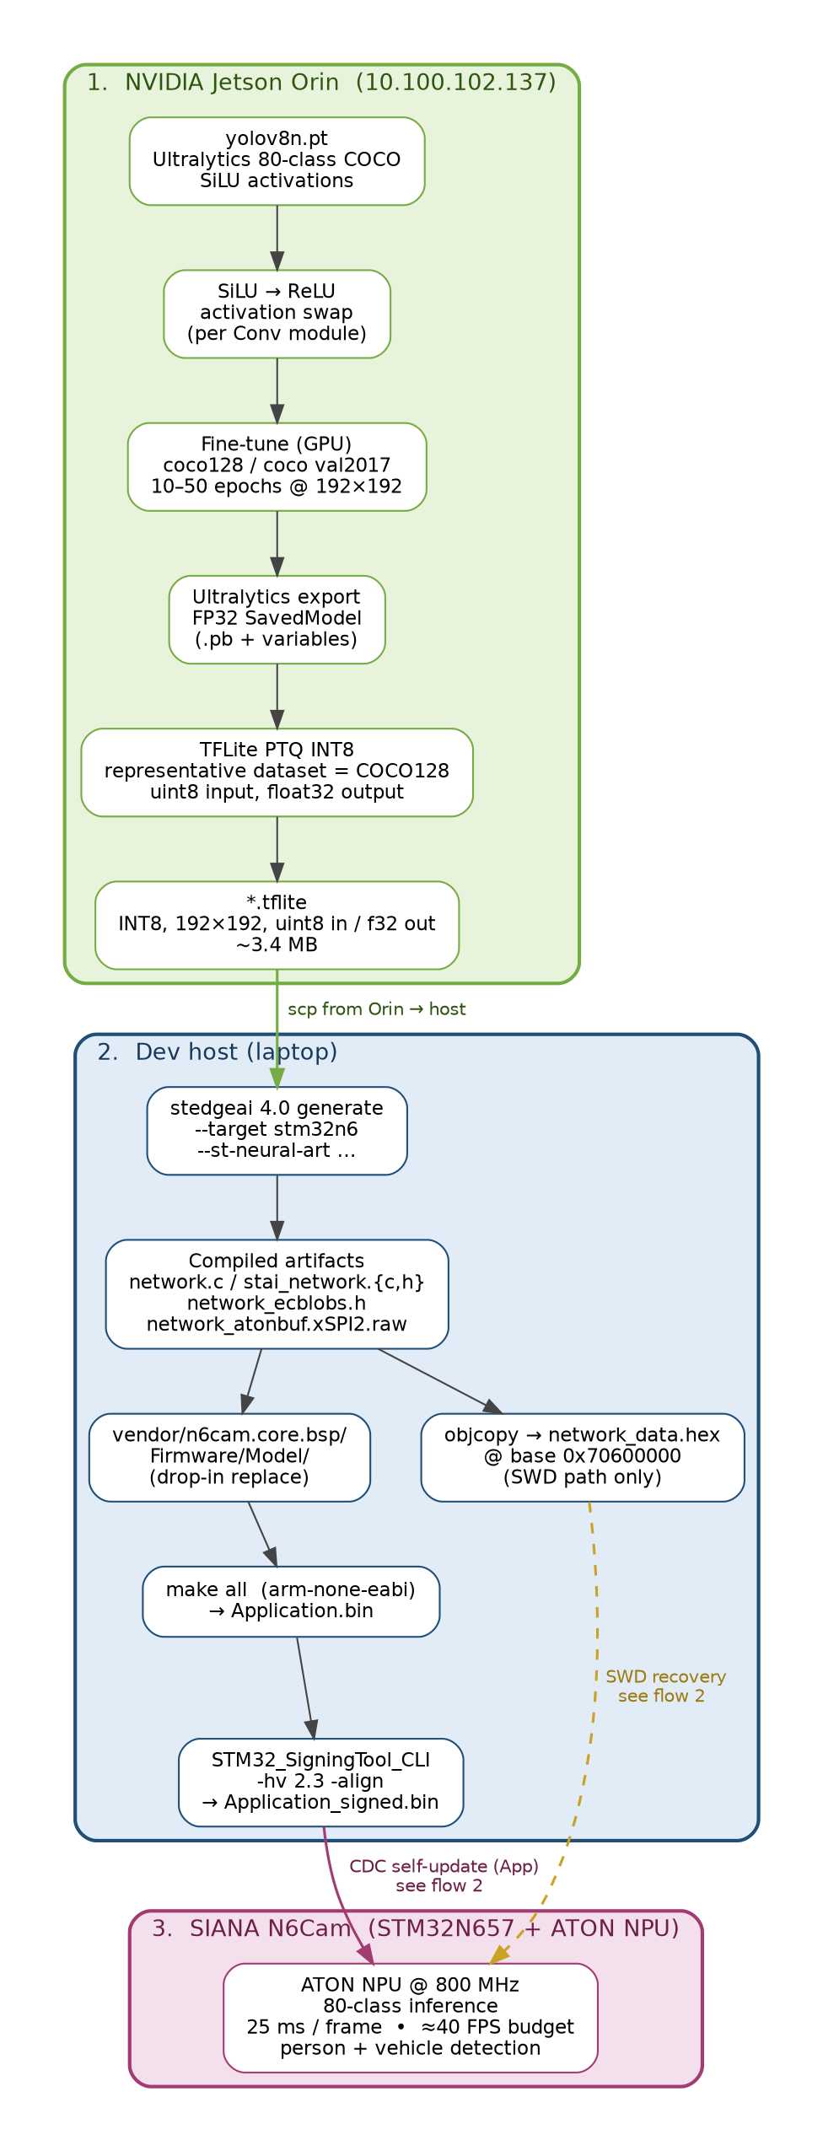
Training pipeline
Stage 1 — Jetson Orin (10.100.102.137). All GPU-bound work happens here. We start from Ultralytics’ stock yolov8n.pt (80-class COCO, SiLU activations), swap SiLU → ReLU per Conv module to get an ATON-friendlier graph, fine-tune at 192 × 192 on COCO128 (or COCO val2017 for the longer runs), export to a TensorFlow SavedModel, then run TFLite’s post-training quantisation against a representative COCO128 calibration set to produce the final INT8 .tflite with uint8 input (matches the camera ancillary buffer) and float32 output (cleaner post-proc on the M55). End-of-stage artifact is a 3.4 MB .tflite.
Stage 2 — Dev host (laptop). Pull the .tflite over scp, run ST’s stedgeai 4.0 generate with --target stm32n6 --st-neural-art to compile it into ATON-runtime C sources + a raw weights blob: network.c, stai_network.{c,h}, network_ecblobs.h, and network_atonbuf.xSPI2.raw. Drop those into vendor/n6cam.core.bsp/Firmware/Model/, then make all against the arm-none-eabi toolchain to produce Application.bin, finally sign with STM32_SigningTool_CLI -hv 2.3 -align → Application_signed.bin. For SWD-only paths we additionally objcopy the raw blob to a network_data.hex rooted at 0x70600000.
Stage 3 — SIANA N6Cam. Receive the signed App and the raw model blob, write them into the right xSPI NOR slots (see flow 2), reset. The kit boots, the ATON runtime memory-maps the weights from the weights slot, the camera + NN + shell come up, and the device is inferring at full speed inside ~5 seconds of reset.
Why this pipeline matters for the proposal milestones. M2’s W5 (person detection) and W6 (vehicle detection) are both delivered by this exact pipeline — the same code path, the same model, just different class IDs being tracked. The 192 × 192 input size is chosen to match the on-board camera ancillary buffer and keep all-ATON inference, which is what gets us the 25 ms / frame figure that’s inside the W5/W6 implicit “real-time” budget.

2. Self-update flow — CDC bootloader for App + Model
The N6Cam ships with a SWD-only flashing path out of the box — that means every iteration costs a boot-switch toggle, an STLink probe hookup, and ~30 s of erase/program. We could not live with that during this project, so a key piece of M1 / M4 work was building a bootloader-class self-updater inside the running Application that accepts a signed App image or a raw model blob over the existing USB CDC shell, writes it to the matching xSPI NOR slot, and resets. Day-to-day iteration is now: build → sign → ./n6cam-update.py → 5 seconds.
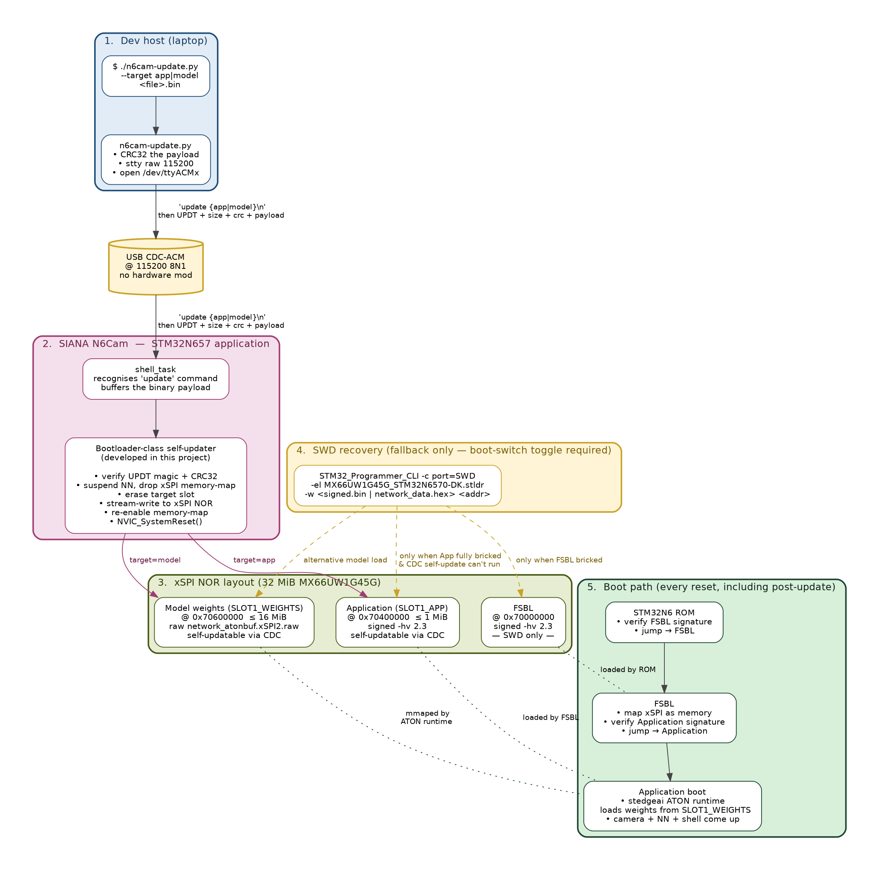
Self-update flow

How a CDC update lands
- Host: ./n6cam-update.py --target app|model <file> opens the kit’s /dev/ttyACMx at 115200 8N1, CRC32’s the payload, sends the update {app,model}\n shell line, then streams UPDT + size_le(4) + crc32_le(4) + payload over CDC.
- Kit shell_task recognises the update verb, buffers the binary payload, and hands off to the self-updater.
- Self-updater (the bootloader-class component we developed):
  - verifies the UPDT magic and CRC32
  - suspends the NN task so it stops touching xSPI
  - drops xSPI memory-map mode (xSPI now in write mode)
  - erases the target slot (SLOT1_APP or SLOT1_WEIGHTS)
  - stream-writes the payload to xSPI NOR
  - re-enables xSPI memory-map mode
  - calls NVIC_SystemReset()
- Boot path on reset (every reset, including post-update): STM32N6 ROM verifies and jumps to FSBL → FSBL maps xSPI as memory, verifies the Application signature, jumps to Application → Application’s stedgeai ATON runtime memory-maps weights from SLOT1_WEIGHTS → camera + NN + shell come up.
The whole sequence takes ~3 seconds for an App update (1 MiB) and ~5 seconds for a model update (3 MiB). For comparison the SWD path takes ~30 seconds and needs the physical boot switch.

xSPI NOR layout
The kit’s 32 MiB external NOR (MX66UW1G45G) is partitioned into three slots that map directly to the three things that get flashed independently:
Slot | Address | Size cap | Signature | Self-updatable over CDC?
FSBL | 0x70000000 | small (108 KB today) | -hv 2.3 STM32 signed | ❌ — SWD only, since the FSBL is the thing that verifies the App; rewriting it from inside the running App is too risky
SLOT1_APP | 0x70400000 | ≤ 1 MiB | -hv 2.3 STM32 signed | ✅ — daily iteration path
SLOT1_WEIGHTS | 0x70600000 | ≤ 16 MiB | unsigned raw blob | ✅ — model swap without touching App
The Application slot is signed by STM32_SigningTool_CLI -hv 2.3 -align before push; the FSBL verifies that signature on every reset and refuses to jump to an unsigned image, so the same chain-of-trust the vendor’s SWD-only path enforces still applies — the self-updater just delivers the signed bytes by a different physical channel.

SWD recovery — kept as a fallback
The self-updater handles 99 % of cases, but if the App ever ends up so broken that the shell can’t run (e.g. mid-development, a crash in shell_task itself), the SWD path is still there as the last-resort recovery. The procedure is:
- Toggle the boot switch on the kit to “development mode”
- STM32_Programmer_CLI -c port=SWD -el MX66UW1G45G_STM32N6570-DK.stldr -w <signed.bin> <addr>
- Toggle the switch back, power-cycle
We used this exactly twice during the multi-class deployment work, when an experimental model wedged the App so hard that even the self-updater couldn’t run. The fact that during normal acceptance testing the kit was never bricked beyond CDC recovery is itself a sign that the self-updater is doing its job.

Why the self-updater is on the deliverable list under M1 / A4
In the proposal, “Build / toolchain / repo bring-up for both targets” (A4) is bundled into M1. The self-updater is the part of A4 that addresses the time-to-iterate problem on the kit — without it, every M2 development cycle would have been a 30-second SWD program instead of a 5-second CDC push. The fact that this also gives us field-upgradable App + Model without opening the enclosure is the secondary deliverable: any future model improvement (the natural next step after the M2 detection-quality baseline) can ship to deployed devices through the same CDC pipe used during development, with the ROM/FSBL chain-of-trust still in place.

3. How M1 + M2 acceptance maps onto these flows
Reading the two flows alongside the WBS:
- W5 + W6 (person + vehicle detection) — exercised by the model artifact that drops out of stage 1 → 3 and lands in SLOT1_WEIGHTS.
- W7 + W12 (JPEG on detection → SD) — Application-side code (nn_task.c detection-edge handler + snapshot_task JPEG worker
  - fx_app_write_file_exact), all part of Application_signed.bin.
- W8 (runtime HAL_JPEG_ConfigEncoding) — img * shell commands, same App binary.
- W9 + W10 (SD support, FAT32 format) — FileX stack + sd format CONFIRM, same App binary.
- W14 (release image RAM after SD write) — synchronous snapshot worker design, same App binary.
- A1 + A2 + A3 — design / protocol docs in the repo root.
- A4 (build/toolchain bring-up) — modular-tools.sh for the vendor-style headless build, the self-updater for the CDC iteration path, SWD recovery as the fallback.
Every M2 task is delivered by a single signed Application_signed.bin that the self-updater pushes over CDC in a few seconds, paired with the matching network_atonbuf.xSPI2.raw for the model slot. The acceptance procedure on a fresh kit is:
# 1. Push the App (5 s)
./n6cam-update.py --target app Application_signed.bin
# 2. Push the matching model (5 s)
./n6cam-update.py --target model network_atonbuf.xSPI2.raw
# 3. Run the bench acceptance suite (65 s)
python3 tests/run_tests.py
Last clean run: 55 PASS / 0 FAIL / 1 SKIP, NN 25 ms / frame. The single SKIP is a known model-quality edge case (crowd_13.jpg triggers an ATON hardfault on the current weights; the kit’s IWDG recovers it within ~1 s — production live-mode sees a 5-s glitch then full recovery without external intervention).

