CS541 Project 3: Textures +

Synopsis
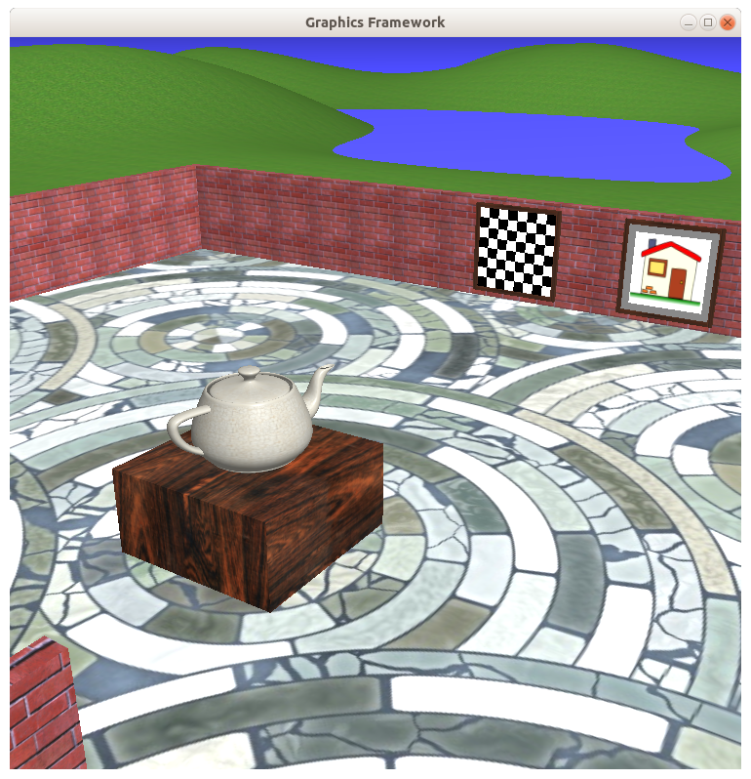An example result after adding textures to most surfaces.
Add textures to all surfaces in your growing application. You may use the textures I supplied with the framework, or better yet, express your artistic side by finding or creating your own textures.

Instructions
Place textures on all surface in the scene. You may use the textures I provide, but I think it's more fun if you find your own textures. The requirements are:
- Surface textures:
  - Texture coordinate functions: The size, position and orientation of all textures are sensible. This may entail scaling (e.g., to make the bricks look the correct size), rotation (e.g., to make the bricks horizontal), and translations (e.g., to center the house image).
  - Procedural texture: One of the textures (the left picture in the sample) must be a “procedural” texture; that is computed directly from the texture coordinates.
  - Conditional processing: One of the textures (the right picture in the sample) is produced via some slightly involved calculation. In this case, the outer 10% is a gray matte, and the inner portion is the texture scaled down to fit within that region.
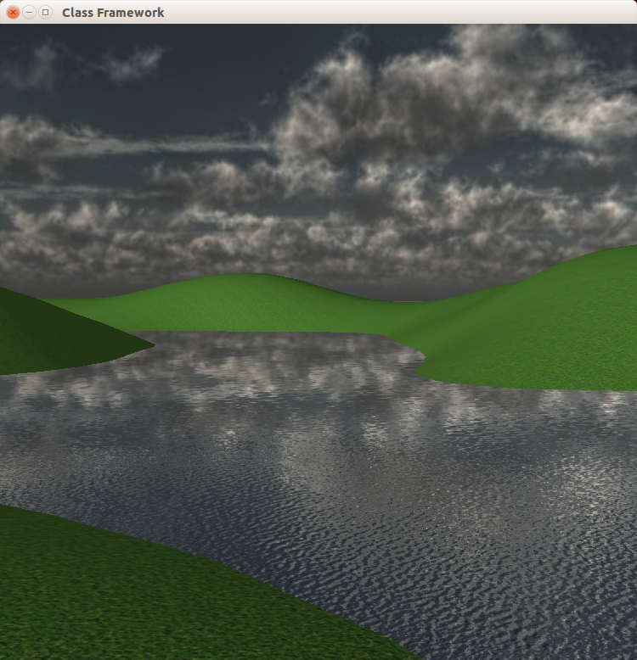Skydome, its reflection, and normal maps.
  - Beware: The texture coordinates on the wall are defined oddly – the brick pattern will be horizontal and way too large. You must rotate (or swizzle with texCoord.yx) to get the correct orientation, and scale the texture down by a large amount.
- Extra features:
  - Skydome: Add a sky-dome with a nice environment image to supply a visible environment around your scene. You may want to remove the rolling hills and sea plane so they don't conflict with the environment image.
  - Reflection of Skydome: Make shiny specular objects reflect the skydome, including water, and the project 3 reflective teapot.
  - Normal Map: Add 3D detail to a surface by using a normal map to modify the surface normal just before using it for the lighting calculation.
  - Warning: This part of the project often fails to run correctly on integrated graphics cards due to a driver bug. Use a better graphics card. Many laptops have both, with some way to explicitly target the non-integrated card.

Framework
Here are instructions, in three steps, for modifying the framework to
- read in each texture
- associate each texture with its object, and
- make each texture available for use in the fragment shader

1. Read each texture
In scene.cpp, near the line “// @@ This is where you could read in all the textures”, create and read each texture like this:
Texture* teapotTexture = new Texture("textures/cracks.png");

2. Associate each texture with an object
In scene.cpp, find the creation of each object, for instance
teapot = new Object(TeapotPolygons, teapotId, brassColor, brightSpec, 120);
and add the object’s texture as a new parameter
teapot = new Object(… 120, teapotTexture);

In object.h and object.cpp, modify the class Object with a new member variable
Texture* texture;
and modify the class Object constructor to receive that new Texture* parameter and store the value in the new member variable. The constructor should provide a NULL default value for objects that don’t specify a texture.

3. Make each texture available in the fragment shader
In object.cpp, find the Object::Draw() method, and find its draw command
shape→DrawVAO();
Before that drawVAO, check if the object has a non-null texture in the new member variable, and if so, follow the instructions in the Flow of data table (below) to load and activate that texture and tell the fragment shader about it.

To submit
Use Moodle to submit your project via an assignment link on the class web page. Be sure your submitted zip file contains all source code, the vcxproj file, all shader code, and any NEW textures you use.

Skydome Instructions
A sky dome is nothing more than a large sphere drawn around your scene's geometry with a texture map wrapped around it.
- Create a sphere and add it to the drawlist with a large scale.
sky = new Object(SpherePolygons, skyId, ...);
objectRoot->add(sky, Scale(2000.0, 2000.0, 2000.0));
- Read in a sky texture and add it to the sky object.
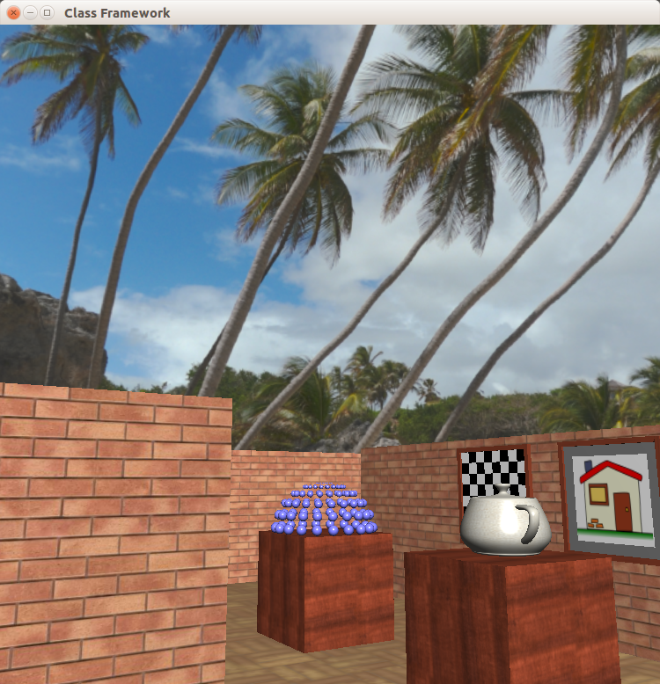
- In the fragment shader, when the mode indicates the skydome is being drawn, calculate a texture coordinate from the view direction V,
vec2(-atan(V.y,V.x)/(2*pi), acos(V.z)/pi);
Use this to access the sky texture and output the color directly to the screen. (No lighting calculation is necessary.)
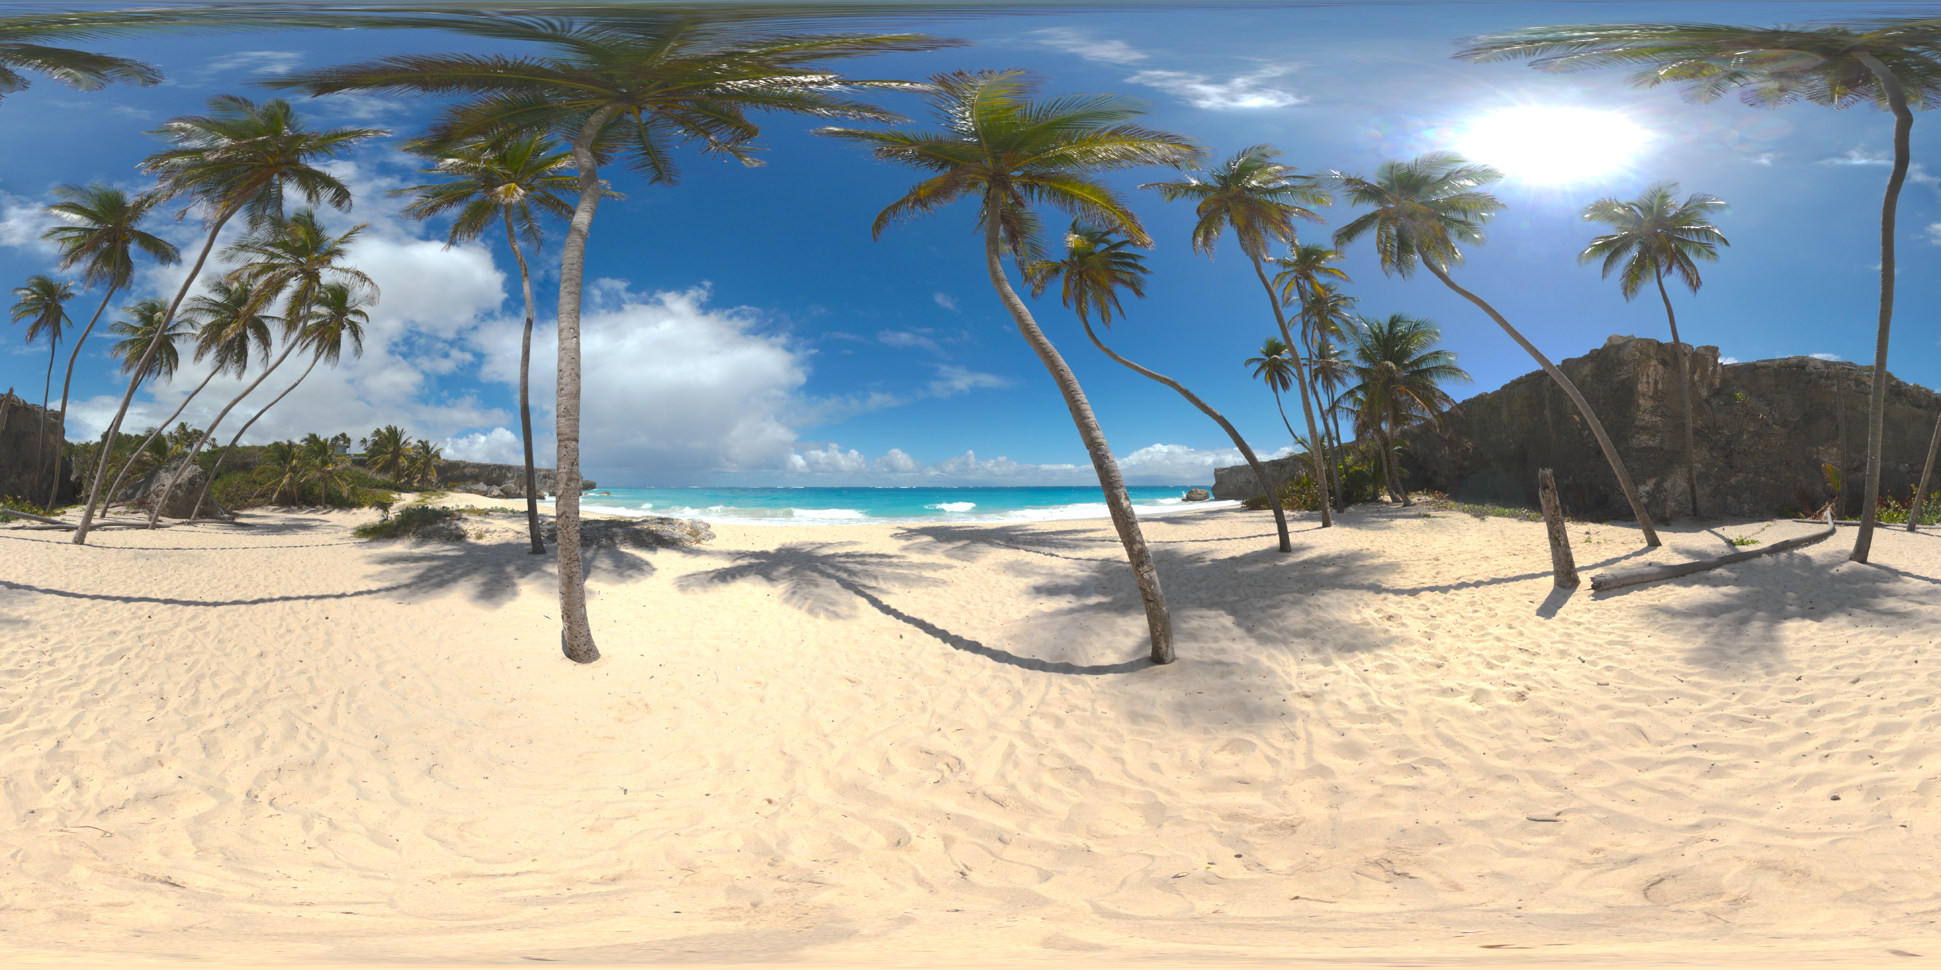
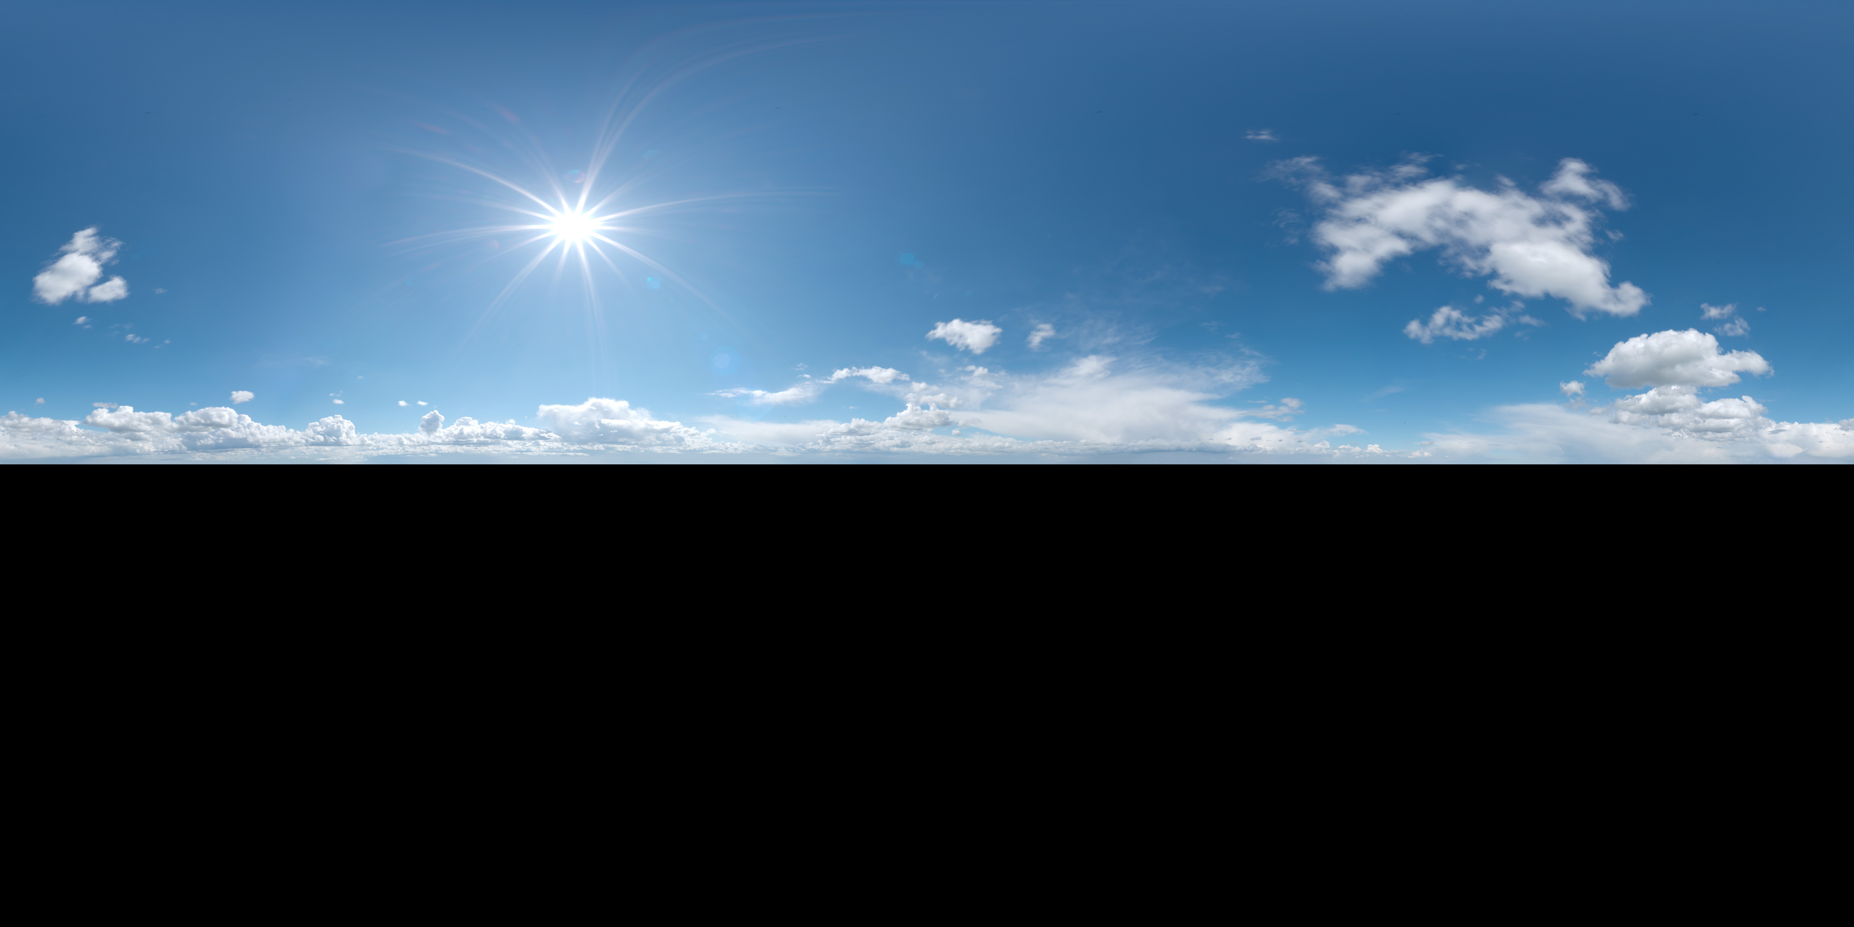
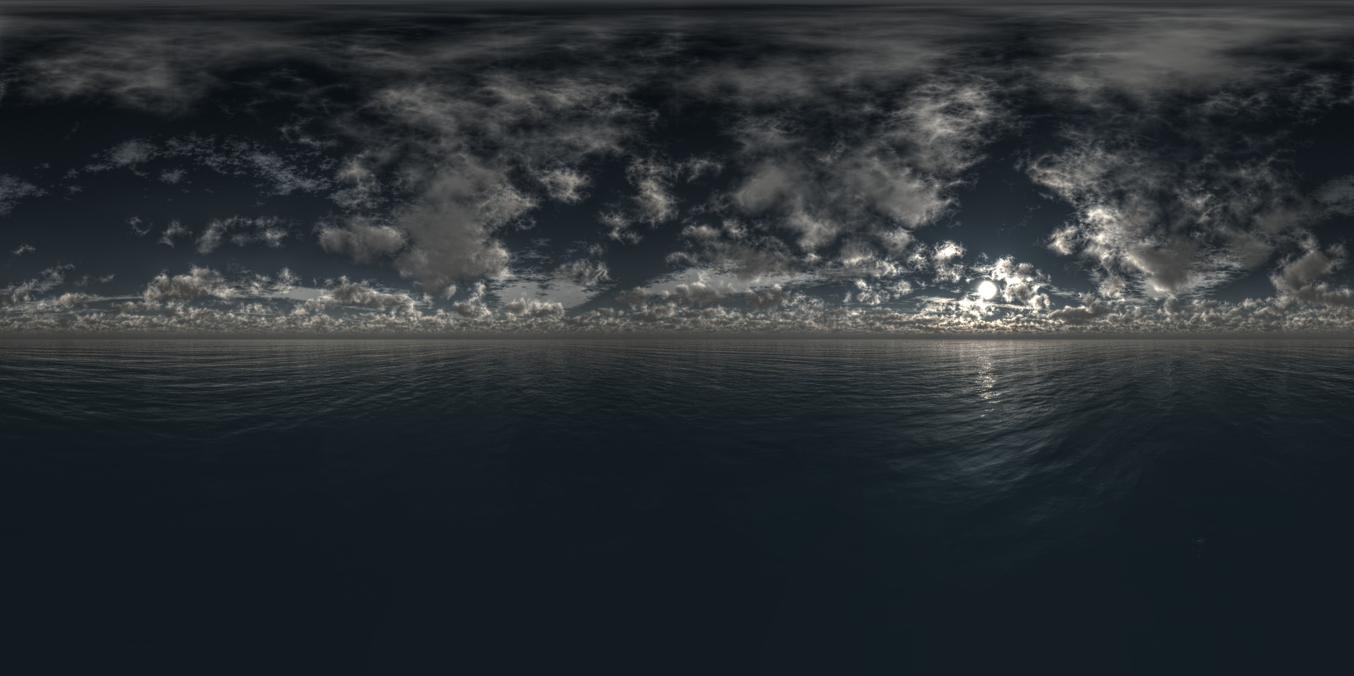

Reflection of Sky Dome

Reflective objects like the water surface should reflect the environment provided by the sky dome. As an easy approximation, assume water has no color of its own, but merely reflects the sky.
- Calculate the direction from which the reflections would come by reflecting the view vector across the normal .
- Make sure that any normal map manipulation of the normal is done before this calculation to incorporate the ripple pattern into above reflection direction.
- Calculate a UV with the equation from above (the skydome section), but use R instead of V.
vec2(-atan(R.y,R.x)/(2*pi), acos(R.z)/pi);
- Read the skydome texture at that uv, and return that color. No lighting calculation needs to be done here as the brightness of the reflection is independent of any other source of light.

Normal Maps
A normal map is a texture whose RGB components are used to make small local modifications to the normal of a surface just before doing the lighting calculation.
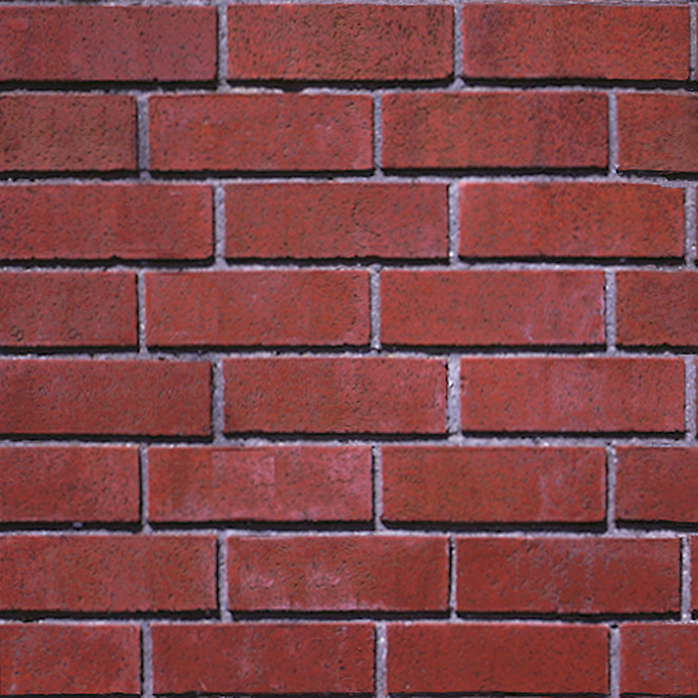
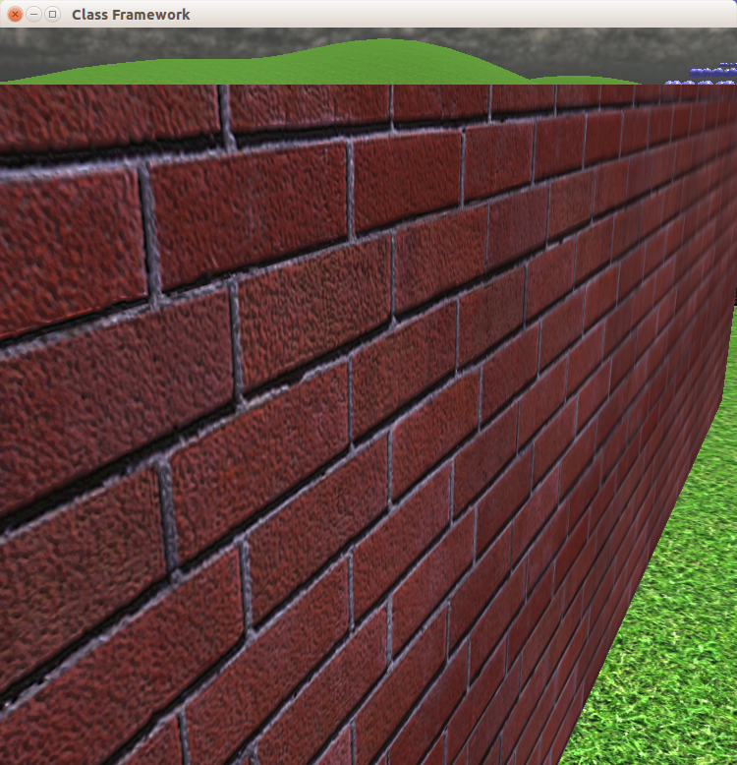
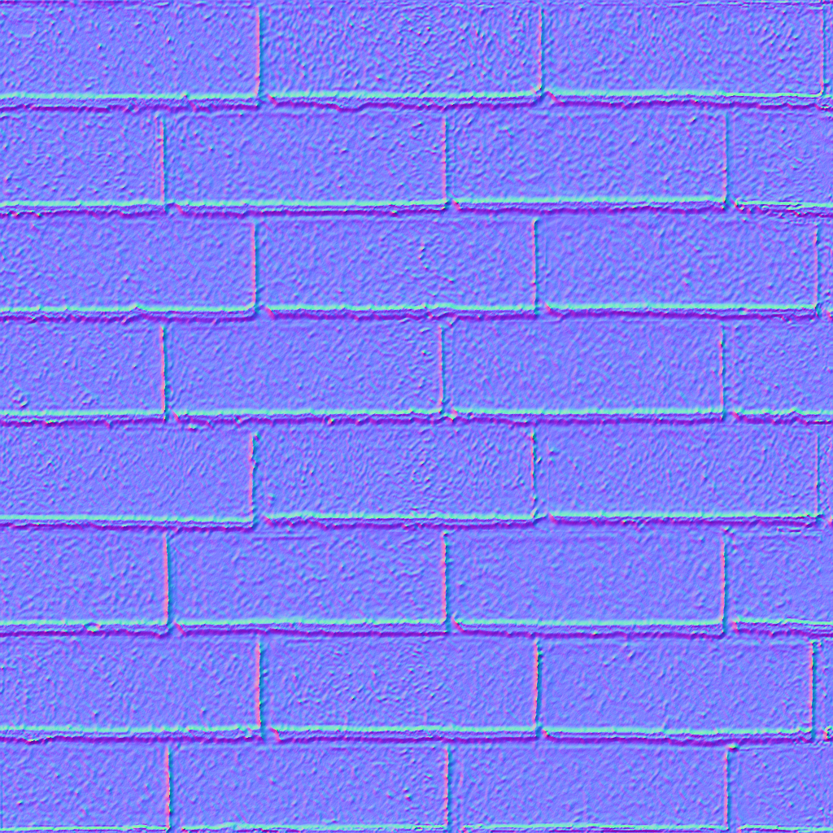

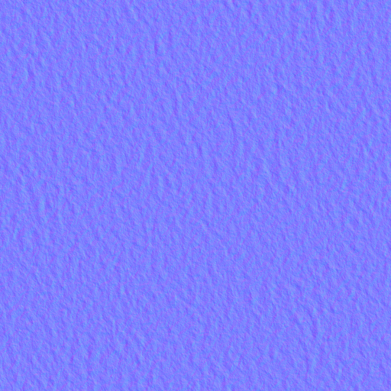

The vertex shader:
in vec3 vertexTangent; // Supplied by the application
out vec3 tanVec; // A name of your choice
tanVec = mat3(ModelTr)*vertexTangent; // Proper way to transform a VECTOR

The pixel shader:
- Read the normal map (and the color map it it exists) at the specified texture coordinates
vec3 delta = texture(normapMap, uv).xyz
- Convert it from 0..1 range to -1...1 range
delta = delta*2.0 – vec3(1,1,1)
- Create three perpendicular vectors (all normalized to unit length of course)
N // Normal vector
T = normalize(tanVec)
B = normalize(cross(T,N))
- And modify the normal according to the texture values read in:
N = delta.x*T + delta.y*B + delta.z*N
- Calculate lighting as usual with this modified N.

Flow of data for Texture Maps
The application reads a texture at startup time and sends it to the graphics card, keeping a small integer identifier to refer to it. Then at runtime it loads the texture into a texture unit, draws the geometry that should receive the texture, and finishes by unloading the texture. The load/draw/unload actions are repeated for each object and its texture.

The vertex shader passes the per-vertex texture coordinates through to per-pixel texture coordinates with a single assignment.

The fragment (pixel) shader receives a texture (in uniform sampler2D tex) and a pixel's texture coordinate (in in vec2 texCoord), processes the texture coordinate if necessary, looks up the texture color (by calling texture(...)), and uses the color as the surface color in the lighting calculation.

 | Application | Shaders
Startup | For each texture to be read do, for example:  Texture* teapotTexture = new Texture("textures/cracks.png");  // See file texture.cpp for the following code.  #define STB_IMAGE_IMPLEMENTATION  #define STBI_FAILURE_USERMSG  #include "stb_image.h"  Texture::Texture(const std::string &path) : textureId(0)  {  stbi_set_flip_vertically_on_load(true);  image = stbi_load(path.c_str(), &width, &height, &depth, 4);  printf("%d %d %d %s\n", depth, width, height, path.c_str());  if (!image) {  printf("\nRead error on file %s:\n %s\n\n", path.c_str(), stbi_failure_reason());  exit(-1); }  glGenTextures(1, &textureId); // Get an integer id for this texture from OpenGL  glBindTexture(GL_TEXTURE_2D, textureId);  glTexImage2D(GL_TEXTURE_2D, 0, (GLint)GL_RGBA, width, height, 0,  GL_RGBA, GL_UNSIGNED_BYTE, image);  glTexParameteri(GL_TEXTURE_2D, GL_TEXTURE_MAX_LEVEL, 10);  glGenerateMipmap(GL_TEXTURE_2D);  glTexParameteri(GL_TEXTURE_2D, GL_TEXTURE_MAG_FILTER, (int)GL_LINEAR);  glTexParameteri(GL_TEXTURE_2D, GL_TEXTURE_MIN_FILTER,  (int)GL_LINEAR_MIPMAP_LINEAR);  glBindTexture(GL_TEXTURE_2D, 0);  stbi_image_free(image);  }
Runtime draw loop | To draw an object with a texture do, in Object::Draw:  int unit=?; // Choose any texture unit 0 … 15 ...  texture->BindTexture(unit, program->programId, "tex");  ...  shape→DrawVAO();  ...  texture->UnbindTexture(unit);  void Texture::BindTexture(const int unit, const int programId,  const std::string& name)  {  glActiveTexture((gl::GLenum)((int)GL_TEXTURE0 + unit));  glBindTexture(GL_TEXTURE_2D, textureId);  int loc = glGetUniformLocation(programId, name.c_str());  glUniform1i(loc, unit);  }  void Texture::UnbindTexture(const int unit)  {  glActiveTexture((gl::GLenum)((int)GL_TEXTURE0 + unit));  glBindTexture(GL_TEXTURE_2D, 0);  } | Vertex shader:  in vec2 vertexTexture;  out vec2 texCoord;  texCoord = vertexTexture;  Fragment Shader:  in vec2 texCoord;  uniform sampler2D tex;  vec2 uv = ...  vec4 color = texture(tex, uv);  // Use color in lighting ...

Grading Rubric
Don’t break the framework:
Scene navigation functionality still works | 5%
Light moving functionality still works | 5%
Shadows and reflections still work. | 10%
Textures on all surfaces | 20%
Textures ca be sensible or whimsical, but must be scaled and oriented sensibly.
Skydome | 20%
Skydome must be accessed and displayed so as to look like an environment around the scene, and not an image painted on a sphere.
Reflection of Skydome | 20%
Reflective surfaces must reflect the skydome at any position not displaying other scene geometry.
Normal maps | 20%
The water and at least one other surface must display surface detail coming from a normal map.
Normal maps are provided for brick wall, wooden box, tile floor, and ripples on water.
Normal map and color texture must align with each other, and both scaled and oriented sensibly.

