Concrete Compressive Strength Prediction
Using Linear Regression
Artificial Intelligence and Machine Learning — Experiential Learning
20 Marks | CO2 and CO3

1. Objective
The objective of this project is to explore a real-world dataset of concrete mixtures, perform exploratory data analysis (EDA), and build a Linear Regression model to predict the compressive strength of concrete based on its ingredients and age.

2. Dataset Description
The dataset used is the Concrete Compressive Strength dataset from the UCI Machine Learning Repository (ID: 165), originally donated by Prof. I-Cheng Yeh (1998). The dataset contains 1,030 samples of concrete with 8 input features and 1 target variable.
Source: https://archive.ics.uci.edu/dataset/165/concrete+compressive+strength

Input Variables and Target
# | Variable | Unit
1 | Cement | kg/m³
2 | Blast Furnace Slag | kg/m³
3 | Fly Ash | kg/m³
4 | Water | kg/m³
5 | Superplasticizer | kg/m³
6 | Coarse Aggregate | kg/m³
7 | Fine Aggregate | kg/m³
8 | Age | days
Target | Concrete Compressive Strength | MPa

3. Data Cleaning and Exploration (Question 1 — CO2)

Missing Values
The dataset contains zero missing values across all 9 columns (1,030 records × 9 columns). No imputation or deletion was needed for missing data.

Duplicate Records
A total of 25 duplicate records were identified — rows where all column values are identical to a previous row. These duplicates were removed to prevent the same data point from appearing in both training and testing sets, which would inflate model performance. After removing duplicates, the cleaned dataset contains 1,005 records.

Descriptive Statistics (Selected Variables)
Variable | Mean | Std Dev | Min | Max
Cement (kg/m³) | 278.63 | 104.34 | 102.00 | 540.00
Water (kg/m³) | 181.49 | 21.24 | 121.75 | 247.00
Age (days) | 45.86 | 63.73 | 1 | 365
Strength (MPa) | 35.25 | 16.28 | 2.33 | 82.60

Scatter Plot: Cement Content vs. Compressive Strength
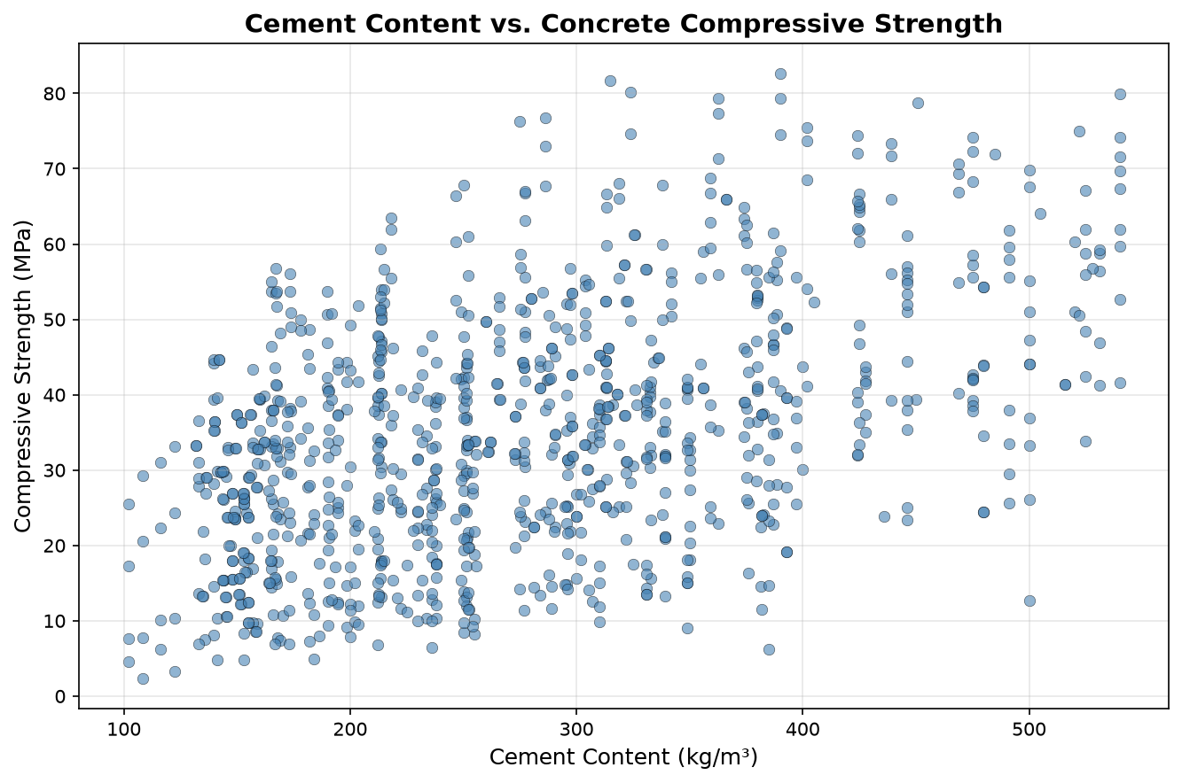
Figure 1: Cement Content (kg/m³) vs. Compressive Strength (MPa)

Observations
- Positive trend between Cement and Strength: The scatter plot shows a general upward trend — as cement content increases, compressive strength tends to increase. This is consistent with civil engineering knowledge, as cement is the primary binding agent. However, for any given cement content, strength varies widely due to the influence of other ingredients and curing age.
- Wide range of strength values: Compressive strength ranges from 2.33 MPa to 82.60 MPa, with a mean of 35.25 MPa and a standard deviation of 16.28 MPa. The standard deviation is nearly half the mean, indicating high variability. This confirms that multiple features (not just cement alone) are needed to predict strength accurately.

4. Linear Regression Model (Question 2 — CO3)

Methodology
Linear Regression is a supervised machine learning algorithm that finds the best linear relationship between input features and a continuous target variable. It learns a coefficient (weight) for each feature and an intercept, minimising the sum of squared errors between predicted and actual values.
The dataset was split into 80% training data (804 records) and 20% testing data (201 records) using scikit-learn's train_test_split function with random_state=42 for reproducibility. The model was trained exclusively on the training set, and evaluated on the unseen test set to ensure no data leakage.

Actual vs. Predicted Strength (Five Test Records)
Test Record | Actual (MPa) | Predicted (MPa) | Absolute Error (MPa)
1 | 19.01 | 23.46 | 4.45
2 | 24.29 | 16.70 | 7.59
3 | 26.32 | 22.45 | 3.87
4 | 34.57 | 37.40 | 2.83
5 | 44.13 | 42.89 | 1.24

Model Performance
Mean Absolute Error (MAE): 8.90 MPa
On average, the model's predictions differ from the actual compressive strength by approximately 8.90 MPa. Given that the test set strength values range from about 2 to 83 MPa, this indicates that the model captures the general trend but cannot precisely predict individual samples. The MAE is the average of all absolute differences between predicted and actual values.
R² Score: 0.5802 — The model explains approximately 58.0% of the variance in compressive strength. The remaining 42% is due to non-linear relationships not captured by Linear Regression.

Prediction for a New Concrete Mix
A new concrete mix was defined using plausible values within the observed dataset ranges:
Input Feature | Value
Cement | 300.0 kg/m³
Blast Furnace Slag | 100.0 kg/m³
Fly Ash | 50.0 kg/m³
Water | 180.0 kg/m³
Superplasticizer | 6.0 kg/m³
Coarse Aggregate | 1000.0 kg/m³
Fine Aggregate | 750.0 kg/m³
Age | 28 days

Predicted Compressive Strength: 38.09 MPa
This is a model estimate, not a laboratory measurement. The predicted strength of 38.09 MPa is within the normal range for a concrete mix with 300 kg/m³ cement, moderate supplementary materials, and tested at 28 days. The actual strength in a real test may differ.

Limitation
Linear Regression assumes that each input feature has a constant, additive effect on the target. In reality, concrete behaviour is non-linear — for instance, strength gain with age follows a logarithmic curve, and the effect of water depends on the water-to-cement ratio rather than the water content alone. Interaction effects between ingredients are also not captured. Non-linear models such as Random Forests or Neural Networks would likely achieve better accuracy.

5. Conclusion
This project demonstrated the complete machine learning workflow — from data acquisition and exploratory analysis to model training and evaluation. The UCI Concrete Compressive Strength dataset (1,030 records) was analysed, cleaned (25 duplicates removed), and used to train a Linear Regression model with an 80:20 train-test split. The model achieved a test MAE of 8.90 MPa and an R² of 0.58, confirming that Linear Regression provides a reasonable baseline but is limited by the non-linear nature of concrete strength. The model successfully predicted a strength of 38.09 MPa for a new concrete mix, demonstrating its practical applicability as a first approximation.

