Cluster Deployment Process for EETeamJ1

Prepare the Environment

To deploy our Cluster using Ambari there are few Pre-requisite which needs to be followed before starting Ambari installation:

- Set up Password-less SSH
- Set up Service User Accounts Enable NTP on the Cluster

- Check DNS

- Configure iptables

- Disable SELinux, PackageKit and Check umask Value

Set Up Password-less SSH

To have Ambari Server automatically install Ambari Agents on all your cluster hosts, you must set up password-less SSH connections between the Ambari Server host and all other hosts in the cluster. The Ambari Server host uses SSH public key authentication to remotely access and install the Ambari Agent.

Note : You can choose to manually install the Agents on each cluster host. In this case, you do not need to generate and distribute SSH keys.

- Generate public and private SSH keys on the Ambari Server host. ssh-keygen

- Copy the SSH Public Key (id_rsa.pub) to the root account on your target hosts.

.ssh/id_rsa
.ssh/id_rsa.pub

- Add the SSH Public Key to the authorized_keys file on your target hosts. cat id_rsa.pub >> authorized_keys Depending on your version of SSH, you may need to set permissions on the .ssh directory (to 700) and the authorized_keys file in that directory (to 600) on the target hosts
chmod 700 ~/.ssh
chmod 600 ~/.ssh/authorized_keys

- From the Ambari Server, make sure you can connect to each host in the cluster using SSH, without having to enter a password. ssh root@<remote.target.host> where <remote.target.host> has the value of each host name in your cluster.

- If the following warning message displays during your first connection: Are you sure you want to continue connecting (yes/no)? Enter Yes.

- Retain a copy of the SSH Private Key on the machine from which you will run the web-based Ambari Install Wizard.

Note: It is possible to use a non-root SSH account, if that account can execute sudo without entering a password.

Enable NTP on the Cluster and on the Browser Host

The clocks of all the nodes in your cluster and the machine that runs the browser through which you access the Ambari Web interface must be able to synchronize with each other.

To check that the NTP service will be automatically started upon boot, run the following command on each host:

Run the following command on all servers

apt-get install ntp

Check DNS

All hosts in your system must be configured for both forward and and reverse DNS.

If you are unable to configure DNS in this way, you should edit the /etc/hosts file on every host in your cluster to contain the IP address and Fully Qualified Domain Name of each of your hosts. The following instructions are provided as an overview and cover a basic network setup for generic.

Linux hosts. Different versions and flavors of Linux might require slightly different commands and procedures. Please refer to the documentation for the operating system(s) deployed in your environment

Edit the Host File

- Using a text editor, open the hosts file on every host in your cluster. For example: vi /etc/hosts

- Add a line for each host in your cluster. The line should consist of the IP address and the FQDN. For example:

1.2.3.4 <fully.qualified.domain.name>

Important

Do not remove the following two lines from your hosts file. Removing or editing the following lines may cause various programs that require network functionality to fail.

127.0.0.1 localhost.localdomain localhost ::1 localhost6.localdomain6 localhost6

Configuring iptables

For Ambari to communicate during setup with the hosts it deploys to and manages, certain ports must be open and available. The easiest way to do this is to temporarily disable iptables, as follows:

# sudo ufw disable

Note: You can restart iptables after setup is complete. If the security protocols in your environment prevent disabling iptables, you can proceed with iptables enabled, if all required ports are open and available.

Ambari checks whether iptables is running during the Ambari Server setup process. If iptables is running, a warning displays, reminding you to check that required ports are open and available. The Host Confirm step in the Cluster Install Wizard also issues a warning for each host that has iptables running.

Disable SELinux and PackageKit and check the umask Value. You must disable SELinux for the Ambari setup to function. On each host in your cluster,

setenforce 0

Note : PackageKit is not enabled by default on SLES or Ubuntu systems. Unless you have specifically enabled PackageKit, you may skip this step for a SLES or Ubuntu installation host.

UMASK (User Mask or User file creation MASK) sets the default permissions or base permissions granted when a new file or folder is created on a Linux machine. Most Linux distros set 022 as the default umask value. A umask value of 022 grants read, write, execute permissions of 755 for new files or folders. A umask value of 027 grants read, write, execute permissions of 750 for new files or folders. Ambari supports a umask value of 022 or 027. For example, to set the umask value to 022, run the following command as root on all hosts, vi /etc/profile then, append the following line: umask 022.

Just check the current umask value with umask command. If its set to 022 no need to change anything.

root@impetus-i0161:~# umask 0022

Check the Maximum Open File Descriptors

The recommended maximum number of open file descriptors is 10000, or more. To check the current value set for the maximum number of open file descriptors, execute the following shell commands on each host:

ulimit -Sn ulimit -Hn

If the output is not greater than 10000, run the following command to set it to a suitable default: ulimit -n 10000

Ubuntu 14

On a server host that has Internet access, use a command line editor to perform the following steps:

1. Log in to your host as root.

Download the Ambari repository file to a directory on your installation host.

wget -nv http://public-repo-1.hortonworks.com/ambari/ubuntu14/2.x/updates/2.2.2.0/ambari.list -O /etc/apt/sources.list.d/ambari.list

apt-key adv --recv-keys --keyserver keyserver.ubuntu.com B9733A7A07513CAD

apt-get update

Important : Do not modify the ambari.list file name. This file is expected to be available on the Ambari Server host during Agent registration.

- Confirm that Ambari packages downloaded successfully by checking the package name list. apt-cache showpkg ambari-server

apt-cache showpkg ambari-agent
apt-cache showpkg ambari-metrics-assembly

You should see the Ambari packages in the list.

- Install the Ambari bits. This also installs the default PostgreSQL Ambari database. apt-get install ambari-server

Note: When deploying HDP on a cluster having limited or no Internet access, you should provide access to the bits using an alternative method.

For more information about setting up local repositories, see Using a Local Repository.

Ambari Server by default uses an embedded PostgreSQL database. When you install the Ambari Server, the PostgreSQL packages and dependencies must be available for install. These packages are typically available as part of your Operating System repositories. Please confirm you have the appropriate repositories available for the postgresql-server packages.

Install Ambari Server

Before starting the Ambari Server, you must set up the Ambari Server. Setup configures Ambari to talk to the Ambari database, installs the JDK and allows you to customize the user account the Ambari Server daemon will run as. The ambari-server setup command manages the setup process. Run the following command on the Ambari server host to start the setup process. You may also append Setup Options to the command.

ambari-server setup

root@impetus-i0161:/etc/apt# ambari-server setup

Using python /usr/bin/python2.7

Setup ambari-server

Checking SELinux...

WARNING: Could not run /usr/sbin/sestatus: OK

By default, Ambari Server runs under root. Accept the default (n) at the Customize user account for ambari-server daemon prompt, to proceed as root. If you want to create a different user to run the Ambari Server, or to assign a previously created user, select y at the Customize user account for ambari-server daemon prompt, then provide a user name

Customize user account for ambari-server daemon [y/n] (n)? y

Enter user account for ambari-server daemon (root):

Adjusting ambari-server permissions and ownership...

Checking firewall status...

Checking JDK...

- Oracle JDK 1.8 + Java Cryptography Extension (JCE) Policy Files 8

- Oracle JDK 1.7 + Java Cryptography Extension (JCE) Policy Files 7

- Custom JDK

==============================================================================

Enter choice (1): 1

To download the Oracle JDK and the Java Cryptography Extension (JCE) Policy Files you must accept the license terms found at http://www.oracle.com/technetwork/java/javase/terms/license/index.html and not accepting will cancel the Ambari Server setup and you must install the JDK and JCE files manually.

Do you accept the Oracle Binary Code License Agreement [y/n] (y)? y

Downloading JDK from http://public-repo-1.hortonworks.com/ARTIFACTS/jdk-8u40-linux-x64.tar.gz to /var/lib/ambari-server/resources/jdk-8u40-linux-x64.tar.gz

jdk-8u40-linux-x64.tar.gz... 100% (165.2 MB of 165.2 MB)

Successfully downloaded JDK distribution to /var/lib/ambari-server/resources/jdk-8u40-linux-x64.tar.gz Installing JDK to /usr/jdk64/

Successfully installed JDK to /usr/jdk64/

Downloading JCE Policy archive from http://public-repo-1.hortonworks.com/ARTIFACTS/jce_policy-8.zip to /var/lib/ambari-server/resources/jce_policy-8.zip

Successfully downloaded JCE Policy archive to /var/lib/ambari-server/resources/jce_policy-8.zip

Installing JCE policy...

Completing setup...

Configuring database...

Enter advanced database configuration [y/n] (n)? y

Configuring database...

==============================================================================

Choose one of the following options: - PostgreSQL (Embedded)

- - Oracle

- - MySQL

- - PostgreSQL

- - Microsoft SQL Server (Tech Preview)

- - SQL Anywhere

==============================================================================
Enter choice (4): 1 Database name (ambari): Postgres schema (ambari): Username (ambari):

Enter Database Password (bigdata):

Default properties detected. Using built-in database. Configuring ambari database...

Checking PostgreSQL...

About to start PostgreSQL Configuring local database...
Connecting to local database...done. Configuring PostgreSQL...

Extracting system views...

.......

Adjusting ambari-server permissions and ownership...

Ambari Server 'setup' completed successfully.

Before starting ambari we need to edit few files for postgres to start successfully

Edit the file /etc/postgresql/9.3/main/pg_hba.conf to use MD5 authentication with the postgres user:

local all postgres md5
# "local" is for Unix domain socket connections only
local | all | all |  | peer
# IPv4 local connections:
host | all | all | 0.0.0.0/0 | md5
# IPv6 local connections:
host | all | all | ::1/128 | md5
# Allow replication connections from localhost, by a user with the

vi /etc/postgresql/9.4/main/postgresql.conf

Edit the above file and ensure the listen address is equal to ‘* ‘

listen_addresses = '*' # what IP address(es) to listen on;

After the above changes restart postgres

# service postgresql restart

Now let’s start the cluster deployment process

Ambari provides an end-to-end management and monitoring solution for your HDP cluster. Using the Ambari Web UI and REST APIs, you can deploy, operate, manage configuration changes, and monitor services for all nodes in your cluster from a central point.

After starting the Ambari service, open Ambari Web using a web browser and log In to Apache Ambari

Point your browser to http://172.26.60.16:8080 , where ambari server is installed Log in to the Ambari Server using the default user name/password: admin/admin.

From the Ambari Welcome page, choose Launch Install Wizard.
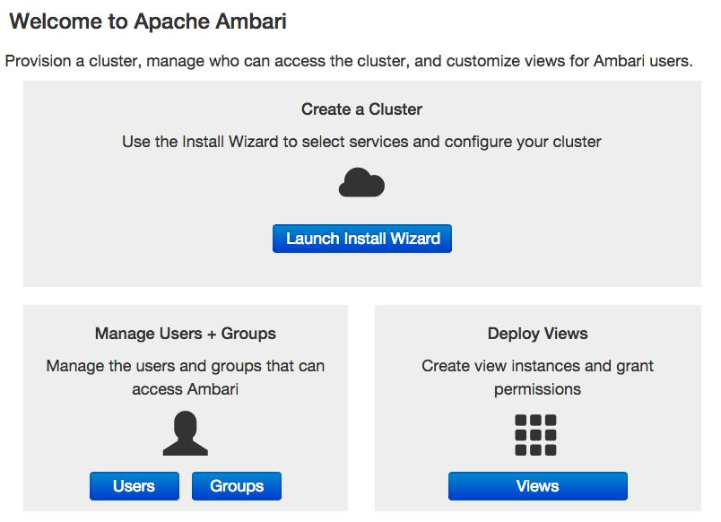

1. Give a name to the cluster

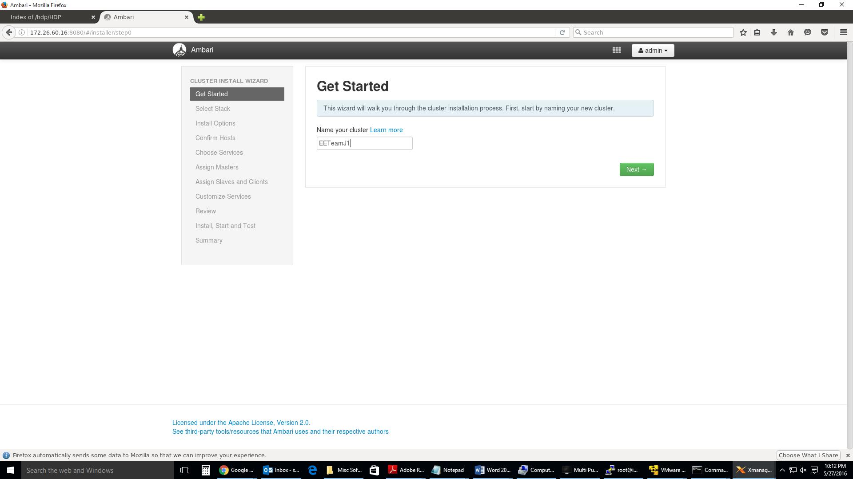

Select HDP stack version and manually enter the path of our local repository for Ubuntu 14 ( http://172.26.60.16/hdp )
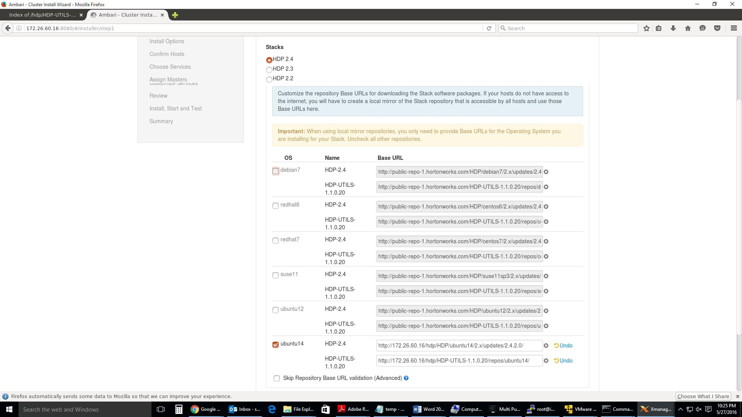

Enter the hostnames ( FQDN) of all box which will be part of our cluster and ftp or copy the id_rsa key for root which was created during the creation of password less ssh.
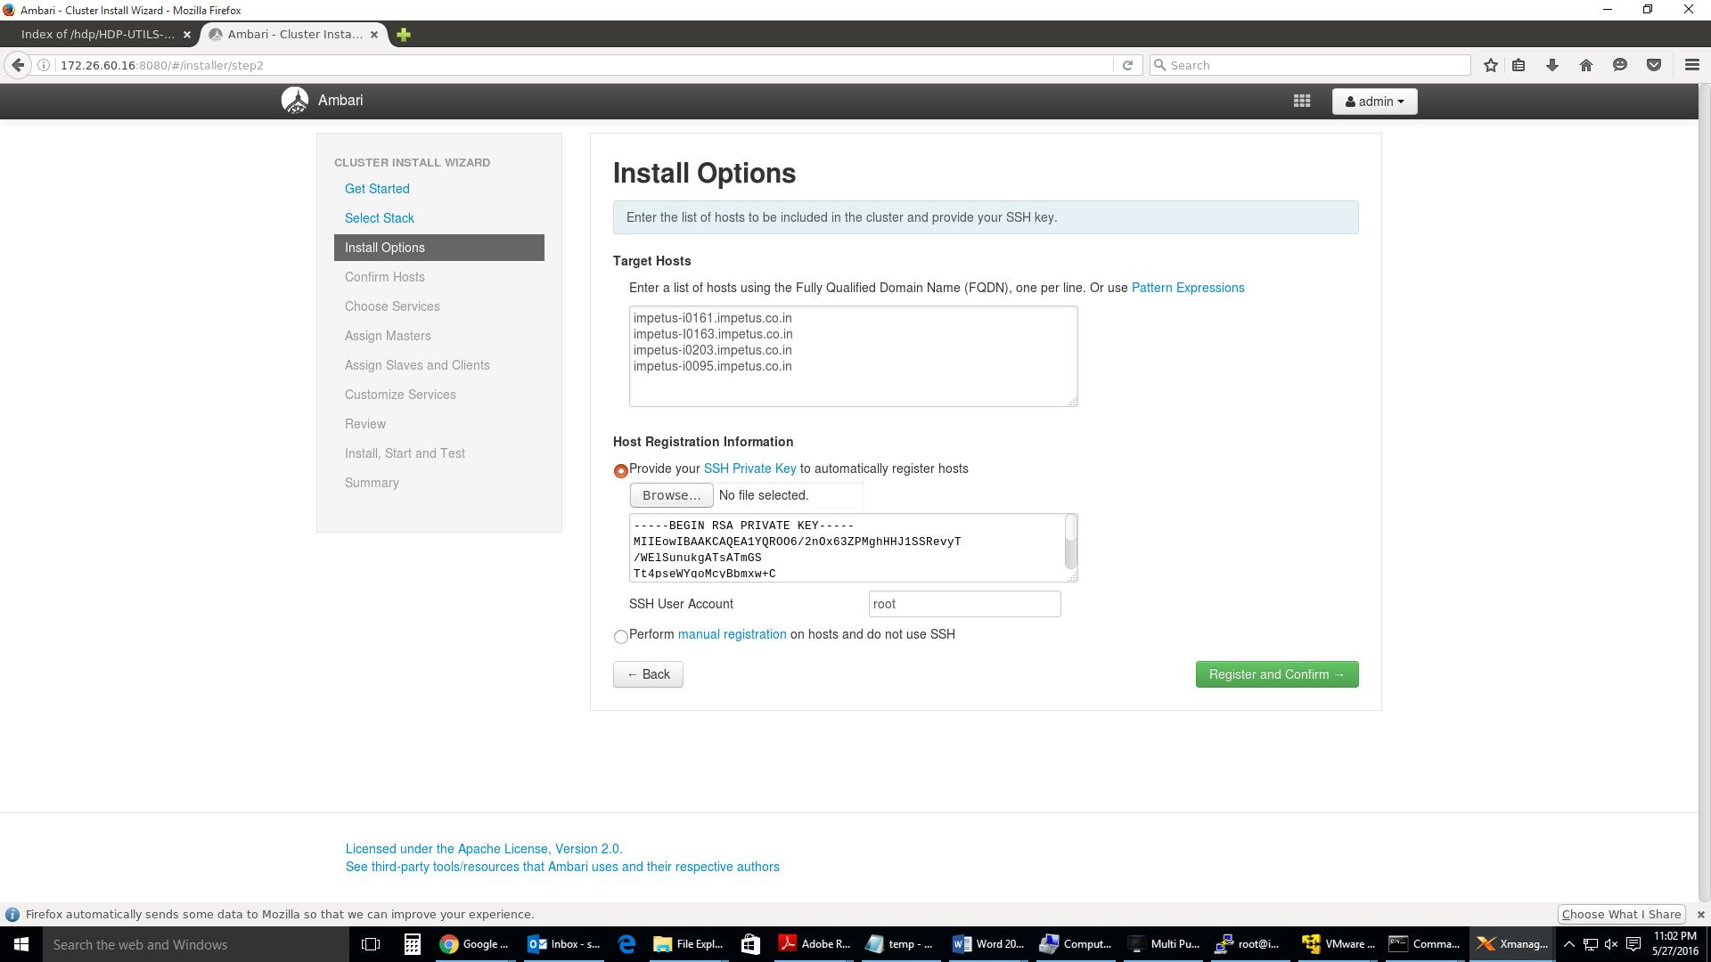
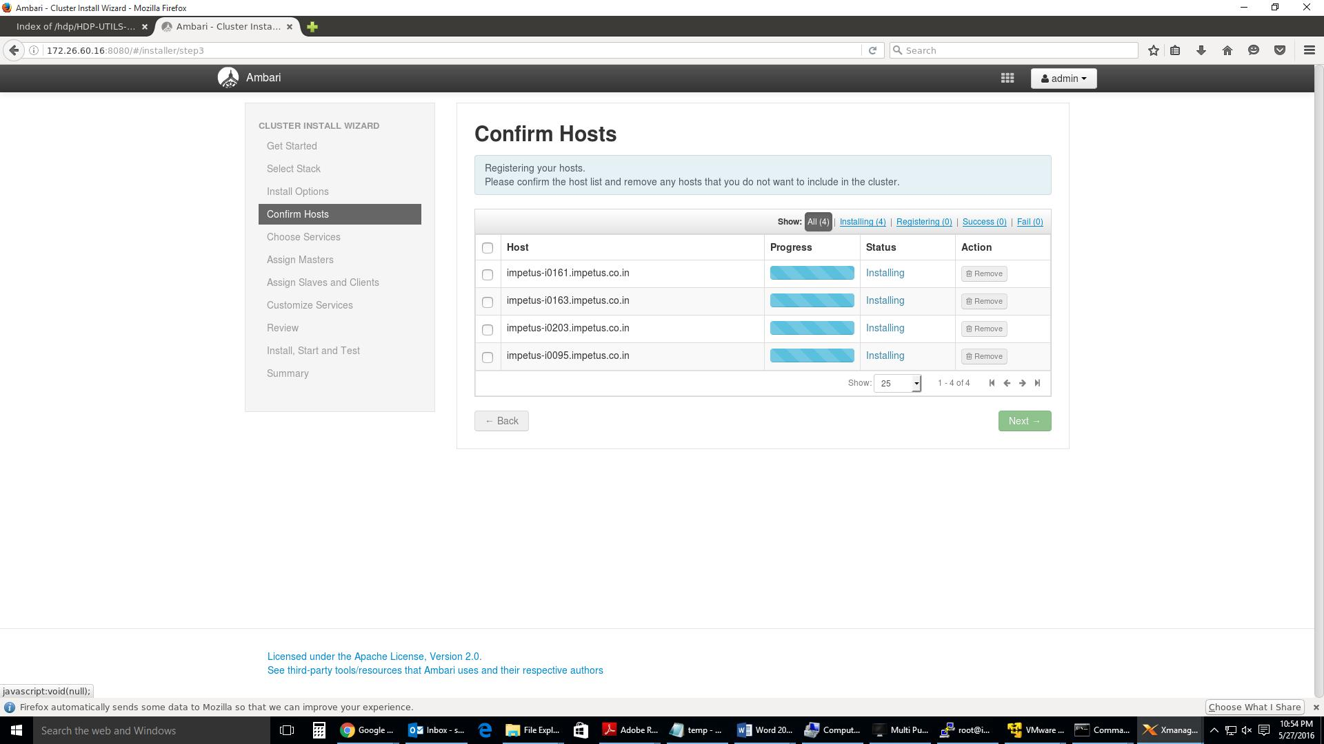
You might get issue multiple time for any one host or all… Check the error by clicking on the failed link and try to resolve errors mentioned.
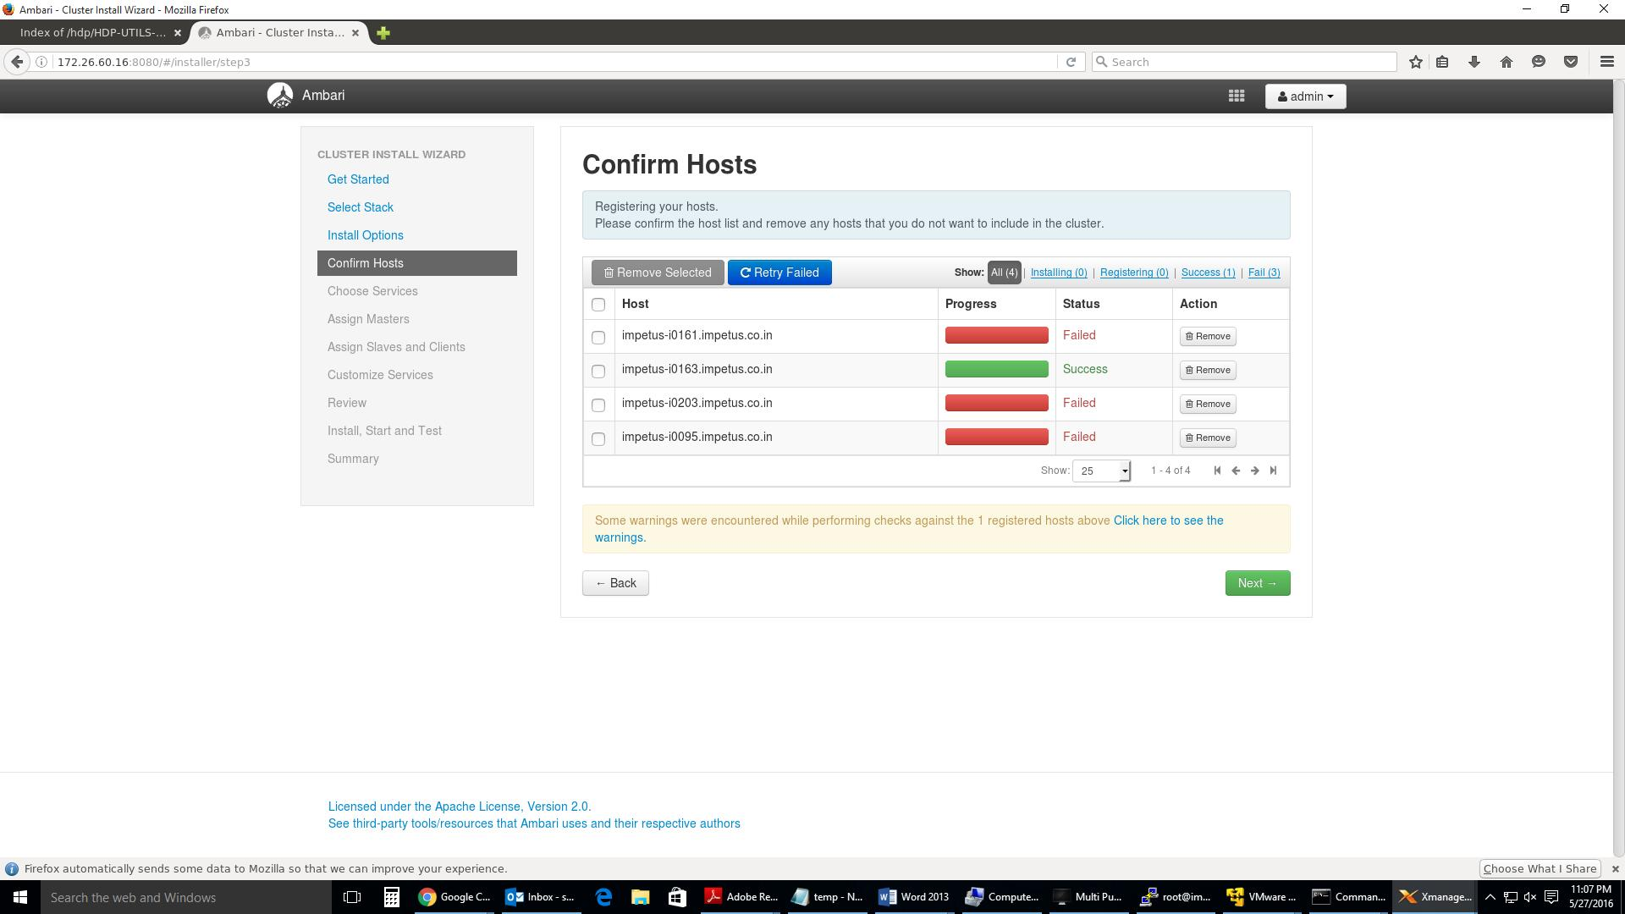
If you get this error “ Transperent Huge Pages Issue” then you can ignore this on Ubuntu 14 and continue.
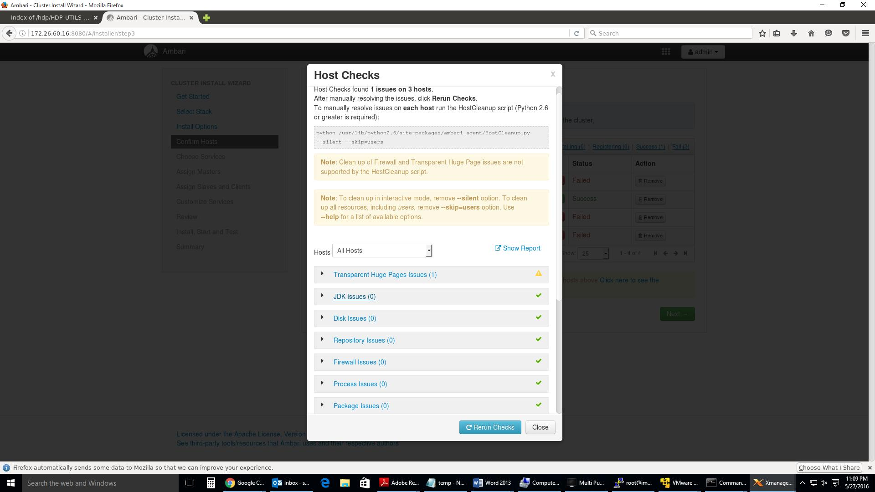
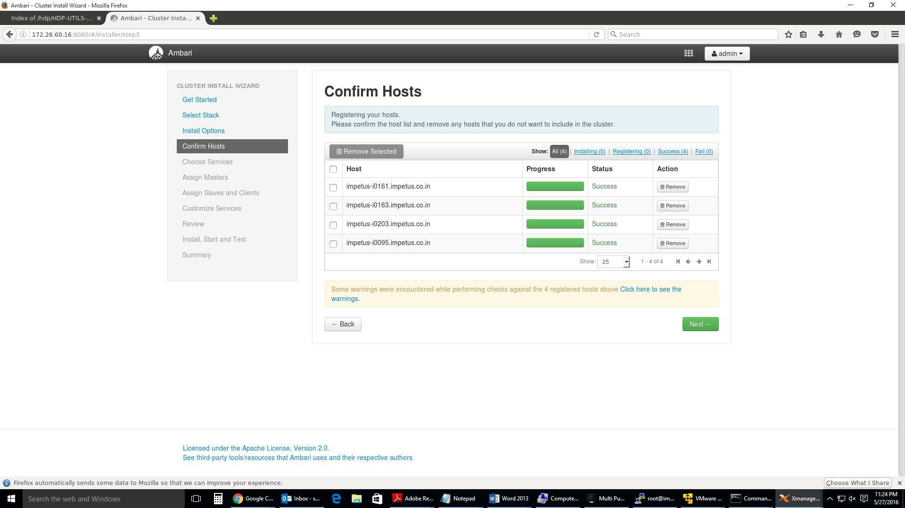
Choose Services

Based on the Stack chosen during Select Stack, you are presented with the choice of Services to install into the cluster. HDP Stack comprises many services. You may choose to install any other available services now, or to add services later. The install wizard selects all available services for installation by default. Choose or clear individual checkboxes to define a set of services to install now. I selected the following service based on our case study.

After selecting the services to install now, choose Next.
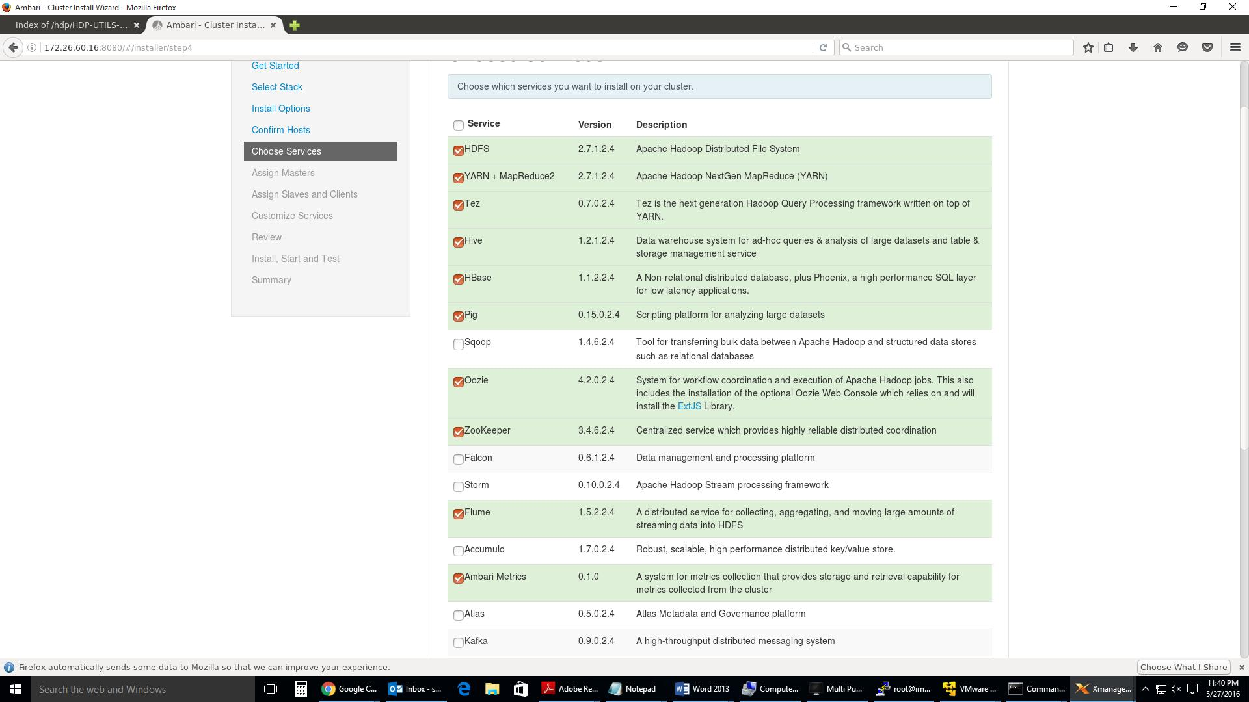
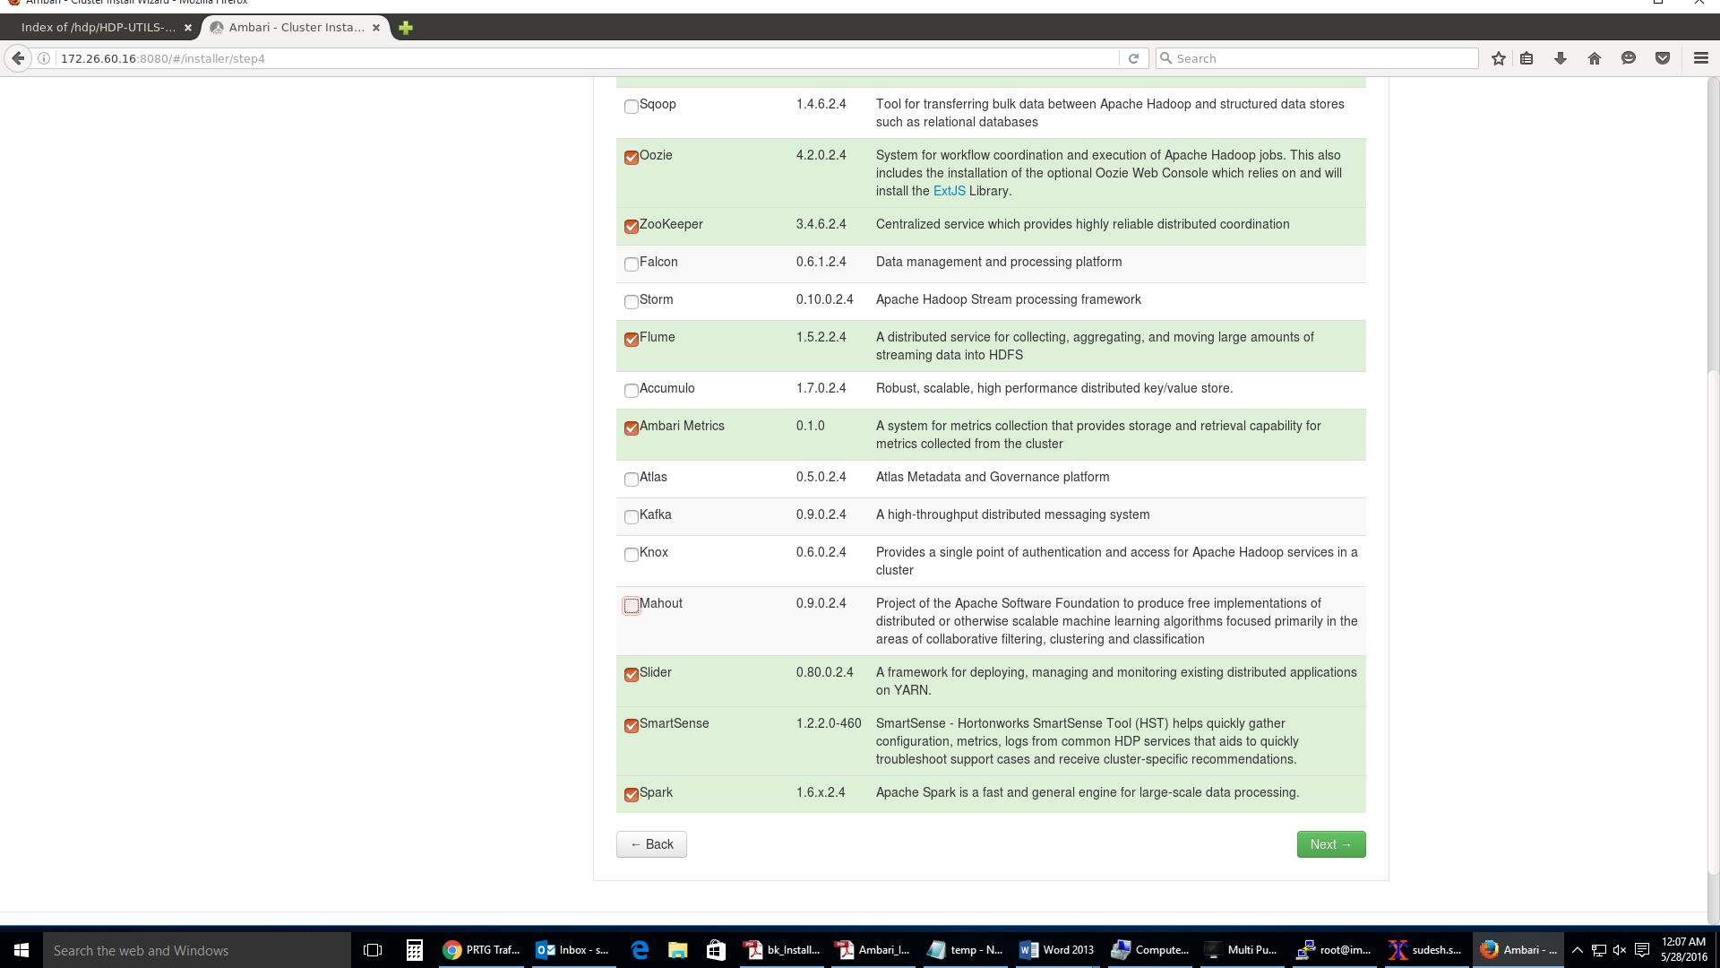

Assign Masters

The Ambari install wizard assigns the master components for selected services to appropriate hosts in your cluster and displays the assignments in Assign Masters. The left column shows services and current hosts. The right column shows current master component assignments by host, indicating the number of CPU cores and amount of RAM installed on each host. To change the host assignment for a service, select a host name from the drop-down menu for that service.

- To remove a ZooKeeper instance, click the green minus icon next to the host address you want to remove.

- When you are satisfied with the assignments, choose Next.

- I moved some components to other server from default ones so that one server is not loaded with more components.
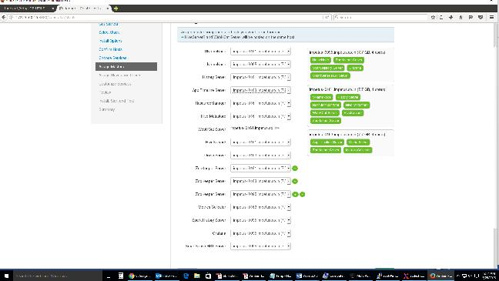
Assign Slaves and Clients

The Ambari installation wizard assigns the slave components (DataNodes, NodeManagers, and RegionServers) to appropriate hosts in your cluster. It also attempts to select hosts for installing the appropriate set of clients.

- Use all or none to select all of the hosts in the column or none of the hosts, respectively.

- If a host has an asterisk next to it, that host is also running one or more master components. Hover your mouse over the asterisk to see which master components are on that host.
- Fine-tune your selections by using the checkboxes next to specific hosts.
- When you are satisfied with your assignments, choose Next.
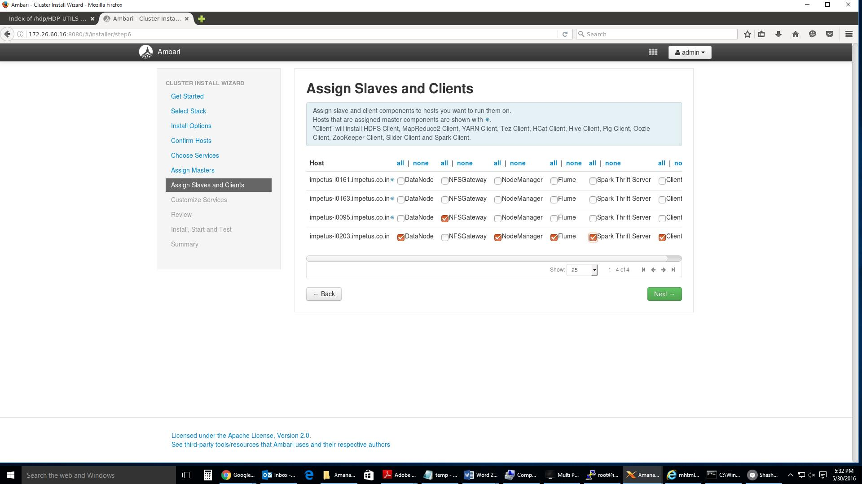
Customize Services
The Customize Services step presents you with a set of tabs that let you review and modify your HDP cluster setup. The wizard attempts to set reasonable defaults for each of the options. You are strongly encouraged to review these settings as your requirements might be slightly different.

Browse through each service tab and by hovering your cursor over each of the properties, you can see a brief description of what the property does. The number of service tabs shown depends on the services you decided to install in your cluster. Any tab that requires input shows a red badge with the number of properties that need attention. Select each service tab that displays a red badge number and enter the appropriate information.

Directories

The choice of directories where HDP will store information is critical. Ambari will attempt to choose reasonable defaults based on the mount points available in your environment but you are strongly encouraged to review the default directory settings recommended by Ambari. In particular, confirm directories such as /tmp and /var are not being used for HDFS NameNode directories and DataNode directories under the HDFS tab.

Passwords

You must provide database passwords for the Hive and Oozie services and the Master Secret for Knox. Using Hive as an example, choose the Hive tab and expand the Advanced section. In Database Password field marked in red, provide a password, then retype to confirm it.

Note

By default, Ambari will install a new MySQL instance for the Hive Metastore and install a Derby instance for Oozie. If you plan to use existing databases for MySQL, Oracle or PostgreSQL, modify these options before proceeding. Refer to Using Non-Default Databases for more information on using existing databases.

Important
Using the Microsoft SQL Server or SQL Anywhere database options are not supported.

Service Account Users and Groups

The service account users and groups are available under the Misc tab. These are the operating system accounts the service components will run as. If these users do not exist on your hosts, Ambari will automatically create the users and groups locally on the hosts. If these users already exist, Ambari will use those accounts.

Depending on how your environment is configured, you might not allow groupmod or usermod operations. If this is the case, you must be sure all users and groups are already created and be sure to select the "Skip group modifications" option on the Misc tab. This tells Ambari to not modify group membership for the service users.

Refer to the Ambari Reference Guide Customizing HDP Services for more information on the service account users and groups that are needed for HDP.
After you complete Customizing Services, choose
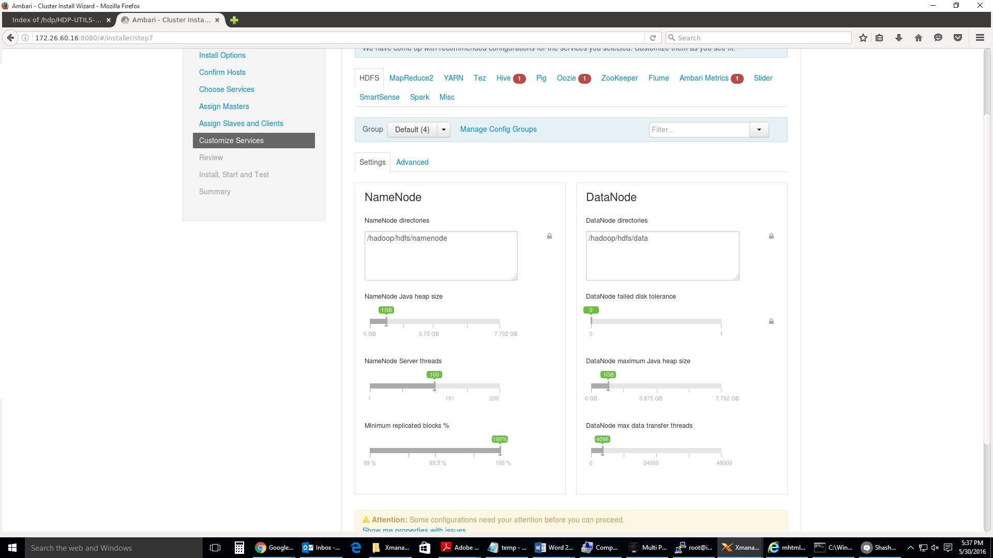

Gave Hive Database password as hive/hive
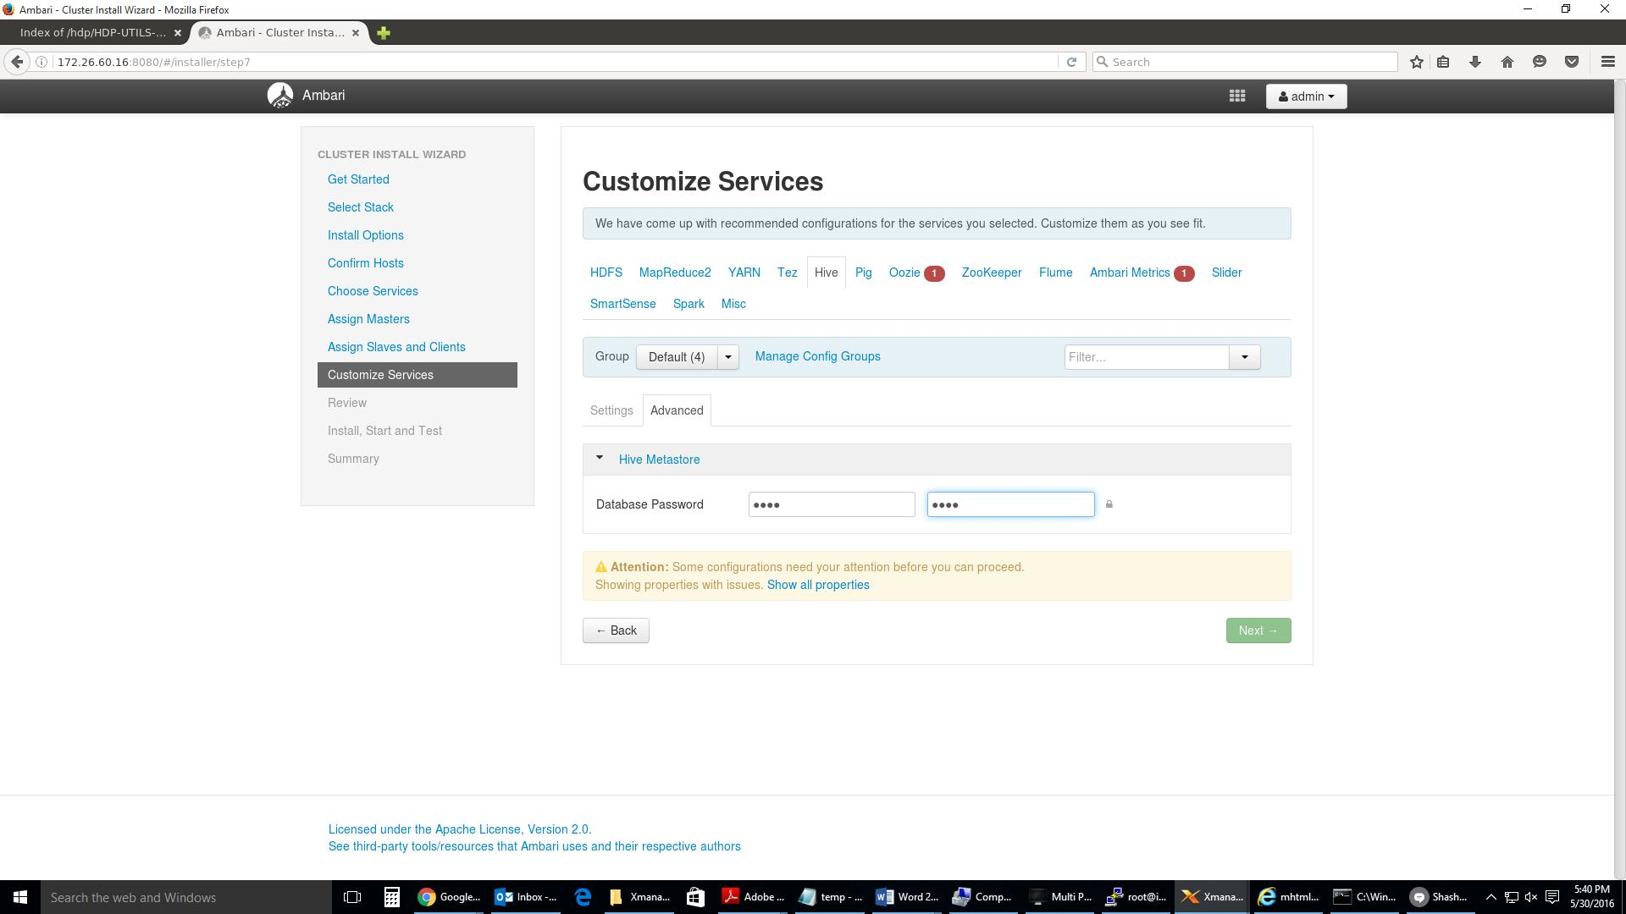

Gave oozie database password as oozie/oozie
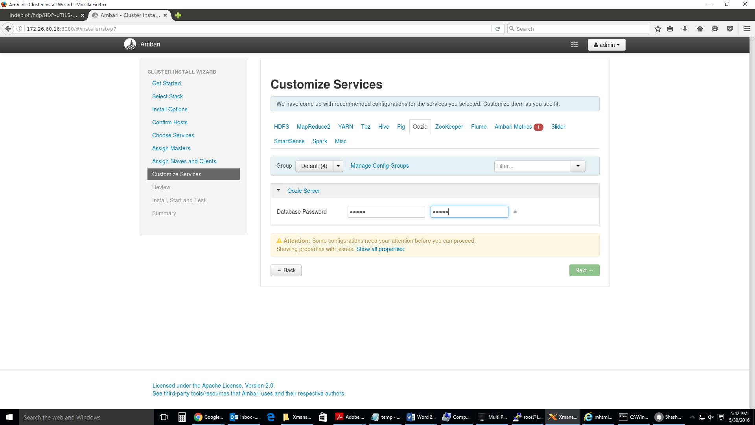

Gave Grafna Admin password as grafana/grafana
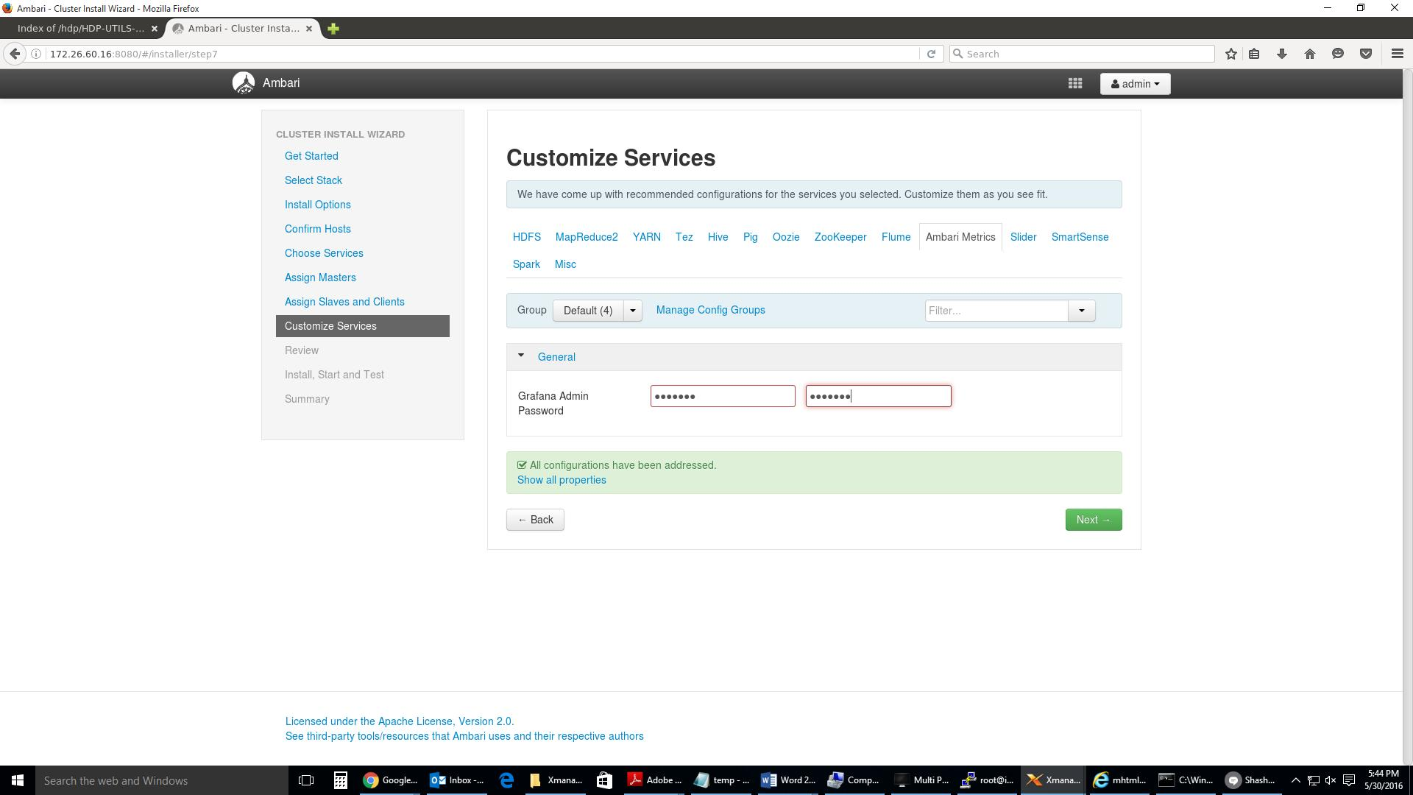
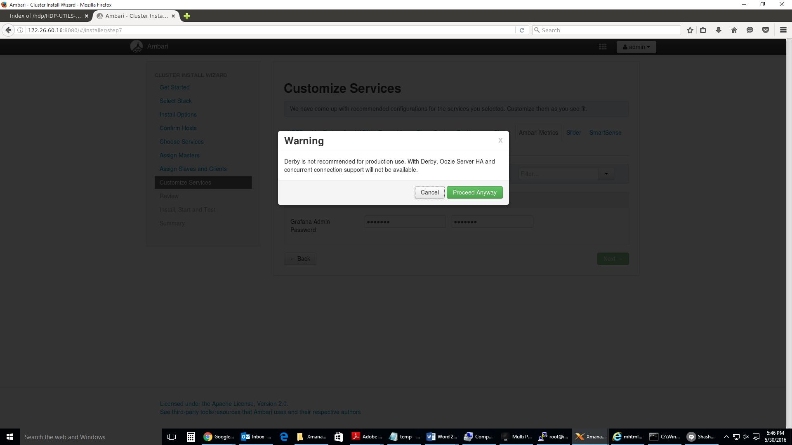

If you get the above warning then go back to customize service and select Oozie → under Oozie server details Select “ existing PostgreSQL database “ and then create a oozie database on the server where it is pointing out. In this case we use impetus-i0161

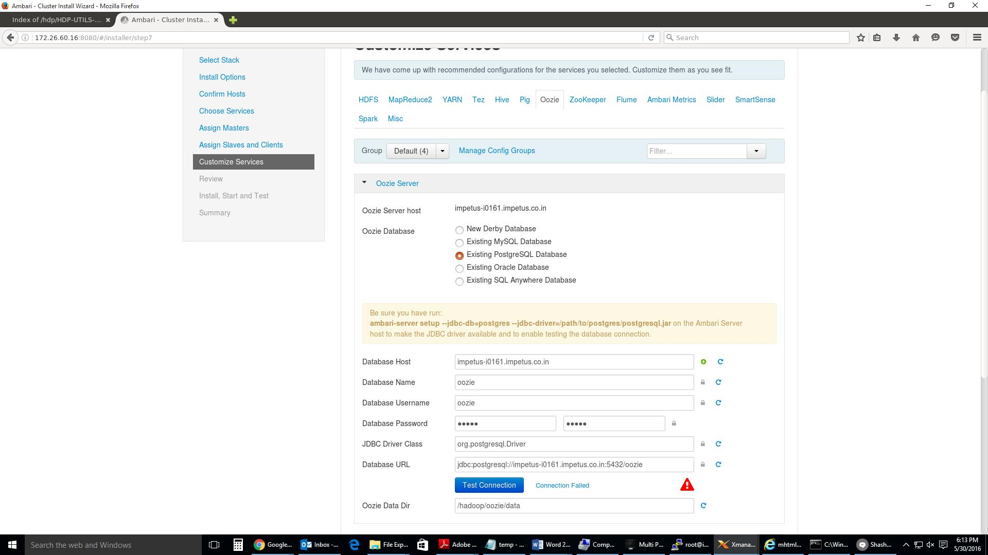

Now follow the below process to create a psql database for oozie. Run the following command at a terminal prompt on impetus-i0161

PostgreSQL setup for use with Oozie:

Execute the following command:

# ambari-server setup --jdbc-db=postgres --jdbc-driver=/usr/lib/ambari-server/postgresql-9.3-1101-jdbc4.jar

Create a user for Oozie and grant it permissions using the PostgreSQL database admin utility:

# sudo su - postgres

postgres@impetus-i0161:~$ echo "CREATE DATABASE oozie"| psql -U postgres postgres@impetus-i0161:~$ echo "CREATE USER oozie WITH PASSWORD 'oozie';" | psql -U postgres

postgres@impetus-i0161:~$ echo "GRANT ALL PRIVILEGES ON DATABASE oozie TO oozie;" | psql -U postgres

To test this connection run the below command on terminal. It should prompt for oozie password and should connect to database.

postgres@impetus-i0161:~$ psql -h impetus-i0161.impetus.co.in -d oozie -U oozie -p 5432

Test it again on ambari GUI
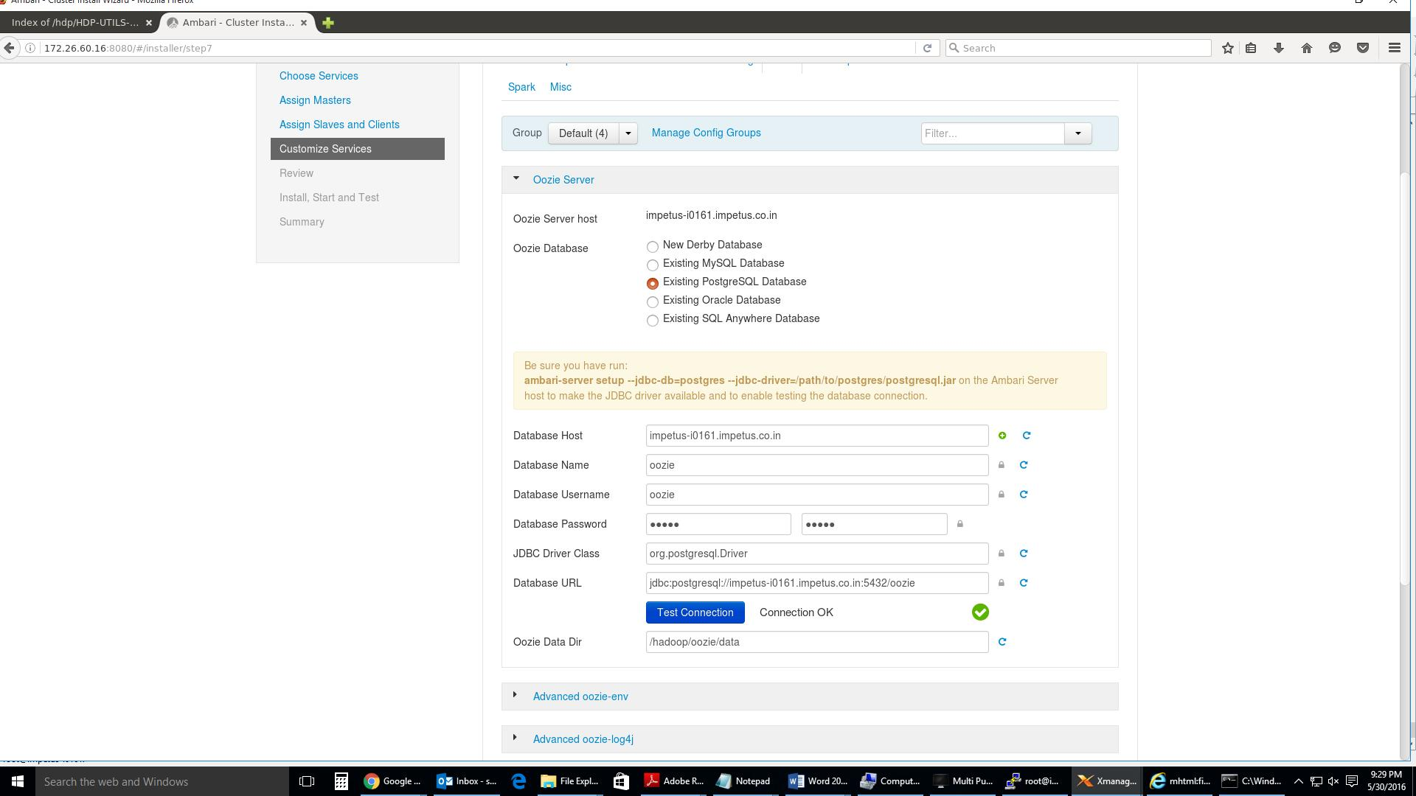

After Review click on Deploy
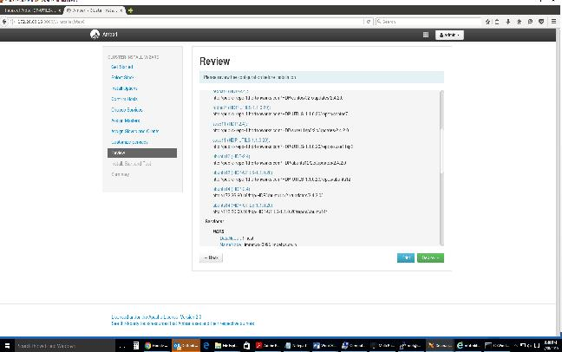
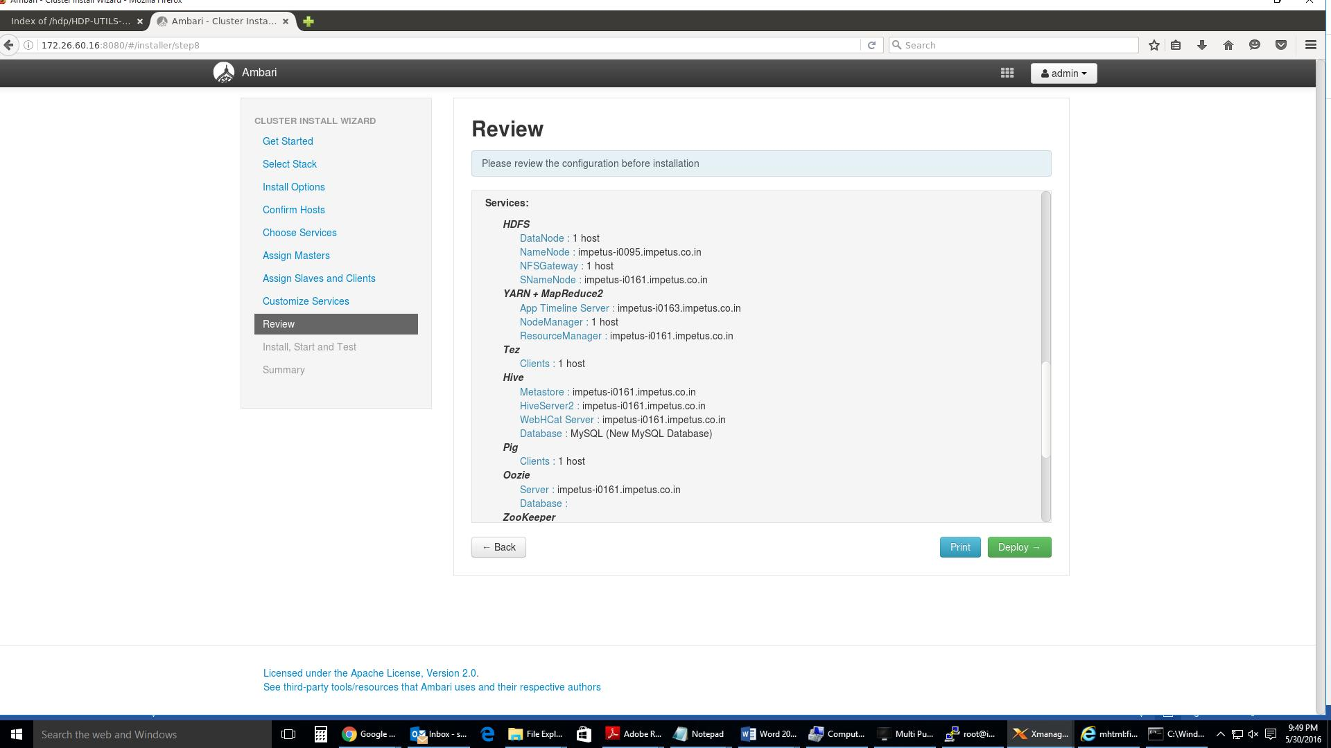
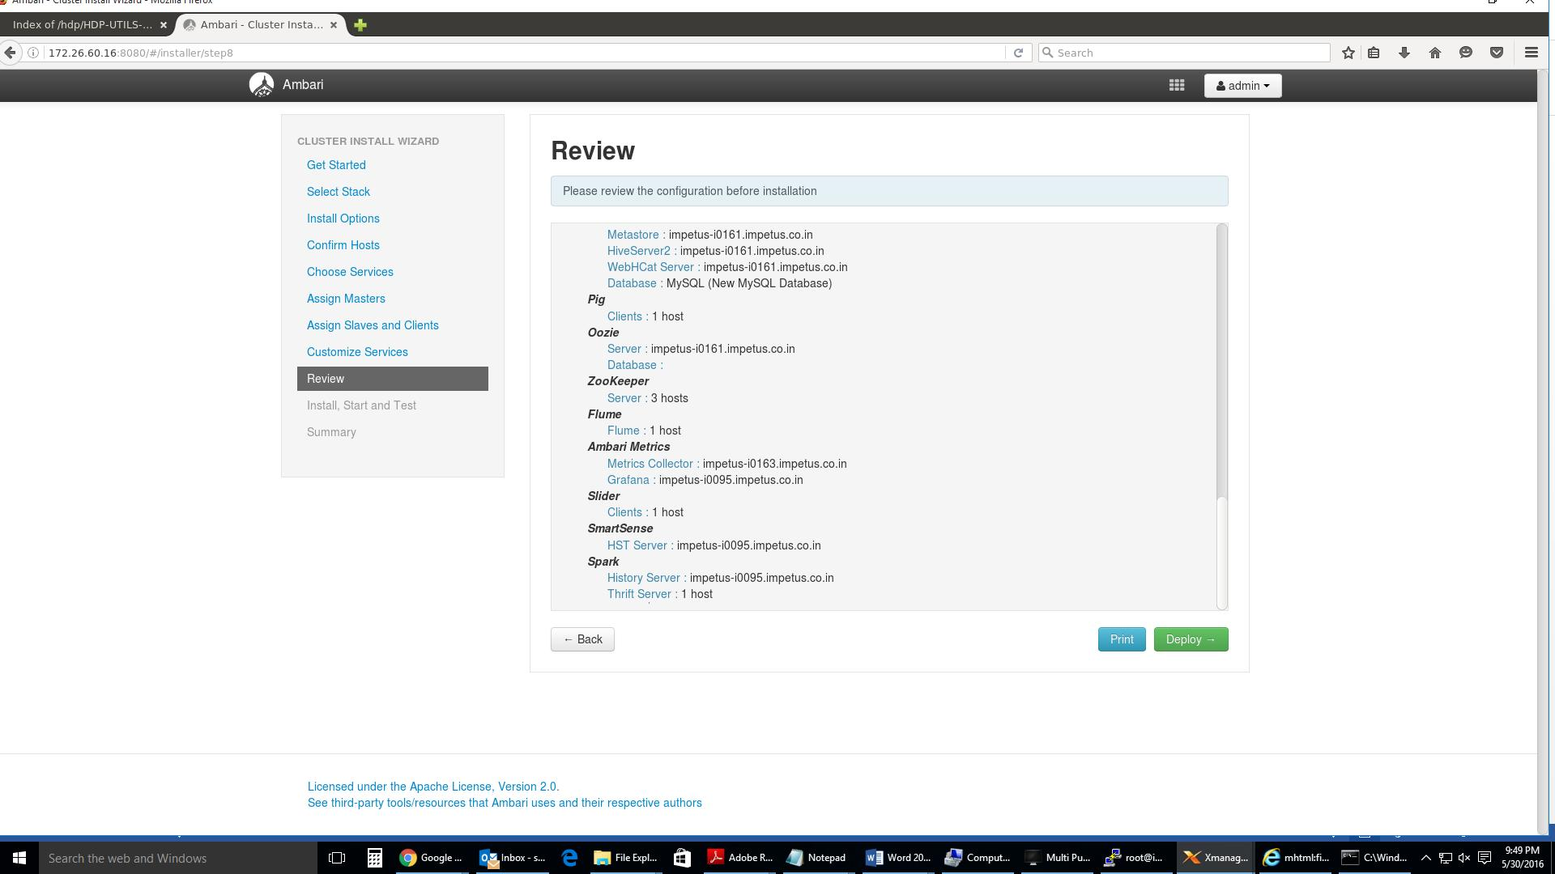

Deployment in progress
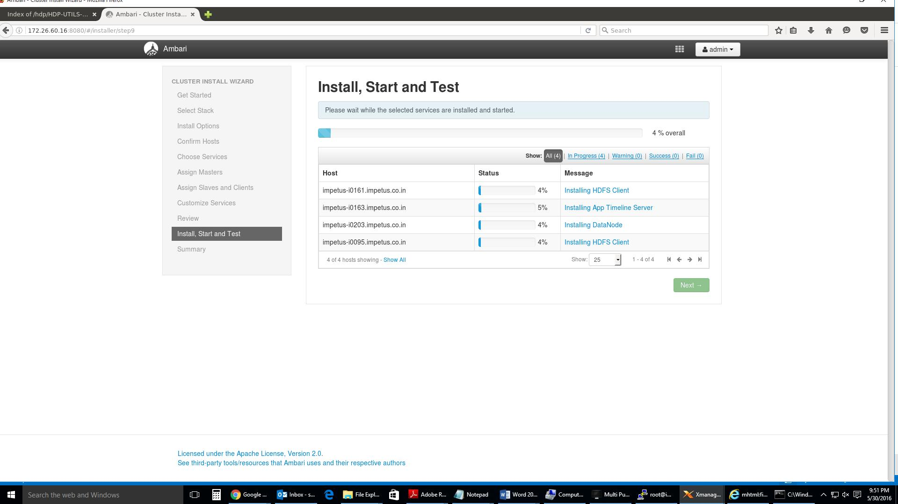
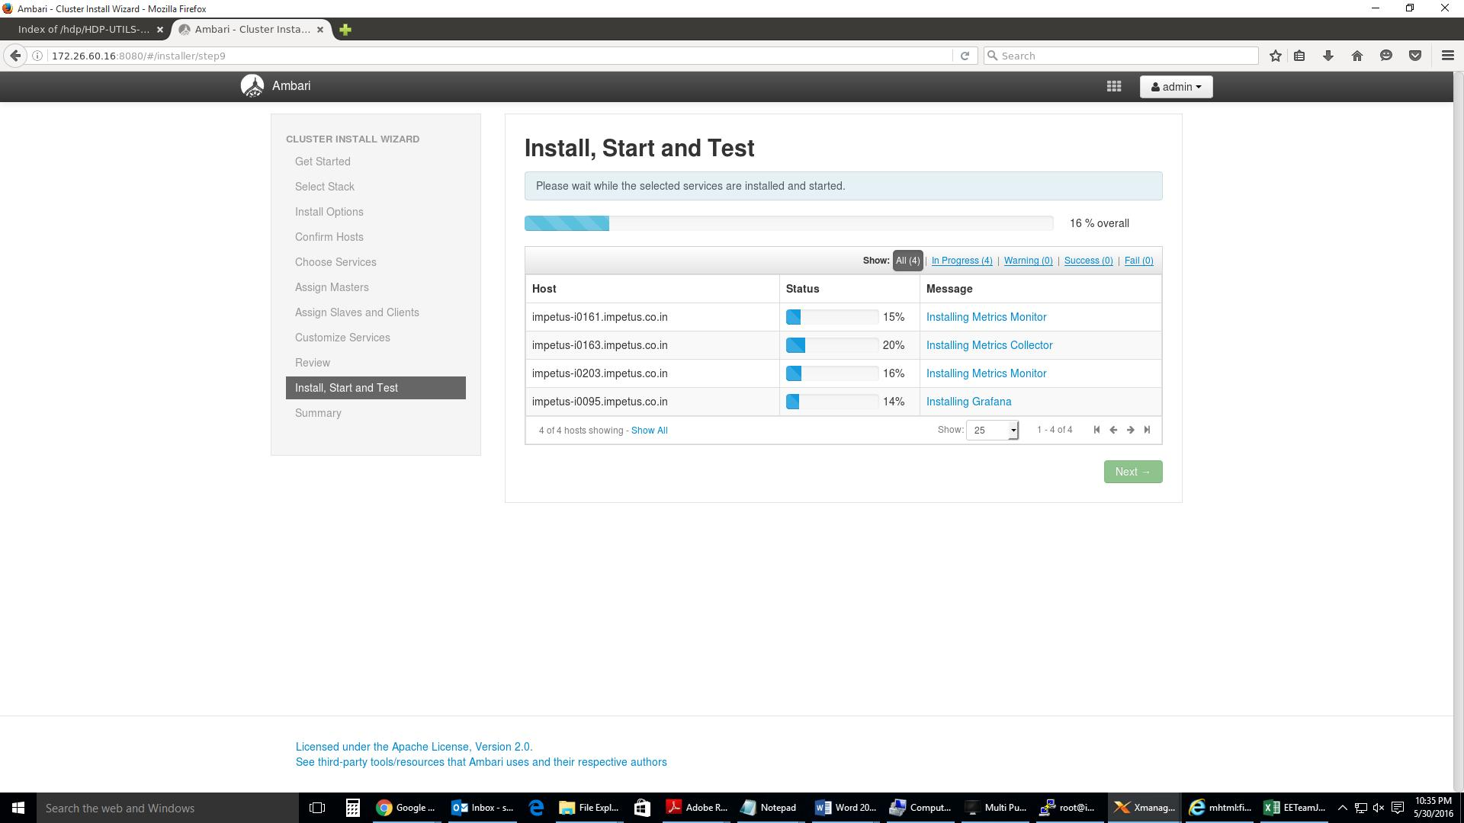
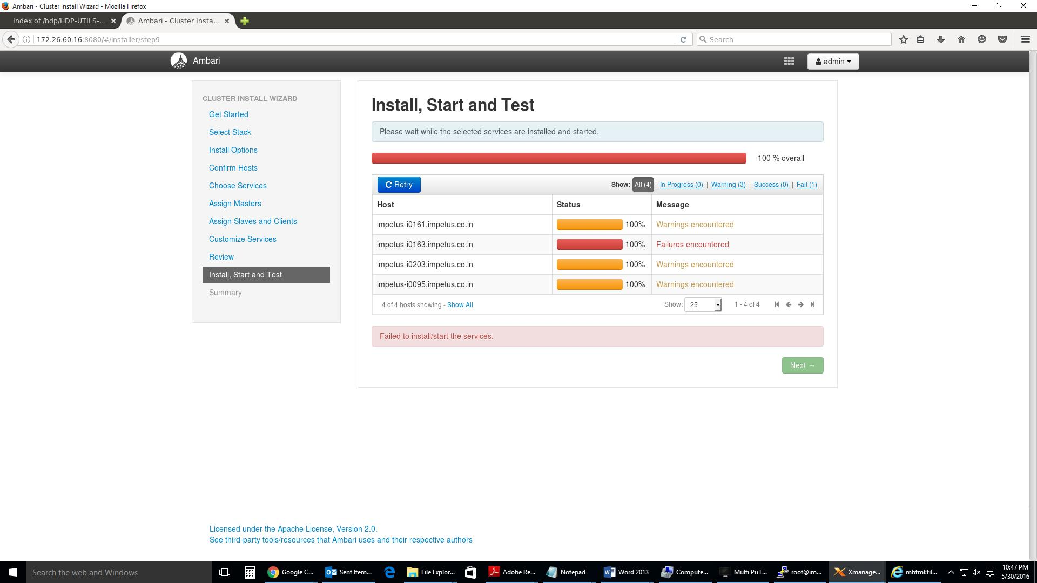

Click on the failure and resolve the issue. In my case installation of one of the component has failed due to timeout. So I just re-tried again.
