Installation and configuration of Elasticsearch, Logstash, and Kibana (ELK Stack)

Introduction

In this tutorial, we will go over the installation of the Elasticsearch ELK Stack on Ubuntu 14.04—that is, Elasticsearch 2.2.x, Logstash 2.2.x, and Kibana 4.4.x. We will also show how to configure it to gather and visualize the syslogs of our systems in a centralized location, using Filebeat 1.1.x. Logstash is an open source tool for collecting, parsing, and storing logs for future use. Kibana is a web interface that can be used to search and view the logs that Logstash has indexed. Both of these tools are based on Elasticsearch, which is used for storing logs.

Centralized logging can be very useful when attempting to identify problems with your servers or applications, as it allows you to search through all of your logs in a single place. It is also useful because it allows you to identify issues that span multiple servers by correlating their logs during a specific time frame.

It is possible to use Logstash to gather logs of all types, but we will limit the scope of this tutorial to syslog gathering.

Our Goal

The goal of the tutorial is to set up Logstash to gather syslogs of multiple servers, and set up Kibana to visualize the gathered logs.

Our ELK stack setup has four main components:

- Logstash​:The server component of Logstash that processes incoming logs

- Elasticsearch​:Stores all of the logs

- Kibana​:Web interface for searching and visualizing logs, which will be proxied through Nginx

- Filebeat​:Installed on client servers that will send their logs to Logstash, Filebeat serves as a log shipping agent that utilizes the ​lumberjack​networking protocol to communicate with Logstash

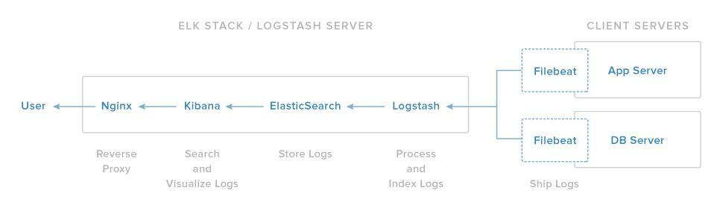

We will install the first three components on a single server, which we will refer to as our ​ELK Server​. Filebeat will be installed on all of the client servers that we want to gather logs for, which we will refer to collectively as our ​Client Servers​.

Prerequisites

To complete this tutorial, you will require root access to an Ubuntu 14.04 VPS. Instructions to set that up can be found here (steps 3 and 4): ​Initial Server Setup with Ubuntu 14.04​.

If you would prefer to use CentOS instead, check out this tutorial: ​How To Install ELK on CentOS 7​.

The amount of CPU, RAM, and storage that your ELK Server will require depends on the volume of logs that you intend to gather. For this setup , we will be using a Ubuntu 14.04 with the following specs for our ELK Server:

- OS: Ubuntu 14.04
- RAM: 8GB
- CPU: 4

In addition to your ELK Server, you will want to have a few other servers that you will gather logs from.

Let's get started on setting up our ELK Server!

Install Java 8

Elasticsearch and Logstash require Java, so we will install that now. We will install a recent version of Oracle Java 8 because that is what Elasticsearch recommends. It should, however, work fine with OpenJDK, if you decide to go that route.
Since we already have installed JDK 1.8.0_60 on this box we can skip this process. Else follow the below steps to install java 8

Add the Oracle Java PPA to apt:

- sudo add­apt­repository ­y ppa:webupd8team/java Update your apt package database:

- sudo apt­get update

Install the latest stable version of Oracle Java 8 with this command (and accept the license agreement that pops up):

● sudo apt­get ­y install oracle­java8­installer

Now that Java 8 is installed, let's install ElasticSearch.

Install Elasticsearch

Elasticsearch can be installed with a package manager by adding Elastic's package source list.

Run the following command to import the Elasticsearch public GPG key into apt:

root@impetus­i0163:~# wget ­qO ­ https://packages.elastic.co/GPG­KEY­elasticsearch | sudo apt­key add ­

OK

Create the Elasticsearch source list:

root@impetus­i0163:~# echo "deb http://packages.elastic.co/elasticsearch/2.x/debian stable main" | sudo tee ­a /etc/apt/sources.list.d/elasticsearch­2.x.list

Update your apt package database:

sudo apt­get update

Install Elasticsearch with this command:

root@impetus­i0163:~# sudo apt­get ­y install elasticsearch

Elasticsearch is now installed. Let's edit the configuration:

sudo vi /etc/elasticsearch/elasticsearch.yml

You will want to restrict outside access to your Elasticsearch instance (port 9200), so outsiders can't read your data or shutdown your Elasticsearch cluster through the HTTP API. Find the line that specifies network.host, uncomment it, and replace its value with "localhost" so it looks like this:

network.host: localhost

Save and exit​elasticsearch.yml​.

Now start Elasticsearch:

sudo service elasticsearch restart

If you get error saying “​Could not find any executable java binary. Please install java in your PATH or set JAVA_HOME​”then add the following line in /etc/init.d/elasticsearch

PATH=/bin:/usr/bin:/sbin:/usr/sbin:/usr/jdk64/jdk1.8.0_60/bin

Then run the following command to start Elasticsearch on boot up:

# sudo update­rc.d elasticsearch defaults 95 10

Adding system startup for /etc/init.d/elasticsearch ...

/etc/rc0.d/K10elasticsearch ­> ../init.d/elasticsearch /etc/rc1.d/K10elasticsearch ­> ../init.d/elasticsearch /etc/rc6.d/K10elasticsearch ­> ../init.d/elasticsearch /etc/rc2.d/S95elasticsearch ­> ../init.d/elasticsearch
/etc/rc3.d/S95elasticsearch ­> ../init.d/elasticsearch

/etc/rc4.d/S95elasticsearch ­> ../init.d/elasticsearch

/etc/rc5.d/S95elasticsearch ­> ../init.d/elasticsearch

Now that Elasticsearch is up and running, let's install Kibana.

Install Kibana

Kibana can be installed with a package manager by adding Elastic's package source list. Create the Kibana source list:

echo "deb http://packages.elastic.co/kibana/4.4/debian stable main" | sudo tee ­a /etc/apt/sources.list.d/kibana­4.4.x.list

Update your apt package database:
sudo apt­get update

Install Kibana with this command​:
sudo apt­get ­y install kibana

Kibana is now installed.

Open the Kibana configuration file for editing:
sudo vi /opt/kibana/config/kibana.yml

In the Kibana configuration file, find the line that specifies server.host, and replace the IP address ("0.0.0.0" by default) with "localhost":
server.host: "localhost"

Save and exit. This setting makes it so Kibana will only be accessible to the localhost. This is fine because we will use an Nginx reverse proxy to allow external access.

Now enable the Kibana service, and start it:

sudo update­rc.d kibana defaults 96 9
sudo service kibana start

Before we can use the Kibana web interface, we have to set up a reverse proxy. Let's do that now, with Nginx.

Install Nginx

Because we configured Kibana to listen on localhost, we must set up a reverse proxy to allow external access to it. We will use Nginx for this purpose.

Note: ​Ifyou already have an Nginx instance that you want to use, feel free to use that instead. Just make sure to configure Kibana so it is reachable by your Nginx server (you probably want to change the hostvalue, in /opt/kibana/config/kibana.yml, to your Kibana server's private IP address or hostname). Also, it is recommended that you enable SSL/TLS.

Use apt to install Nginx and Apache2­utils:

sudo apt­get install nginx apache2­utils

Use htpasswd to create an admin user, called "kibanaadmin" (you should use another name), that can access the Kibana web interface:

sudo htpasswd ­c /etc/nginx/htpasswd.users ​kibanaadmin

Enter a password at the prompt. Remember this login, as you will need it to access the Kibana web interface. I have set the password as ​eeteamj1

Now open the Nginx default server block in your favorite editor. We will use vi:

Delete the file's contents, and paste the following code block into the file. Be sure to update the server_name​tomatch your server's name:

sudo vi /etc/nginx/sites­available/default
server { listen 80;
server_name example.com; auth_basic "Restricted Access";

auth_basic_user_file /etc/nginx/htpasswd.users; location / {

proxy_pass http://localhost:5601; proxy_http_version 1.1; proxy_set_header Upgrade $http_upgrade; proxy_set_header Connection 'upgrade'; proxy_set_header Host $host; proxy_cache_bypass $http_upgrade;
}

}

Save and exit. This configures Nginx to direct your server's HTTP traffic to the Kibana application, which is listening on localhost:5601. Also, Nginx will use the htpasswd.users file, that we created earlier, and require basic authentication.

Now restart Nginx to put our changes into effect:

sudo service nginx restart

If the service fails to start then check if default port 80 is being used. If yes then stop the application using it and start nginx service once again. Else use some other port in the file above for nginx.

Kibana is now accessible via your FQDN or the public IP address of your ELK Server i.e. ​http:// impetus­I0163.impetus.co.in/​.If you go there in a web browser, after entering the "kibanaadmin" credentials, you should see a Kibana welcome page which will ask you to configure an index pattern. Let's get back to that later, after we install all of the other components.

Install Logstash

The Logstash package is available from the same repository as Elasticsearch, and we already installed that public key, so let's create the Logstash source list:

echo 'deb http://packages.elastic.co/logstash/2.2/debian stable main' | sudo tee /etc/apt/sources.list.d/logstash­2.2.x.list
Update your apt package database:

sudo apt­get update

Install Logstash with this command:

sudo apt­get install logstash

Logstash is installed but it is not configured yet Generate SSL Certificates

Since we are going to use Filebeat to ship logs from our Client Servers to our ELK Server, we need to create an SSL certificate and key pair. The certificate is used by Filebeat to verify the identity of ELK Server. Create the directories that will store the certificate and private key with the following commands:

sudo mkdir ­p /etc/pki/tls/certs

sudo mkdir –p /etc/pki/tls/private

Now you have two options for generating your SSL certificates. If you have a DNS setup that will allow your client servers to resolve the IP address of the ELK Server, use ​Option 2​.Otherwise, ​Option 1​will allow you to use IP addresses.

Option 1: IP Address

If you don't have a DNS setup—that would allow your servers, that you will gather logs from, to resolve the IP address of your ELK Server—you will have to add your ELK Server's private IP address to thesubjectAltName (SAN) field of the SSL certificate that we are about to generate. To do so, open the OpenSSL configuration file:

sudo vi /etc/ssl/openssl.cnf

Find the [ v3_ca ] section in the file, and add this line under it (substituting in the ELK Server's private IP address):

subjectAltName = IP: ​172.26.60.17

Save and exit.

Now generate the SSL certificate and private key in the appropriate locations (/etc/pki/tls/), with the following commands:

cd /etc/pki/tls

sudo openssl req ­config /etc/ssl/openssl.cnf ­x509 ­days 3650 ­batch ­nodes ­newkey rsa:2048 ­keyout private/logstash­forwarder.key ­out certs/logstash­forwarder.crt

The ​logstash­forwarder.crt​file will be copied to all of the servers that will send logs to Logstash but we will do that a little later. Let's complete our Logstash configuration. If you went with this option, skip option 2 and move on to ​Configure Logstash​.

Option 2: FQDN (DNS)

If you have a DNS setup with your private networking, you should create an A record that contains the ELK Server's private IP address—this domain name will be used in the next command, to generate the SSL certificate. Alternatively, you can use a record that points to the server's public IP address. Just be sure that your servers (the ones that you will be gathering logs from) will be able to resolve the domain name to your ELK Server.

Now generate the SSL certificate and private key, in the appropriate locations (/etc/pki/tls/...), with the following command (substitute in the FQDN of the ELK Server):

cd /etc/pki/tls; sudo openssl req ­subj '/CN=​ELK_server_fqdn​/' ­x509 ­days 3650 ­batch ­nodes ­newkey rsa:2048 ­keyout private/logstash­forwarder.key ­out certs/logstash­forwarder.crt

The ​logstash­forwarder.crt​file will be copied to all of the servers that will send logs to Logstash but we will do that a little later. Let's complete our Logstash configuration.

Configure Logstash

Logstash configuration files are in the JSON­format, and reside in /etc/logstash/conf.d. The configuration consists of three sections: inputs, filters, and outputs.

Let's create a configuration file called 02­beats­input.conf and set up our "filebeat" input:

sudo vi /etc/logstash/conf.d/02­beats­input.conf

Insert the following ​input​configuration:

input { beats {
port => 5044 ssl => true

ssl_certificate => "/etc/pki/tls/certs/logstash­forwarder.crt"
ssl_key => "/etc/pki/tls/private/logstash­forwarder.key"
}
}

Save and quit. This specifies a beats input that will listen on tcp port 5044, and it will use the SSL certificate and private key that we created earlier.

Now let's create a configuration file called 10­syslog­filter.conf, where we will add a filter for syslog messages:

sudo vi /etc/logstash/conf.d/10­syslog­filter.conf

Insert the following syslog ​filter​configuration:

filter {
if [type] == "syslog" { grok {
match => { "message" => "%{SYSLOGTIMESTAMP:syslog_timestamp} %{SYSLOGHOST:syslog_hostname} %{DATA:syslog_program}(?:\[%{POSINT:syslog_pid}\])?: %{GREEDYDATA:syslog_message}" }
add_field => [ "received_at", "%{@timestamp}" ] add_field => [ "received_from", "%{host}" ]
}
syslog_pri { } date {
match => [ "syslog_timestamp", "MMM d HH:mm:ss", "MMM dd HH:mm:ss" ]
}
}
}

Save and quit. This filter looks for logs that are labeled as "syslog" type (by Filebeat), and it will try to usegrok to parse incoming syslog logs to make it structured and query­able.

Lastly, we will create a configuration file called 30­elasticsearch­output.conf:

sudo vi /etc/logstash/conf.d/30­elasticsearch­output.conf

Insert the following ​output​configuration:

output { elasticsearch {
hosts => ["localhost:9200"] sniffing => true manage_template => false

index => "%{[@metadata][beat]}­%{+YYYY.MM.dd}" document_type => "%{[@metadata][type]}"
}
}

Save and exit. This output basically configures Logstash to store the beats data in Elasticsearch which is running at localhost:9200, in an index named after the beat used (filebeat, in our case).

If you want to add filters for other applications that use the Filebeat input, be sure to name the files so they sort between the input and the output configuration (i.e. between 02­ and 30­).

Test your Logstash configuration with this command:

sudo service logstash configtest

It should display ​Configuration OK​ifthere are no syntax errors. Otherwise, try and read the error output to see what's wrong with your Logstash configuration.

Restart Logstash, and enable it, to put our configuration changes into effect:

sudo service logstash restart
sudo update­rc.d logstash defaults 96 9

Next, we'll load the sample Kibana dashboards.

Load Kibana Dashboards

Elastic provides several sample Kibana dashboards and Beats index patterns that can help you get started with Kibana. Although we won't use the dashboards in this tutorial, we'll load them anyway so we can use the Filebeat index pattern that it includes.

First, download the sample dashboards archive to your home directory:

cd ~
curl ­L ­O https://download.elastic.co/beats/dashboards/beats­dashboards­1.1.0.zip

Install the unzip package with this command:

sudo apt­get ­y install unzip

Next, extract the contents of the archive:

unzip beats­dashboards­*.zip

And load the sample dashboards, visualizations and Beats index patterns into Elasticsearch with these commands:

cd beats­dashboards­*
./load.sh

These are the index patterns that we just loaded:

- [packetbeat­]YYYY.MM.DD
- [topbeat­]YYYY.MM.DD
- [filebeat­]YYYY.MM.DD
- [winlogbeat­]YYYY.MM.DD

When we start using Kibana, we will select the Filebeat index pattern as our default.

Load Filebeat Index Template in Elasticsearch

Because we are planning on using Filebeat to ship logs to Elasticsearch, we should load a Filebeat index template. The index template will configure Elasticsearch to analyze incoming Filebeat fields in an intelligent way.

First, download the Filebeat index template to your home directory:

cd ~
curl ­O https://gist.githubusercontent.com/thisismitch/3429023e8438cc25b86c/raw/d8 c479e2a1adcea8b1fe86570e42abab0f10f364/filebeat­index­template.json

Then load the template with this command:
curl ­XPUT 'http://localhost:9200/_template/filebeat?pretty' ­d@filebeat­index­template.json

If the template loaded properly, you should see a message like this:

{
"acknowledged" : true
}

Now that our ELK Server is ready to receive Filebeat data, let's move onto setting up Filebeat on each client server.

Set Up Filebeat (Add Client Servers)

Do these steps for each Ubuntu or Debian server that you want to send logs to Logstash on your ELK Server. For instructions on installing Filebeat on Red Hat­based Linux distributions (e.g. RHEL, CentOS, etc.), refer to the ​Set Up Filebeat (Add Client Servers) section​of the CentOS variation of this tutorial.

Copy SSL Certificate

On your ​ELK Server​,copy the SSL certificate—created in the prerequisite tutorial—to your ​Client Server​(substitute the client server's address, and your own login):

scp /etc/pki/tls/certs/logstash­forwarder.crt ​root@172.26.60.18:/tmp
scp /etc/pki/tls/certs/logstash­forwarder.crt ​root@172.26.60.16:/tmp
scp /etc/pki/tls/certs/logstash­forwarder.crt ​root@172.26.60.19:/tmp

After providing your login's credentials, ensure that the certificate copy was successful. It is required for communication between the client servers and the ELK Server.

Now, on your ​Client Server​,copy the ELK Server's SSL certificate into the appropriate location (/etc/pki/tls/certs):

sudo mkdir ­p /etc/pki/tls/certs
sudo cp /tmp/logstash­forwarder.crt /etc/pki/tls/certs/

Now we will install the Topbeat package.

Install Filebeat Package

On ​Client Server​,create the Beats source list:

echo "deb https://packages.elastic.co/beats/apt stable main" | sudo tee ­a /etc/apt/sources.list.d/beats.list

It also uses the same GPG key as Elasticsearch, which can be installed with this command:

wget ­qO ­ https://packages.elastic.co/GPG­KEY­elasticsearch | sudo apt­key add –
Then install the Filebeat package:

sudo apt­get update
sudo apt­get install filebeat

Filebeat is installed but it is not configured yet.

Configure Filebeat

Now we will configure Filebeat to connect to Logstash on our ELK Server. This section will step you through modifying the example configuration file that comes with Filebeat. When you complete the steps, you should have a file that looks something like ​this​.

On ​Client Server​,create and edit Filebeat configuration file:
sudo vi /etc/filebeat/filebeat.yml

Note: ​Filebeat's configuration file is in YAML format, which means that indentation is very important! Be sure to use the same number of spaces that are indicated in these instructions.

Near the top of the file, you will see the prospectors section, which is where you can

define ​prospectors ​that specify which log files should be shipped and how they should be handled. Each prospector is indicated by the ­ character.

We'll modify the existing prospector to send syslog and auth.log to Logstash. Under paths, comment out the ­ /var/log/*.log file. This will prevent Filebeat from sending every .log in that directory to Logstash. Then add new entries for syslog and auth.log. It should look something like this when you're done:

... | paths:
 | ­ /var/log/auth.log
#​ | ­ /var/log/syslog
#​ | ­ /var/log/*.log
...

Then find the line that specifies document_type:, uncomment it and change its value to "syslog". It should look like this after the modification:

...
document_type: ​syslog

...

This specifies that the logs in this prospector are of type ​syslog​(which is the type that our Logstash filter is looking for).

If you want to send other files to your ELK server, or make any changes to how Filebeat handles your logs, feel free to modify or add prospector entries.

Next, under the output section, find the line that says elasticsearch:, which indicates the Elasticsearch output section (which we are not going to use). ​Delete or comment out the entire Elasticsearch output section​(up to the line that says #logstash:).

Find the commented out Logstash output section, indicated by the line that says #logstash:, and uncomment it by deleting the preceding #. In this section, uncomment the hosts: ["localhost:5044"]line. Change localhost to the private IP address (or hostname, if you went with that option) of your ELK server:

# vi filebeat.yml

### Logstash as output logstash:
# The Logstash hosts

hosts: ["​ELK_server_private_IP​:5044"]

This configures Filebeat to connect to Logstash on your ELK Server at port 5044 (the port that we specified a Logstash input for earlier).

Directly under the hosts entry, and with the same indentation, add this line:

bulk_max_size: 1024

Next, find the​tls​section, and uncomment it. Then uncomment the line that specifies certificate_authorities​,​and change its value to​["/etc/pki/tls/certs/logstash­forwarder.crt"]​.

The final contents of filebeat.yml file should look like this:

filebeat:

prospectors:

­

paths:

  - /var/log/auth.log

  - /var/log/syslog

- ­ /var/log/*.log

input_type: log

document_type: syslog

registry_file: /var/lib/filebeat/registry

output:

logstash:

hosts: ["172.26.60.17:5044"] bulk_max_size: 1024

tls: certificate_authorities:

["/etc/pki/tls/certs/logstash­forwarder.crt"]

shipper:

logging:

files:

rotateeverybytes: 10485760 # = 10MB

This configures Filebeat to use the SSL certificate that we created on the ELK Server. Save and quit. Now restart Filebeat to put our changes into place:

- sudo service filebeat restart

- sudo update­rc.d filebeat defaults 95 10

Now Filebeat is sending syslog and auth.log to Logstash on your ELK server! We need to repeat this section for all of the other three nodes.

Test Filebeat Installation

If your ELK stack is setup properly, Filebeat (on your client server) should be shipping your logs to Logstash on your ELK server. Logstash should be loading the Filebeat data into Elasticsearch in an date­stamped index, filebeat­YYYY.MM.DD.

On your ​ELK Server​,verify that Elasticsearch is indeed receiving the data by querying for the Filebeat index with this command:

curl ­XGET 'http://localhost:9200/filebeat­*/_search?pretty'

You should see a bunch of output that looks like this:

root@impetus­i0163:# curl ­XGET 'http://localhost:9200/filebeat­*/_search?pretty'

% Total | % Received % Xferd | Average Speed |  | Time | Time | Time Current
100 11947 | 100 11947 0 | Dload | Upload | Total | Spent | Left Speed
100 11947 | 100 11947 0 | 0 1167k | 0 ­­:­­:­­ |  | ­­:­­:­­ ­­:­­:­­ 1296k

{

"took" : 6, "timed_out" : false, "_shards" : {
"total" : 60, "successful" : 60, "failed" : 0
},

"hits" : {

"total" : 5399992, "max_score" : 1.0, "hits" : [ {
"_index" : "filebeat­2016.07.10", "_type" : "syslog",
"_id" : "AVXqZ_cebv7c­XrC2Z1c", "_score" : 1.0,
"_source" : {

"message" : "Jul 10 07:59:00 impetus­i0161 su[17454]: + ??? root:ambari­qa", "@version" : "1",
"@timestamp" : "2016­07­10T02:29:00.000Z", "source" : "/var/log/auth.log",
"offset" : 18834, "fields" : null, "beat" : {
"hostname" : "impetus­i0161", "name" : "impetus­i0161"
},

"type" : "syslog", "input_type" : "log", "count" : 1,
"host" : "impetus­i0161",
"tags" : [ "beats_input_codec_plain_applied" ], "syslog_timestamp" : "Jul 10 07:59:00", "syslog_hostname" : "impetus­i0161", "syslog_program" : "su",

"syslog_pid" : "17454",

"syslog_message" : "+ ??? root:ambari­qa", "received_at" : "2016­07­14T17:15:28.128Z", "received_from" : "impetus­i0161", "syslog_severity_code" : 5, "syslog_facility_code" : 1, "syslog_facility" : "user­level", "syslog_severity" : "notice"

}

If your output shows 0 total hits, Elasticsearch is not loading any logs under the index you searched for, and you should review your setup for errors. If you received the expected output, continue to the next step.

Connect to Kibana

When you are finished setting up Filebeat on all of the servers that you want to gather logs for, let's look at Kibana, the web interface that we installed earlier.

In a web browser, go to the FQDN or public IP address of your ELK Server. After entering the "kibanaadmin" credentials, you should see a page prompting you to configure a default index pattern:

Go ahead and select ​[filebeat]­YYY.MM.DD​from the Index Patterns menu (left side), then click the ​Star (Set as default index)​button to set the Filebeat index as the default.

Now click the ​Discover​link in the top navigation bar. By default, this will show you all of the log data over the last 15 minutes. You should see a histogram with log events, with log messages below:

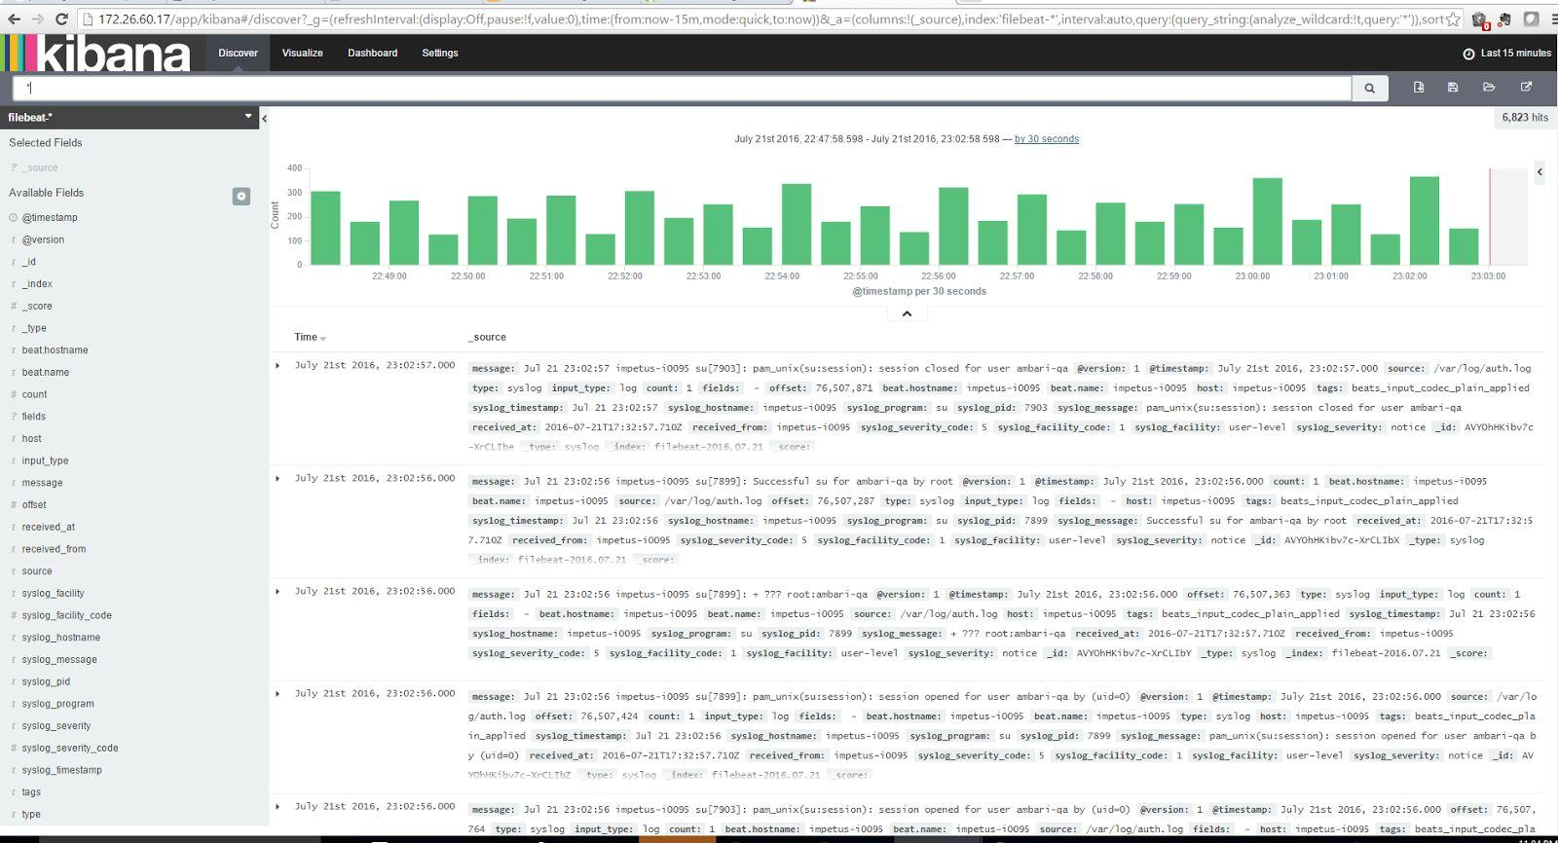

Here you can search and browse through your logs. You can also customize your dashboard.

Try the following things:

- Search for "root" to see if anyone is trying to log into your servers as root
- Search for a particular hostname (search for host: "hostname")
- Change the time frame by selecting an area on the histogram or from the menu above
- Click on messages below the histogram to see how the data is being filtered

Kibana has many other features, such as graphing and filtering.

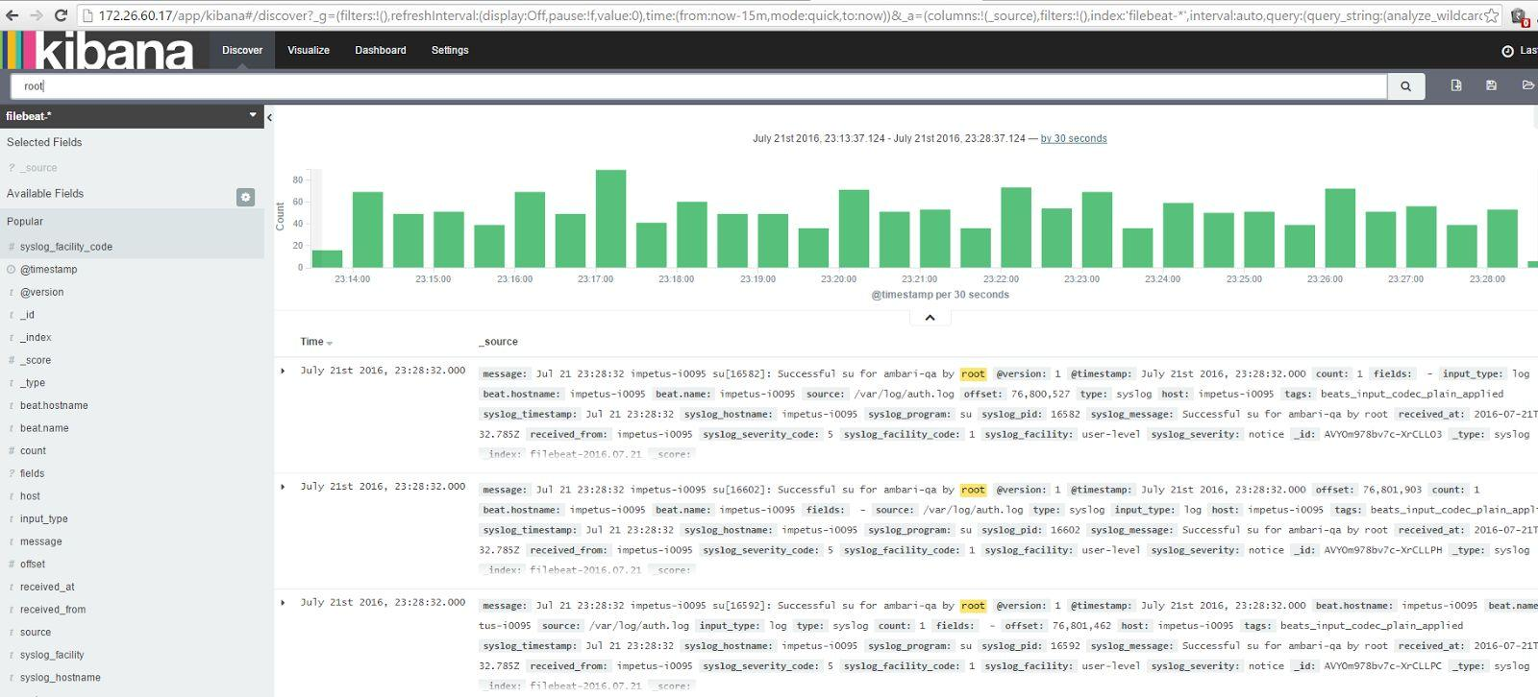Search for root to see who is trying to log into servers as root

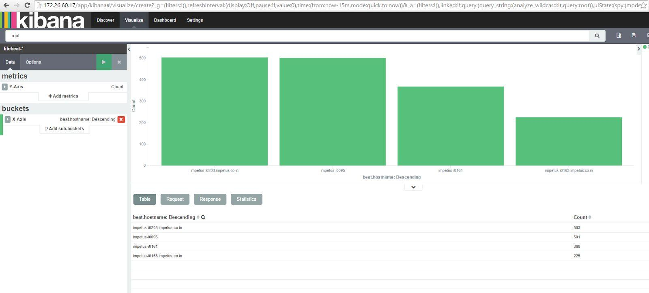Searching for a particular hostaname

Changing the time frame by selecting an area on the histogram

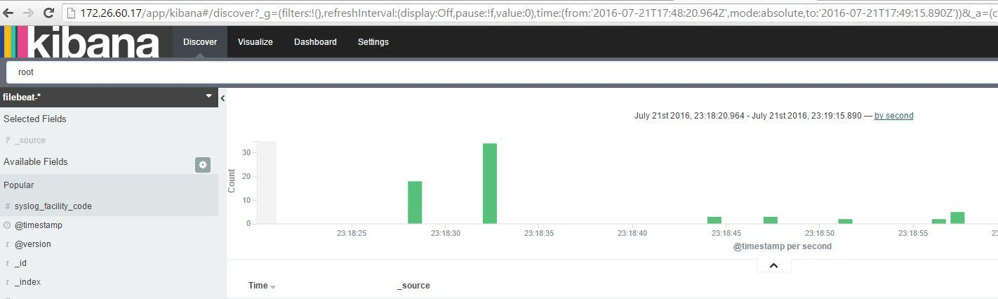

Click on messages below the histogram to see how the data is being filtered

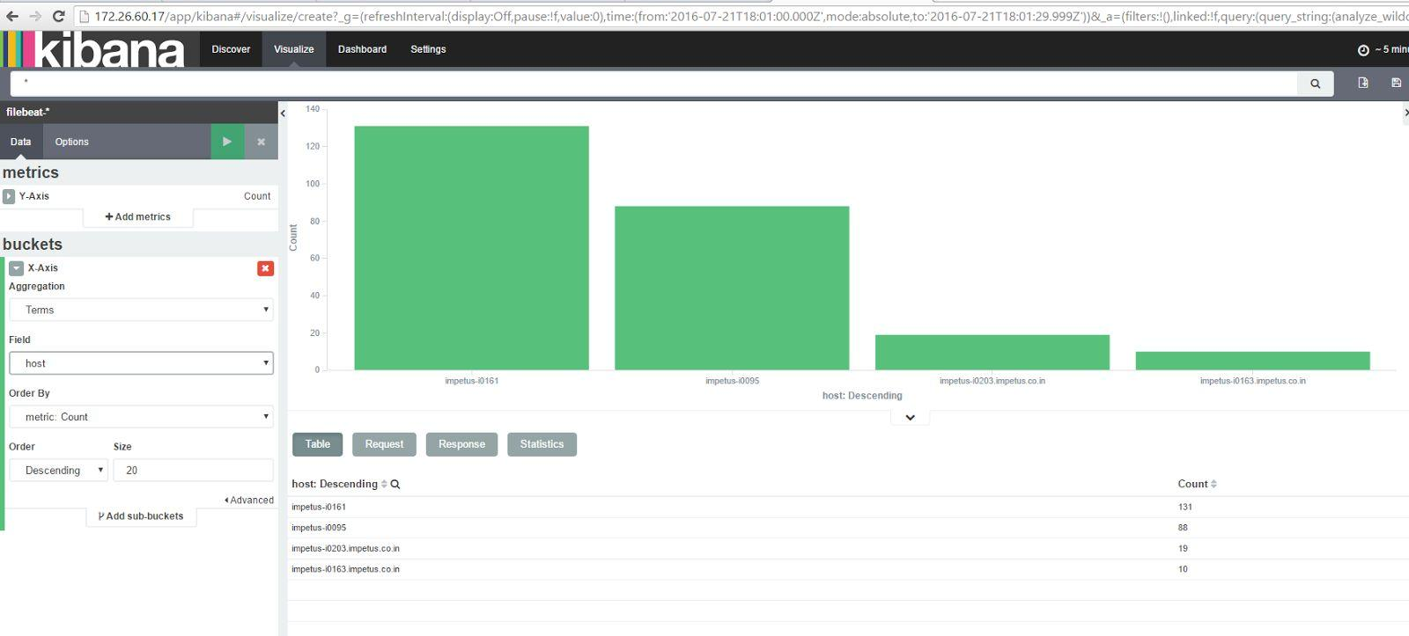

Conclusion

Now that our syslogs are centralized via Elasticsearch and Logstash, and we are able to visualize them with Kibana, we can also centralize all of our important logs. We can send pretty much any type of log or indexed data to Logstash, but the data becomes even more useful if it is parsed and structured with grok. To improve our ELK stack, we should look into gathering and filtering our other logs with Logstash, and ​creating Kibana dashboards​.We can also try to ​gather system metrics by using Topbeat​with our ELK stack.

