Namenode High Availability

The HDFS NameNode High Availability feature enables you to run redundant NameNodes in the same cluster in an Active/Passive configuration with a hot standby. This eliminates the NameNode as a potential single point of failure (SPOF) in an HDFS cluster.

Formerly, if a cluster had a single NameNode, and that machine or process became unavailable, the entire cluster would be unavailable until the NameNode was either restarted or started on a separate machine. This situation impacted the total availability of the HDFS cluster in two major ways:

- In the case of an unplanned event such as a machine crash, the cluster would be unavailable until an operator restarted the NameNode.
- Planned maintenance events such as software or hardware upgrades on the NameNode machine would result in periods of cluster downtime.

HDFS NameNode HA avoids this by facilitating either a fast failover to the new NameNode during machine crash, or a graceful administrator-initiated failover during planned maintenance.

This guide provides an overview of the HDFS NameNode High Availability (HA) feature, instructions on how to deploy Hue with an HA cluster, and instructions on how to enable HA on top of an existing HDP cluster using the Quorum Journal Manager (QJM) and Zookeeper Failover Controller for configuration and management. Using the QJM and Zookeeper Failover Controller enables the sharing of edit logs between the Active and Standby NameNodes.

Note : This guide assumes that an existing HDP cluster has been manually installed and deployed. If your existing HDP cluster was installed using Ambari, configure NameNode HA using the Ambari wizard, as described in the Ambari User's Guide

To ensure that a NameNode in your cluster is always available if the primary NameNode host fails, enable and set up NameNode High Availability on your cluster using Ambari Web.

Follow the steps in the Enable NameNode HA Wizard.

For more information about using the Enable NameNode HA Wizard, see How to Configure NameNode High Availability.
How To Configure NameNode High Availability

- Check to make sure you have at least three hosts in your cluster and are running at least three ZooKeeper servers.

In our case we are running ZooKeeper servers on the following box.

Impetus-i0161.impetus.co.in
impetus-I0163.impetus.co.in
impetus-i0095.impetus.co.in

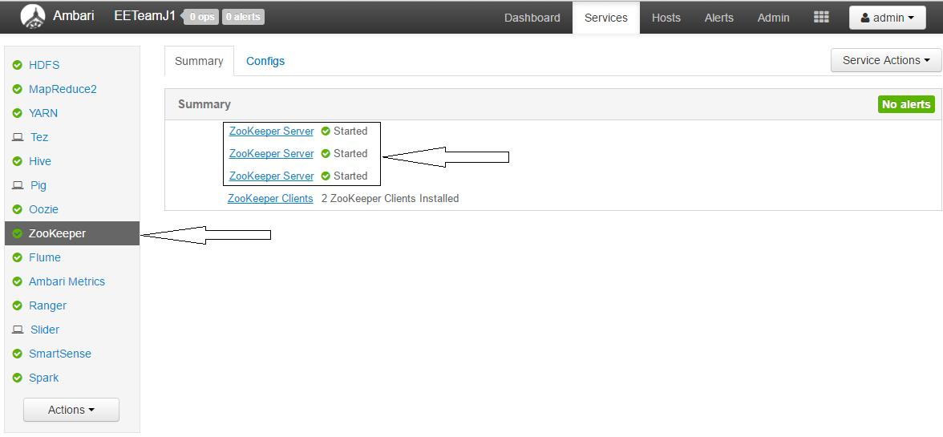

- Check to make sure that the HDFS and ZooKeeper services are not in Maintenance Mode. These services will be stopped and started when enabling NameNode HA. Maintenance Mode will prevent those start and stop operations from occurring. If the HDFS or ZooKeeper services are in Maintenance Mode the NameNode HA wizard will not complete successfully.

3. In Ambari Web, select Services > HDFS > Summary.

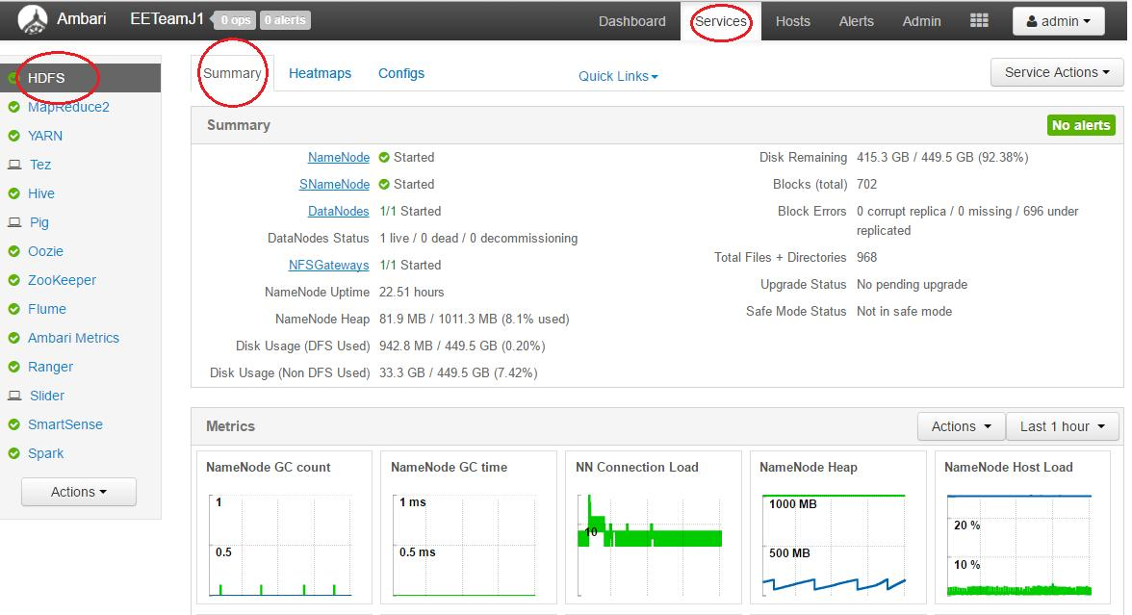

4. Select Service Actions and choose Enable NameNode HA.

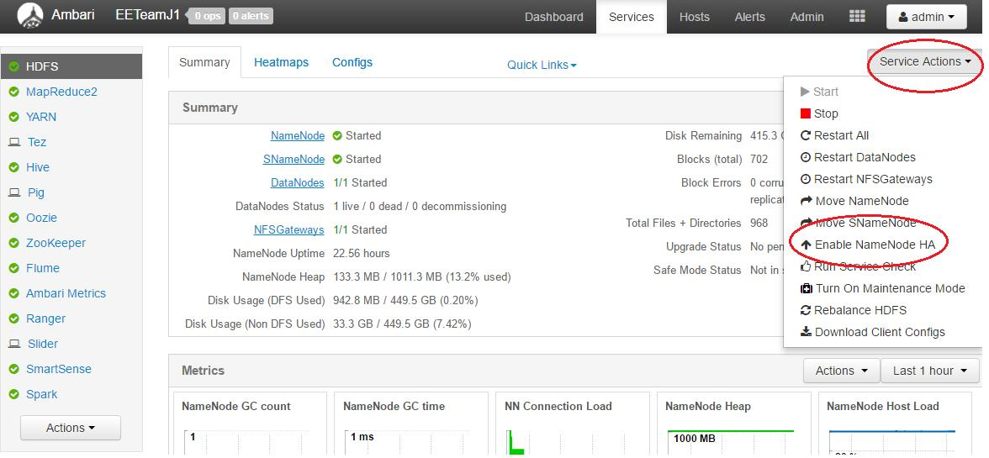

- The Enable HA Wizard launches. This wizard describes the set of automated and manual steps you must take to set up NameNode high availability.

- Get Started : This step gives you an overview of the process and allows you to select a Nameservice ID. You use this Nameservice ID instead of the NameNode FQDN once HA has been set up.

Click Next to proceed.

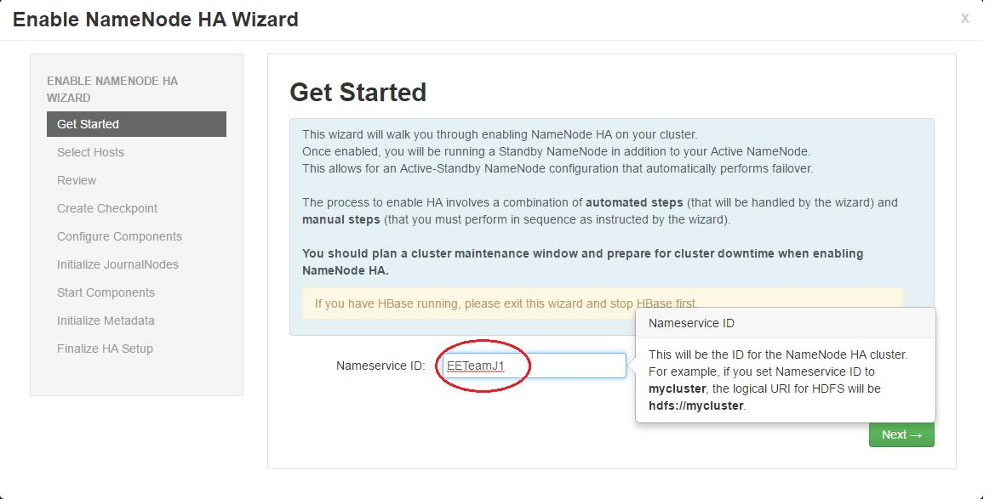

- 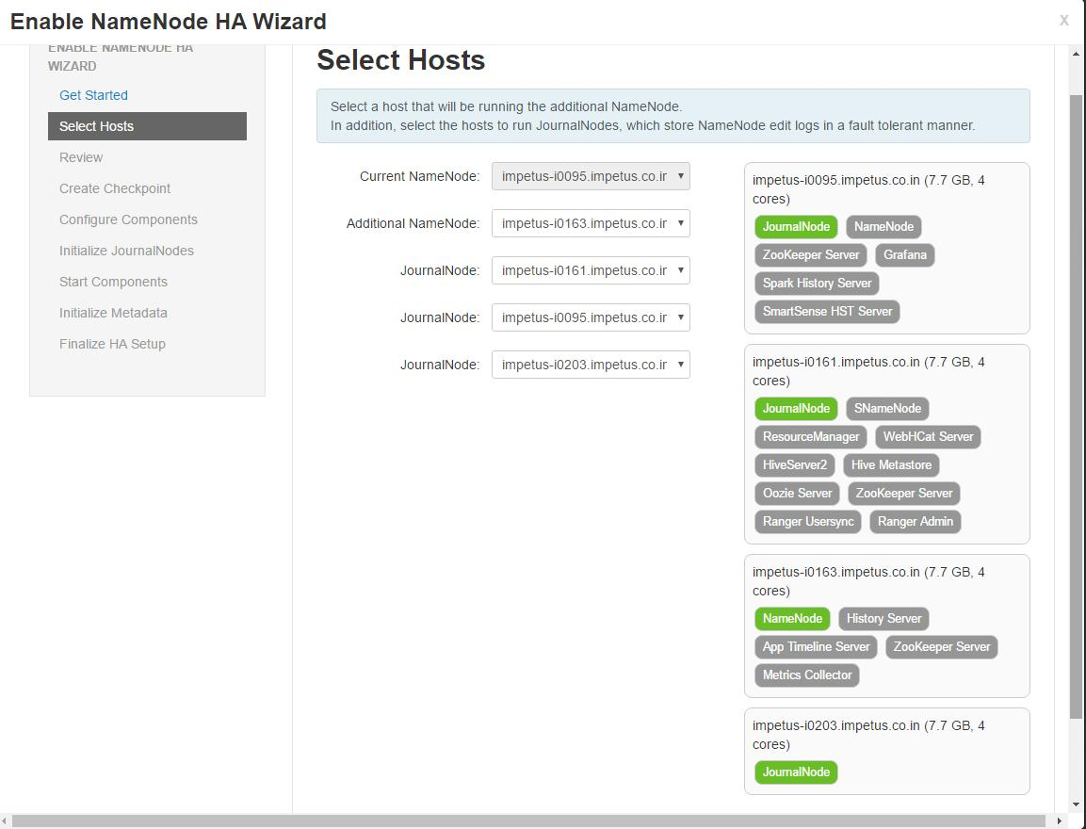Select Hosts : Select a host for the additional NameNode and the JournalNodes. The wizard suggest options that you can adjust using the drop-down lists. Click Next to proceed.

- Review : Confirm your host selections and click Next.

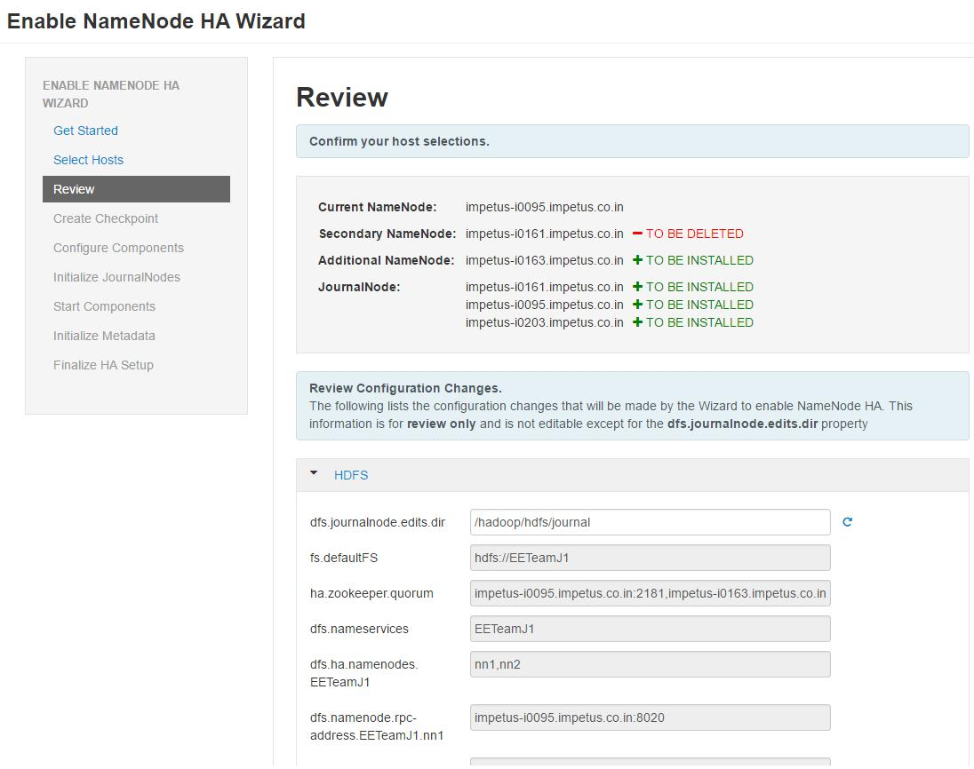

- Create Checkpoints : Follow the instructions in the step. You need to log in to your current NameNode host to run the commands to put your NameNode into safe mode and create a checkpoint. When Ambari detects success, the message on the bottom of the window changes. Click Next.

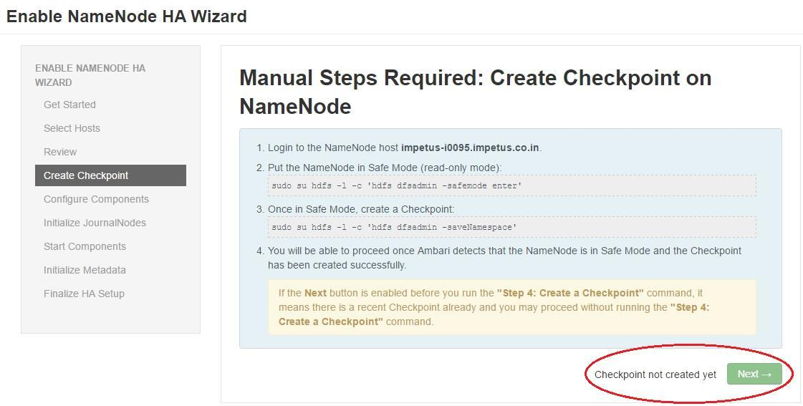

impetus-i0095:$ sudo su hdfs -l -c 'hdfs dfsadmin -safemode enter'

Safe mode is ON

impetus-i0095:~$ sudo su hdfs -l -c 'hdfs dfsadmin -saveNamespace'

Save namespace successful

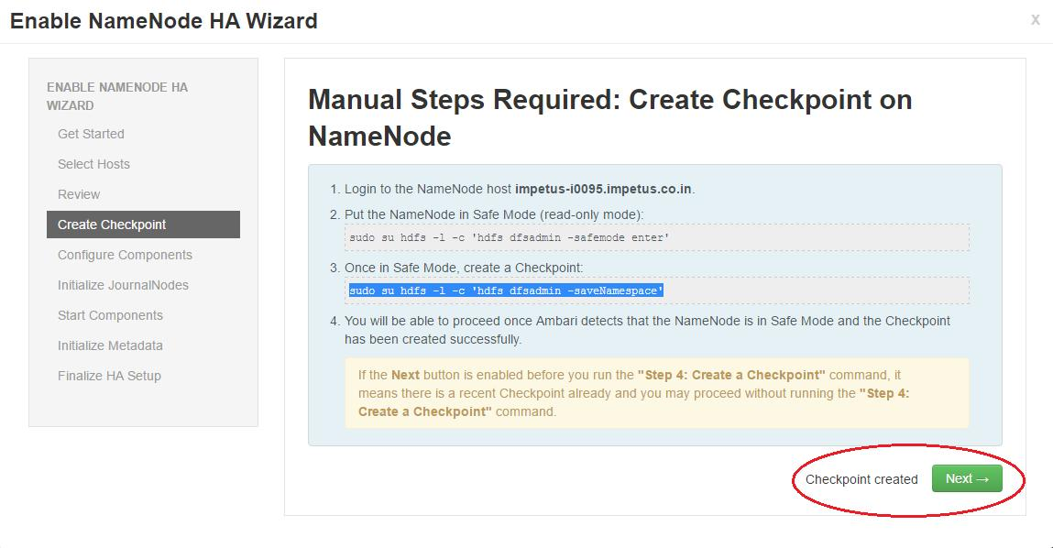

- Configure Components : The wizard configures your components, displaying progress bars to let you track the steps. Click Next to continue.

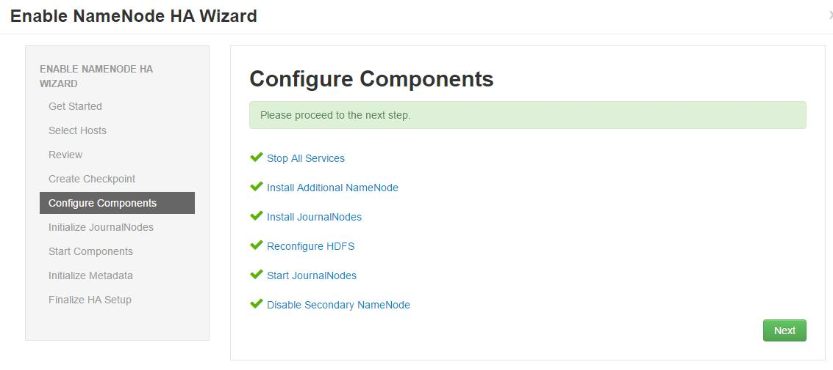

- Initialize JournalNodes : Follow the instructions in the step. You need to login to
your current NameNode host to run the command to initialize the JournalNodes. When Ambari detects success, the message on the bottom of the window changes. Click Next.

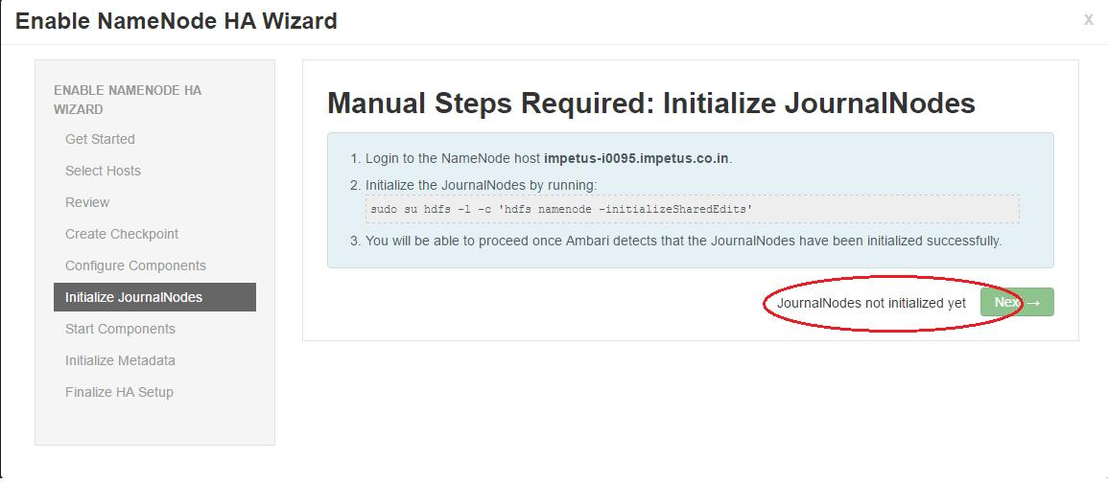

impetus-i0095:~$ sudo su hdfs -l -c 'hdfs namenode -initializeSharedEdits'

16/06/02 19:08:31 INFO namenode.NameNode: STARTUP_MSG: /************************************************************ STARTUP_MSG: Starting NameNode

STARTUP_MSG: host = impetus-i0095.impetus.co.in/172.26.60.19 STARTUP_MSG: args = [-initializeSharedEdits]

STARTUP_MSG: version = 2.7.1.2.4.2.0-258 epoch 1

16/06/02 19:08:32 INFO namenode.EditLogInputStream: Fast-forwarding stream '/hadoop/hdfs/namenode/current/edits_0000000000000062342-0000000000000062342' to transaction ID 62342

16/06/02 19:08:32 INFO namenode.FSEditLog: Starting log segment at 62342 16/06/02 19:08:32 INFO namenode.FSEditLog: Ending log segment 62342

16/06/02 19:08:32 INFO namenode.FSEditLog: Number of transactions: 1 Total time for transactions(ms): 1 Number of transactions batched in Syncs: 0 Number of syncs: 1 SyncTimes(ms): 29

16/06/02 19:08:32 INFO util.ExitUtil: Exiting with status 0 16/06/02 19:08:32 INFO namenode.NameNode: SHUTDOWN_MSG: /************************************************************ SHUTDOWN_MSG: Shutting down NameNode at impetus-i0095.impetus.co.in/172.26.60.19

************************************************************/

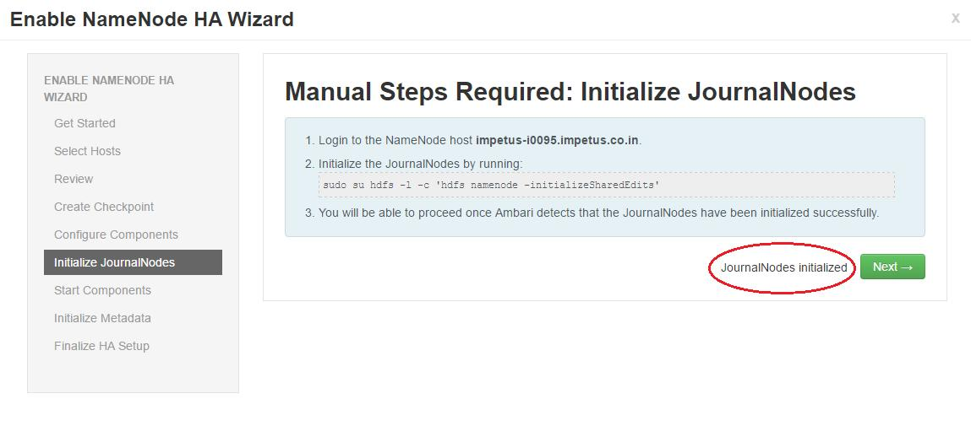

- Start Components : The wizard starts the ZooKeeper servers and the NameNode, displaying progress bars to let you track the steps. Click Next to continue.

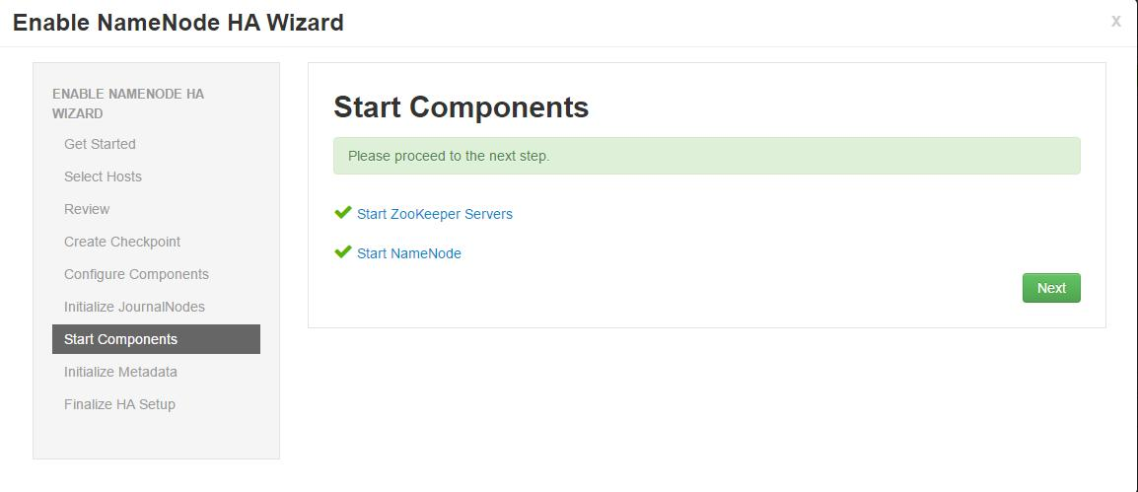

Initialize Metadata : Follow the instructions in the step. For this step you must log in to both the current NameNode and the additional NameNode. Make sure you are logged in to the correct host for each command. Click Next when you have completed the two commands.

A Confirmation pop-up window displays, reminding you to do both steps. Click OK to confirm.

- Login to the NameNode host impetus-i0095.impetus.co.in.

- Initialize the metadata for NameNode automatic failover by running: sudo su hdfs -l -c 'hdfs zkfc -formatZK'

- Login to the Additional NameNode host impetus-i0163.impetus.co.in.

Important! Be sure to login to the Additional NameNode host. This is a different host from the Steps 1 and 2 above.

- Initialize the metadata for the Additional NameNode by running:
sudo su hdfs -l -c 'hdfs namenode -bootstrapStandby'
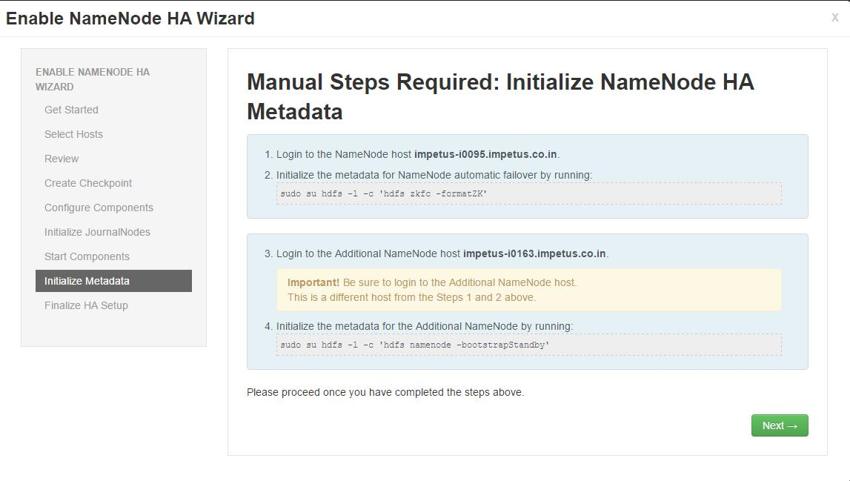

- Finalize HA Setup : The wizard the setup, displaying progress bars to let you track the steps. Click Done to finish the wizard. After the Ambari Web GUI reloads, you may see some alert notifications. Wait a few minutes until the services come back up. If necessary, restart any components using Ambari Web.

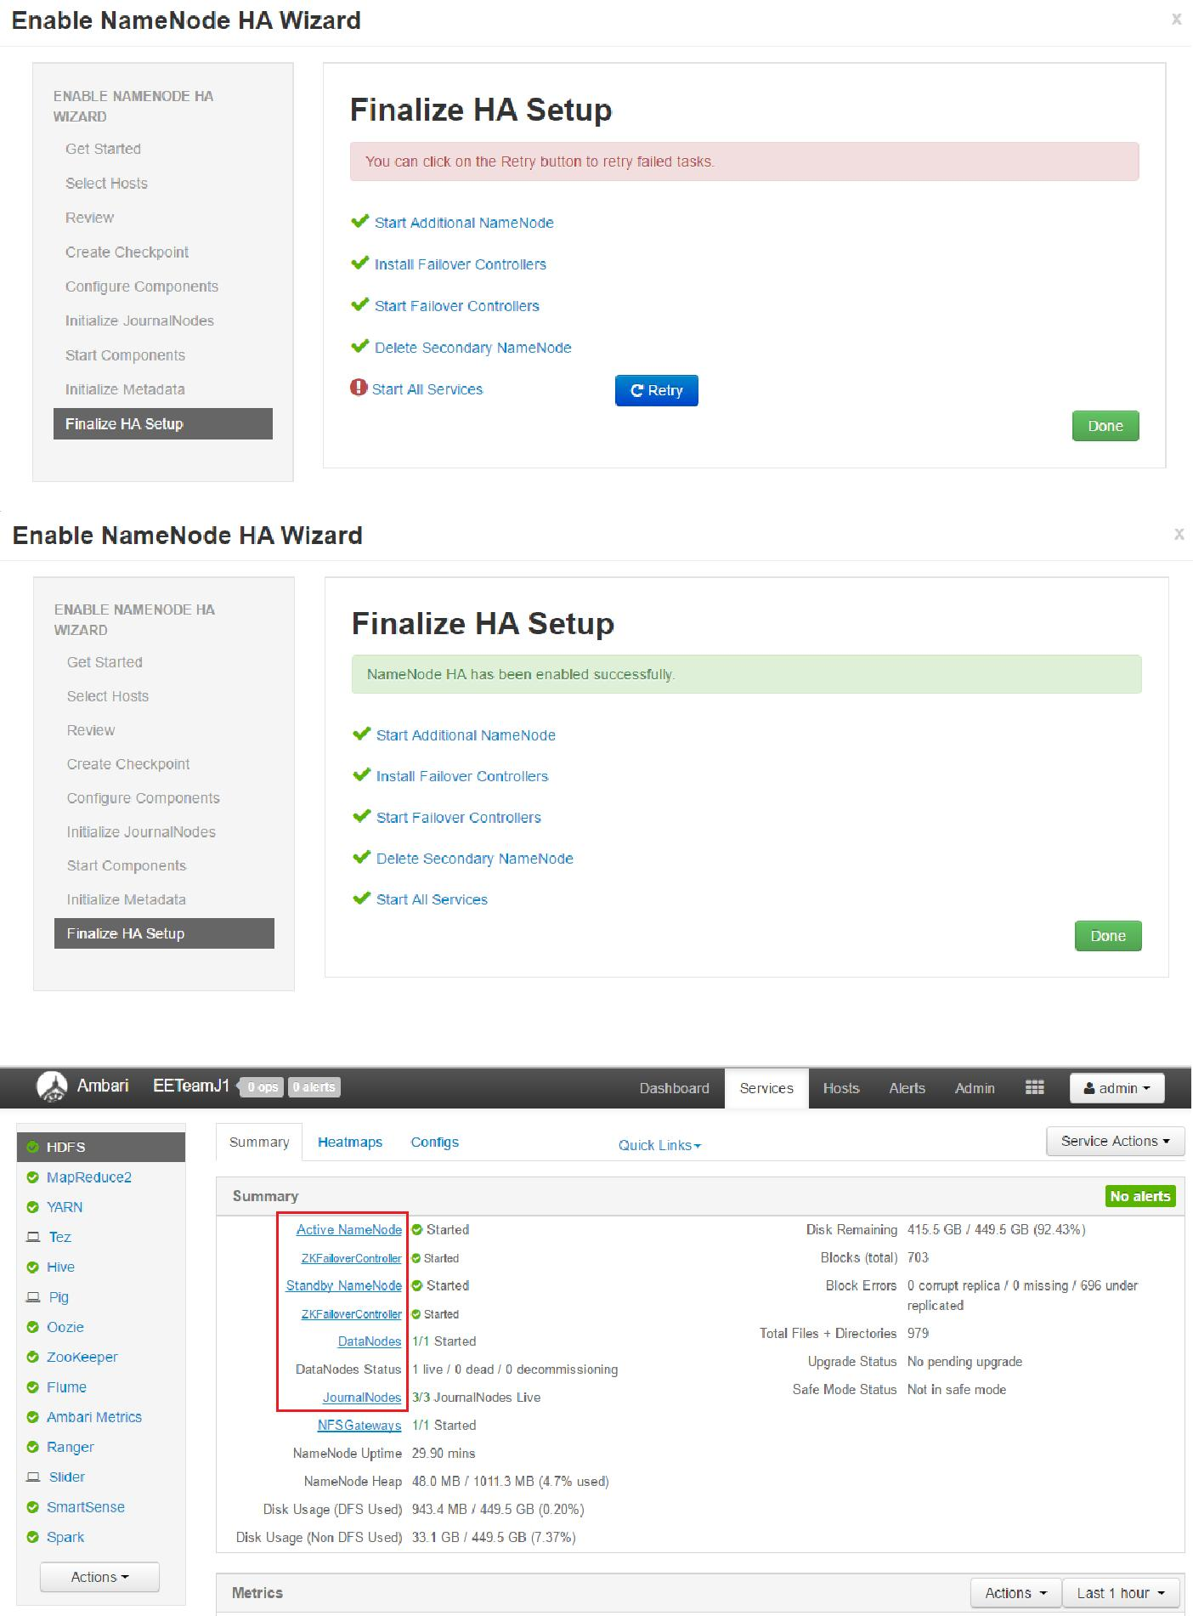

15. Adjust the ZooKeeper Failover Controller retries setting for your environment. Browse to Services > HDFS > Configs >core-site.
Setha.failover-controller.active-standby-elector.zk.op.retries=120
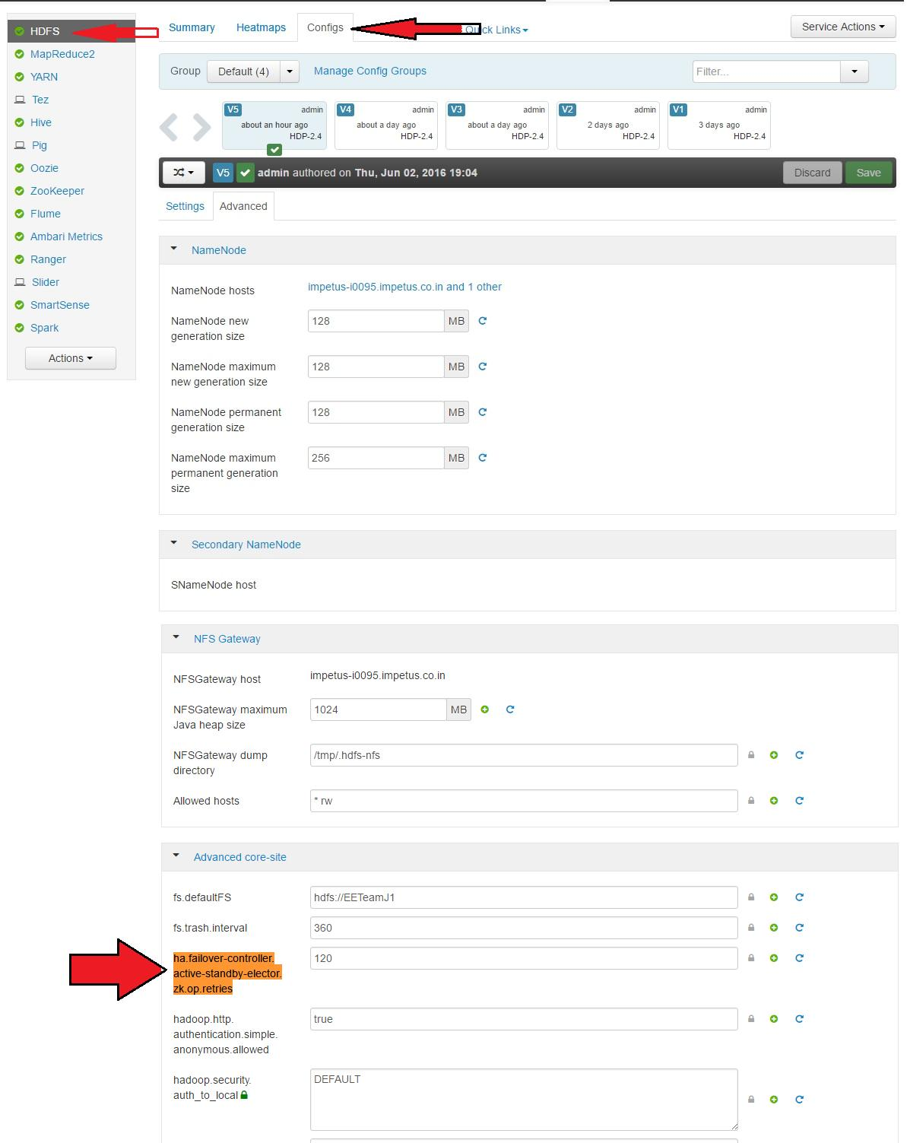
ResourceManager High Availability

The ResourceManager (RM) is responsible for tracking the resources in a cluster, and scheduling applications (e.g., MapReduce jobs). Prior to Hadoop 2.4, the ResourceManager is the single point of failure in a YARN cluster. The High Availability feature adds redundancy in the form of an Active/Standby ResourceManager pair to remove this otherwise single point of failure.

Note: This feature is available with HDP Stack 2.2 or later.

The following topic explains How to Configure ResourceManager High Availability.

How to Configure ResourceManager High Availability

- Check to make sure you have at least three hosts in your cluster and are running at least three ZooKeeper servers.

- In Ambari Web, browse to Services > YARN > Summary. Select Service Actions and choose Enable ResourceManager HA.

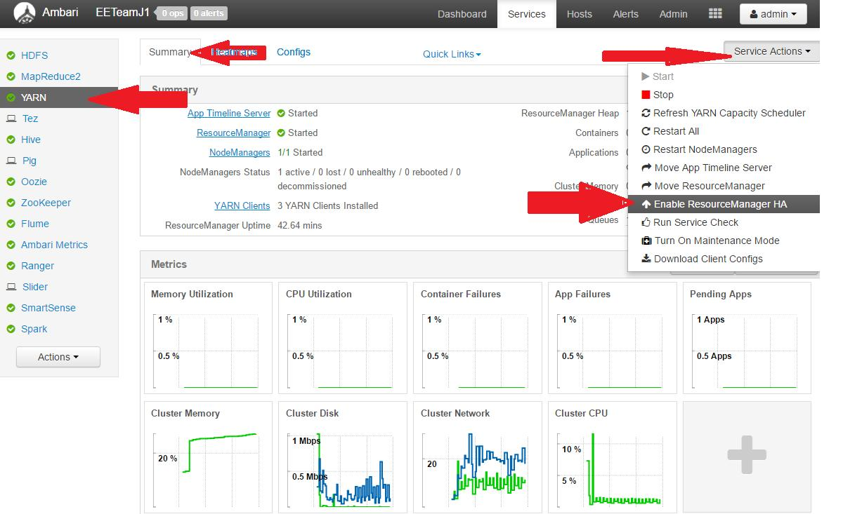

- The Enable ResourceManager HA Wizard launches. The wizard describes a set of automated and manual steps you must take to set up ResourceManager High Availability.

- Get Started: This step gives you an overview of enabling ResourceManager HA. Click Next to proceed.

- Select Host: The wizard shows you the host on which the current ResourceManager is installed and suggests a default host on which to install an additional ResourceManager. Accept the default selection, or choose an available host. Click Next to proceed.
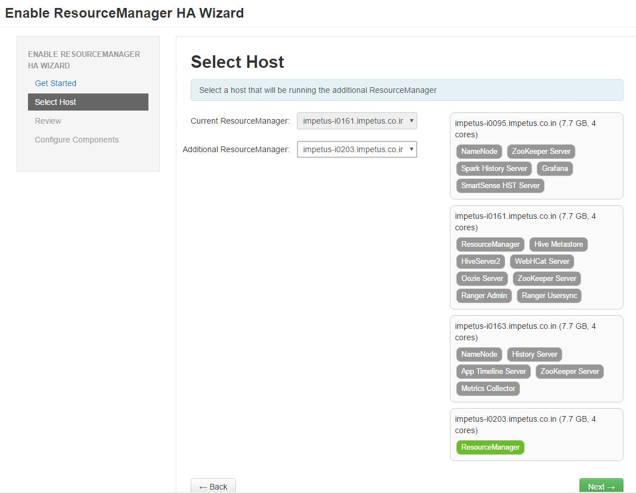

- Review Selections: The wizard shows you the host selections and configuration changes that will occur to enable ResourceManager HA. Expand YARN, if necessary, to review all the YARN configuration changes. Click Next to approve the changes and start automatically configuring ResourceManager HA.

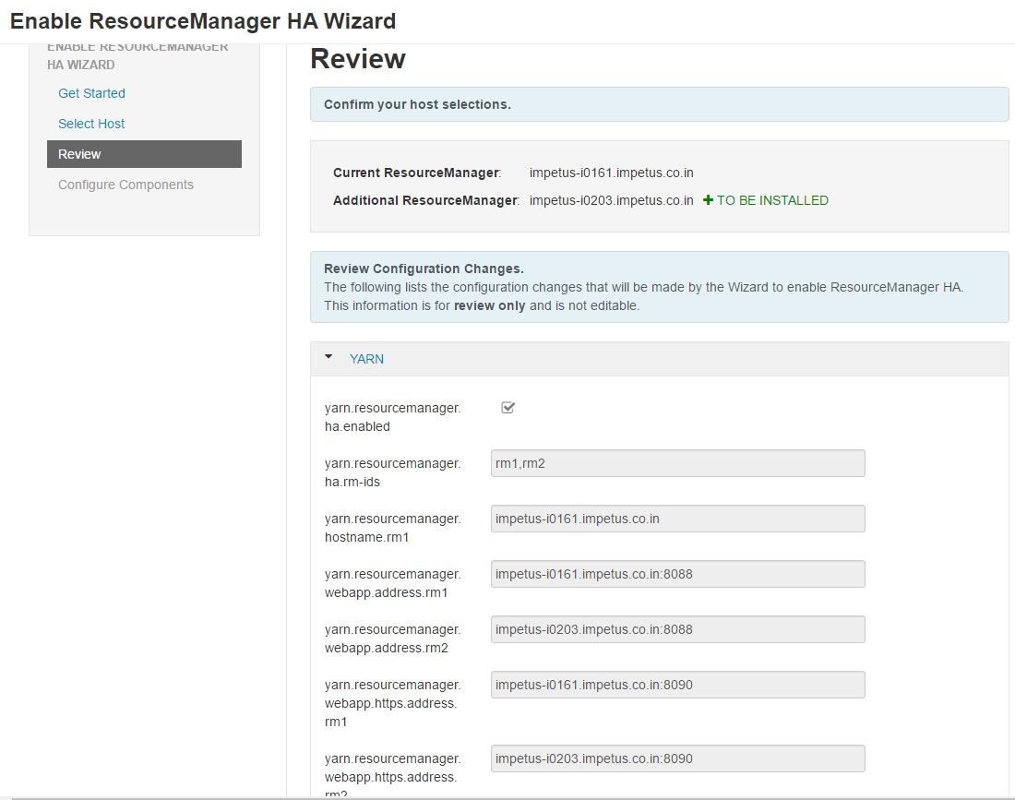

- Configure Components: The wizard configures your components automatically, displaying progress bars to let you track the steps. After all progress bars complete, click Complete to finish the wizard.

