Data upload using PIG

Load Movies data into HIVE table:

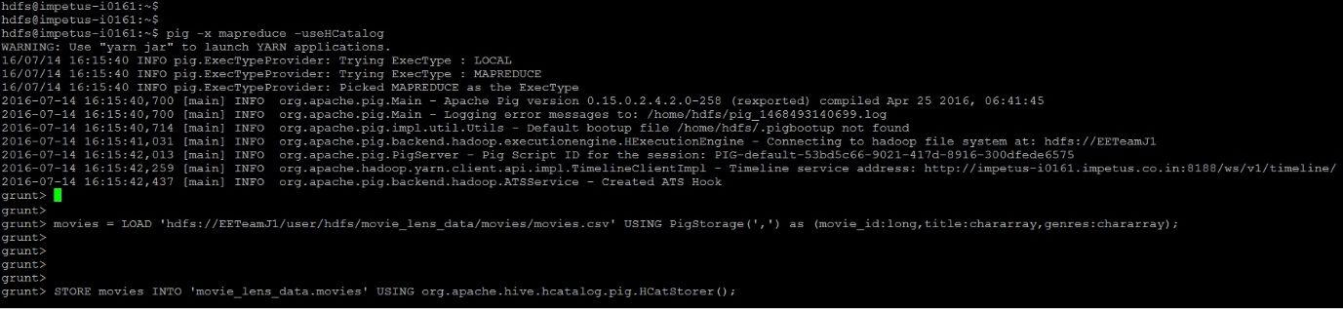

Movie data upload result:

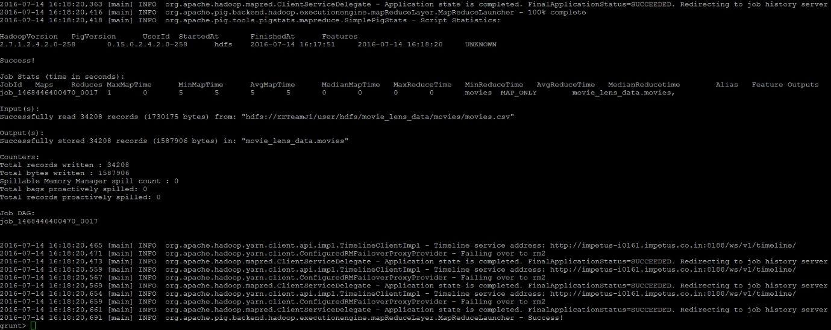

Load Ratings data into HIVE table:
Ratings data upload result:

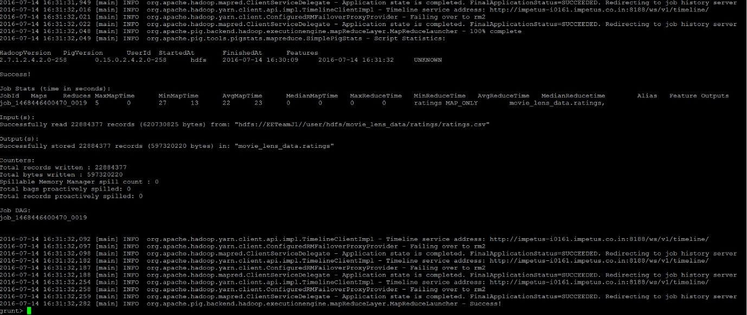

Load Users data into HIVE table:

Users data upload result:

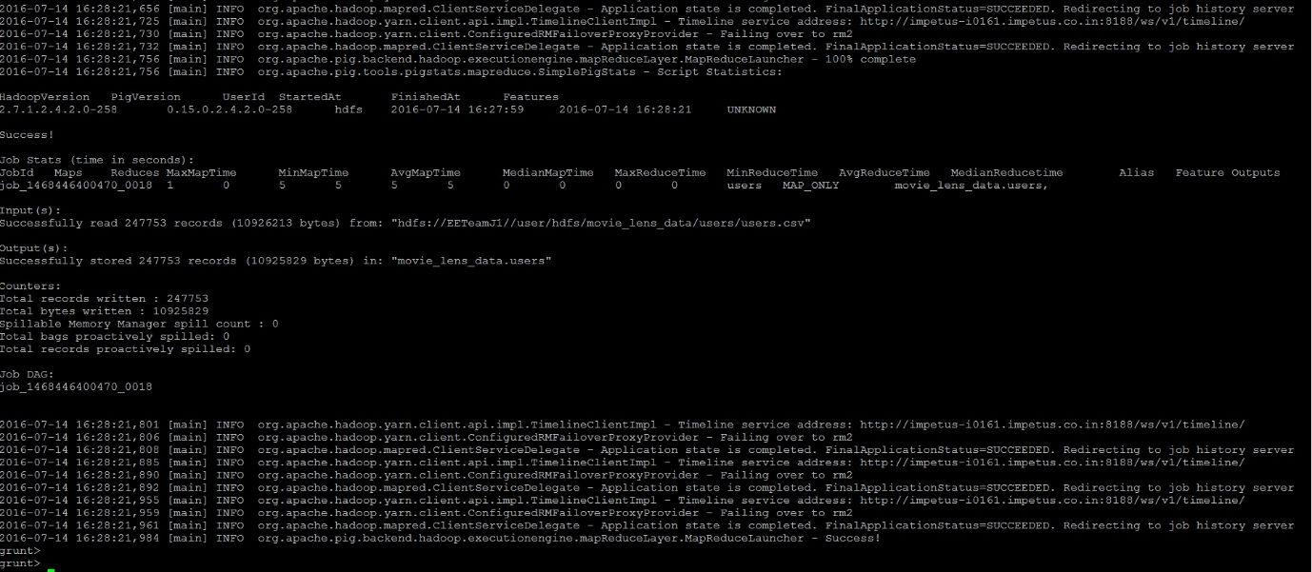
HIVE Queries execution:

Create Database & Users table:

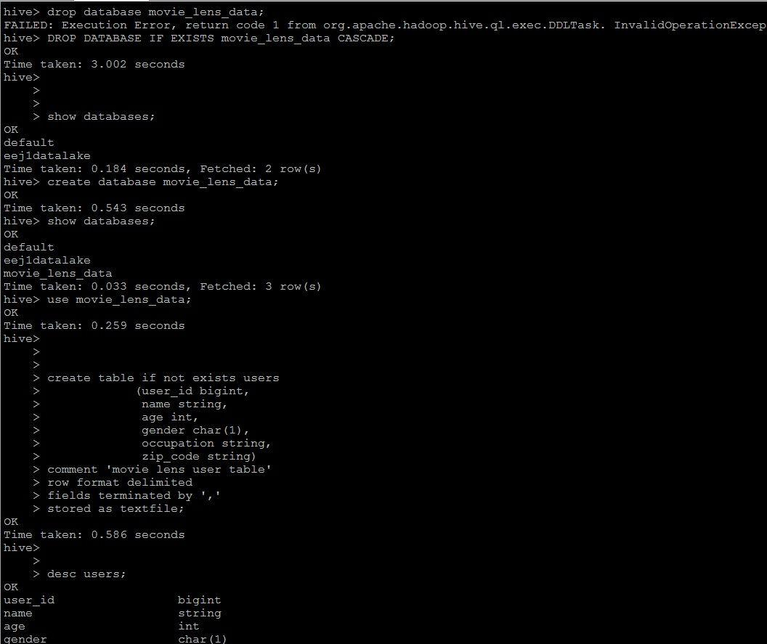
Create Movies Table:

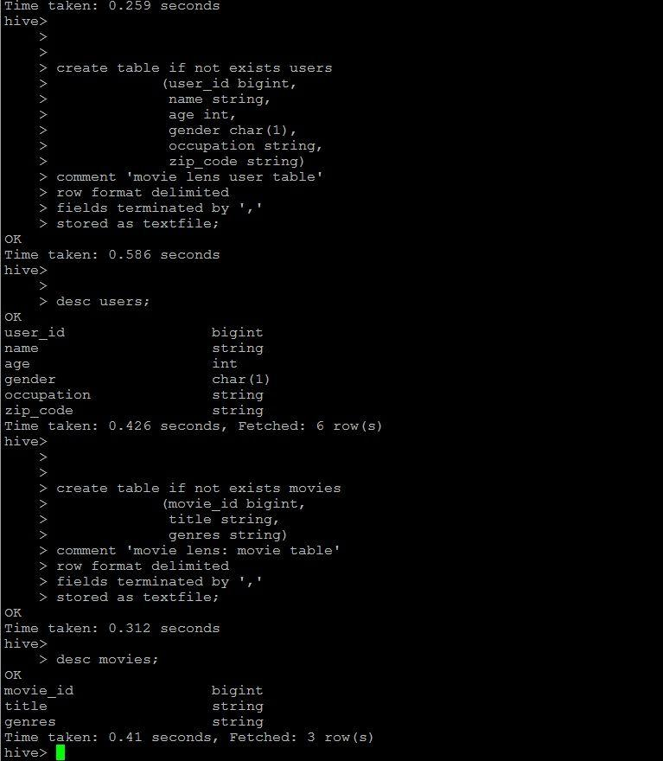
Create Ratings Table:
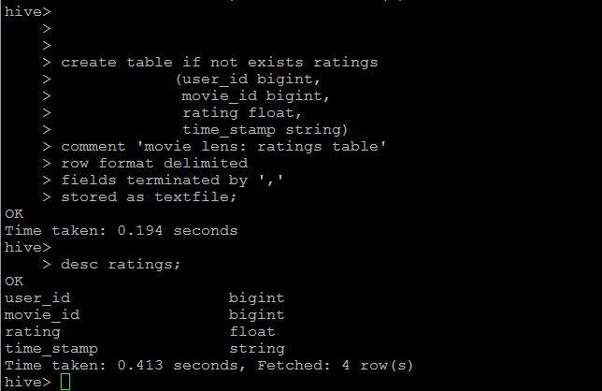

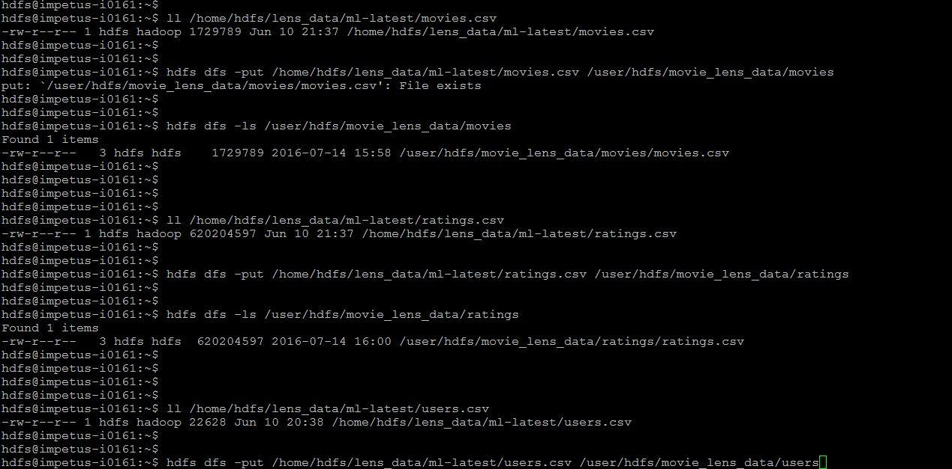Load Data to HDFS:

Movies Count Verification:

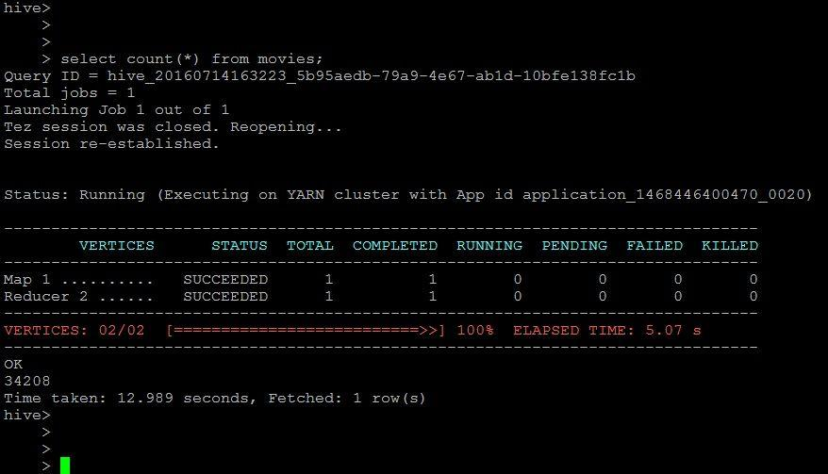

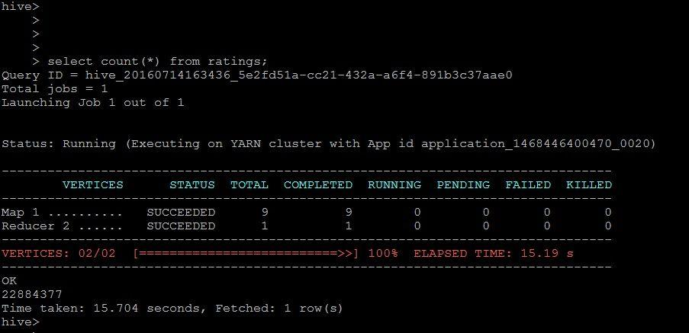Ratings Count Verification:

Users Count Verification:
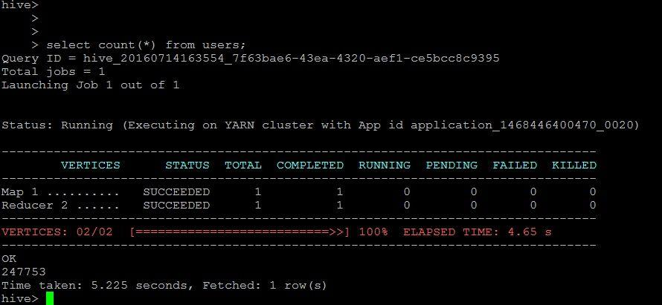
Use Case #1: List all the movies and the number of ratings



Use Case #2: List all the users and the number of ratings they have done for a movie

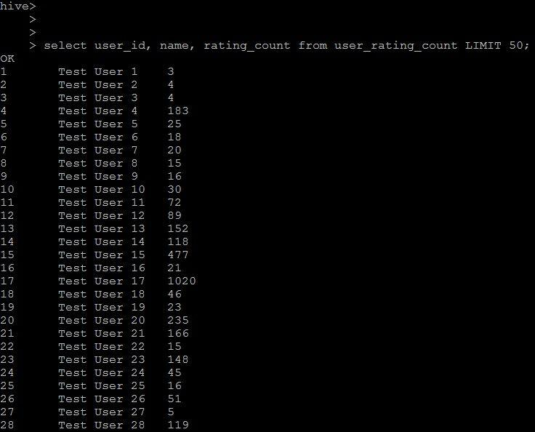

Use Case #3: List all the Movie IDs which have been rated (Movie Id with atleast one user rating it)



Use Case #4: List all the Users who have rated the movies (Users who have rated atleast one movie)
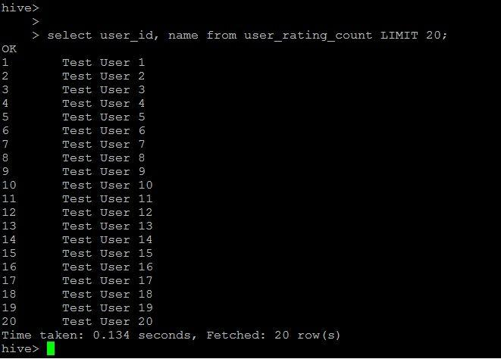

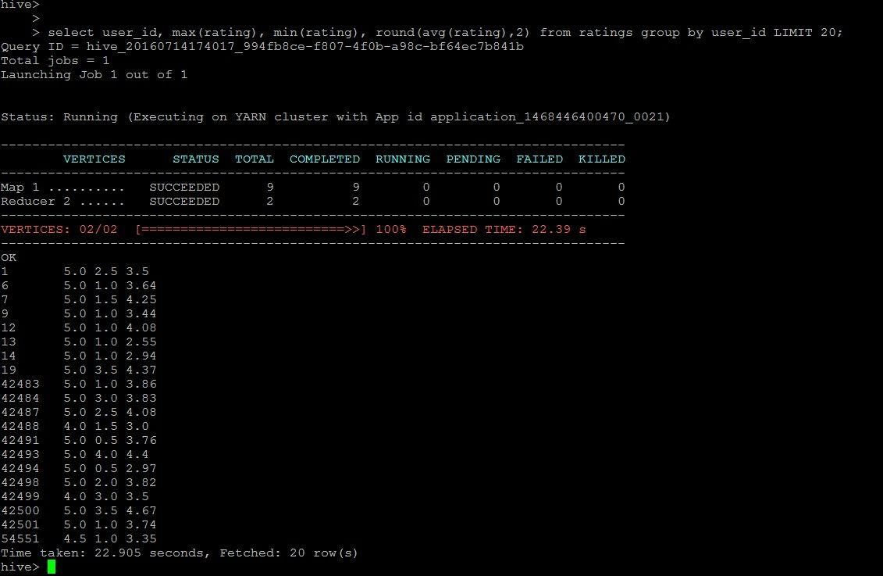Use Case #5: List of all the User with the max,min,average ratings they have given against any movie

Use Case #6: List all the Movies with the max, min, average ratings given by any user

