APACHE RANGER

Comprehensive security for Enterprise Hadoop

Apache Ranger delivers a comprehensive approach to security for a Hadoop cluster. It provides central security policy administration across the core enterprise security requirements of authorization, authentication, audit and data protection.

Apache Ranger offers a centralized security framework to manage fine-grained access control over Hadoop data access components like Apache Hive and Apache HBase. Using the Apache Ranger console, security administrators can easily manage policies for access to files, folders, databases, tables, or column. These policies can be set for individual users or groups and then enforced within Hadoop.

Security administrators can also use Apache Ranger to manage audit tracking and policy analytics for deeper control of the environment. The solution also provides an option to delegate administration of certain data to other group owners, with the aim of securely decentralizing data ownership.

Apache Ranger currently supports authorization, authentication, auditing, data encryption and security administration for the following HDP components:
Apache Hadoop HDFS Apache Hive

Apache HBase Apache Storm Apache Knox Apache Solr

Apache Kafka YARN

Overview
Apache Ranger can be installed either manually using the Hortonworks Data Platform (HDP) or the Ambari 2.1 User Interface (UI). Unlike the manual installation process, which requires you to perform a number of installation steps, installing Ranger using the Ambari UI is simpler and easier. The Ranger service option will be made available through the Add Service wizard after the HDP cluster is installed using the installation wizard.
Once Ambari has been installed and configured, you can use the Add Service wizard to install the following components:

Ranger Admin

Ranger UserSync

Ranger Key Management Service

After these components are installed and started, you can enable Ranger plugins by navigating to each individual Ranger service (HDFS, HBase, Hiveserver2, Storm, Knox, YARN, and Kafka) and modifying the configuration under advanced ranger-<service>-plugin-properties.

Note that when you enable a Ranger plugin, you will need to restart the component.

Note

Enabling Apache Storm or Apace Kafka requires you to enable Kerberos. To enable Kerberos on your cluster, see Enabling Kerberos Security in the Ambari Security Guide.

Installation Prerequisites

Before you install Ranger, make sure your cluster meets the following requirements:

A MySQL, Oracle, or PostgreSQL database instance is running and available to be used by Ranger.

The Ranger installation will create two new users (default names: rangeradmin and rangerlogger) and two new databases (default names: ranger and ranger_audit).

Configure the database instance for Ranger as described in the following sections.

- Configuring MySQL for Ranger

- Configuring PostgreSQL for Ranger

- Configuring Oracle for Ranger

Ranger Installation

Use the following steps to install Ranger using Ambari.

Start the Installation

- Log into your Ambari cluster with your user credentials. The main Ambari Dashboard page will be displayed.

- In the left navigation menu, click Actions, then select Add Service.

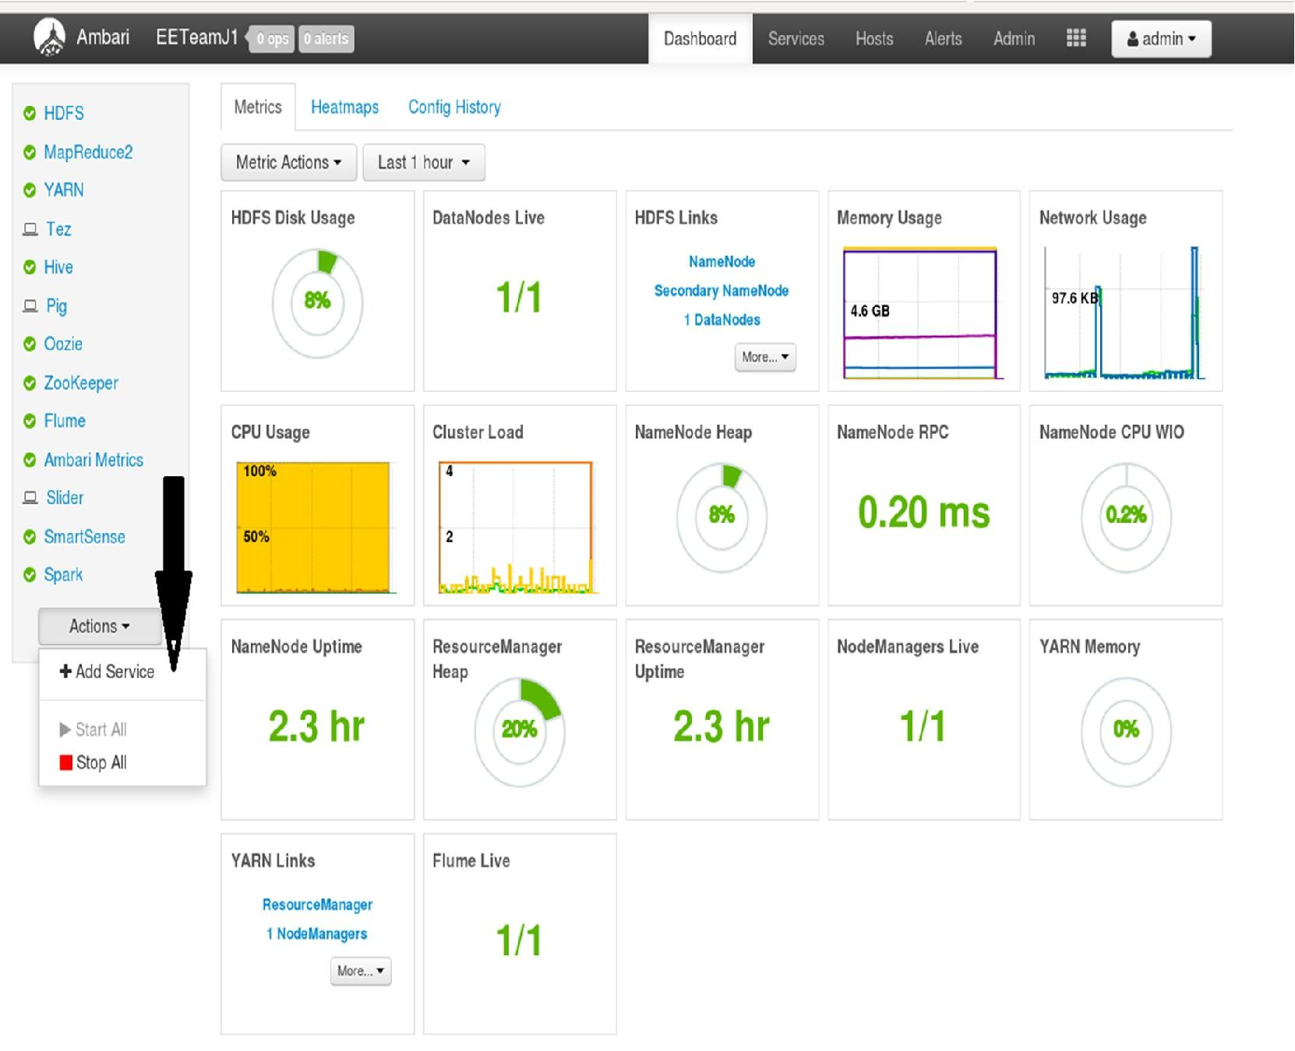

- On the Choose Services page, select Ranger, then click Next

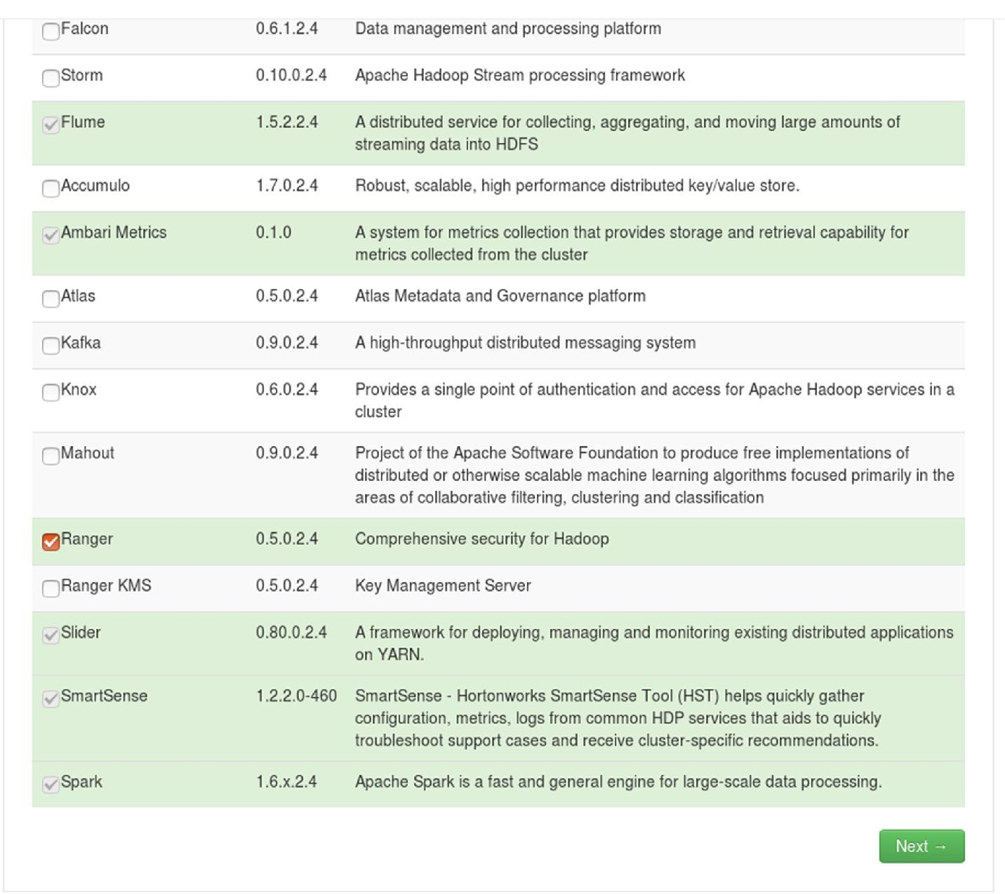

- The Ranger Requirements page appears. Ensure that you have met all of the installation requirements, then select the "I have met all the requirements above" check box and click Proceed.

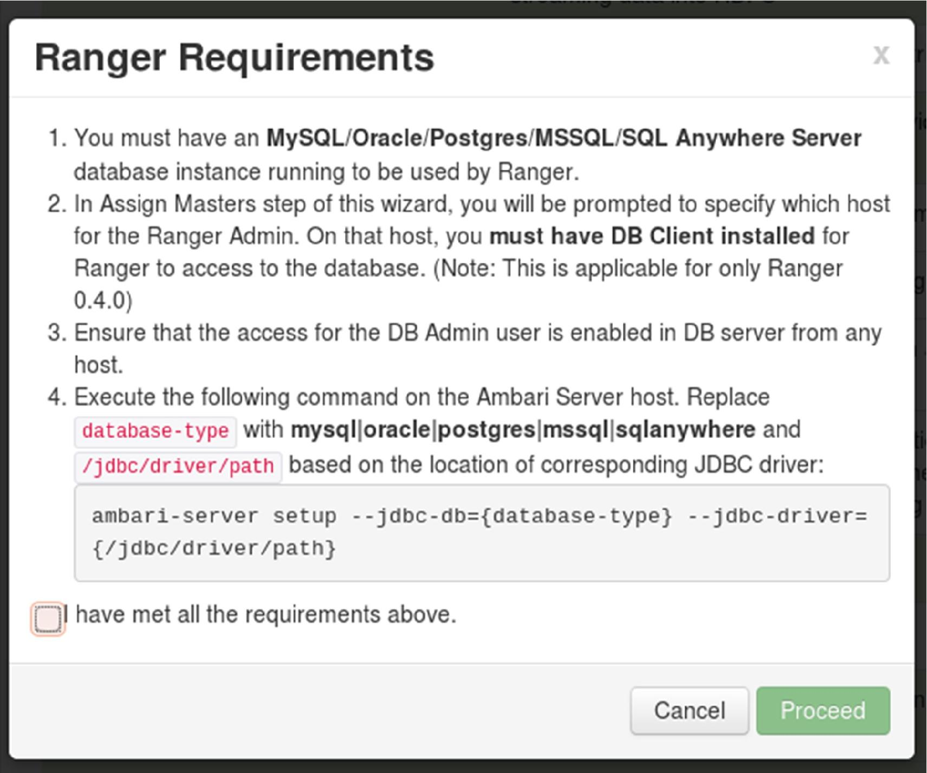

Run the below command using root or postgres user on impetus-i0161.impetus.co.in as that’s where ambari is running. Once you get the setup successful message then we can proceed to the next step.

# ambari-server setup --jdbc-db=postgres --jdbc-driver=/usr/lib/ambari-server/postgresql-9.3-1101-jdbc4.jar

Using python /usr/bin/python

Setup ambari-server

Copying /usr/lib/ambari-server/postgresql-9.3-1101-jdbc4.jar to /var/lib/ambari-server/resources

JDBC driver was successfully initialized.

Ambari Server 'setup' completed successfully.

You are then prompted to select the host where Ranger Admin will be installed. This host should have DB admin access to the Ranger DB host and UserSync. Notice in the figure below that both the Ranger Admin and Ranger Usersync services will be installed on the host impetus-i0161.impetus.co.in as postgres is already configured on that host.

Make a note of the Ranger Admin host for use in subsequent installation steps. Click Next when finished to continue with the installation.

Note: The Ranger Admin and Ranger Usersync services must be installed on the same cluster node.
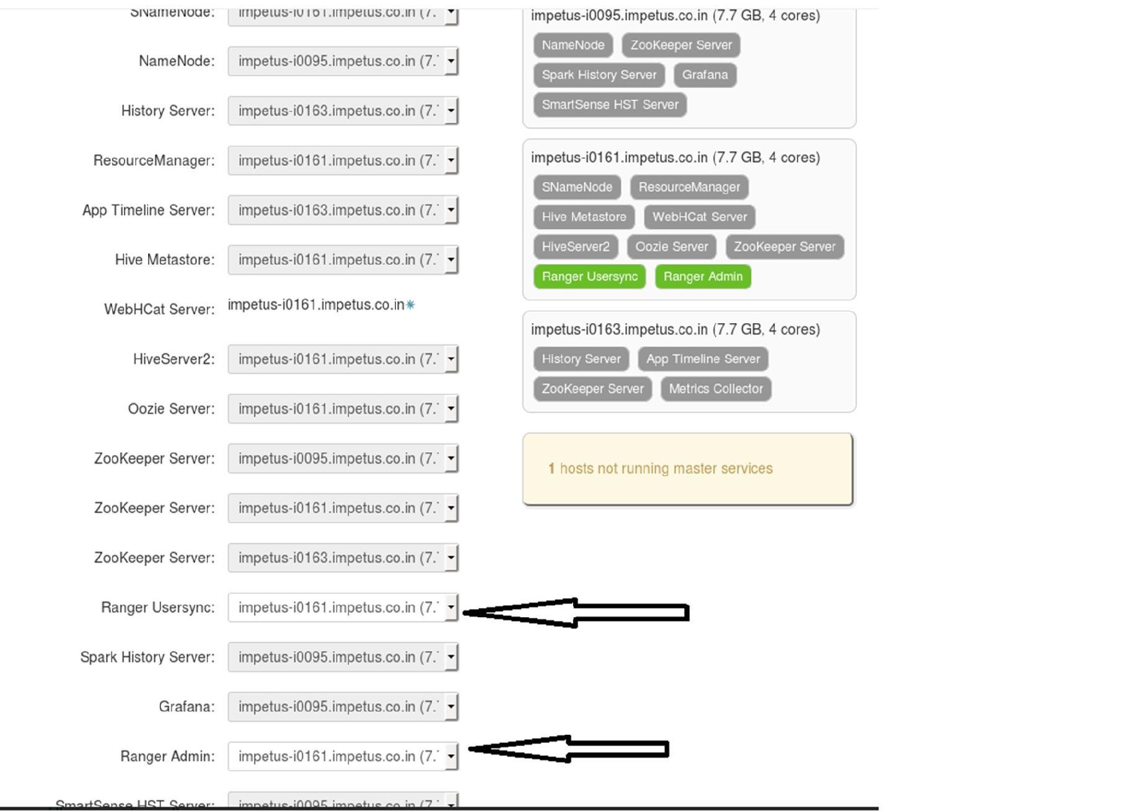

Customize Services

The next step in the installation process is to specify Ranger settings on the Customize Services page. You must specify all of the following settings on the Customize Services page before clicking Next at the bottom of the page to continue with the installation.
Admin Settings

- Under Admin Settings on the Customize Services page, type in the password for the user account used by Ambari( This setting is only on a non-ambari host ) . This password will only be used by the Ambari Agent, and will be used with the user name specified in the Ranger configuration asranger_admin_username under "Advanced ranger-env".

Use postgres as DB_Flavour and enter the Ranger DB host as impetus-i0161.impetus.co.in and set the Ranger DB password as “ranger”
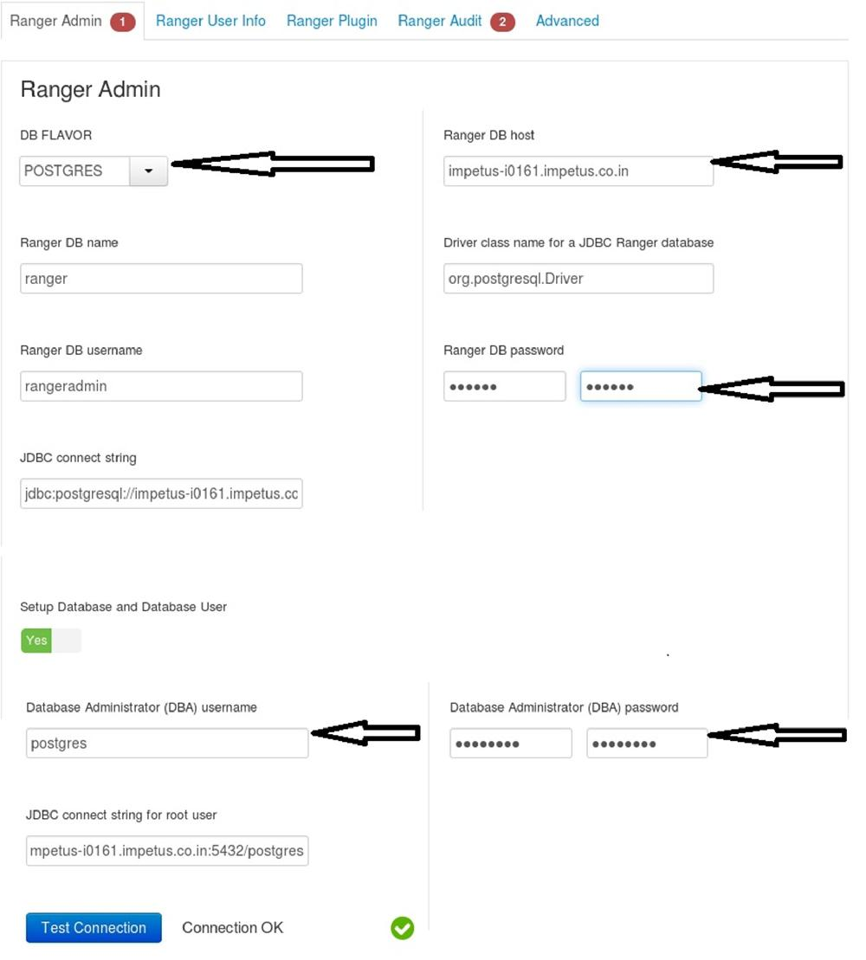
If you get error while testing connection saying postgres password is wrong then run the following on the box impetus-i0161.impetus.co.in

- sudo su – postgres

- psql
postgres=# ALTER USER postgres with encrypted password 'postgres';

Leave default settings for Ranger User info and enable all available plugins under Ranger Plugin tabs. In Ranger Audits and advance tabs change only those show in the figure leave others default.

Ranger.audit.solr.username = http://impetus-i0161.impetus.co.in:6083/solr/ranger_audits Ranger Audit DB password = ranger
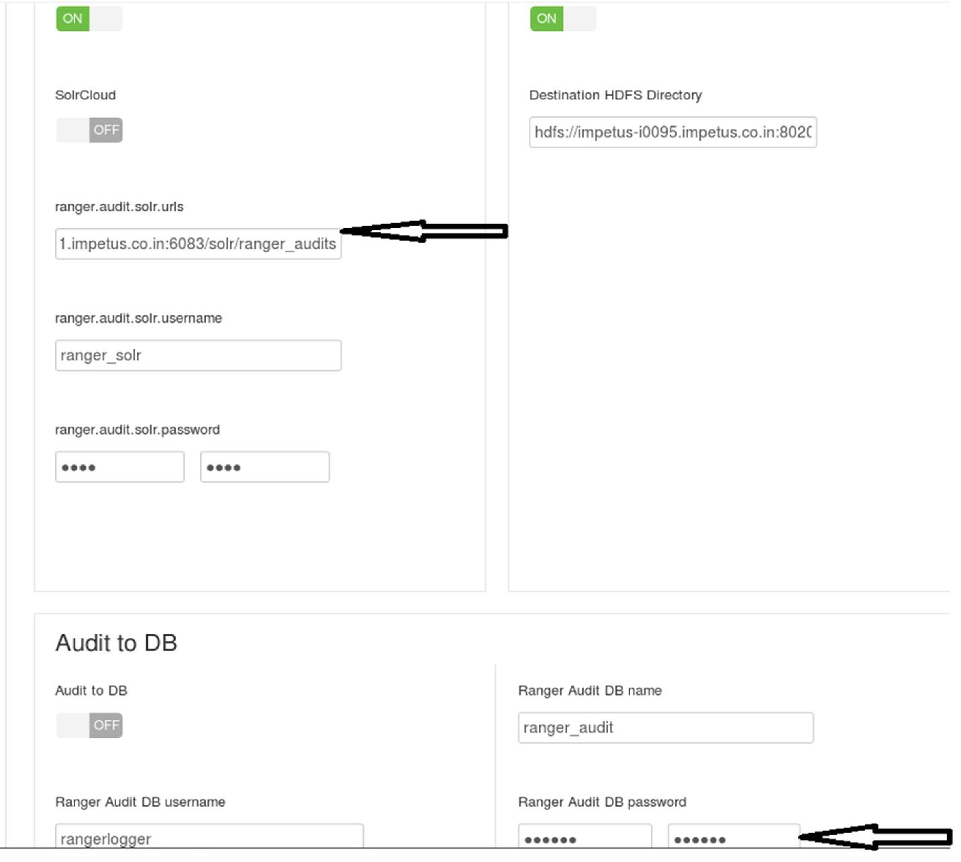
Using Apache Solr for Ranger Audits : Apache Solr is an open-source enterprise search platform. Apache Ranger can use Apache Solr to store audit logs, and Solr can also to provide a search capability of the audit logs through the ranger Admin UI

Solr Prerequisites

Ranger supports Apache Solr 5.2 or higher. Apache Solr requires the Java Runtime Environment (JRE) version 1.7 or higher. 1 TB free space in the volume where Solr will store the index data. 32 GB RAM.
