Engineering Excellence J1

(Configuring Ambari and Hadoop for Kerberos)

Contents

- Configuring Ambari and Hadoop for Kerberos …………………………………………………………………….1
- Installing and Configuring the KDC .…………………..……………………………………………………………… .3

Configuring Ambari and Hadoop for Kerberos

This chapter describes how to configure Kerberos for strong authentication for Hadoop users and hosts in an Ambari­managed cluster.

Kerberos Overview

Strongly authenticating and establishing a user’s identity is the basis for secure access in Hadoop. Users need to be able to reliably “identify” themselves and then have that identity propagated throughout the Hadoop cluster. Once this is done, those users can access resources (such as files or directories) or interact with the cluster (like running MapReduce jobs). Besides users, Hadoop cluster resources themselves (such as Hosts and Services) need to authenticate with each other to avoid potential malicious systems or daemon’s “posing as” trusted components of the cluster to gain access to data.

Hadoop uses Kerberos as the basis for strong authentication and identity propagation for both user and services. Kerberos is a third party authentication mechanism, in which users and services rely on a third party ­ the Kerberos server ­ to authenticate each to the other. The Kerberos server itself is known as the ​Key Distribution Center​,or ​KDC​.At a high level, it has three parts:

- A database of the users and services (known as ​principals​)that it knows about and their respective Kerberos passwords

- An ​Authentication Server​(​AS​)which performs the initial authentication and issues a ​Ticket Granting Ticket​(​TGT​)

- A ​Ticket Granting Server​(​TGS​)that issues subsequent service tickets based on the initial ​TGT

A ​user principal​requests authentication from the AS. The AS returns a TGT that is encrypted using the user principal's Kerberos password, which is known only to the user principal and the AS. The user principal decrypts the TGT locally using its Kerberos password, and from that point forward, until the ticket expires, the user principal can use the TGT to get service tickets from the TGS. Service tickets are what allow a principal to access various services.

Because cluster resources (hosts or services) cannot provide a password each time to decrypt the TGT, they use a special file, called a ​keytab​,which contains the resource principal's authentication credentials. The set of hosts, users, and services over which the Kerberos server has control is called a ​realm​.

Terminology

Term | Description
Key Distribution Center, | The trusted source for authentication in a Kerberos­enabled
or KDC | environment.
Kerberos KDC Server | The machine, or server, that serves as the Key Distribution Center (KDC).
Kerberos Client | Any machine in the cluster that authenticates against the KDC.
Principal | The unique name of a user or service that authenticates against the KDC
Keytab | A file that includes one or more principals and their keys.
Realm | The Kerberos network that includes a KDC and a number of Clients.
KDC Admin Account | An administrative account used by Ambari to create principals and generate keytabs in the KDC.

Installing and Configuring the KDC

Ambari is able to configure Kerberos in the cluster to work with an existing MIT KDC, or existing Active Directory installation. This section describes the steps necessary to prepare for this integration.

Note: ​Ifyou do not have an existing KDC (MIT or Active Directory), ​Install a new MIT KDC​.Please be aware that installing a KDC on a cluster host ​after​installing the Kerberos client may overwrite the krb5.conf file generated by Ambari.

You can choose to have Ambari connect to the KDC and automatically create the necessary Service and Ambari principals, generate and distribute the keytabs (“Automated Kerberos Setup”).

For convenience, use the instructions to ​(Optional) Install a new MIT KDC​ifyou do not have an existing KDC available.

Install a new MIT KDC

The following gives a very high level description of the KDC installation process. To get more information see specific Operating Systems documentation, such as ​RHEL documentation​,​ CentOS documentation​,or ​SLES documentation​.

Note:​ Because Kerberos is a time­sensitive protocol, all hosts in the realm must be time­synchronized, for example, by using the Network Time Protocol (NTP). If the local system time of a client differs from that of the KDC by as little as 5 minutes (the default), the client will not be able to authenticate.

Install the KDC Server

- Install a new version of the KDC server on Ubuntu/Debian. We select host impetus­I0163 as a KDC server as it has very less component installed as of now.

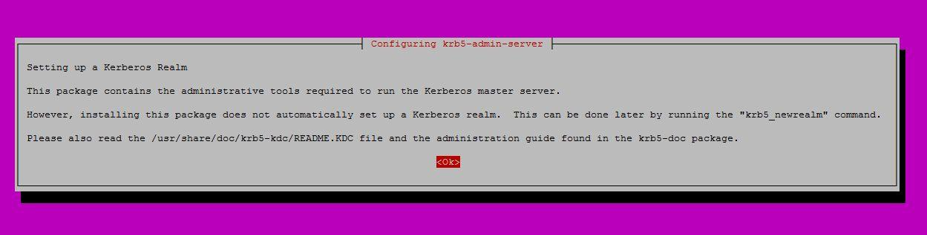apt­get install krb5­kdc krb5­admin­server

root@impetus­I0163:~# apt­get install krb5­kdc krb5­admin­server Reading package lists... Done
Building dependency tree

Reading state information... Done

The following extra packages will be installed: libverto­libevent1 libverto1
Suggested packages:

openbsd­inetd inet­superserver krb5­kdc­ldap The following NEW packages will be installed:
krb5­admin­server krb5­kdc libverto­libevent1 libverto1

0 upgraded, 4 newly installed, 0 to remove and 680 not upgraded. Need to get 269 kB of archives.
After this operation, 1,044 kB of additional disk space will be used. Do you want to continue? [Y/n] y
Get:1 http://in.archive.ubuntu.com/ubuntu/ trusty/main libverto1 amd64 0.2.4­1ubuntu2 [9,178 B]
Get:2 http://in.archive.ubuntu.com/ubuntu/ trusty/main libverto­libevent1 amd64 0.2.4­1ubuntu2 [5,354 B]
Get:3 http://in.archive.ubuntu.com/ubuntu/ trusty­updates/universe krb5­kdc amd64 1.12+dfsg­2ubuntu5.2 [171 kB]
Get:4 http://in.archive.ubuntu.com/ubuntu/ trusty­updates/universe krb5­admin­server amd64 1.12+dfsg­2ubuntu5.2 [82.8 kB]
Fetched 269 kB in 1s (162 kB/s) Preconfiguring packages ...
Selecting previously unselected package libverto1:amd64.

(Reading database ... 175540 files and directories currently installed.) Preparing to unpack .../libverto1_0.2.4­1ubuntu2_amd64.deb ...
Unpacking libverto1:amd64 (0.2.4­1ubuntu2) ...

Selecting previously unselected package libverto­libevent1:amd64. Preparing to unpack .../libverto­libevent1_0.2.4­1ubuntu2_amd64.deb ...
Unpacking libverto­libevent1:amd64 (0.2.4­1ubuntu2) ...

Selecting previously unselected package krb5­kdc.

Preparing to unpack .../krb5­kdc_1.12+dfsg­2ubuntu5.2_amd64.deb ...

Unpacking krb5­kdc (1.12+dfsg­2ubuntu5.2) ...

Selecting previously unselected package krb5­admin­server.

Preparing to unpack .../krb5­admin­server_1.12+dfsg­2ubuntu5.2_amd64.deb ...

Unpacking krb5­admin­server (1.12+dfsg­2ubuntu5.2) ...

Processing triggers for man­db (2.6.7.1­1) ...

Processing triggers for ureadahead (0.100.0­16) ...

ureadahead will be reprofiled on next reboot Setting up libverto1:amd64 (0.2.4­1ubuntu2) ...
Setting up libverto­libevent1:amd64 (0.2.4­1ubuntu2) ...

Setting up krb5­kdc (1.12+dfsg­2ubuntu5.2) ...

* Starting Kerberos KDC krb5kdc

krb5kdc: cannot initialize realm IMPETUS.CO.IN ­ see log file for details

[fail]

Processing triggers for ureadahead (0.100.0­16) ...

Setting up krb5­admin­server (1.12+dfsg­2ubuntu5.2) ...

* Starting Kerberos administrative servers kadmind

kadmind: No such file or directory while initializing, aborting

[fail]

Processing triggers for libc­bin (2.19­0ubuntu6) ...

Processing triggers for ureadahead (0.100.0­16) ...

- Using a text editor, open the KDC server configuration file, located by default here:
vi /etc/krb5.conf

- Change the [realms] section of this file by replacing the default “kerberos.example.com” setting for the kdc and admin_server properties with the Fully Qualified Domain Name of the KDC server host. In the following example, “kerberos.example.com” has been replaced with “my.kdc.server”.

[realms] IMPETUS.CO.IN = {

kdc = impetus­I0163.impetus.co.in kdc = impetus­dc11.impetus.co.in
admin_server = ​impetus­I0163.impetus.co.in​impetus­dc11.impetus.co.in

}

- Some components such as HUE require renewable tickets. To configure MIT KDC to support them, ensure the following settings are specified in the libdefaults section of the /etc/krb5.conf file.

[libdefaults]

default_realm = IMPETUS.CO.IN dns_lookup_realm = false dns_lookup_kdc = false ticket_lifetime = 24h

​renew_lifetime = 7d forwardable = true

Note : For Ubuntu/Debian, the setup of the default realm for the KDC and KDC Admin hostnames is performed during the KDC server install. You can re­run setup using dpkg­reconfigure krb5­kdc. Therefore, Steps 2 and 3 above are not needed for Ubuntu/Debian.

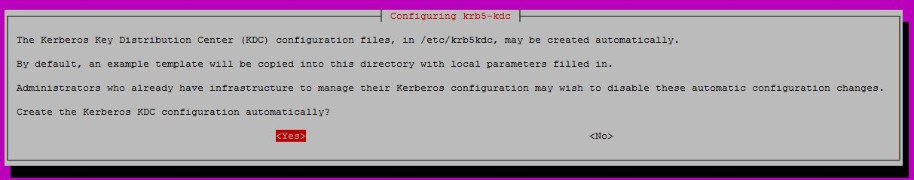

root@impetus­I0163:~# dpkg­reconfigure krb5­kdc
* Stopping Kerberos KDC krb5kdc * Starting Kerberos KDC krb5kdc
krb5kdc: cannot initialize realm IMPETUS.CO.IN ­ see log file for details
[fail]

Create the Kerberos Database

- Use the below utility kdb5_util to create the Kerberos database f or Ubuntu/Debian

# krb5_newrealm

root@impetus­I0163:/etc# krb5_newrealm

This script should be run on the master KDC/admin server to initialize a Kerberos realm. It will ask you to type in a master key password. This password will be used to generate a key that is stored in /etc/krb5kdc/stash. You should try to remember this password, but it is much more important that it be a strong password than that it be remembered. However, if you lose the password and /etc/krb5kdc/stash, you cannot decrypt your Kerberos database.

Loading random data

Initializing database '/var/lib/krb5kdc/principal' for realm 'IMPETUS.CO.IN', master key name 'K/M@IMPETUS.CO.IN'
You will be prompted for the database Master Password. It is important that you NOT FORGET this password. Enter KDC database master key:
Re­enter KDC database master key to verify:

- Starting Kerberos KDC krb5kdc [ OK ]
- Starting Kerberos administrative servers kadmind [ OK ]

Now that your realm is set up you may wish to create an administrative principal using the addprinc subcommand of the kadmin.local program. Then, this principal can be added to /etc/krb5kdc/kadm5.acl so that you can use the kadmin program on other computers. Kerberos admin principals usually belong to a single user and end in /admin. For example, if jruser is a Kerberos administrator, then in addition to the normal jruser principal, a jruser/admin principal should be created.

Don't forget to set up DNS information so your clients can find your KDC and admin servers. Doing so is documented in the administration guide.

Start the KDC

Start the KDC server and the KDC admin server. For ​Ubuntu ​run the below command:
- service krb5­kdc restart
- service krb5­admin­server restart

Important : ​When installing and managing your own MIT KDC, it is ​very important​to ​set up the KDC server to auto­start on boot

Create a Kerberos Admin

Kerberos principals can be created either on the KDC machine itself or through the network, using an “admin” principal. The following instructions assume you are using the KDC machine and using

the kadmin.local command line administration utility. Using kadmin.local on the KDC machine allows you to create principals without needing to create a separate "admin" principal before you start.

Note : ​You will need to provide these admin account credentials to Ambari when enabling Kerberos. This allows Ambari to connect to the KDC, create the cluster principals and generate the keytabs.

1. Create a KDC admin by creating an admin principal.

root@impetus­I0163:/etc# ​kadmin.local ­q "addprinc admin/admin"
Authenticating as principal root/admin@IMPETUS.CO.IN with password.

WARNING: no policy specified for admin/admin@IMPETUS.CO.IN; defaulting to no policy Enter password for principal "admin/admin@IMPETUS.CO.IN":
Re­enter password for principal "admin/admin@IMPETUS.CO.IN": Principal "admin/admin@IMPETUS.CO.IN" created.

- Confirm that this admin principal has permissions in the KDC ACL. Using a text editor, open the KDC ACL file and uncomment the following line */admin *

For Ubuntu/Debian

vi /etc/krb5kdc/kadm5.acl

*/admin *
- Ensure that the KDC ACL file includes an entry so to allow the admin principal to administer the KDC for your specific realm. When using a realm that is different than EXAMPLE.COM, ​be sure there is an entry for the realm you are using​.If not present, principal creation will fail. For example, for an admin/admin@HADOOP.COM principal, you should have an entry: */admin@HADOOP.COM *

vi /etc/krb5kdc/kadm5.acl

*/admin@IMPETUS.CO.IN *

4. After editing and saving the kadm5.acl file, you must restart the kadmin process.

root@impetus­I0163:/etc# service krb5­admin­server restart | [ OK ]
* Restarting Kerberos administrative servers kadmind | [ OK ]

Enabling Kerberos Security

Whether you choose automated or manual Kerberos setup, Ambari provides a wizard to help with enabling Kerberos in the cluster. This section provides information on preparing Ambari before running the wizard, and the steps to run the wizard.

- Installing the JCE
- Running the Kerberos Wizard

Important: ​Prerequisites for enabling Kererbos are having the JCE installed on all hosts on the cluster (including the Ambari Server) and having the Ambari Server host as part of the cluster. This means the Ambari Server host should be running an Ambari Agent.

Note: ​Ambari Metrics will not be secured with Kerberos unless it is configured for distributed metrics storage. By default, it uses embedded metrics storage and will not be secured as part of the Kerberos Wizard. If you wish to have Ambari Metrics secured with Kerberos, please see ​this topic​to enable distributed metrics storage prior to running the Kerberos Wizard.

Installing the JCE

Before enabling Kerberos in the cluster, you must deploy the Java Cryptography Extension (JCE) security policy files on the Ambari Server and on all hosts in the cluster.
Important: ​Ifyou are using Oracle JDK, ​you must ​distribute and install the JCE​on all hosts​in the cluster, including the Ambari Server. ​Be sure to restart Ambari Server after installng the JCE​.If you are using OpenJDK, some distributions of the OpenJDK come with unlimited strength JCE automatically and therefore, installation of JCE is not required.
Install the JCE

- On the Ambari Server, obtain the JCE policy file appropriate for the JDK version in your cluster.
  - For Oracle JDK 1.8:
http://www.oracle.com/technetwork/java/javase/downloads/jce8­download­2133166.html
- For Oracle JDK 1.7:
http://www.oracle.com/technetwork/java/javase/downloads/jce­7­download­432124.html

- Save the policy file archive in a temporary location.

- On Ambari Server and on each host in the cluster, add the unlimited security policy JCE jars to $JAVA_HOME/jre/lib/security/.

Download the file ​jce_policy­8.zip​onto one server and then push to all

impetus­i0161:~$scp jce_policy­8.zip 172.26.60.17:/home/IMPETUS/sudesh.shettigar jce_policy­8.zip 100% 8409 8.2KB/s 00:00

impetus­i0161:~$ scp jce_policy­8.zip 172.26.60.18:/home/IMPETUS/sudesh.shettigar
jce_policy­8.zip 100% 8409 8.2KB/s 00:00

impetus­i0161:~$ scp jce_policy­8.zip 172.26.60.19:/home/IMPETUS/sudesh.shettigar sudesh.shettigar@172.26.60.19's password: jce_policy­8.zip 100% 8409 8.2KB/s 00:00

Run the following to extract the policy jars into the JDK installed on your host:

impetus­i0161:~$ sudo unzip ­o ­j ­q jce_policy­8.zip ­d /usr/jdk64/jdk1.8.0_60/jre/lib/security/
Restart Ambari Server.

root@impetus­i0161:~# ambari­server restart

Using python /usr/bin/python Restarting ambari­server Using python /usr/bin/python Stopping ambari­server Ambari Server stopped

Using python /usr/bin/python Starting ambari­server
Ambari Server running with administrator privileges. About to start PostgreSQL
Organizing resource files at /var/lib/ambari­server/resources...

Server PID at: /var/run/ambari­server/ambari­server.pid Server out at: /var/log/ambari­server/ambari­server.out Server log at: /var/log/ambari­server/ambari­server.log Waiting for server start....................

Ambari Server 'start' completed successfully.

Running the Kerberos Security Wizard

Ambari provides three options for enabling Kerberos:
- Existing MIT KDC
- Existing Active Directory
- Manage Kerberos principals and keytabs manually

When choosing ​Existing MIT KDC​or ​Existing Active Directory​,the Kerberos Wizard prompts for information related to the KDC, the KDC Admin Account and the Service and Ambari principals. Once provided, Ambari will automatically create principals, generate keytabs and distribute keytabs to the hosts in the cluster. The services will be configured for Kerberos and the service components are restarted to authenticate against the KDC. We select the ​Automated Setup​ option.

When choosing ​Manage Kerberos principals and keytabs manually​, you must create the principals, generate and distribute the keytabs. Ambari will not do this automatically. This is the ​Manual Setup​option. See ​Launching the Kerberos Wizard (Manual Setup)​for more details.

Launching the Kerberos Wizard (Automated Setup)

- Be sure you have ​Installed and Configured your KDC​and have ​prepared the JCE​on each host in the cluster.

- Log in to Ambari Web and Browse to Admin > Kerberos. 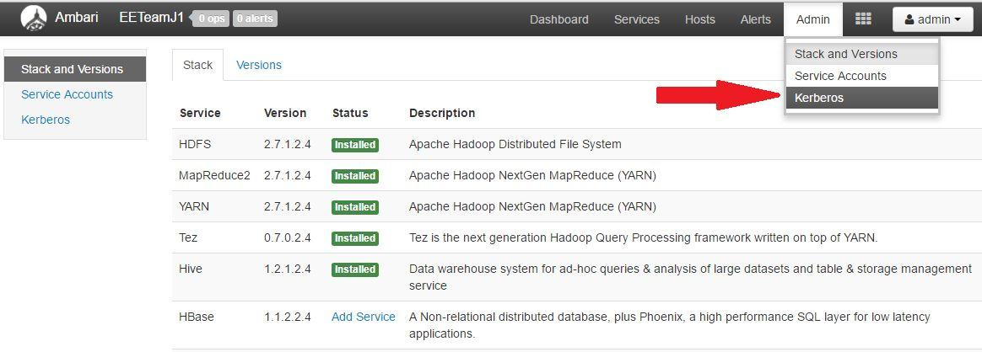

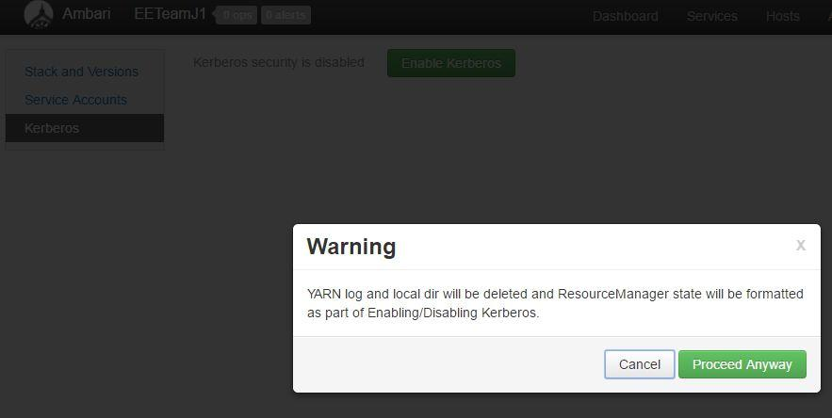3. Click “Enable Kerberos” to launch the wizard.

4. Select the type of KDC you are using and confirm you have met the prerequisites.

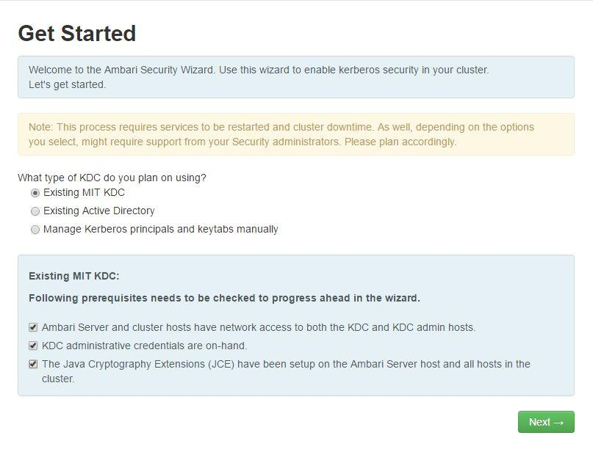

5. Provide information about the KDC and admin account. Please enter the details shown in picture.

In the ​Kadmin​section, enter the ​Admin principal​and ​password​that was created in “Create​a Kerberos Admin”​section. If you have configured Ambari for encrypted passwords, the ​Save Admin Credentials​option will be enabled. With this option, you can have Ambari store the KDC Admin credentials to use when making cluster changes.
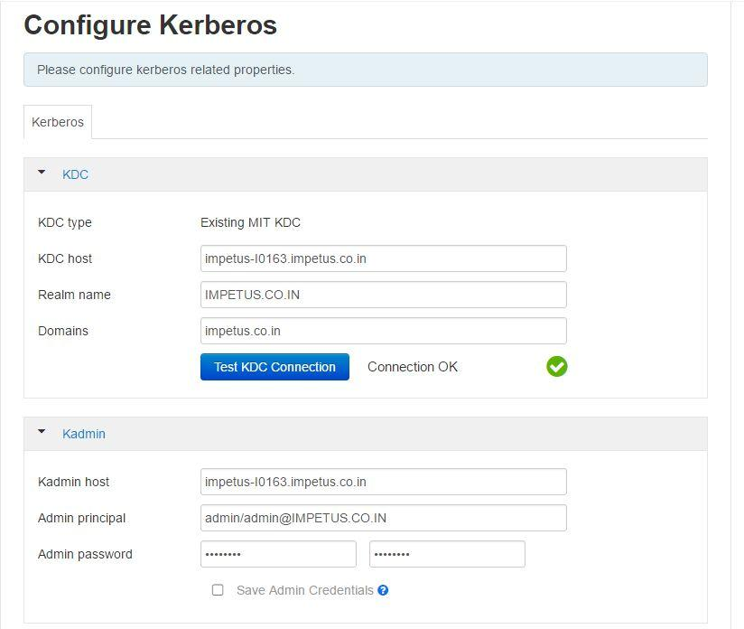

6. Modify any advanced Kerberos settings based on your environment.
- (Optional) To manage your Kerberos client krb5.conf manually (and not have Ambari manage the krb5.conf), expand the ​Advanced krb5­conf​section and uncheck the "Manage" option. ​You must have the krb5.conf configured on each host​.

Note : ​When manually managing the krb5.conf it is recommended to ensure that DNS is not used for looking up KDC, and REALM entries. Relying on DNS can cause negative performance, and functional impact. To ensure that DNS is not used, ensure the following entries are set in the libdefaults section of your configuration.

[libdefaults]
dns_lookup_kdc = false
dns_lookup_realm = false

- (Optional) to configure any additional KDC's to be used for this environment, add an entry for each additional KDC to the realms section of the Advanced krb5­conf's krb5­conf template.

kdc = {{kdc_host}}
kdc = otherkdc.example.com

- (Optional) To not have Ambari install the Kerberos client libraries on all hosts, expand the ​Advanced kerberos­env​section and uncheck the “Install OS­specific Kerberos client package(s)” option. ​You must have the Kerberos client utilities installed on each host​.

- (Optional) If your Kerberos client libraries are in non­standard path locations, expand the ​Advanced kerberos­env​section and adjust the “Executable Search Paths” option.

- (Optional) If your KDC has a password policy, expand the ​Advanced kerberos­env​section and adjust the Password options.

- (Optional) Ambari will test your Kerberos settings by generating a test principal and authenticating with that principal. To customize the test principal name that Ambari will use, expand the ​Advanced kerberos­env​section and adjust the ​Test Kerberos Principal​value. By default, the test princial name is a combination of cluster name and date ​(${cluster_name}­${short_date})​.This test principal ​will be deleted​after the test is complete.

- (Optional) If you need to customize the attributes for the principals Ambari will create, when using Active Directory, see the ​Customizing the Attribute Template​for more information. When using MIT KDC, you can pass ​Principal Attributes​options in the​Advanced kerberos­env​section. For example, you can set options related to pre­auth or max. renew life by passing:

­requires_preauth ­maxrenewlife "7 days"

7. Proceed with the install.
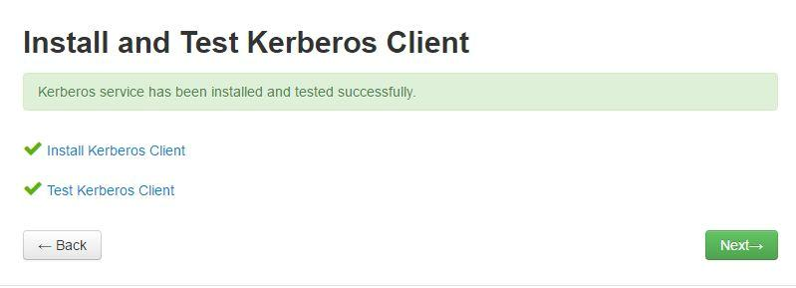

- Ambari will install Kerberos clients on the hosts and test access to the KDC by testing that Ambari can create a principal, generate a keytab and distribute that keytab.

- Customize the Kerberos identities used by Hadoop and proceed to kerberize the cluster.
Important : ​On the Configure Identities step, be sure to review the principal names, particularly the Ambari Principals on the General tab. These principal names, by default, append the name of the cluster to each of the Ambari principals. You can leave this as default or adjust these by removing the "­${cluster­name}" from principal name string. For example, if your cluster is named HDP and your realm is EXAMPLE.COM, the hdfs principal will be created as ​hdfs­HDP@EXAMPLE.COM​.

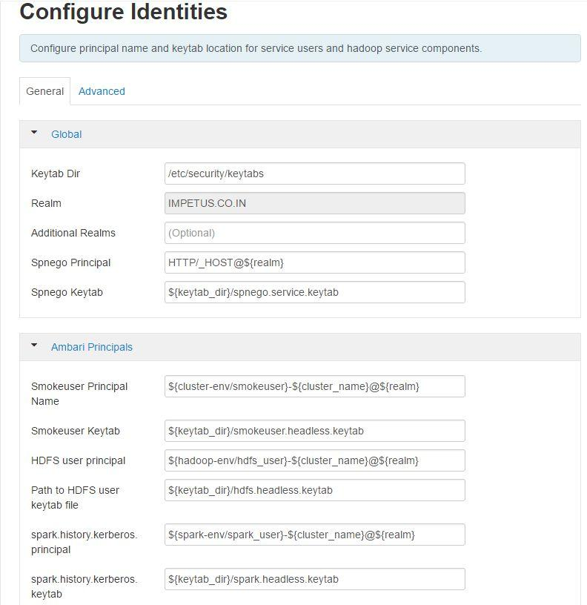

Leave all Defaults

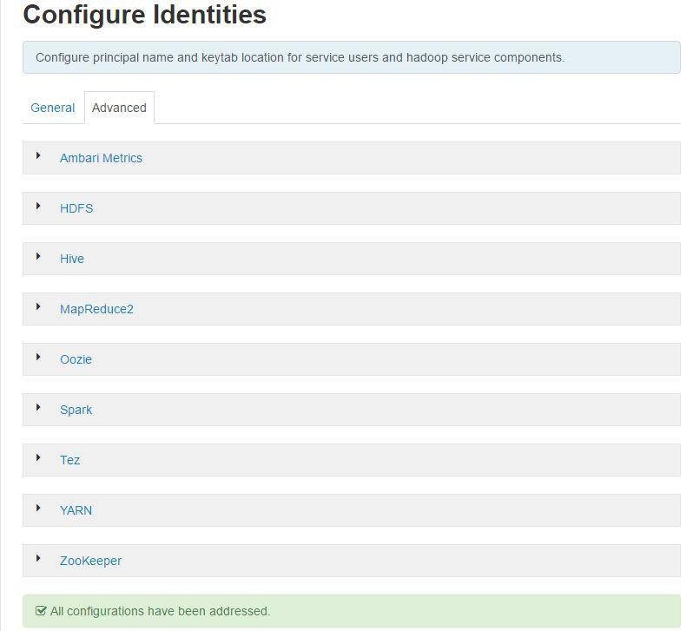

- 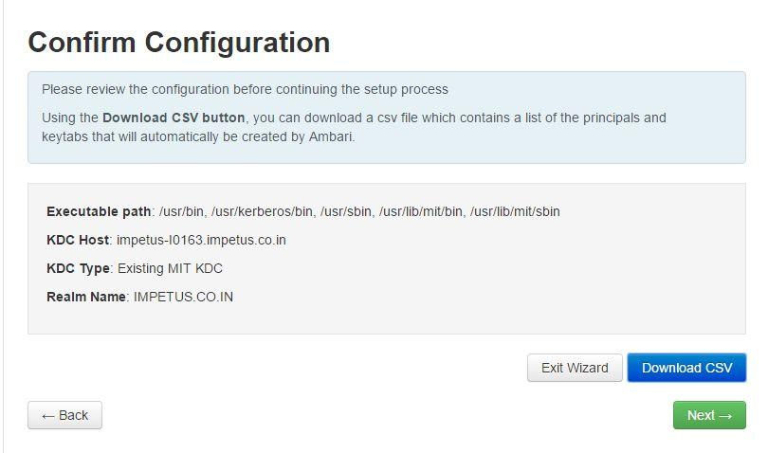Confirm your configuration. You can optionally download a CSV file of the principals and keytabs that Ambari will automatically create.

11. Click ​Next​to start the process.

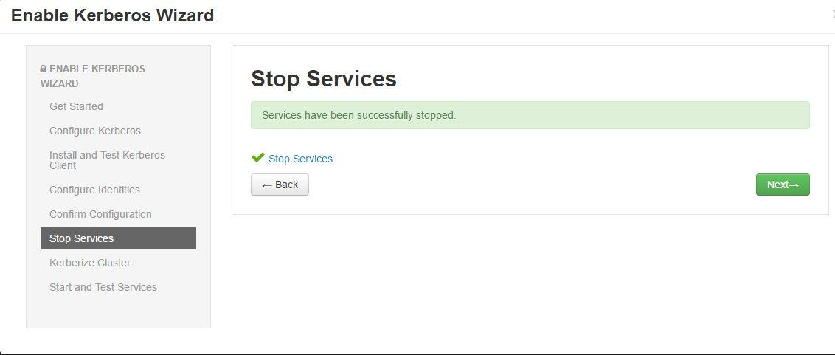

- 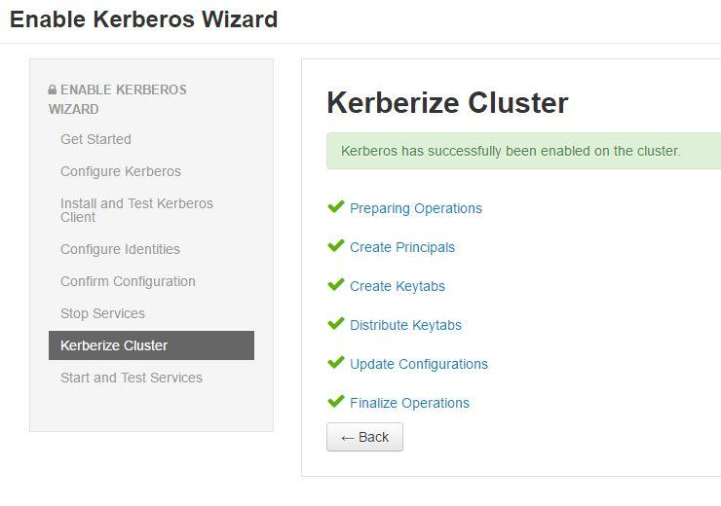After principals have been created and keytabs have been generated and distributed, Ambari updates the cluster configurations, then starts and tests the Services in the cluster.

Note : ​Ifyour cluster includes Storm, after enabling Kerberos, you must also ​Set Up Ambari for Kerberos​for Storm Service Summary information to be displayed in Ambari Web. Otherwise, you will see n/a for Storm information such as Slots, Tasks, Executors and Topologies.

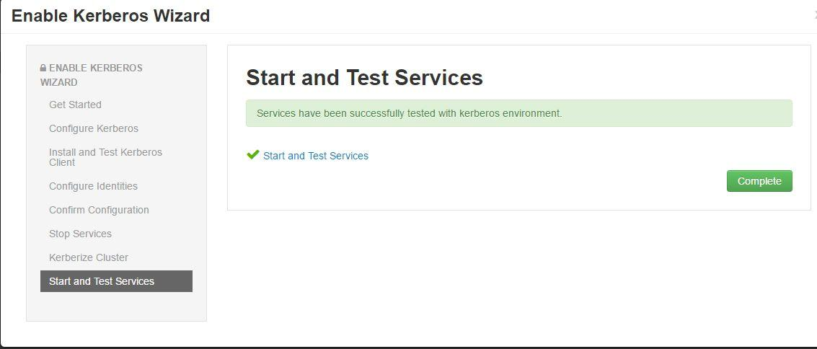

Final status should look like below:

