**Game Design Document**

Declan Diderich, Hunter McCulloch

Dr. David Mould

COMP1501A

4/15/2016

**Playing the Game**

The player will begin each level with a specific set of guns, infinite ammo, and a select amount of stamina. Using w, a, s, d the player navigates the static background of the level clicking to shoot waves of oncoming enemies. When all enemies have been killed for that level, the next begins.   
Throughout the level the player must keep an eye on his health, as well as his stamina bar. The health bar simply depletes upon being hit by an enemy. The stamina bar however, decreases slowly as the level progresses, as well as when the player shoots.

The spacebar in game will bring up the pause menu.

The number keys swap between available weapons:

1 – Pistol   
2 – Machinegun   
3 – Shotgun  
4 – Railgun

**Strategies**

The player will have to kill waves of different types of enemies. As it is the game has two different enemy follow patterns, a ranged enemy and a melee enemy.   
The melee enemies do not stop chasing the player, always getting as close as they can to him. This means a good idea is to take them out first.

The player will encounter different amounts of enemies at slightly varying distances depending on the situation. The player must adapt his weapon choice to these things. A far single enemy would promote the pistol, multiple far enemies promote the machine gun, close few enemies promotes the shotgun, and of course, any time the player can get the enemies in any sort of mediocre line the rail gun will be his best bet.

Clearly, running and gunning is the player’s only option. Staying put the player simply won’t be able to kill off the enemies before they get to him.  
The drops from the enemies are extremely important, as ignoring them for too long will leave the player with no stamina.

Another thing the player must be aware of is his use of ammo, shoot precisely and as few as you can to save the most stamina.

**Game logic**

The system we’ve created is fairly straight forward.

Anything that appears on the screen other than the background image is considered a sprite object. These sprite objects all have individual images, velocities, and knowledge of the other sprites. This sprite object is extended by the player, enemies, objects, and bullets. This each have their specific attributes to make them unique. The object won’t let other sprites pass through it, the enemies will chase and attack the player, and the bullets will do damage do any sprite that isn’t on the same team as the sprite that shot it.  
WASD simply sets the correct velocities on the player object.   
Each sprite has an alive Boolean that is simply turned false when the object must be removed.

As for the mechanics of the actual level, each enemy has a specific ‘cost’, based on how powerful they are (more powerful = more cost). Each level has a specific amount in the bank, and a list of the enemies it’s allowed to use. When the levels timer to spawn an enemy has come to and end it will pick a random enemy from the list and charge the enemy’s cost to the level bank. When the level bank is empty, all enemies have spawned, and the player must just eliminate the remaining to progress to the next level. This provides a bit of uniqueness to each level played, even if it is the same stage of the game.

**Game Balance**

Clearly for a shooter such as ours balance is key. What this basically came down to was trial and error.  
In order to keep things from getting too complicated or out of hand we began using very small, basic numbers for speed, damage, health, etc.. then slowly complicated and adjusted them as we saw fit while playing the game.

This meant going through each individual weapon, making sure that the player could survive with it as well as die with it, adjusting damage output and reload times and penetration, etc.  
Each enemy had to be tested against the player, as well as the enemies in group, so to see that they would not be too overwhelming for the user.

The player health and stamina bar were fairly straight forward, the player health we adjusted until we enjoyed the difficulty of the game, and the fatigue bar we adjusted until we enjoyed how rushed the player felt upon playing it. The pickups, as well as the idea that consuming ammo would also consume stamina, came after realizing that the bar had been merely acting as a timer before, whereas with these two mechanics, actually influenced the players behavior and approach to each level.

**Kleenex Test**

I had my roommate Brandon play the game for the first time.  
His first time around he died fairly quickly, it seemed he didn’t quite grasp swapping between the weapons as well as deciding which pickups would be worthwhile and which wouldn’t be. There was a chorus of “holy”, “oh man”, “get me out of here”, that seemed to be coming from an exhilarated standpoint which means good things for the actual entertainment value.

After his first death however he came back and navigated the game as if he were a professional. He was weaving in and out of enemies, swapping weapons, grabbing pickups, nearly flawlessly.  
At first he complained that the game was now a piece of cake, however, the ‘flow’ that had been achieved because of his consistency of surviving was great and he soon admitted that. He had a terrible time detaching himself from the game until finally he was overwhelmed and killed.

One thing he constantly seemed to do was group the enemies behind a wall and hide for a few seconds, even though this contributed nothing to the level and depleted his fatigue bar more than if he had not done so. I would say we should find some way to prevent this, however I don’t truly believe it affects the gameplay in any negative form.

**Design Ideas:**

With Insomnia, we wanted to create a top down shooter uniquely based on strategic decision making, instead of just simply trying to survive. In order to do this, we made a fatigue element in the game. Measured as a bar, it decreases over time, and proportionally with each shot. However, when it reaches 0, the player dies. This means that literally every shot counts, as they each bring you closer to death. This causes players to think about what gun to use and when to use it, and it makes the player aim carefully and shoot infrequently. We represented the player’s fatigue as a stamina bar under the player’s health bar. The stamina bar is brown, like coffee, and in line with that thought, it is replenished by the player picking up power-ups which decrease the people’s fatigue in real life. Other extra design elements we included were things such as story, and all the sprites/backgrounds etc. which were drawn by Declan Diderich. The title screen was also done by Declan, and it is meant to set the scene for the game; the player lives in a harmonious world, with roses blowing in the wind and the sun in the blue sky. However, when they blink, which represents their fatigue, the world changes into a grotesque and phantasmagorical one, with eyes watching and grey flowers blowing the wrong way.

**Story:**

The title of the game, Insomnia, relates to the story because the game is about the outbreak of a disease that causes people to die when they fall asleep. As the protagonist, you must struggle to stay awake as you fend off hordes of enemies borne from your sleep deprived hallucinations, and make your way into the city to find the cure.

**Characters:**

**PLAYER**

C:\Users\Declan\Downloads\Shooter (7)\Shooter\data\player1.png

The protagonist of the story is a person who has recently been infected by the virus. They hear on the radio that there is an outbreak, and they seem to have the symptoms of the disease. The broadcast mentions that the hospital of nearby city may have found the disease, so they leave their house to try and get to the hospital. When the game starts, they are in an abandoned house, and they have been awake for more than 72 hours. They are beginning to have enhanced hallucinations, which are attacking them from outside the house. The hallucinations are enhanced by the disease, and they will get hurt and die when “attacked” by them. Using their hallucinated weapons, they begin to fight off their attackers.

**Enemies:**

The enemies in insomnia represent the subconscious fears and desires of the main character. Each enemy has an eye on it, to represent that it is a hallucination due to sleep deprivation.

C:\Users\Declan\Downloads\Shooter (7)\Shooter\data\melee1.png**Zombie Hand**

This is a hallucinated zombie hand, one of the enemies the player must fend off when trying to survive. The hand represents the unconscious fear of brainwashing and loss of autonomy that are so commonly found in today’s society, due to capitalist idealism having consumed the western world.

**C:\Users\Declan\Downloads\Shooter (3) (1)\Shooter\data\archer1.pngFloating Orb**

The floating orb represents the NSA and the way that people in western societies are constantly being watched and monitored by security cameras, tracking software and the like. The eye on this enemy is more central to its design than on the zombie hand, but it still retains its meaning of hallucination.

**Places:**

**The Abandoned House**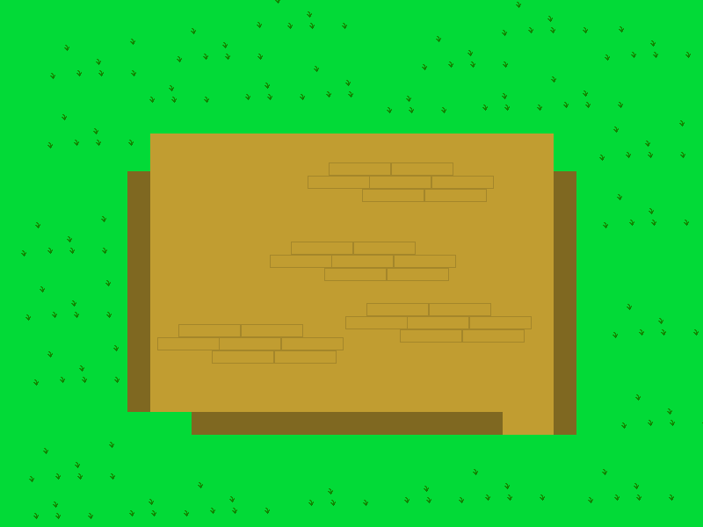

The main character is hiding from their hallucinations in this house, as it is where they first begin to have them. The house itself is old and decrepit, and the walls have holes in them where hallucinations can pass through. One wall has been completely destroyed. The house lies abandoned in a grassy field.

**Stamina Replenishing Pickups**

**Large Coffee:**

**C:\Users\Declan\Downloads\Shooter (3) (1)\Shooter\data\cBoost1.png**

This coffee is completely black, and restores the player’s fatigue when picked up. It is the least effective items.

**Caffeine Pills:**

**C:\Users\Declan\Downloads\Shooter (3) (1)\Shooter\data\cBoost2.png**

These are caffeine pills, which restore the player’s stamina by a medium amount.

**Adrenaline Shot:**

**C:\Users\Declan\Downloads\Shooter (3) (1)\Shooter\data\cBoost3.png**

This is an adrenaline shot, which restores the player’s stamina by the largest amount. It is brown to go along with the theme of stamina being brown.

**Gun Bullets**

**Pistol:**

C:\Users\Declan\Downloads\Shooter (3) (1)\Shooter\data\bullet.png

This is the basic pistol bullet, which is also used for enemies’ attacks. The pistol is the standard weapon, and does a medium amount of damage, has a medium range and medium reload time.

**Machine Gun Bullet**

C:\Users\Declan\Downloads\Shooter (3) (1)\Shooter\data\MACHINEGUNBULLET.png

This is the machinegun bullet, which looks like a plus for the sake of differentiability. It can be shot frequently and uses less stamina than a pistol, but it deals less damage. It also has a shorter range.

**Shotgun Bullet**

C:\Users\Declan\Downloads\Shooter (3) (1)\Shooter\data\SHOTGUNBULLET.png

The shotgun bullet does more damage than the pistol, and can also pierce through one enemy to hit a second behind it. The shotgun has little range and cannot be fired as quickly as the machine gun however, so it must be used wisely.

**Railgun Shot**

C:\Users\Declan\Downloads\Shooter (3) (1)\Shooter\data\RAILGUNSHOT.png

The railgun bullet is extremely powerful and can pierce many enemies, goes very far, but can only be fired once and awhile, and uses much stamina. It is more of a last resort weapon.