All: Vx3 Ix3 P Q PF

* SS18, SS19 ‘Barnes Solar’?
  + 
* SS30 has extra info?
  + 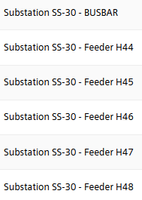
* Other generators
  + These all seem to be small arrays so will not consider here
  + 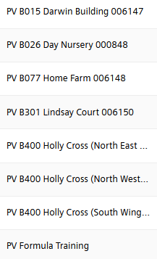

MGCs

SS02

* 
* Only current

SS03

* 
* All

SS04

* 
* All

SS05

* 
* All

SS13

* SS13_1
  + 
  + All
* SS13_2
  + 
  + All

SS18

* 
* All

SS19

* 
* All

SS25

* 
* all

SS30

* 
  + Nothing (!)
* Storage
  + 
  + All
* Wind
  + 
  + All (‘power generated’ instead of ‘power’)
* Solar
  + 
  + All (as wind)

Power Meters 30 second freq

SS11

* 
* NB, NOT:
  + 
* All

SS01

* Two Tfrmrs:
  + 
  + all
* And
  + 
  + all

SS24

* 
* All
* **NB:** Power listed as being ‘calculated’?

SS15

* 
* All

SS21

* 
* All

SS29

* 
* All

SS12

* 
* All

SS14

* 
* All

SS16

* 
* All

SS17

* 
* All