**Project Management Case Study**

**Name: Xuan Linh Tang**

**SID: 218559008**

Concept and context:

Concept: Interactive ArchViz, specially focus on interior decor

Context: In this case, the application is focusing on interior design of the house by generating 3D model of a real furniture/décor and placing that model into a real room through AR camera on a smartphone. Furthermore, the application also provides some extra useful features such as space measurement, voice command etc. to bring the most comfortable experience to users.

Project manager:

Full name: Xuan Linh Tang

Phone number: +61444547079

Email address: xltang@deakin.edu.au

## **I. Requirements Analysis**

### **1. Project details:**

#### **a. Team and roles**

Client: Shaun Bangay

Project manager: Xuan Linh Tang

Designer: Xuan Linh Tang

Developer: Rohan Brahmakshatriya

Q/A testing: to be assigned

#### **b. Goals of the project**

Background: Customers always want “try before buy” approach when they need to purchase things. There is no exception for furniture/décor products, but unlike clothes or accessories, customers could not actually know if the product is suitable until they buy it and place it in their own room. Moreover, they could not customize the product instantly such as changing the color, the size etc. This is when AR technologies jump in and make huge differences in user experiences. The basic idea is to generate virtual scene with 3D virtual model of the furniture/décor overlaying on the real room so customers could have general visualization of the product presence in the room.

Market analysis: There are already some AR furniture applications out there in the market, including 2 well-implemented apps: IKEA Place and Houzz

IKEA Place: Provide 3D model of IKEA products with 98% rate of accuracy (as IKEA claim) and the amazing floor detection feature so the products look like they are on the real room floor, not just “floating” on the phone screen. The limitation of this app: It only supports iOS user and only provides IKEA products.

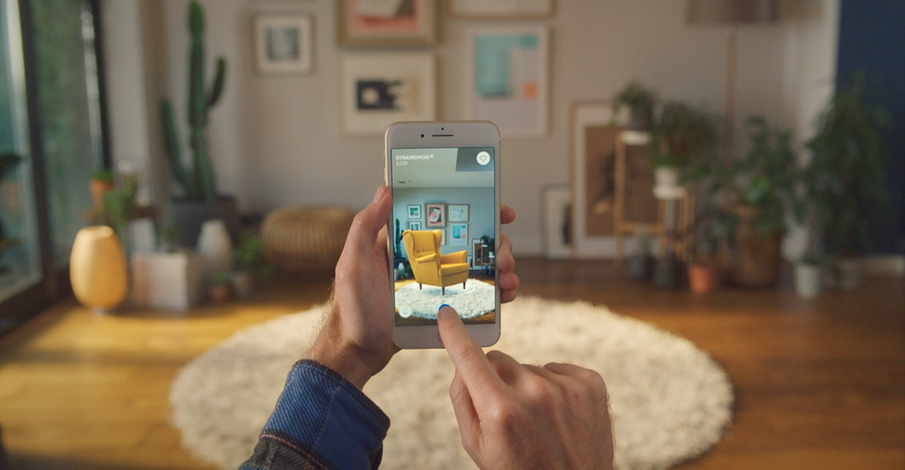

Image reference: <https://www.ikea.com/au/en/apps/IKEAPlace.html>

Houzz: Provide huge database of items from many retailers, but not all of them have 3D model. The environment detection is not as good as IKEA Place. Houzz app supports both iOS and Android platform.

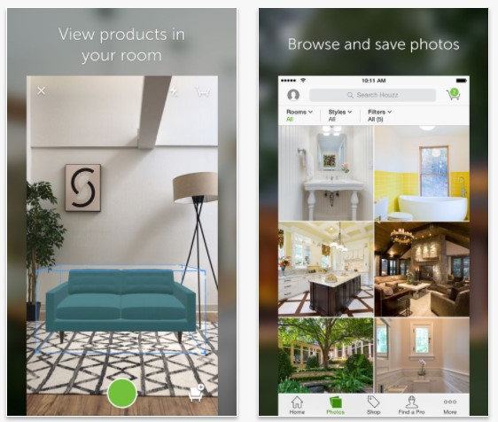

Image reference: <https://www.pocketables.com/2017/12/houzz-adds-augmented-reality-to-its-app.html>

The project goal:

After analysing similar applications and the need of customers, the final goals of this application is to allow customers to see the furniture/décors presence in their own room and make some customization before buying them. In addition, this app will also allow customers to measure the physical space to decide the suitable size of furniture before buying.

#### **c. List of requirements**

Based on the project goals, a list of requirements is provided below, which have 3 priority levels: Level 1 contains requirements that are essential for the project and directly related to AR experience of the user, Level 2 contains requirements that are achievable but have less impact to AR experience, and Level 3 contains requirements that are about basic component of any applications such as UI, database etc.

**Level 1 requirements:**

- Customers must be able to load a 3D model into the real scene of the room via smartphone camera and able to rotate and move it anywhere in the room. (The scale function is not supported because we want to keep the real size of the actual product). This is the basic function to provide customer the visualization of the real product.

- Customers must be able to place multiple instance of an object, and multiple types of objects in the same room. The application must remember the location of those objects in the physical world even when the camera is not pointing at them. This requirement is to ensure that customers can visualize many products in the same room.

- The application must have some kinds of surface detection for the 3D model to be put on, so that customers could feel more realistic about the scene.

- Customer should be able to measure the physical space around the room, so that they can know which size of the furniture is suitable.

- Also, the user could enable the function to detect object around the room and measure their size to support the arrangement of furniture should they decide to buy a new one.

**Level 2 requirements:**

- Customers should be able to use voice to control the process of putting object into the scene or the process of scanning object. This requirements is to bring more quality of life feature to customers, but is not essential to have.

- 3D object should have proper light and shadow on it based on the current light condition of the room. This can be achievable by using ARCore to increase the realistic feeling, but is not essential to have.

- The application should have a spatial sound feedback when object is placed to bring more responsive feeling.

**Level 3 requirements:**

- Customers should be able to control the application via well-organized UI.

- The application should have default database with 3D models of objects for customers to begin with.

#### **d. Assumptions**

- This application needs to make use of AR technology because it’s hard for customers to try the furniture/décor before buying them.

- The design will be completed in the designated time frame, providing the developer clear and explicit instructions that can result in a system implemented and tested in the time allowed.

- The target customer smartphone supports latest Android version and ARCore.

- This application use Unity to render and control the scene.

#### **e. User stories**

***Story 1:***

- Alice want to buy a sofa for her living room. After viewing a catalogue, she wants to know what sofa could be the best for her room, the red armchair or the yellow ottoman. She opens our application and place the 3D model of two sofas in her room to make comparison. After a while, she decides to take the red one.

***Story 2:***

- Peter just bought a new apartment. He need to buy many stuffs for his empty bedroom including a bed, a lamp, a closet and a TV set. He want to be able to organize and see the final arrangement of those furniture in the room before buying them. He opens our application to place the furniture around the bedroom as he see fit. Thank to our application, he will save a lot of time spent on moving the real furniture around the room.

***Story 3:***

- Mary needs a dining table for her kitchen. Her kitchen has small space, so she needs to find a dining table with suitable size. She opens the application and measure the space she want to put the dining table, so that she could know which size of the dining table she could get.

#### **f. User interaction and design**

**UI design:**

* Default screen:

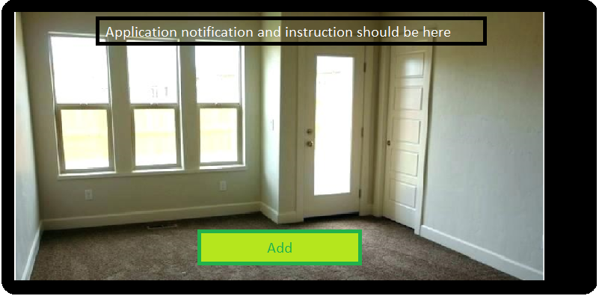

* Choose item from item list:

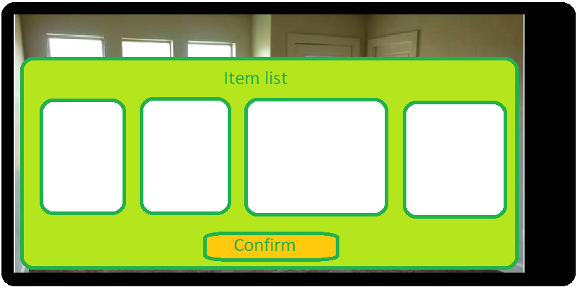

* Ready to place item:

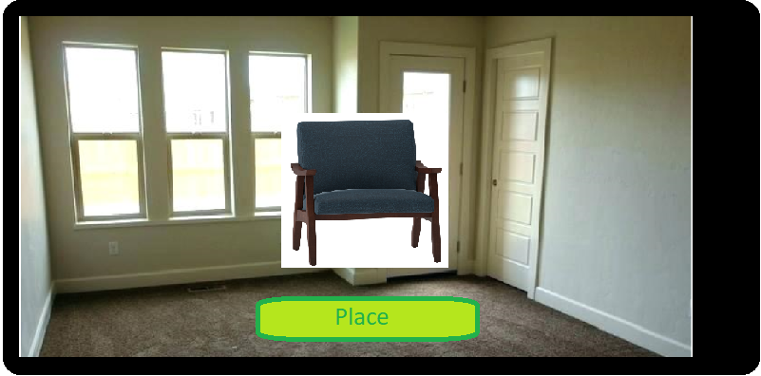

* ***UI for 3D scan feature will be updated later when scanning technique is decided***

**Use case**:

Use case for choosing an object and place it in the environment:

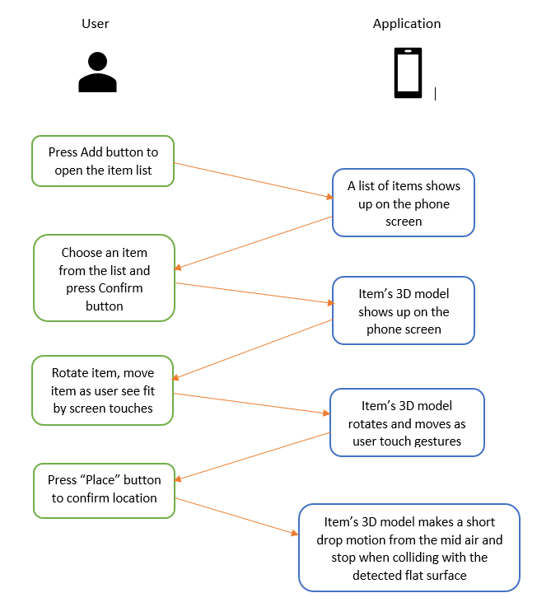

## **2. Proposed Solution Design**

- The use of smartphone camera to manipulate the scene could be achieved by using ARCore Device prefab.

- The loading and placing 3D object could be achieved using basic object in Unity.

- To track the physical location of the 3D object, we can utilize the AR Core tracking features.

- To interact with the object, first we point the centre of the screen to the object and pick it up, then we could move the object by moving the phone around, or rotate the object using swipe touch on the phone screen.

- To detect the flat surface to put 3D objects on, we can use the PointCloud concept in ARCore which only use the phone camera.

- Voice control could be achieved by following example 39 of week 9.

- Spatial sound feedback could also be achieved by following example 38 of week 9.

## **3. Project Development Plan (Out of date)**

Please find the new plan in the Training Manual

Note: The estimated time is the time spent in best scenario. In the worst scenario, the time spent might be doubled.

#### **Trimester week 3**

**Goals:**

For designer:

- Collect research materials and read them to have the general ideas to make the draft solution design for the project (all of them are mentioned in section 2. Proposed Solution Design)

**Tasks:**

For designer:

- Read examples and research materials to understand how to use the phone camera to manipulate the scene (1 hour)

- Read examples and research materials to understand how to track the physical location of the 3D object (1 hour)

- Read examples and research materials to understand how to control and interact with the 3D object (2 hour)

- Read examples and research materials to understand how to detect flat surface to put 3D object on (2 hour)

- Read examples and research materials to understand how to 3D scan the real object into 3D model (2 hour)

- Read examples and research materials to understand how to generate light and shadow based on environment condition (1 hour)

- Read examples and research materials to understand how to utilize voice control (1 hour)

- Complete the case study (2 hours)

**Progress:**

- To be added

#### **Trimester week 4**

**Goals:**

For designer:

- Update training manual with step by step information about how to use the phone camera, how to place multiple 3D objects into the scene and track their physical location, and how to interact with the 3D objects using screen touches or phone gestures. All of those technique should be covered in week 1 and week 3 already.

- Make a prototype application having a simple scene with multiple controllable 3D objects in it.

**Tasks:**

For designer:

- Create a Unity prototype application. This application UI will have a create button overlaying on the real scene to spawn an object at the centre of the screen. Multiple object spawn is available (0.5 hour)

- Implement simple screen touch control to interact with the objects. Tap and hold the object to move it around, or tap and using 2 finger to rotate it (1.5 hour)

- Implement phone gesture control to interact with the objects. (1.5 hour)

- Implement physical location tracking feature (1.5 hour)

- Write step by step instruction of all above testing features into the training manual (2 hours)

**Progress:**

- To be added

#### **Trimester week 5**

**Goals:**

For designer:

- Update training manual with step by step information about how to detect flat surface and put a 3D object on it; how to recognize hand gesture. All of those technique should be covered in week 5 already.

- Make a prototype application having a simple scene with 3D objects lying on the flat surface detected by the phone camera (such as table, floor etc.)

**Tasks:**

For designer:

- Create a Unity prototype application. This app will detect the flat surface and show a grid on that surface. The UI will have a button to spawn an object to test if the object could stay on the surface or not. Multiple object spawn is available (3 hours). I intend to create something like this picture:

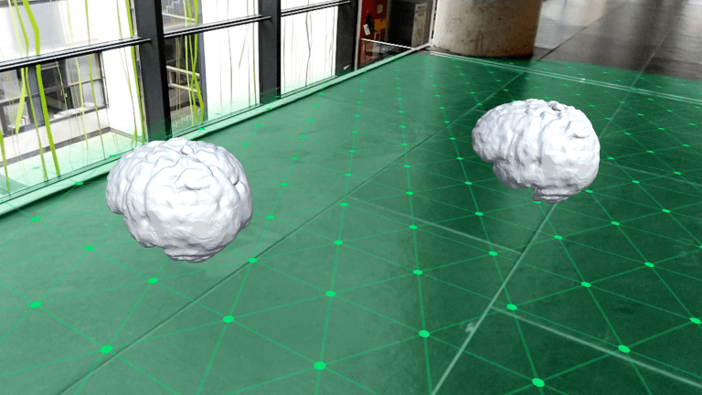

Reference: <https://www.andreasjakl.com/getting-started-with-google-arcore-part-2-visualizing-planes-placing-objects/>

- Implement hand gesture using Kinect or Leap Motion (have not decided yet) to control the objects. (3 hours).

- Write step by step instruction of all above testing features into the training manual (2 hours)

**Progress:**

- To be added

#### **Trimester week 6**

**Goals:**

For designer:

- Choose the best method for object 3D scanning after research.

- Update training manual with step by step information about how to 3D scan a real object and export as a 3D model. All of those technique should be covered in week 6 already.

- Make a prototype application to scan an object with simple geometry first, if it’s success, try to scan objects with more complex shapes.

- Design the wireframe for the final application UI.

**Tasks:**

For designer:

- Create a Unity prototype application. Implement 3D scanning feature. (5 hours) (This will be clearer when the method of 3D scanning is decided).

- Try to export scanned 3D model. (1 hour)

- Sketch the wireframe for the final application UI (1 hour)

- Write step by step instruction of all above testing features into the training manual (2 hours)

#### **Trimester week 7**

**Goals:**

For designer:

- Update training manual with step by step information about how to add environment light and shadow; how to use voice control. Designer need to research external materials beside the course note for the light and shadow part; and go ahead and research week 9 course note for speech recognition.

- Create 3D model of some objects to add to the default database (using 3ds Max)

- Make a prototype application to demonstrate the real environment light and shadow on virtual objects and the voice control.

- Make an appointment with the developer to discuss the general concept of the final application

For developer:

- Meet with the designer to have the general understanding of the concepts and the goals of the final application

**Tasks:**

For designer:

- Create a Unity prototype application. Implement real environment light and shadow following this reference: <https://www.andreasjakl.com/real-time-light-estimation-with-google-arcore/> (2 hours)

- Implement voice control feature. When user say “Create”, an object will be spawn (1 hour)

- Create 3D model of a chair, a table, a bed and a sofa for default database (3 hours)

- Meet with the developer to transfer the general concept and goals (1 hour)

For developer:

- Meet with the designer to understand the general concept and goals (1 hour)

#### **Trimester week 8**

**Goals:**

For designer:

- Explain to the developer in detail every components of the training manual, as well as give the access to all the prototype applications that the designer has done before.

- Support the developer if he/she has problems following the instruction

For developer:

- Meet with the designer to know what component should be implemented and what platform/software/techniques should be used.

- Start the implementation. These features should be completed and available to test: place multiple 3D objects into the scene, tracking their physical location and interact with the objects. The application should have a simple UI with options to choose the type of object. The application should be able to put many objects into a room and remember the physical location so when user point the camera elsewhere and point back, the objects still stay at the same position. User also could rotate and move every single object in the scene.

**Tasks:**

For designer:

- Explain and showcase all components in the training manual to the developer (2 hours)

- Reserve some spare time to help the developer (approx. 1 hour)

For developer:

- Discuss with the designer to understand all components of the final application (2 hours)

- Implement simple UI with options to choose object from a list of default objects (which is imported from the designer’s provided 3D model), a button to place the object. (2 hour)

- Implement screen touches to control the object, tap and hold the object to move it around, or tap and using 2 finger to rotate it (1 hour)

- Implement phone gesture to control the object, such as tap and rotate the phone to rotate the object (1 hour)

- Implement physical location tracking feature (1 hour)

**Progress:**

- To be added

#### **Trimester week 9**

**Goals:**

For designer:

- Support the developer if he/she has problems following the instruction

- Check the progress and consider alternative approach if some features are hard to implement.

For developer:

- Continue developing the application. These features should be completed and available to test: hand gesture recognition, flat surface detection. In this stage, the application also detection flat surface such as the floor, the table surface to place the object on them. In addition, the application should allow user to use hand gestures to control the object (this feature is secondary features, so if things are going off track, this feature could be skipped)

- Polishing previous features after correcting the defects detected by the tester.

For tester:

- Finish testing week 8 features and report the defects to both the designer and the developer

**Tasks:**

For designer:

- Reserve some spare time to help the developer (approx. 1 hour)

- Reserve some spare time to review the defects detected by tester if it related to design phase (1 hour)

For developer:

- Implement surface detection feature. The application should at least be capable of detecting the floor and showing the grid (3 hours).

- Implement the interaction between objects and the surface. When user confirm to place the object, there should be a short drop motion of object, from the mid air and stop when collide with the detected surface. (1 hours)

- Implement simple hand gestures. User can use the vertical tap gestures in front of the camera to confirm the placement of object, a circle gesture with the forefinger to rotate the object and a swipe gesture to move the object. (3 hours)

- Fix defects of week 8 features that detected by tester (1 hour).

For tester:

- Test each feature implemented in week 8 (2 hours).

**Progress:**

- To be added

#### **Trimester week 10**

**Goals:**

For designer:

- Support the developer if he/she has problems following the instruction

- Check the progress and consider alternative approach if some features are hard to implement.

For developer:

- Continue developing the application. The 3D scanning feature should be completed and available to be tested. In this stage, the application should be able to scan real object into 3D model which then will be saved to application item list.

- Polishing previous features after correcting the defects detected by the tester.

For tester:

- Finish testing week 9 features and report the defects to both the designer and the developer.

**Tasks:**

For designer:

- Reserve some spare time to help the developer (approx. 1 hour)

- Reserve some spare time to review the defects detected by tester if it related to design phase (1 hour)

For developer:

- Implement 3D scanning feature (the used technique has not yet to be decided). The application should be at least able to scan object with simple shape (sphere, cube etc.) (5 hours)

- Export scanned 3D model and save to the application item list (1 hour)

- Fix defects of week 9 features that detected by tester (1 hour).

For tester:

- Test each feature implemented in week 9 (2 hours).

**Progress:**

- To be added

#### **Trimester week 11**

**Goals:**

For designer:

- Support the developer if he/she has problems following the instruction

- Check the progress and consider alternative approach if some features are hard to implement. Also, in this late stage, consider which features should be skipped if the progress is too slow.

For developer:

- Complete the application by adding secondary features. These features should be completed and available to be tested: real environment light and shadow, voice control. In this stage, the application should be able to generate light and shadow based on the condition of the real environment. Also, the application should provide some simple voice control such as say “Create” to confirm place object, or “Scan” to beginning the scan process. Note that any secondary features might be skipped based on the decision of the project manager if main features implemented in previous weeks have too many defects.

- Polish previous features after correcting the defects detected by the tester.

For tester:

- Finish testing week 10 features and report the defects to both the designer and the developer.

**Tasks:**

For designer:

- Reserve some spare time to help the developer (approx. 1 hour)

- Reserve some spare time to review the defects detected by tester if it related to design phase. Also make decision of which secondary feature should be skipped if there are too many defects detected on main feature (1.5 hour)

For developer:

- Implement light and shadow feature. The application should be able to generate correct light and shadow based on the light of the real environment (optional feature) (0 - 2 hours)

- Implement voice control feature. The application should react to user saying “Create” to place the object and “Scan” to begin scan process (optional feature) (0 – 2 hours)

- Fix defects of week 10 feature detected by the tester (2 - 6 hours)

For tester:

- Test each feature implemented in week 10 (3 hours).

**Progress:**

- To be added

#### **Trimester week 12**

**Goals:**

For both designer and developer:

- Review all artefacts including documents, 3D models, all application features

- Polish secondary features implemented in week 11 after correcting the defects detected by tester.

- Complete a short, easy-to-understand “How to use” document for non-technical user

For tester:

- Finish testing week 11 features and report the defects to both the designer and the developer.

For all members:

- Successfully demonstrate the final product: show all working features; explain why some features did not work (if any), what features should be improved and what features should be added in the future.

**Tasks:**

For designer:

- Review the defects of week 11 features detected by tester if it related to design phase (1 hour)

- Review the training manual (1 hour)

- Review the UI (0.5 hour)

- Review the default 3D models (0.5 hour)

- Write “How to use” document (in collaboration with the developer) (1 hour)

- Demonstrate the final product (with other members) (1 hour)

For developer:

- Review source code and checking indentation style and comments (2 hours)

- Fix defects of week 11 feature detected by the tester (1 hour)

- Write “How to use” document (in collaboration with the designer) (1 hour)

- Demonstrate the final product (with other members) (1 hour)

For tester:

- Test each feature implemented in week 11 (1 hours).

- Demonstrate the final product (with other members) (1 hour)

**Training Manual**

***Reference list:***

<https://www.ikea.com/au/en/apps/IKEAPlace.html>, retrieved 26th Jul 2019.

<https://www.pocketables.com/2017/12/houzz-adds-augmented-reality-to-its-app.html>, retrieved 26th Jul 2019.

<https://www.andreasjakl.com/getting-started-with-google-arcore-part-2-visualizing-planes-placing-objects/>, retrieved 26th Jul 2019.

<https://www.qlone.pro/>, retrieved 26th Jul 2019.

<https://play.google.com/store/apps/details?id=com.lvonasek.arcore3dscanner&hl=en_AU>, retrieved 26th Jul 2019.

<https://developers.google.com/ar/discover/concepts>, retrieved 26th Jul 2019.

<https://www.andreasjakl.com/real-time-light-estimation-with-google-arcore/>, retrieved 26th Jul 2019.

Shaun Bangay, 2019, weekly course notes.