|  |  |
| --- | --- |
| NITWlogoFeb2012 | **NATIONAL INSTITUTE OF TECHNOLOGY WARANGAL**  **DEPARTMENT OF COMPUTER SCIENCE & ENGINEERING**  **MCA, IV Semester**  **KE Lab Assignment-05** |

**Date :10/03/2022**

-- Que 1)

/* ITEM TABLE */

create table item_dimension( item_key Number(5), item_name varchar(10), brand varchar(10), type varchar(10), supplier_type varchar(10));

/* TIME TABLE */

create table timedimension ( time_key Number(5), day Number(5), day_of_the_week Varchar(10), month Number(5), quarter Number(5), year Number(5));

/* BRANCH TABLE */

create table branch_dimension (branch_key Number(5),branch_name varchar(20),branch_type varchar(20));

/* LOCATION TABLE */

create table location_dimension( location_key Number(5), street varchar(10), city varchar(10), province varchar(10), country varchar(10));

/* SALES TABLE */

create table sales_fact(id Number(5), dollor_sold number(7,2), units_sold Number(5), time_key Number(5), item_key Number(5), location_key Number(5), branch_key Number(5));

-- ADD PRIMANY KEY TO time table

alter table timedimension add constraint pk_timedimension primary key(time_key);

-- ADD PRIMANY KEY TO branch table

alter table branch_dimension add constraint pk_branch_dimension primary key(branch_key);

-- ADD PRIMANY KEY TO item table

alter table item_dimension add constraint pk_item_dimension primary key(item_key);

-- ADD PRIMANY KEY TO location table

alter table location_dimension add constraint pk_location_dimension primary key(location_key);

desc sales_fact;

desc timedimension;

desc branch_dimension;

desc location_dimension;

desc item_dimension;

-- Connecting all tables to sales table using Foreign Keys

alter table sales_fact add constraint fk_timedimension_sales_fact foreign key (time_key) references timedimension(time_key);

alter table sales_fact add constraint fk_branch_dimension_sales_fact foreign key (branch_key) references branch_dimension(branch_key);

alter table sales_fact add constraint fk_item_dimension_sales_fact foreign key (item_key) references item_dimension(item_key);

alter table sales_fact add constraint fk_location_dimension_sales_fact foreign key(location_key) references location_dimension(location_key);

-- INSERT DATA into location table

insert into location_dimension values(301,'RAMKRISHNA','PATNA','BIHAR','INDIA');

insert into location_dimension values(302,'MSDHONI ','RANCHI','JHARKHAND','INDIA');

insert into location_dimension values(303,'JOYPUR','KHARAK','WEST BENG','INDIA');

insert into location_dimension values(304,'RAMNAGAR','AYODHYA','UP','INDIA');

insert into location_dimension values(305,'CHROMPET','CHENNAI','TAMIL NADU','INDIA');

-- INSERT DATA into branch table

insert into branch_dimension values(401,'IOT','SALES');

insert into branch_dimension values(402,'ELECTRICAL','SALES');

insert into branch_dimension values(403,'MECHANICAL','SALES');

insert into branch_dimension values(404,'EDIBLE','SALES');

insert into branch_dimension values(405,'ELETRONICS','SALES');

-- INSERT DATA into item table

insert into item_dimension values(101,'SMART','WIPRO','ELECTRIC','online');

insert into item_dimension values(102,'LAPTO','DELL','ELECTRIC','shop');

insert into item_dimension values(103,'DRILL','TATA','MECHANIC','online');

insert into item_dimension values(104,'NOODL','NESTLE','EDIBLE','online');

insert into item_dimension values(105,'FAN','USHA','ELECTRO','online');

-- INSERT DATA into time table

insert into timedimension values(201,2,'Monday',5,2,2021);

insert into timedimension values(202,23,'Saturday',9,3,2009);

insert into timedimension values(203,14,'Wednesday',12,4,2010);

insert into timedimension values(204,10,'Monday',12,4,2021);

insert into timedimension values(205,6,'Wednesday',2,1,2010);

-- INSERT DATA into sales table

insert into sales_fact values(1,1500,41,201,101,301,401);

insert into sales_fact values(2,1022,42,202,102,302,402);

insert into sales_fact values(3,1034,43,203,103,303,403);

insert into sales_fact values(4,1046,44,204,104,304,404);

insert into sales_fact values(5,1058,45,205,105,305,405);

select * from item_dimension;

select * from timedimension;

select * from branch_dimension;

select * from location_dimension;

select * from sales_fact;

-- RUNNING Queries

-- (A) “Compute the sum of sales, grouping by city and item.”

SELECT

city,

item_name,

sum(dollor_sold * units_sold) amount

FROM

sales_fact,location_dimension,

item_dimension

GROUP BY

ROLLUP(city,

item_name);

Output🡪

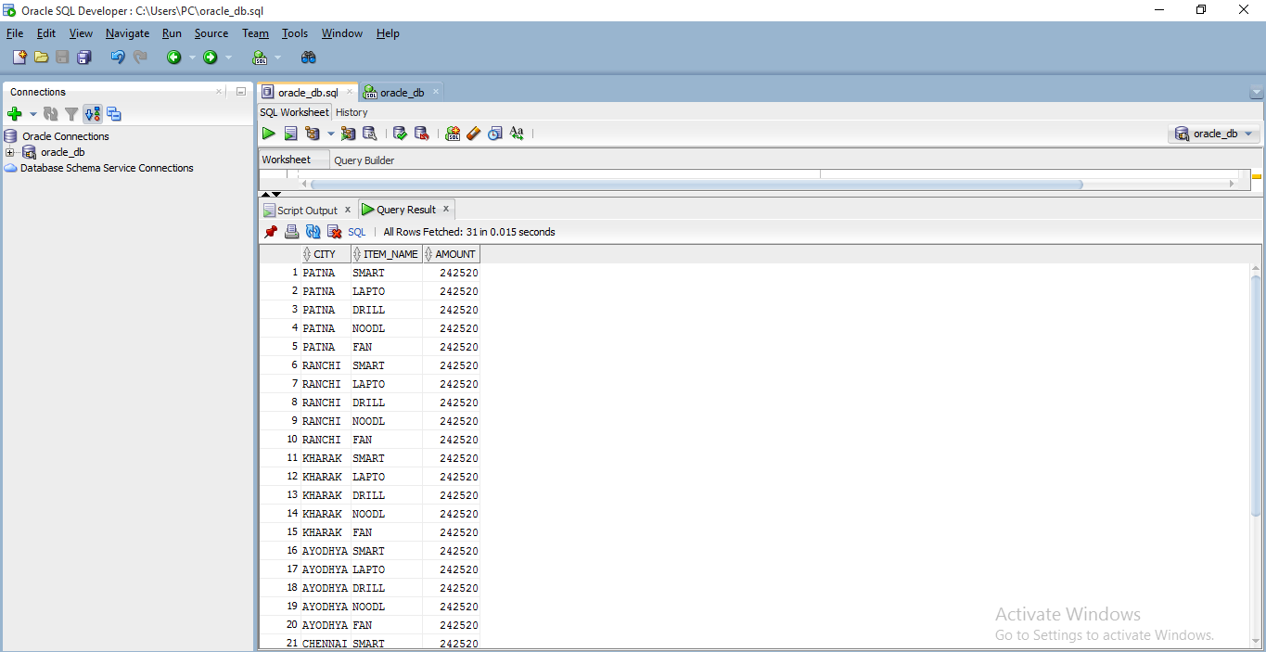

-- (B) “Compute the sum of sales, grouping by city.”

SELECT

city,

sum(dollor_sold * units_sold) amount

FROM

sales_fact,location_dimension

GROUP BY

ROLLUP(city);

Output🡪

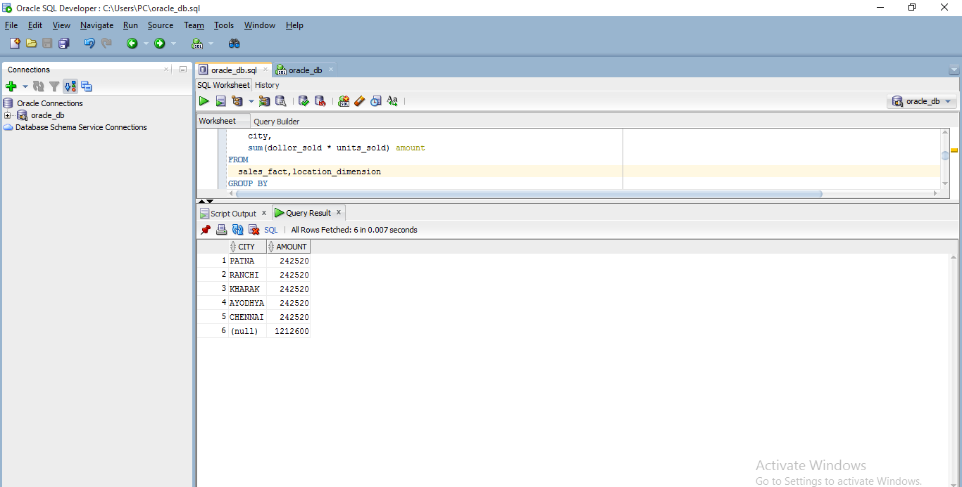

-- (C) “Compute the sum of sales, grouping by item.”

SELECT

item_name,

sum(dollor_sold * units_sold) amount

FROM

sales_fact,location_dimension,item_dimension

GROUP BY

ROLLUP(item_name);

Output🡪

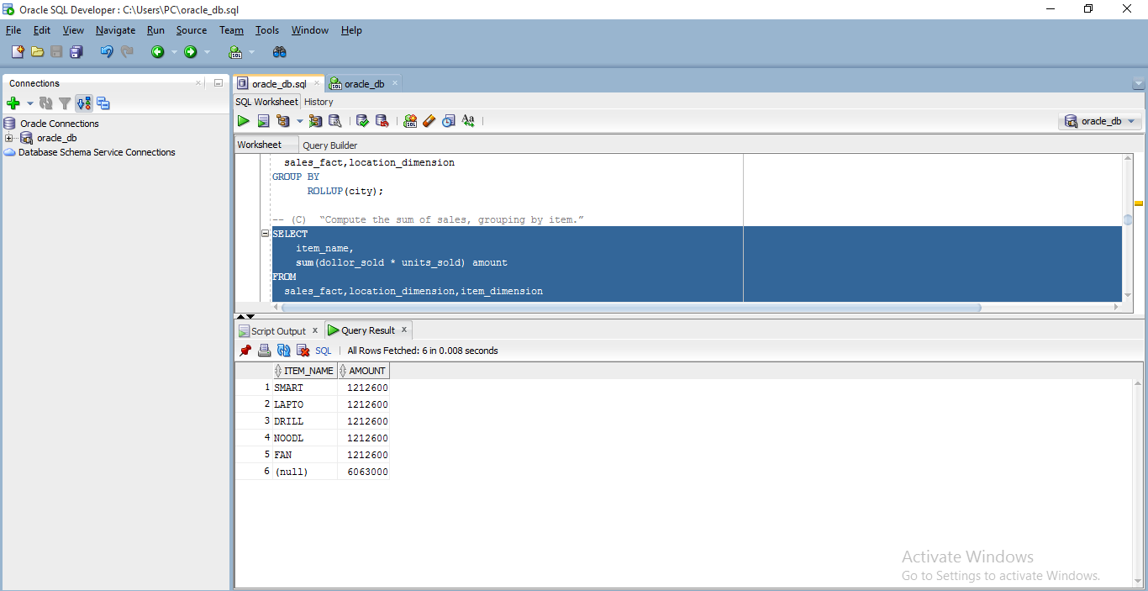

-- (D) What is the maximum number of cells in the base cuboid.

-- (p+1)^n Here p=4, n = 4

-- So (p+1)^n => (4+1)^4 -->so, maximum number of cells in base cuboid is = 625

-- (E) What is the minimum number of cells in base cuboid.

-- Here p=4 --> so, minimum number of cells in base cuboid is = 4

-- -------------------------------------------------------------------------------------------

-- Que 2)

-- CREATE game table

create table Game( Game_Id Number(5), Name varchar(20));

-- CREATE location table

create table Location( Location_Id Number(5), City varchar(20), state Varchar(15));

-- CREATE date table

create table Date_Game( date_Id Number(5), Day Number(5),Month Number(5), Year Number(5));

--CREATE spectator table

create table spectator( spectator_Id Number(5),Name Varchar(15), Type varchar(20));

-- CREATE Sales table which also contain COUNT and CHARGE

create table sales_game( sales_id Number(5),Game_Id Number(5),Date_Id Number(5),Spectator_Id Number(5),Location_Id Number(5), Count Number(5), Charge Number(5));

-- ADD Primary Key to game table

alter table Game add constraint pk_Game primary key(Game_Id);

-- ADD Primary Key to location table

alter table Location add constraint pk_Location primary key(Location_Id);

-- ADD Primary Key to date table

alter table Date_Game add constraint pk_Date_Game primary key(date_id);

-- ADD Primary Key to spectator table

alter table spectator add constraint pk_spectator primary key(spectator_Id);

-- ADD Primary Key to sales table

alter table sales_game add constraint pk_sales_game primary key(sales_Id);

-- Connecting all tables to sales table By Foreign keys

alter table sales_game add constraint fk_Game_sales_game foreign key (Game_Id) references Game(Game_Id);

alter table sales_game add constraint fk_Location_sales_game foreign key(Location_Id) references Location(Location_id);

alter table sales_game add constraint fk_Date_Game_sales_game foreign key(Date_Id) references Date_game(Date_id);

alter table sales_game add constraint fk_spectator_sales_game foreign key(spectator_Id) references spectator(spectator_id);

desc Game;

desc Location;

desc Date_Game;

desc spectator;

desc sales_game;

-- Insert DATA into Game table

insert into Game values (101,'Cricket');

insert into Game values (102,'Football');

insert into Game values (103,'Kabaddi');

insert into Game values (104,'Basket Ball');

-- Insert DATA into location table

insert into Location values(201,'Patna','Bihar');

insert into Location values(202,'Ranchi','Jharkhand');

insert into Location values(203,'GM_Place','West Bengal');

insert into Location values(204,'Mumbai','Maharashtra');

-- Insert DATA into Date table

insert into Date_Game values(301,23,11,2009);

insert into Date_Game values(302,12,4,2010);

insert into Date_Game values(303,5,9,2019);

insert into date_Game values(304,30,6,2021);

-- Insert DATA into spectator table

insert into spectator values(401,'Gaurav','Student');

insert into spectator values(402,'Sunny','Adult');

insert into spectator values(403,'Pankaj','Senior');

insert into spectator values(404,'Abhishek','Student');

-- Insert DATA into sales table

insert into sales_game values(1,101,301,401,201,34,4500);

insert into sales_game values(2,102,302,402,202,12,9800);

insert into sales_game values(3,103,303,403,203,45,3400);

insert into sales_game values(4,104,304,404,204,67,6700);

select* from Game;

select* from Location;

select* from Date_Game;

select* from spectator;

select* from sales_game;

-- A) Implement that operation using OLAP query language.

select

city,

sum(charge*count)

from

sales_game,Location,spectator,Date_game

where

city = 'GM_Place' and year=2010 and type='Student'

Group by

city;

Output🡪

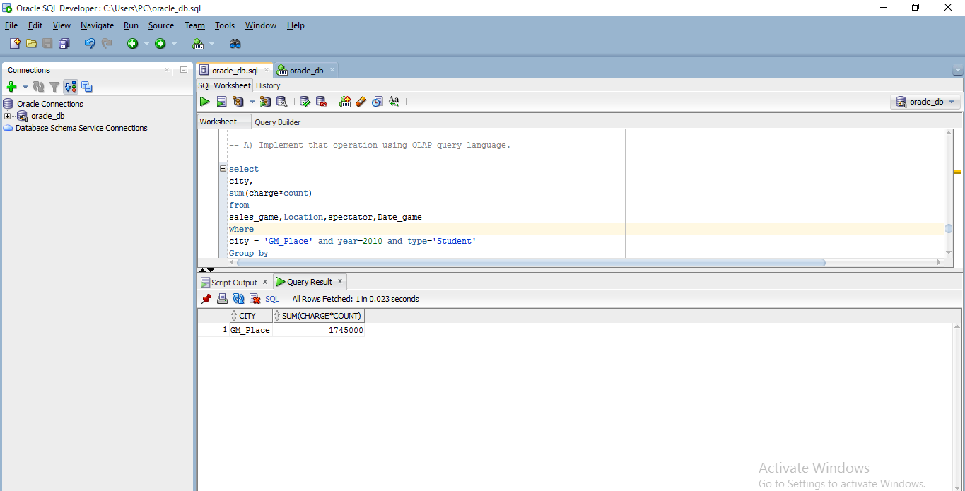

-- B) Perform roll up operation from date to year.

SELECT

day,month,year,

sum(charge * count) amount

FROM

sales_game,date_game

GROUP BY

ROLLUP(day,month,year);

Output🡪

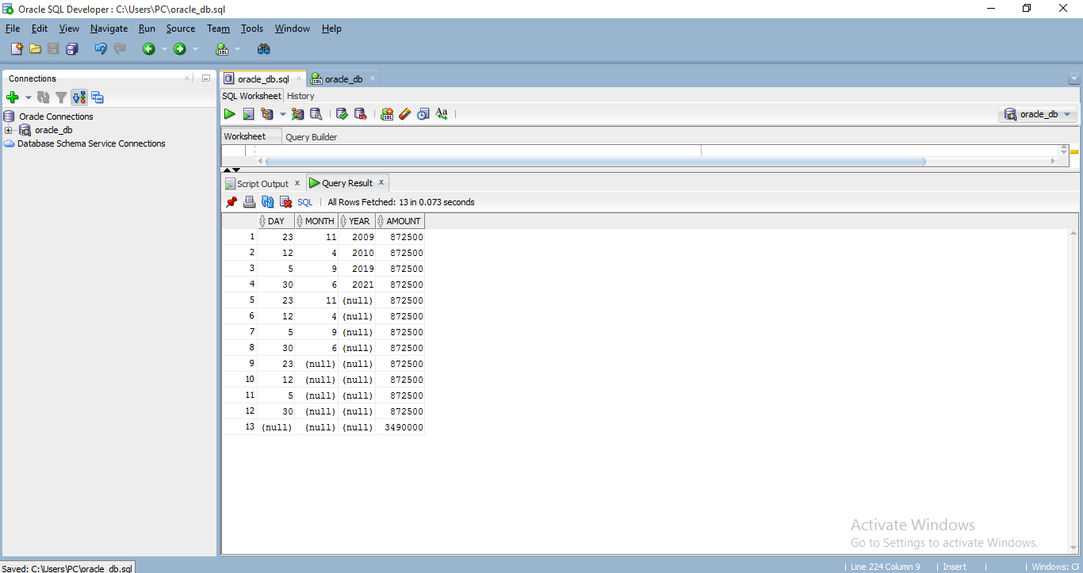

-- C) What is the average charge paid by students, adults and seniors for each category you need to compute average?

select

type,

avg(charge*count)

from

sales_game,spectator

where

spectator.spectator_id = sales_game.spectator_Id

group by

type;

Output🡪

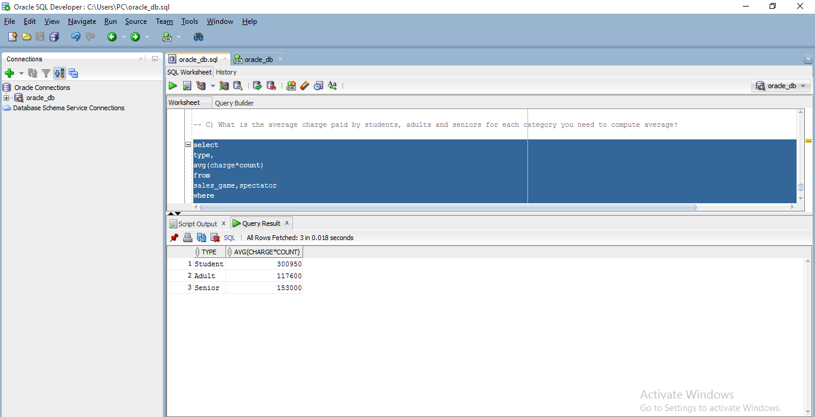

-- D) Draw the snowflake schema diagram for the data ware house.

Answer 🡪

