D2.7
Deployment of the PoC platform
Project Title | dealii-X: an Exascale Framework for Digital Twins of the Human Body
Project Number | 101172493
Funding Program | European High-Performance Computing Joint Undertaking
Project start date | 1 October 2024
Duration | 27 months
Deliverable title | D2.7: Deployment of the PoC platform
Deliverable number | D2.7
Deliverable version | 0.1
Date of delivery | 31/07/2026
Actual date of delivery | [TBD]
Nature of deliverable | Report
Dissemination level | Public
Work Package | WP2
Partner responsible | eXact lab

Abstract | dealii-X D2.7 reports on the deployment of the first version of the Proof of Concept (PoC) platform, whose design was presented in D2.6. The platform, named DealiiX Platform, is a desktop application providing a node-based low-code editor for building computational graphs, which are executed by CORAL, a C++ computational graph engine backed by the deal.II library. The no-code layer envisioned in D2.6 is realized through subnetwork nodes, allowing users to encapsulate low-code graphs into reusable high-level components. The platform transparently targets computational resources ranging from the local machine to remote HPC systems managed by the Slurm scheduler, including MPI-parallel executions, and integrates a collaborative project server and a visualization service. This deliverable describes the architecture and the main features of the deployed platform, its packaging, testing and continuous integration infrastructure, and outlines the activities planned for the final development phase of the project.
Keywords | PoC platform; low-code interface; no-code interface; computational graph; CORAL; deal.II; metascheduler; HPC

Document Control Information
Version | Date | Author | Changes Made
0.1 | 16/07/2026 | M. Franzon | Initial draft

Approval Details
Approved by: [TBD]
Approval Date: [TBD]

Distribution List
- - Project Coordinators (PCs)
- - Work Package Leaders (WPLs)
- - Steering Committee (SC)
- - European Commission (EC)
Disclaimer: This project has received funding from the European Union. The views and opinions expressed are those of the author(s) only and do not necessarily reflect those of the European Union or the European High-Performance Computing Joint Undertaking (the “granting authority”). Neither the European Union nor the granting authority can be held responsible for them.

Introduction
Deliverable D2.6 presented the design of the Proof of Concept (PoC) platform of the dealii-X project: a single environment in which professionals with different levels of technical expertise can build, run and inspect simulations based on the dealii-X libraries, without having to deal with the complexity of the traditional HPC workflow. The design identified four main requirements: a collaborative space, a modular architecture, an interaction model that allows deep customization without requiring specific coding skills, and a transparent usage of computational resources, from local machines to HPC clusters. These requirements led to the adoption of a combined low-code/no-code approach, in which users can define custom no-code nodes in terms of low-code logic.
The present deliverable reports on the deployment of the first version of the PoC platform, named DealiiX Platform. Following the development plan outlined in D2.6, the implementation activities of tasks 2.6.2 (development of the no-code/low-code graphical user interface) and 2.6.3 (development of a meta-scheduler system) started in M7 and proceeded iteratively, with a first version of the platform available at M17 and the deployment and testing phase (task 2.6.4) carried out between M18 and M22. The platform has been developed in the open, with an iterative release process: six versions have been released between M12 and M22, each accompanied by a public changelog, packaged installers for Linux and macOS, and an automated test suite.
The rest of the deliverable is organized as follows. Section 2 presents the architecture of the platform and its components. Section 3 describes the low-code node editor, the concrete realization of the design sketched in section 2 of D2.6. Section 4 describes the no-code layer, based on subnetwork nodes. Section 5 covers the execution modes and the meta-scheduling functionality, which transparently target local and remote computational resources. Section 6 presents the collaborative and visualization services. Section 7 reports on packaging, deployment and quality assurance, and section 8 outlines the activities planned for the final phase of the project.

Architecture of the PoC platform
The PoC platform is composed of four cooperating components, shown in Fig. 1:
- DealiiX Platform, the desktop application that provides the user interface. It is built with the Electron framework and the Svelte 5 web framework, and embeds the node-based canvas editor on which the low-code and no-code interactions take place.
- CORAL (Computational Object-oriented Representation And Library), the C++ computational graph engine that executes the graphs built in the editor. CORAL exposes the classes and functions of an underlying scientific library as a registry of nodes, and executes networks of such nodes. The main backend is a deal.II plugin, which makes the deal.II finite element machinery available as graph nodes.
- Coral Remote Server, a REST API server written in Go that provides user authentication and collaborative project management, backed by an SQLite database.
- Coral Visualizer, a Python web application for the visualization of simulation results in VTK formats, built on the Trame framework with a ParaView-based rendering backend.
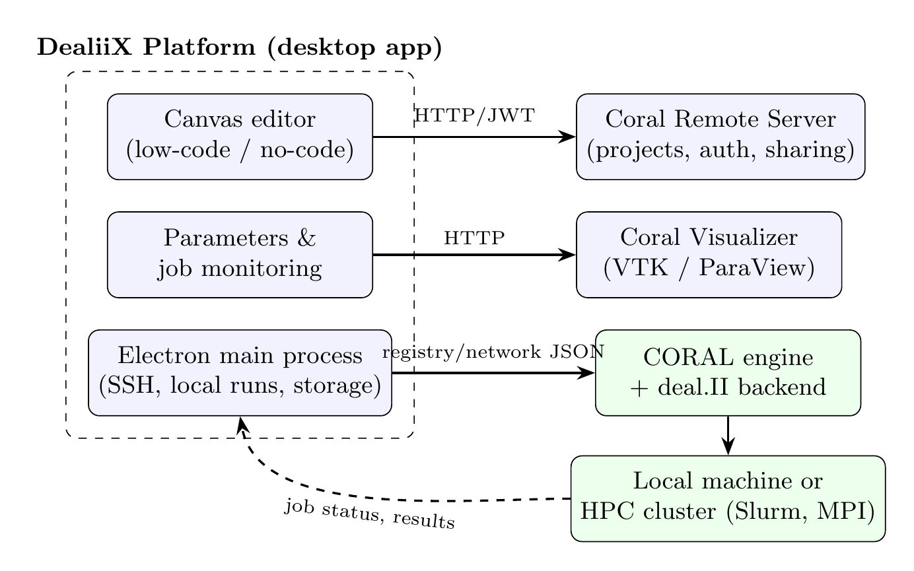
Figure 1: Architecture of the PoC platform and its components
The desktop application and CORAL communicate through two JSON-based protocols, which constitute the contract between the user interface and the computational engine:
- The registry protocol describes the node types made available by a CORAL backend: for each node, its arguments with their types, its input and output connections, and its nature (constructor, member function, free function, etc.). The registry is loaded by the application at startup, validated, and used to populate the palette of available nodes.
- The network protocol describes a computational graph as a list of nodes and typed edges. It is used to save and load projects, to exchange graphs between users, and to submit graphs to CORAL for execution.
This clean separation keeps the user interface completely agnostic of the underlying simulation library: any library wrapped by a CORAL backend automatically becomes available in the visual editor, without changes to the application. This fulfills one of the key modularity requirements set in D2.6.

The low-code node editor
The low-code interface implements the node-based programming model designed in section 2 of D2.6. The minimal set of object-oriented entities identified there is mapped onto a family of node types: elementary constructors for primitive values (integers, floating point numbers, booleans, strings), class constructors, member functions (including const and value-returning methods), free functions, and abstract base classes used for polymorphic connections. Each node exposes typed input and output pins, and edges between pins are validated in real time against the type system: a connection is accepted only if the output type of the source node matches the input type of the target node, including inheritance relations through abstract base classes. The same validation is applied when a graph is imported from a file or loaded from the remote server, so that only well-formed graphs reach the execution engine.
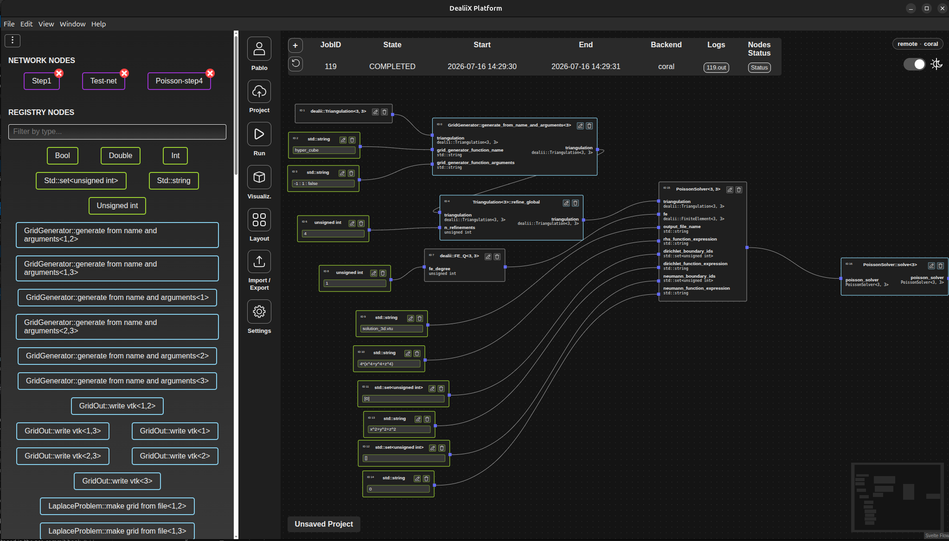
[Figure 2 — A computational graph built in the DealiiX Platform's node-based low-code editor, executed by CORAL and equivalent to deal.II's step-4 tutorial in three dimensions. ]
On top of this typed graph model, the editor (Fig. 2) provides the interaction features expected from a modern visual programming environment:
- a searchable node palette, from which nodes are added to the canvas via drag and drop;
- a create-on-connect flow: dragging a connection onto an empty area of the canvas offers the compatible node types and creates the selected one, already connected;
- editable literal fields directly on primitive nodes, editable node names, multi-selection with bulk deletion;
- per-level undo/redo history and automatic graph layout based on a rank-based algorithm, with horizontal and vertical orientations;
- import and export of graphs as JSON files following the network protocol, so that graphs can be shared and versioned outside the platform;
- a light and a dark theme, with a fully semantic color system.
Simulation parameters are handled through a dedicated collapsible panel. The platform probes the simulation code to obtain its parameter tree: following the deal.II parameter handling conventions, both JSON and .prm text formats are supported, with automatic format detection. Parameters can be edited, sections can be duplicated (for parameter studies of repeated subsections), and the resulting file is uploaded alongside the graph at execution time.

The no-code layer: subnetwork nodes
The key feature linking the low-code and the no-code approaches, as anticipated in D2.6, is the ability to encapsulate a collection of nodes into a single reusable node. In the deployed platform this is realized by subnetwork nodes (network nodes in the protocol nomenclature).
Any selection of nodes on the canvas can be collapsed into a named subnetwork node. The platform automatically computes the boundary of the selection: the unconnected inputs and outputs of the selected nodes become the external interface of the new node, while the internal edges are hidden. The resulting node behaves like any other node in the palette — it can be dragged onto the canvas, connected, and shared — but it encapsulates an entire computational graph, which is stored in its definition following the network protocol and persisted across sessions.
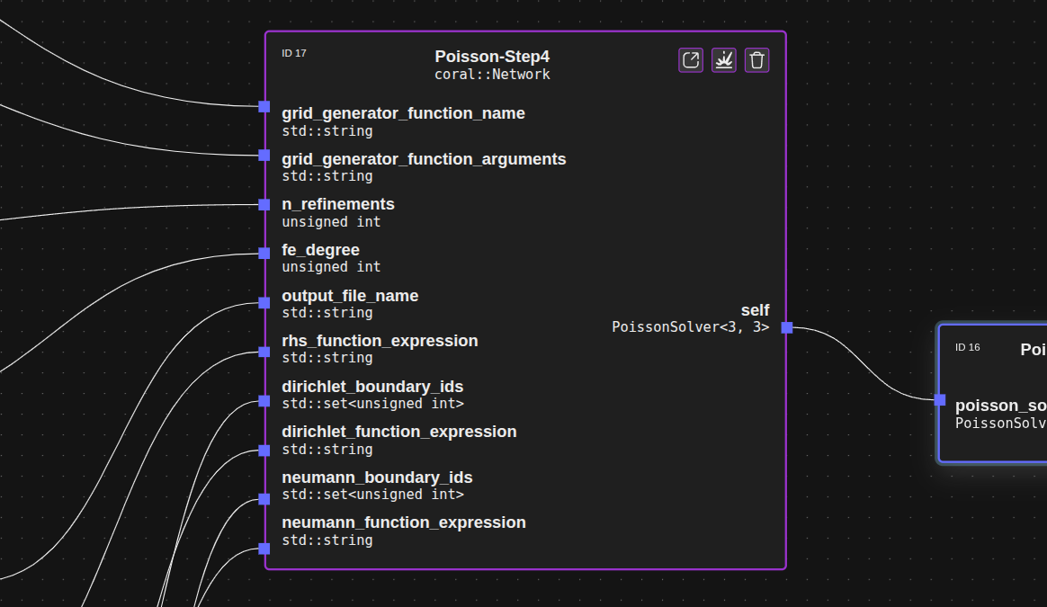
[Figure 3 a — Subnetwork nodes: a collapsed high-level node]
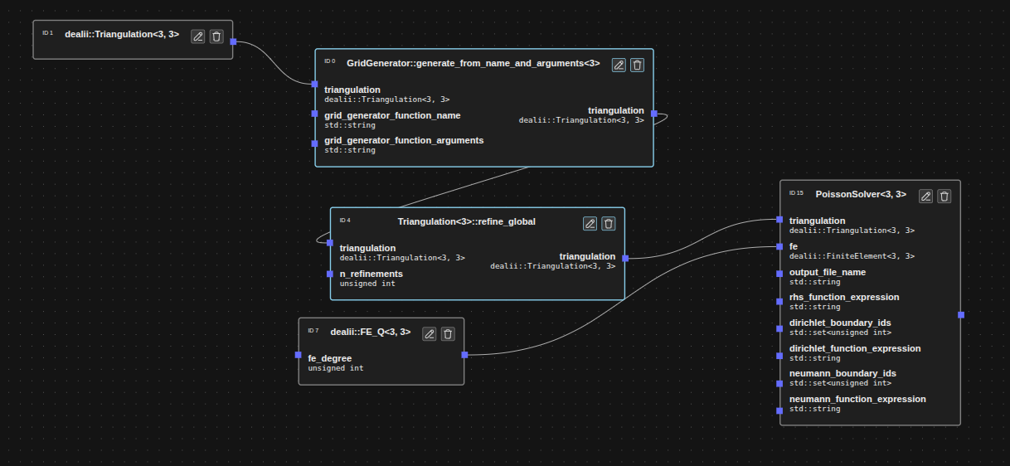
[Figure 3 b — Subnetwork nodes: the internal lower level definition of subnetwork node showed in Fig. 3 a]
Subnetworks are fully editable in place: the user can enter a subnetwork node and modify its internal graph, navigating arbitrarily nested levels through a breadcrumb bar (Fig. 3). A subnetwork can also be exploded back into its constituent nodes in the parent graph. On export, every node is annotated with a qualified identifier that encodes its position in the nesting hierarchy, which is what allows the per-node execution monitoring described in section 5 to work transparently across nested graphs.
This mechanism directly realizes the vision of D2.6: an expert user builds a simulation workflow with the low-code editor and collapses it into a single opaque node — for example a complete solver that only exposes a mesh input and a result output — and a non-expert user then operates purely at the no-code level, connecting a few high-level nodes and running the simulation without ever seeing the underlying logic.

Execution modes and meta-scheduling
The design requirement of a transparent usage of computational resources is implemented by a meta-scheduling layer that supports four execution modes, selected in the application settings and always visible through a dedicated execution badge:
- Local + CORAL: the graph is executed by a CORAL binary running directly on the user’s machine;
- Remote + CORAL: the graph is submitted over SSH to a remote system, where it is queued through the Slurm workload manager and executed by CORAL;
- Local + Executable: any deal.II program following the DealiiX executable contract is run locally;
- Remote + Executable: the same, on a remote machine over SSH.
The executable contract is a deliberately minimal convention that makes existing deal.II applications usable from the platform without modification of the platform itself: when invoked with a parameters file path that does not exist, the program writes a template file containing all its parameters and exits (this is the probing step used to build the parameters panel); when the file exists, the program reads it and runs the simulation. The standard deal.II tutorial step-70 is included in the repository as a reference example and works out of the box.
For the remote modes, the platform manages the whole job lifecycle. Graph and parameter files are uploaded over SSH (using public key authentication), and a Slurm batch script is generated from a template. Two templates are provided, for serial and MPI execution; when MPI is enabled, the job configuration dialog exposes the number of nodes and tasks per node, and the exported network JSON is annotated with the MPI plugin block required by CORAL for parallel initialization. Submitted jobs are tracked in a persistent jobs table showing scheduler status (pending, running, completed, failed, cancelled), submission and completion times, and the backend used. For CORAL jobs, the execution status of every individual node of the graph — including nodes nested inside subnetworks, via their qualified identifiers — can be inspected from the interface, and the standard output of the job can be opened directly in the application.
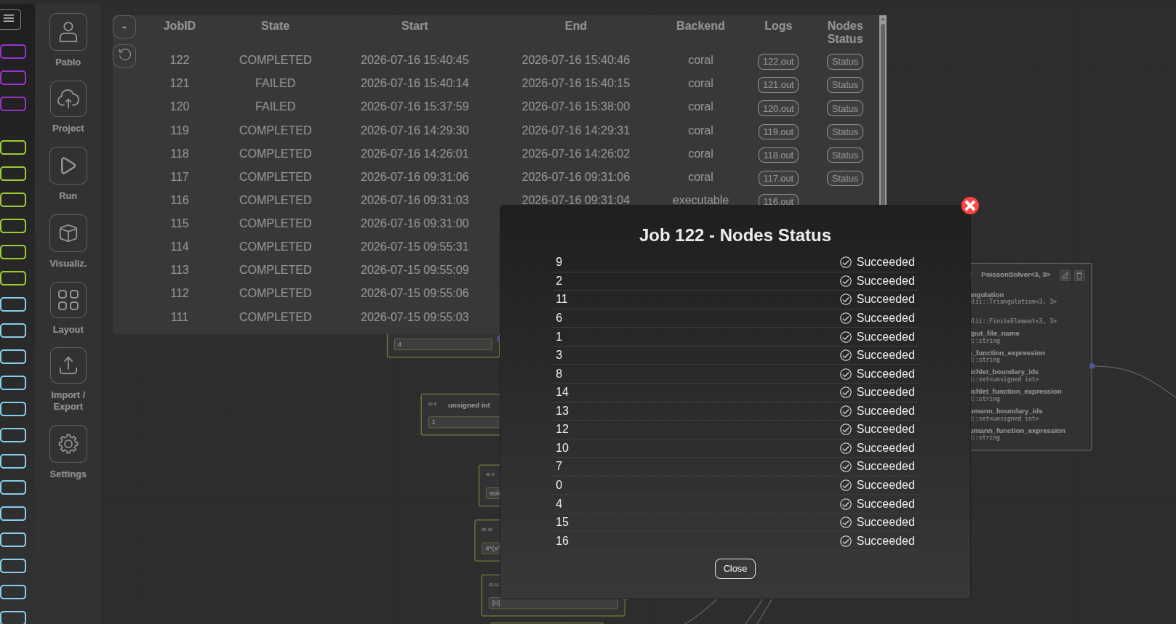
[Figure 4 — Job monitoring: jobs table and per-node execution status]
Two deployment targets have been exercised during the testing phase. The first is a containerized environment, distributed with the platform, in which a Docker container runs CORAL together with a complete Slurm installation and an SSH server, faithfully simulating a remote HPC cluster on the developer’s machine. The second is a real remote machine: the same containers are deployed on a remote host and reached through an SSH tunnel, with a documented step-by-step setup guide. Since the application only assumes SSH access and a Slurm scheduler, the same mechanism applies to production HPC systems.

Collaborative and visualization services
The collaborative space requirement is served by the Coral Remote Server, a lightweight REST service with JWT-based authentication. From the application, users can register and log in, create projects, and save and load computational graphs to and from the server. Projects can be renamed, described, deleted, and — crucially for the collaborative workflows envisioned in D2.6 — shared with other users with read or write permissions. This allows, for instance, an expert user to prepare and share a validated simulation workflow that a colleague can open and run without rebuilding it.
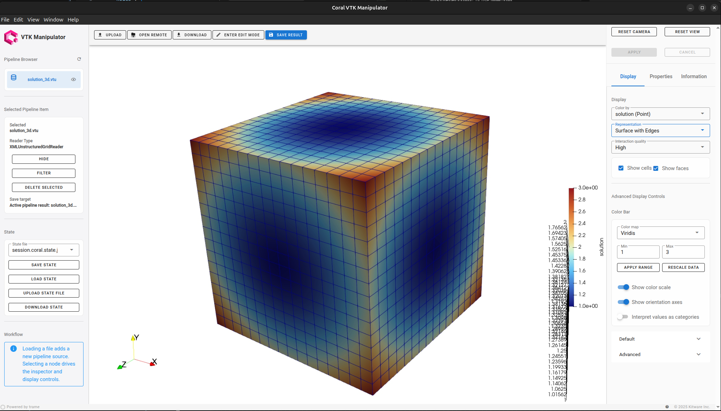
Figure 5: Poisson solution in the Coral Visualizer as a result of the workflow in Fig. 2
Simulation results are inspected through the Coral Visualizer, a web-based viewer for VTK/deal.II output formats (.vtk, .vtu), reachable directly from the application. During the reporting period the visualizer has been substantially extended with a ParaView-based rendering backend providing filters, visualization pipelines, solution field rendering, cell manipulation and edit sessions, while retaining a lightweight VTK backend for local usage. The visualizer has been tested with project-relevant datasets, including vascular geometries such as carotid artery meshes.

Packaging, deployment and quality assurance
The platform is distributed as native installers for Linux (.deb) and macOS (.dmg), produced by an automated release pipeline: tagging a version on the main branch triggers GitHub Actions workflows that run the full check and test suite, build the application, and attach the installers to a public GitHub release. For evaluation and testing, the full server-side stack (CORAL with Slurm and SSH, the remote server, and the visualizer) is started with a single docker compose up command.
Six versions have been released during the reporting period, following the iterative plan of D2.6:
- 1.0.9 (September 2025): first packaged version — canvas editor with typed validation, deal.II nodes, SSH execution;
- 1.1.0 (January 2026): remote server integration (authentication, projects, sharing), jobs panel, protocol simplification;
- 1.2.0 (January 2026): network (subnetwork) nodes, graph download, unit testing infrastructure;
- 1.3.0 (March 2026): MPI support, persistent jobs with per-node execution status, job log inspection, parameter handling;
- 1.4.0 (May 2026): execution modes with local runs and the executable contract, in-place subnetwork editing, full TypeScript migration, redesigned settings;
- 1.4.1 (July 2026): deployment on real remote machines, single-command full stack, end-to-end test suites, complete theming overhaul, .prm parameter support.
Quality assurance is enforced at three levels. At commit time, git hooks run the linter, the type checker and the code formatter. On every push and pull request, a continuous integration pipeline runs static type checking of both the frontend and the Electron backend, plus the unit test suite (Vitest), and blocks merging on failure. Finally, two tiers of end-to-end tests, based on Playwright driving the real Electron application, cover the interactive flows: Tier 1 exercises the canvas (node creation, connections, undo/redo, graph import, subnetwork collapse and explode) without external services, and runs headlessly in CI on every push; Tier 2 covers authentication and project management flows against a live Coral Remote Server instance. Both tiers run against an isolated configuration store, so tests are reproducible and cannot interfere with a user’s installation.

Validation with the lighthouse applications and partner feedback
[TODO: placeholder — to be written.]

Outlook
With the deployment of the first version of the PoC platform, task 2.6.4 of the development plan presented in D2.6 (Fig. 5) is completed. The final phase of the project (task 2.6.5, M23–M27) is devoted to the development of additional features, driven by the feedback collected from the project partners during the testing period. The main directions are:
- enrichment of the node registries with the dealii-X application libraries developed in the other work packages, moving from tutorial examples towards the organ-scale digital twin workflows targeted by the project;
- deployment and validation of the remote execution modes on production HPC systems;
- continued improvement of the visualization service and of the no-code user experience for non-expert users.
Figure 6: Timeline of the activities of task 2.6; D2.7 marks the end of the deployment phase (task 2.6.4)
The PoC platform is one of the main exploitable results of the dealii-X project: it demonstrates, end to end, that the simulation capabilities developed in the project can be operated through an intuitive low-code/no-code environment by users with widely different technical backgrounds, and it provides the foundation on which the final version of the platform will be delivered at the end of the project.

