WarcLock
By Deamonmist
A wardriving pocket watch with style.

Readme
June 15th, 2026 | Status: 1.0.0-beta.1

Contents
Pg 1. – Contents
Pg 1. – Mission Statement
Pg 2. – Overall Design
– Form Factor
– Components
Pg 3. – Assembly
– Wiring Diagrams
Pg 5. – Circuit Assembly
Pg 9. – 3D Printing
Pg 10. – Final Assembly
Pg 18. – Flashing Your XIAO ESP32-C5

Mission Statement
The goal of this project is simple: use basic components to make a portable war-driver that can pass as some kind of nifty home-made clock.

Overall Design

Form Factor
Small 3d-printed case containing a series of small modules and development boards that can display the real time on an analog clock. Clock comes with satellite connection indicator, battery life gauge, active wardriving indicator, and random messages. The design is based on a digital Arte Deco style.

Components
- GPS module (ATGM336H) with ceramic antenna
- 1.28” TFT screen (GC9A01TFT)
- SD Module
- Xiao ESP32-C5
- 400mAh LiPo battery (AKZYTUE 3.7V 522332)
- Perforated Board
- Leads
- Two sliding switches
- 1 tactile switch

Assembly

Wiring Diagrams
Complete pin mapping for all components. XIAO ESP32-C5 silkscreen D-numbers do not match GPIO numbers — always use the GPIO column when writing firmware.

ATGM336H — GPS Module
GPS Pin | XIAO Pin | GPIO
TX | D7 (RX) | GPIO12
RX | D6 (TX) | GPIO11
VCC | 3V3 | —
GND | GND | —

GC9A01 — Round TFT Display
TFT Pin | XIAO Pin | GPIO
SCL / SCK | D8 | GPIO8
SDA / MOSI | D10 | GPIO10
CS | D2 | GPIO25
DC | D3 | GPIO7
RST | D1 | GPIO0
VCC | 3V3 | —
GND | GND | —

V474 — SD Card Module
SD Pin | XIAO Pin | GPIO
SCK | D8 (shared SPI) | GPIO8
MOSI | D10 (shared SPI) | GPIO10
MISO | D9 (shared SPI) | GPIO9
CS | D0 | GPIO1
VCC | 3V3 | —
GND | GND | —

XIAO ESP32-C5 — MCU Pin Usage
Function | XIAO Pin | GPIO
SPI SCK | D8 | GPIO8
SPI MOSI | D10 | GPIO10
SPI MISO | D9 | GPIO9
GPS RX (← GPS TX) | D7 | GPIO12
GPS TX (→ GPS RX) | D6 | GPIO11
TFT CS | D2 | GPIO25
TFT DC | D3 | GPIO7
TFT RST | D1 | GPIO0
SD CS | D0 | GPIO1
Wardrive Switch | D5 | GPIO24
Dim Button | D4 | GPIO23
Battery +/− | BAT pads | —

On Off Switch (Left Side)
Switch Leg | XIAO Pin | GPIO
Leg 1 (signal) | Bat +
Leg 2 (common) | Bat + | —
Interrupt the positive battery line with a switch.

Wardrive Slide Switch (Right Side)
Switch Leg | XIAO Pin | GPIO
Leg 1 (signal) | D5 | GPIO24
Leg 2 (common) | GND | —
LOW = wardrive active. HIGH = idle. Internal pullup enabled in firmware.

Dim Tactile Button
Button Leg | XIAO Pin | GPIO
Leg 1 (signal) | D4 | GPIO23
Leg 2 (common) | GND | —
Press toggles black-screen dim. Auto-dims after 2 minutes. Internal pullup enabled.

LiPo Battery (500mAh)
Battery Wire | XIAO Pad | Note
Positive (+) | BAT + | Soldered direct to pad
Negative (−) | BAT − | Soldered direct to pad
Charged via USB-C. SGM40567 onboard handles charge management. Do not exceed 500mAh cell rating.

Battery Voltage Sense Circuit (onboard)
Signal | XIAO Pin | GPIO | Note
ADC input | — | GPIO6 | Reads divided BAT voltage
ADC enable | Back pad A4 | GPIO26 | Drive HIGH to enable, LOW when idle

Circuit Assembly
Because a perforated board, modules, and dev boards are being used there is a lot to pack in a very small space. I have provided a general step by step visual guide. However, visually representing wiring is too challenging. Please refer to the wiring diagrams above.

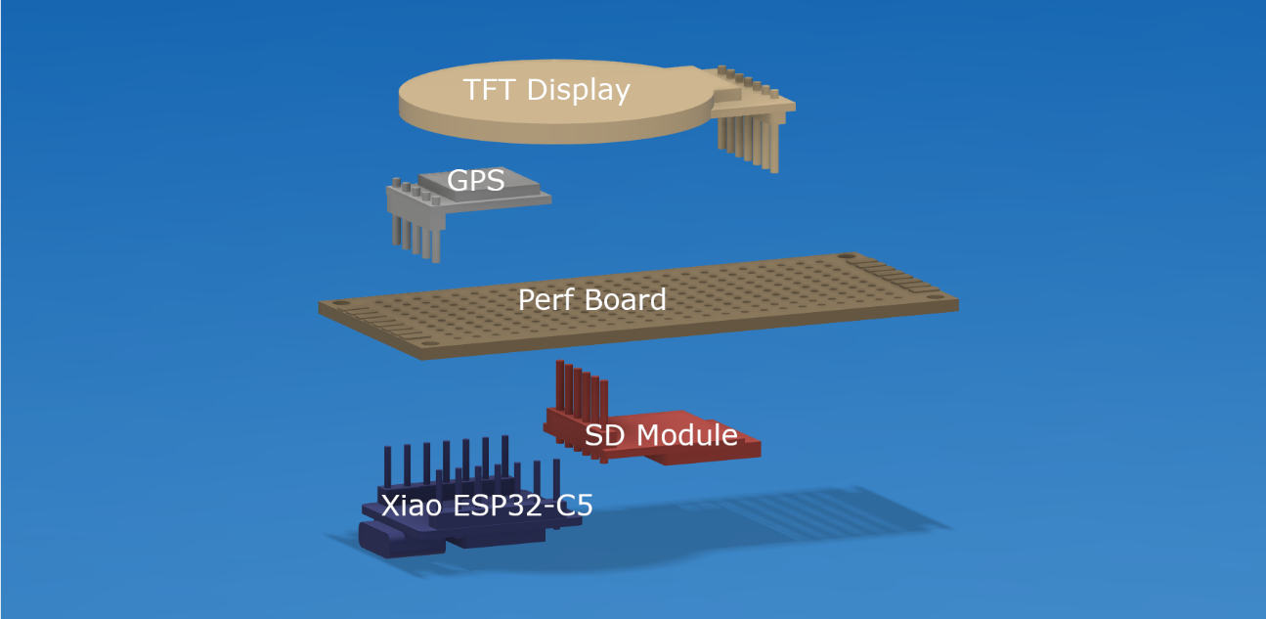
This is the rough orientation of the various components.

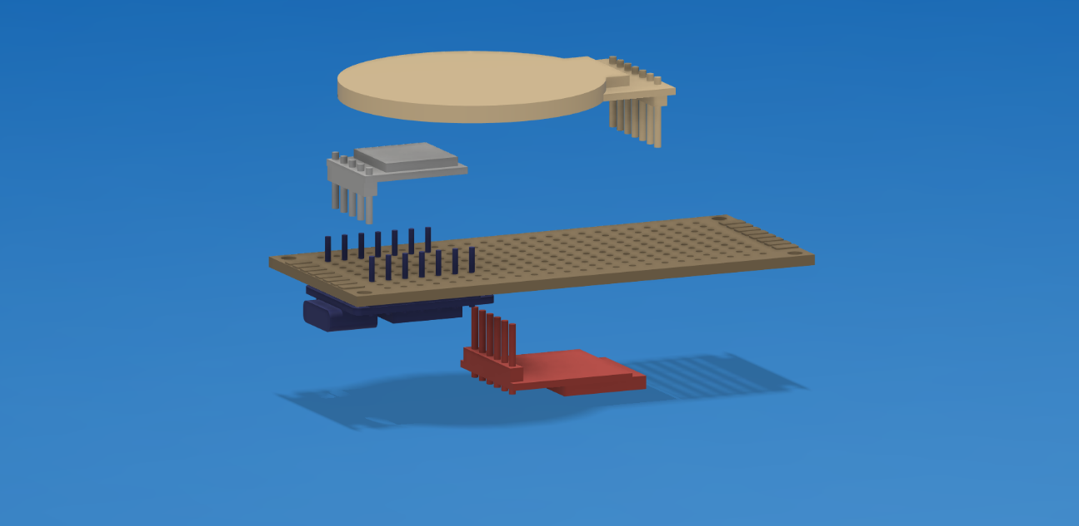
Start by moving the Xiao ESP32-C5 into the location shown. Solder one or two of the posts to the breadboard to keep it in place. Alternatively you can bend a pin or two flush with perf-board to hold it in place.

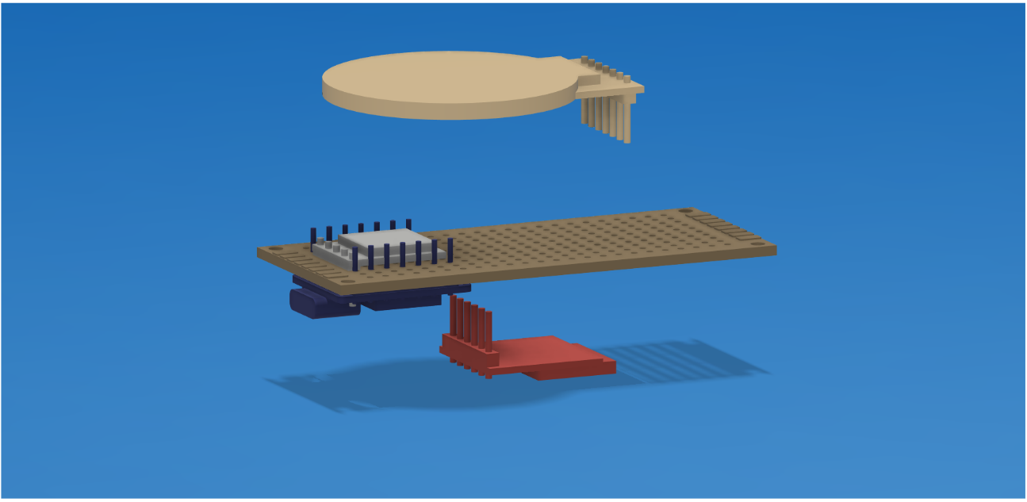
Next, move the GPS down. You may have to trim the pins to get it to fit. Again, solder in one or two places to keep it from moving.

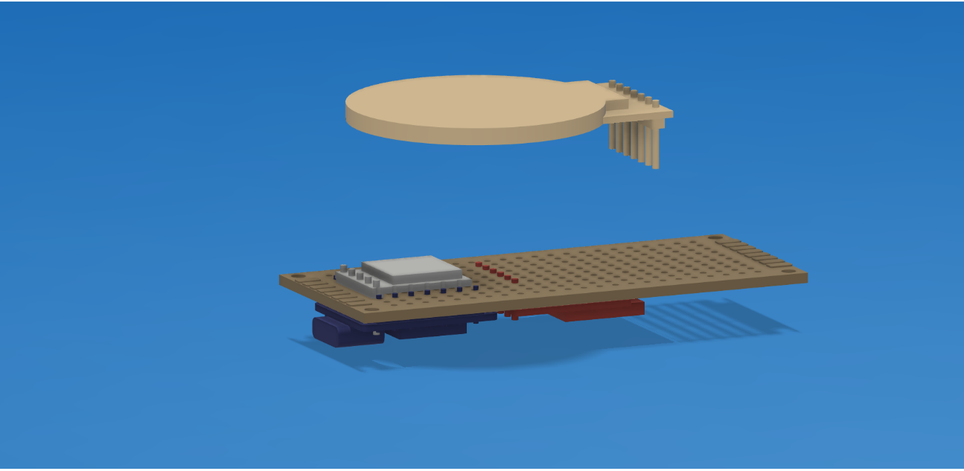
Now move the SD card up as shown. Solder into place.

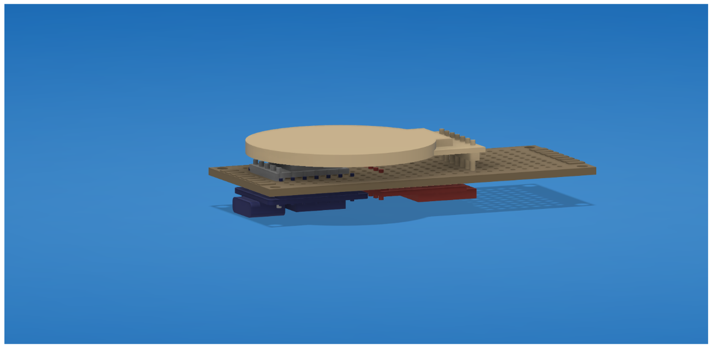
Now drop the screen down in place. You’ll want to leave enough of a gap between the perf-board and the TFT screen to hold the battery, or else the device will have to be much thicker to accommodate a battery.

See wiring charts below to solder the necessary leads into place.

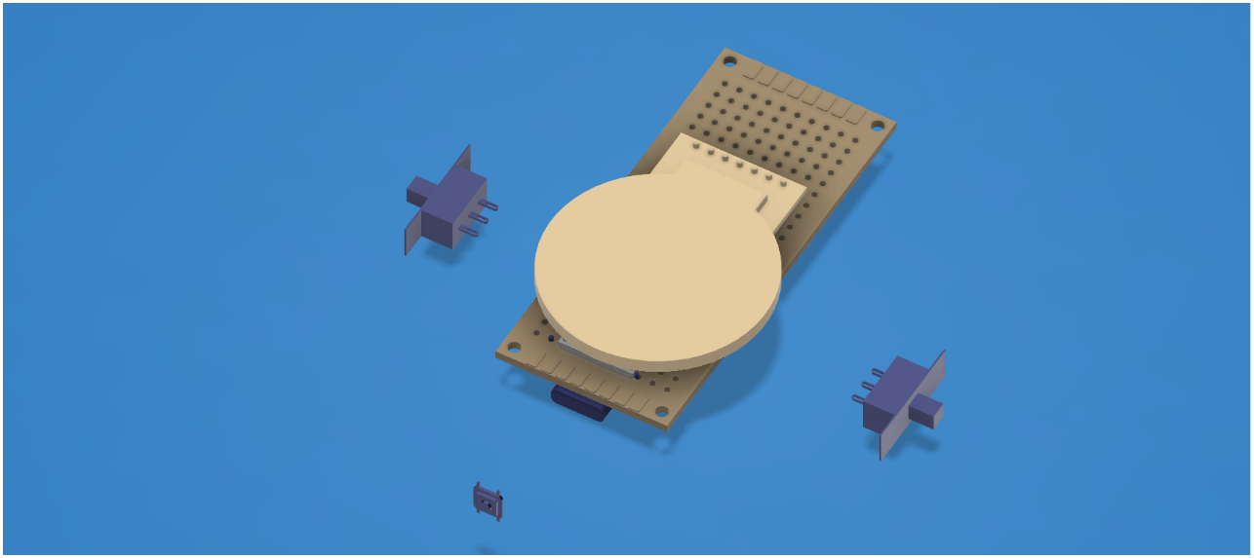
You’ll need two sliding switches and one tactile switch in this general orientation. You’ll want to use short leads on the sliding switches so they can fit properly into the housing.

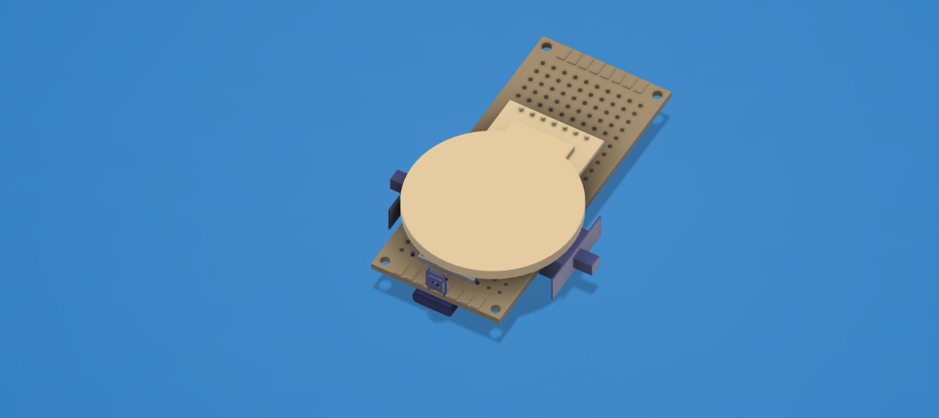
This will be the final orientation of the switches and buttons for the housing.

Once your wiring is all set, it’s time to carefully trim the excess perf board away. You’ll want to make sure the front of the perf board follows the curves of the screen. The back can be largely chopped away entirely.

3D Printing
There are a total of 5 parts that need to be printed. They are listed on the github page for download. They include from bottom to top:

- ClockBottomInlay.stl
- ClockBottomSupports.stl
- ClockBodywSupports.stl
- ClockTopwSuppports.stl
- ClockDetailInlay.stl

All prints contain designed supports. If they are laid flat for print, you should not need to add any supports.

Sometimes you’ll get an error on the ClockBodywSupports.stl file, so you can enable them but they just make it harder to take the design supports out. If this file starts to spagettify, enable supports.

Final Assembly
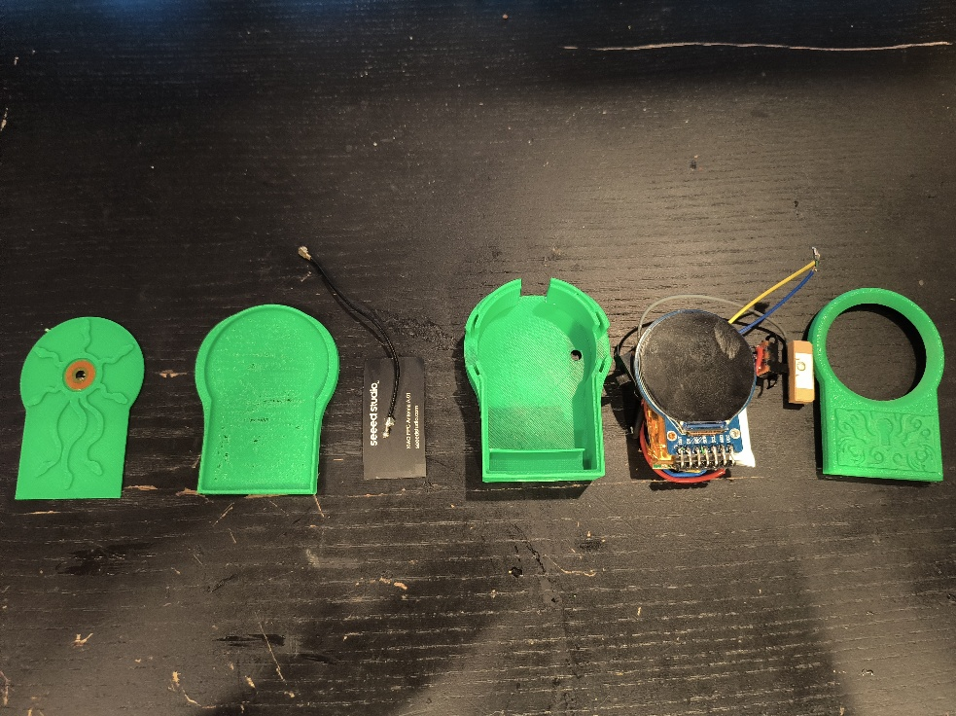
1. These are the pieces that will be used in the final construction from left to right:
- ClockBottomInlay.stl
- ClockBottomwSupports.stl
- WiFi Antenna
- ClockBodywSupports.stl
- Soldered Components
- ClockTopwSupports.stl
- ClockDetailInlay.stl

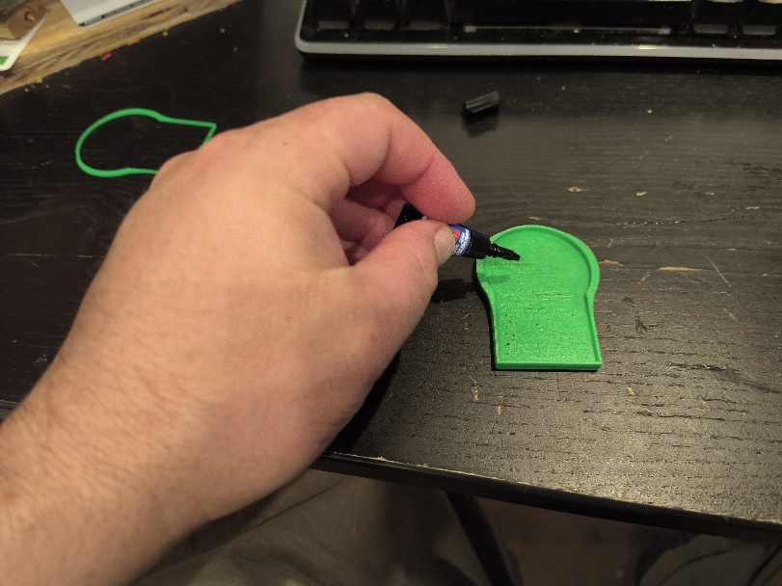
2. Apply crazy glue to the back of the bottom plate.

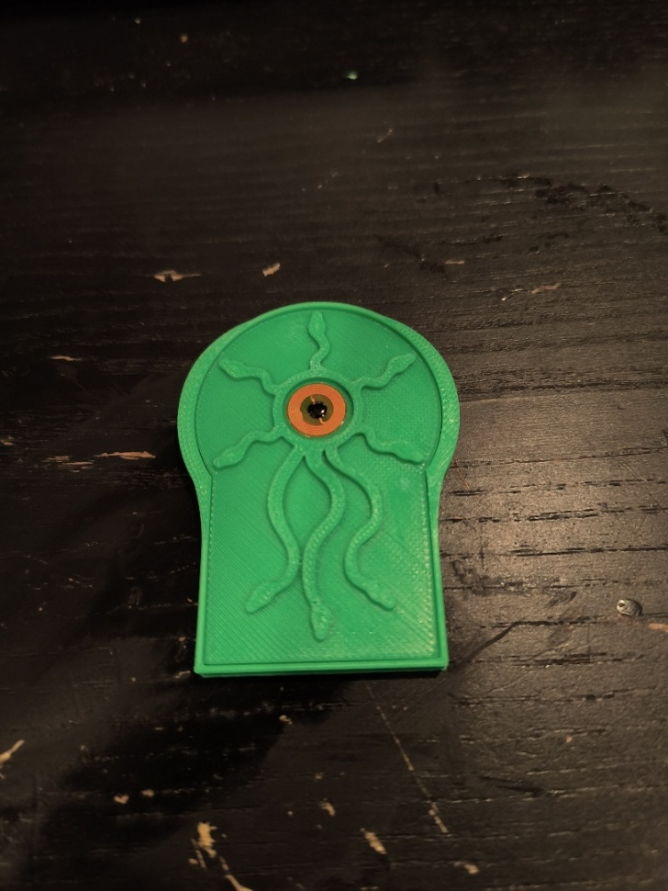
3. Attach the back plate to the bottom plate (and place NFC tag if desired).

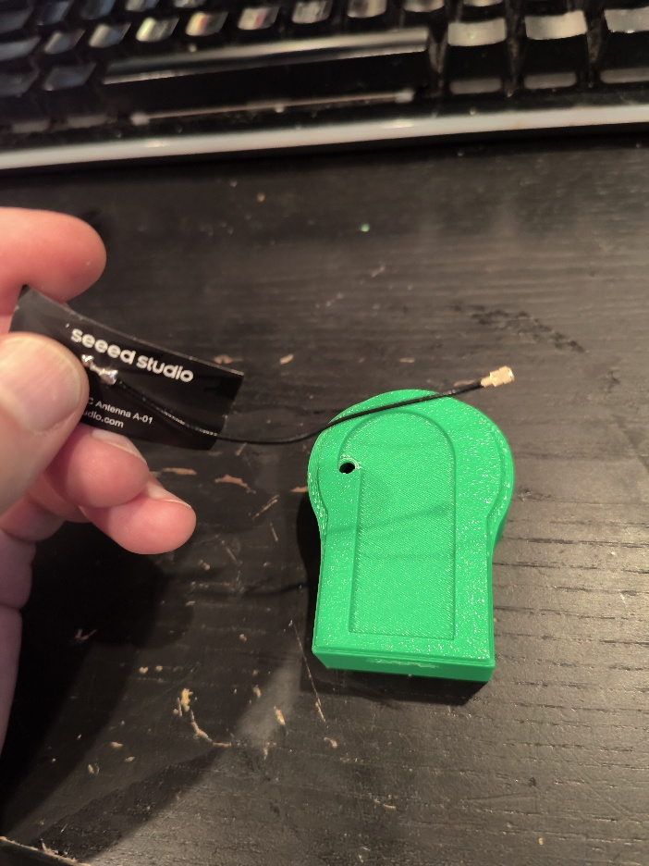
4. The antenna that comes with the Xiao ESP32-C5 must have the connection end fed through the hole in the clock body housing.

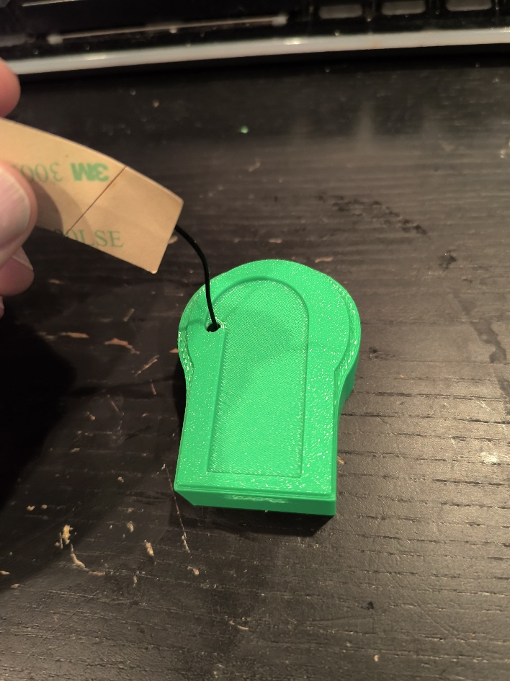
5. The connection end of the antenna fits easily.

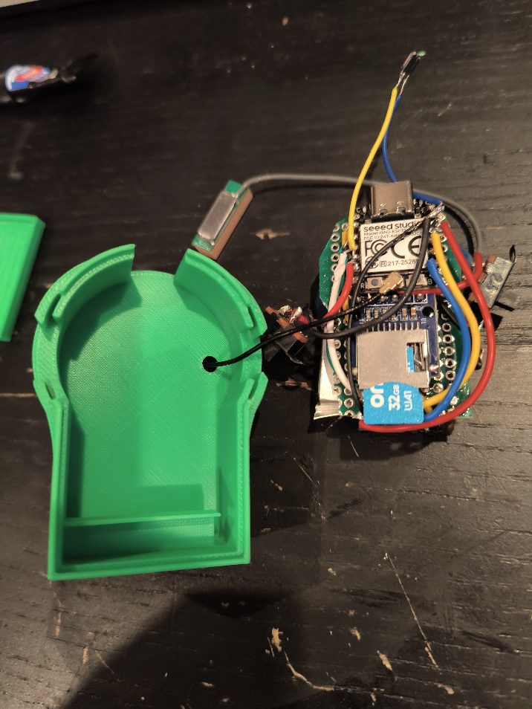
6. Attach the antenna connection end to the Xiao ESP32-C5’s UFI port.
7. Carefully place the clock into the clock body housing. You’ll have to bend the wings of the slide switches to fit the slots made for the wings.
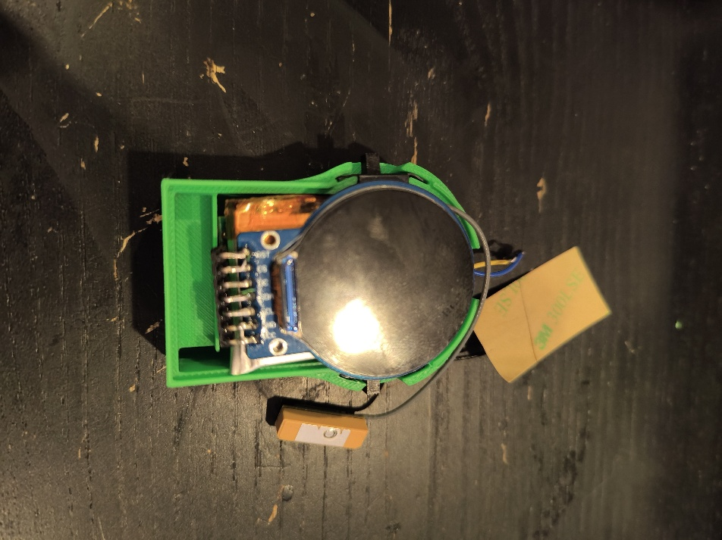

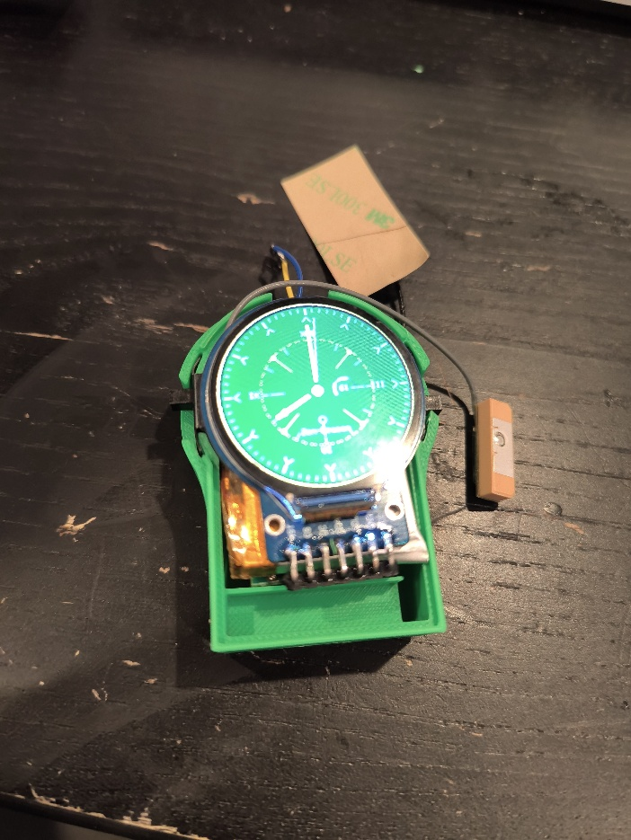
8. Test your hardware to ensure none of the cabling was compromised during the fitting.

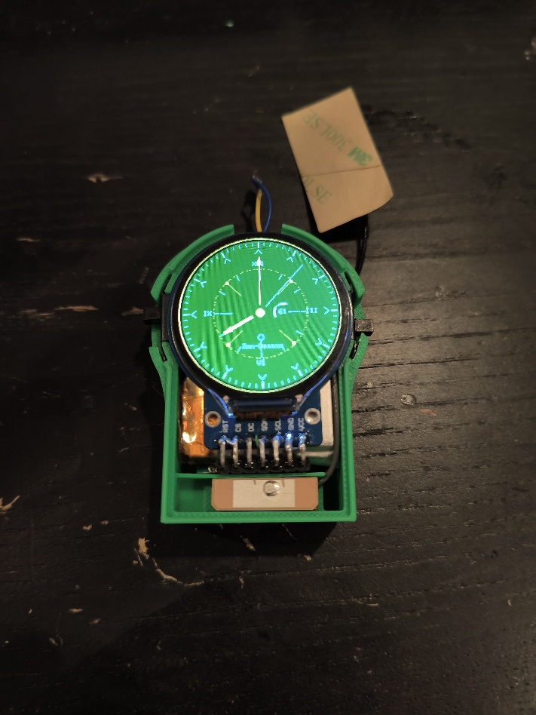
9. Place the ceramic antenna into the slot at the bottom of the clock body housing.

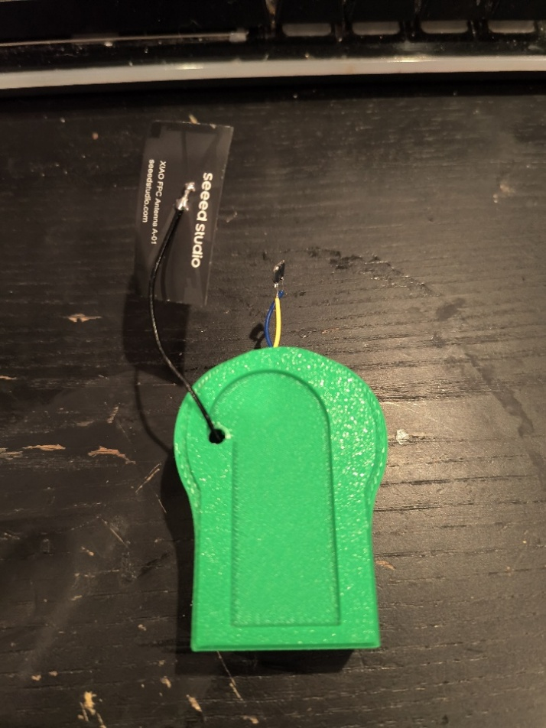
10. It is time to attach the antenna to the back of the clock body housing.

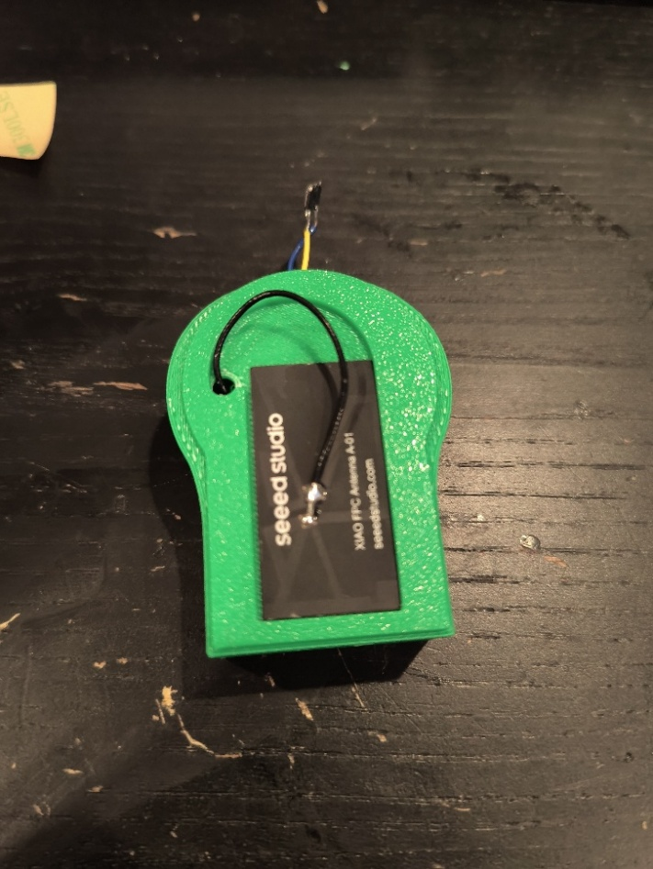
11. Remove the two sticker backs from the antenna and stick it in place.

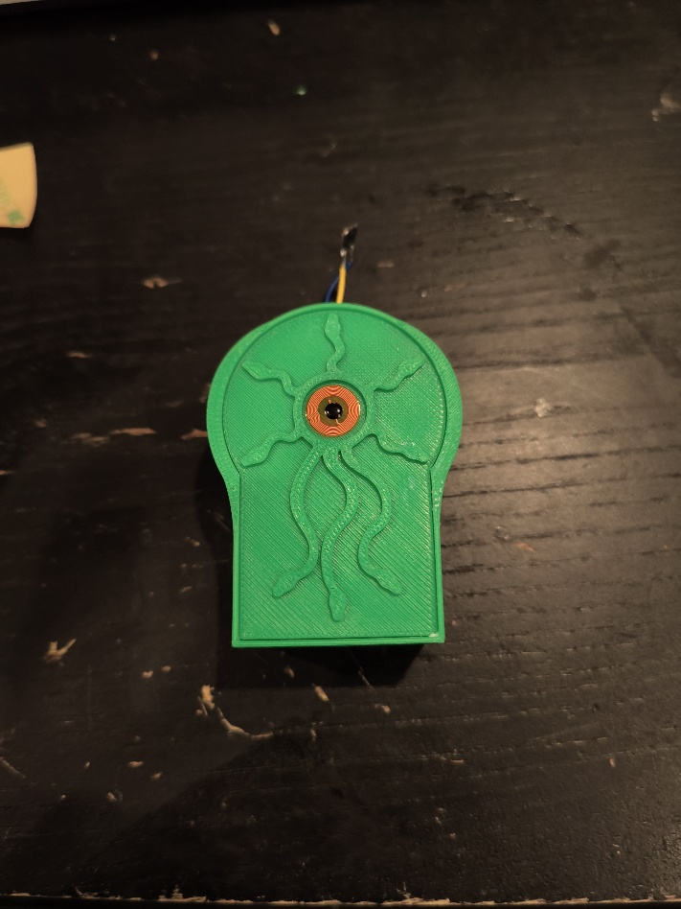
12. Attach the assembled backplate to the bottom of the clock body housing. This may be glued later.

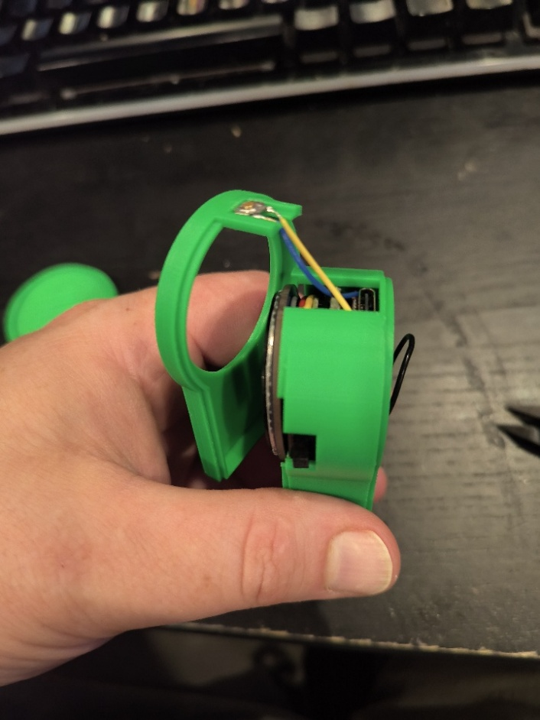
13. Carefully glue the tactile push button into the slot at the front of the clock top housing. The slit will allow the cables to the wire to be buried into the clock body housing.

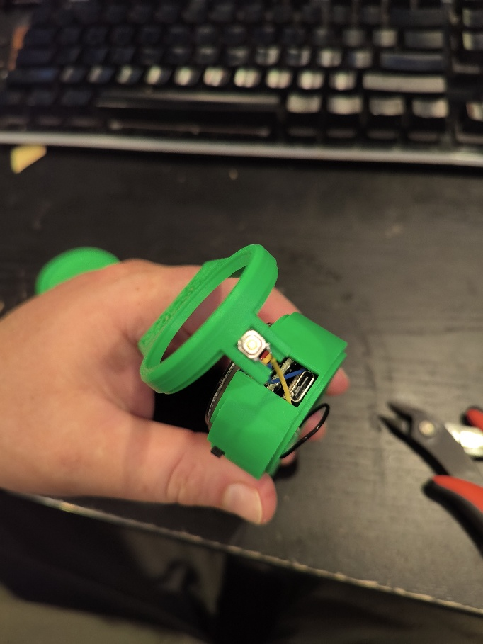
14. Begin to fit the clock top housing onto the clock body housing.

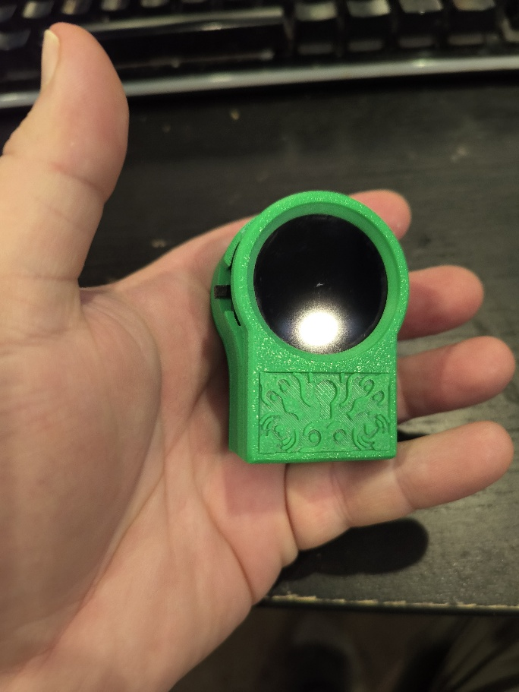
15. Once everything is working and fits snugly, use a few small dabs of super glue to make the assembly more permanent.

Flashing Your XIAO ESP32-C5
The firmware that allows the watch to display the time and wardrive was made by me. You might consider flashing the firmware onto your XIAO ESP32-C5 before you stuff everything into the 3d printed parts.

Use Arduino SDK to install the firmware on your device. There are 10 files in total. Just drag all 10 to a new folder and open the “WarcLock.ino” file with Arduino SDK to get started.

You will need the following libraries:

Arduino.h
Arduino_GFX_Library.h
<math.h>
<HardwareSerial.h>
<WiFi.h>
<SPI.h>
<SD.h>

The rest of the libraries are included in the files.

When in doubt, flash again!

