[Your report title, e.g. Predicting FIFA World Cup 2026 Match Outcomes with Linear Regression]
HIT140 Foundations of Data Science · Assessment 3 · Sydney Group 07 · Code: [GitHub/OneDrive URL]
Name | Student ID | Name | Student ID
[Member 1 full name] | [Student ID] | [Member 2 full name] | [Student ID]
[Member 3 full name] | [Student ID] | [Member 4 full name] | [Student ID]

1. Introduction and Data
[Write in your own words: aim of Objective 2 and the two regression tasks; data sources (see data/raw/SOURCES.md); how 104/208 rows were compiled; the 'known before kick-off' rule and how it was enforced; score convention (extra time counted, shoot-out = draw); validation against the 12 group tables.]
Table 1. Explanatory variables (all known before kick-off)
Concept | LR 2.1 variable (match level) | LR 2.2 variable (team level) | Source
FIFA ranking | fifa_rank_diff (team1 − team2) | fifa_rank, opp_fifa_rank | FIFA ranking, 11 Jun 2026
Squad market value | log_value_ratio = ln(V1/V2) | log_market_value, opp_log_market_value | Transfermarkt
Average squad age | avg_age_diff | — | RotoWire
Host nation | host_diff (+1/0/−1) | is_host | CAN, MEX, USA
World Cup experience | wc_experience_diff | — | Wikipedia
Confederation strength | elite_conf_diff (UEFA/CONMEBOL) | — | FIFA
Rest days | rest_days_diff | — | Match schedule
Tournament form (earlier matches only) | form_gd_pg_diff | form_gf_pg, opp_form_ga_pg | Match results
Stage | — | is_knockout | Match schedule
Target | goal_difference (104 rows) | goals (208 rows)

2. Linear Regression 2.1 — Goal Difference

2.1 Exploration and model building
[Write in your own words: target distribution (mean 0.48, SD 2.02); strongest correlations (value ratio r = 0.66, rank r = −0.62); collinearity between value and rank (r = −0.79, VIF 7.4); Model A with all 8 variables; backward elimination to Model B.]
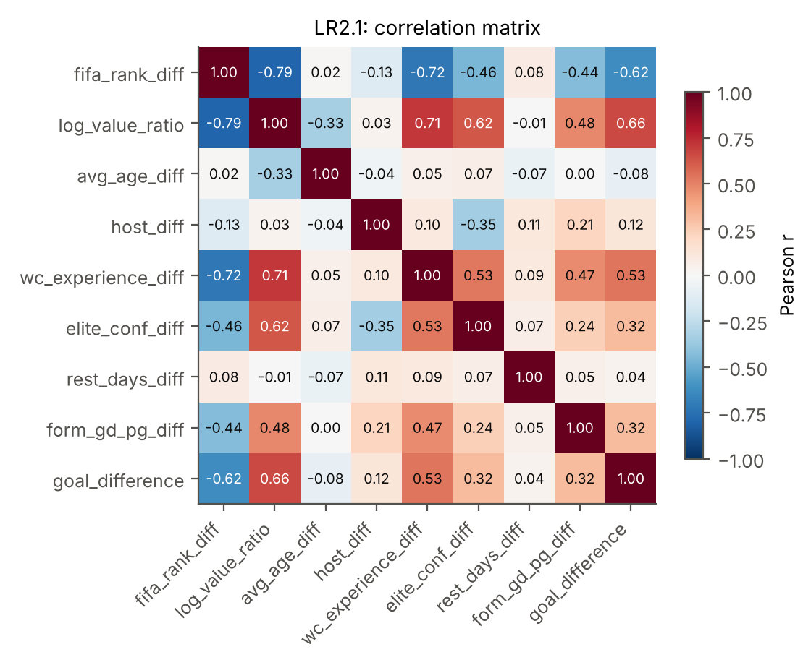 | 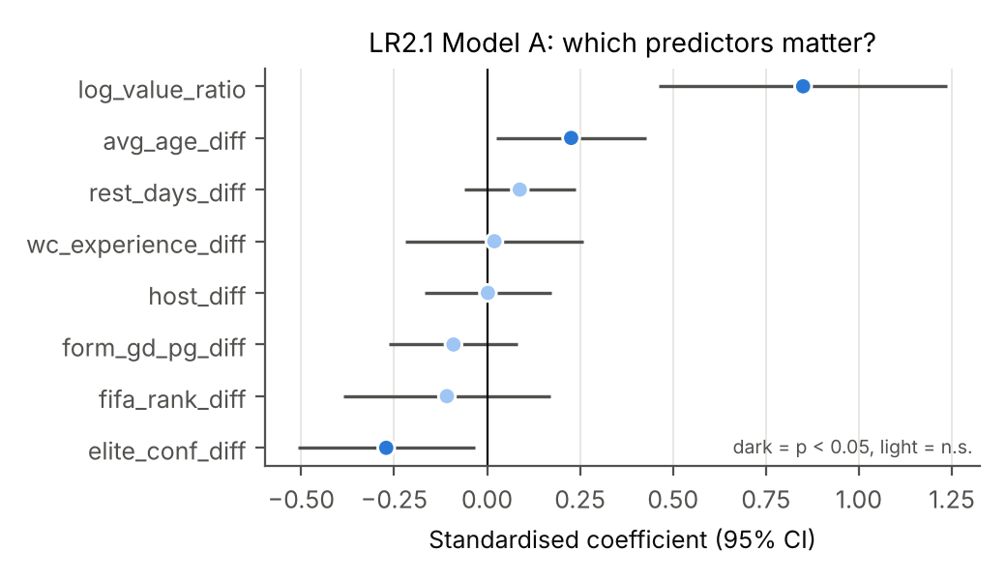
Figure 1. LR 2.1 — correlation matrix (left) and standardised coefficients of Model A with 95% CIs (right)

2.2 Evaluation and interpretation
[Write in your own words: compare Model A vs B using Table 2 (overfitting of A; B better on unseen data; both beat the mean baseline); interpret the Model B coefficients in Table 3 in plain football terms; discuss the negative elite_conf_diff carefully (no causal claim); residual checks (assumptions reasonably met).]
Table 2. Model comparison (A = all 8 variables; B = backward elimination, p < 0.05; C = A with log(1 + goals) target, predictions back-transformed)
Metric | 2.1 Model A | 2.1 Model B | 2.2 Model A | 2.2 Model B | 2.2 Model C (log)
Explanatory variables used | 8 | 3 | 8 | 2 | 8
R² / adj. R² (all rows) | 0.511 / 0.469 | 0.495 / 0.480 | 0.295 / 0.267 | 0.268 / 0.261 | 0.272 / 0.242 (log)
F-test p-value | <0.001 | <0.001 | <0.001 | <0.001 | <0.001
Test R² (80/20 split) | 0.284 | 0.495 | 0.149 | 0.180 | 0.247
Test RMSE / MAE | 1.78 / 1.44 | 1.50 / 1.16 | 1.02 / 0.81 | 1.01 / 0.78 | 0.96 / 0.73
Test NRMSE | 0.223 | 0.187 | 0.205 | 0.201 | 0.193
Baseline (mean) test RMSE | 2.11 | 2.11 | 1.18 | 1.18 | 1.18
10-fold CV (×20) R² | 0.261 | 0.336 | 0.104 | 0.142 | 0.093
10-fold CV RMSE (baseline) | 1.53 (1.98) | 1.45 (1.98) | 1.21 (1.37) | 1.19 (1.37) | 1.24 (1.37)
Shapiro–Wilk p / Breusch–Pagan p | 0.60 / 0.15 |  | 0.001 / <0.001 |  | 0.021 / –
Table 3. Final (Model B) coefficients
Model | Variable | Coef. | 95% CI | p-value | Std. coef.
2.1-B | log_value_ratio | 1.089 | [0.841, 1.336] | <0.001 | 0.90
2.1-B | avg_age_diff | 0.321 | [0.101, 0.540] | 0.005 | 0.24
2.1-B | elite_conf_diff | −0.706 | [−1.231, −0.180] | 0.009 | −0.26
2.2-B | log_market_value | 0.448 | [0.312, 0.585] | <0.001 | 0.39
2.2-B | opp_fifa_rank | 0.020 | [0.013, 0.027] | <0.001 | 0.33

3. Linear Regression 2.2 — Goals Scored by a Team

3.1 Exploration and model building
[Write in your own words: target is a right-skewed count (mean 1.48, 0–7 goals); why both own and opponent variables are needed; weaker correlations than 2.1; VIF all < 3.2; Model A and backward elimination to Model B.]
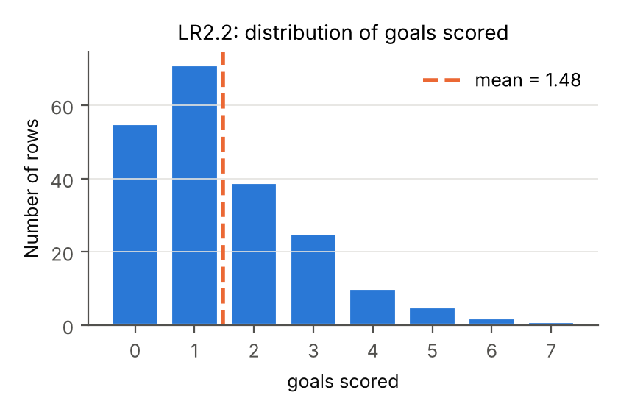 | 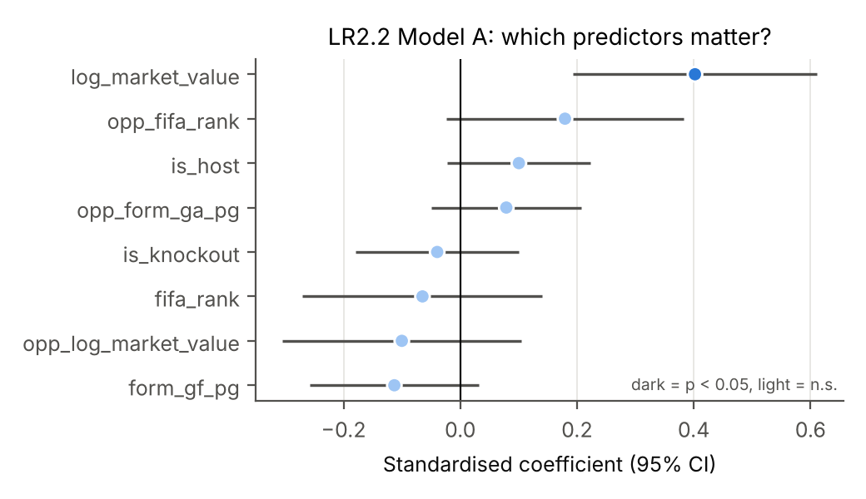
Figure 2. LR 2.2 — distribution of goals per team per match (left) and standardised coefficients of Model A (right)

3.2 Evaluation and interpretation
[Write in your own words: compare Model A vs B (Table 2); interpret Model B (Table 3), e.g. what a 50-place weaker opponent means; diagnostics show non-normal, heteroscedastic residuals because goals are counts (Figure 3); Model C (log(1 + goals) target) as an improvement attempt: better residual normality and test-split error, but no gain in cross-validation; Poisson regression as future work.]
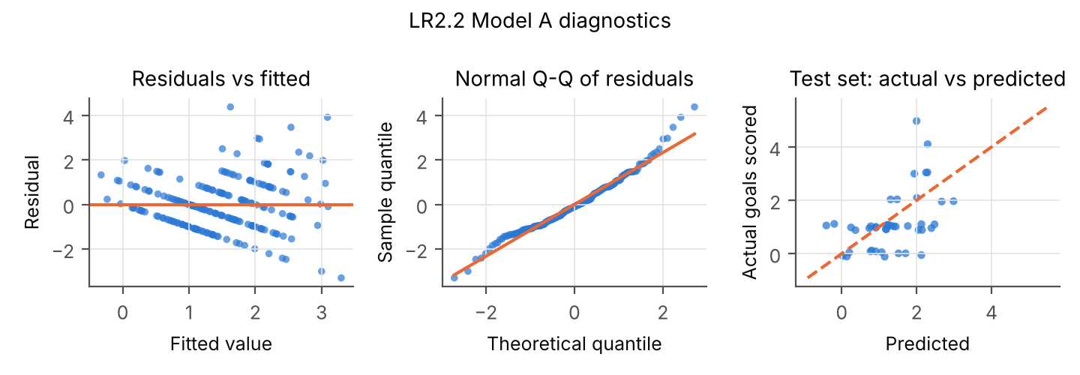
Figure 3. LR 2.2 Model A — residuals vs fitted, normal Q-Q plot, and actual vs predicted on the test set

4. Discussion and Conclusion
[Write in your own words: why 2.1 explains more variance than 2.2; squad value as the most consistent predictor; limitations (small n, Transfermarkt snapshot date, form = 0 in first match, arbitrary team1/team2 order, paired rows in 2.2, ordinal ranking, secondary sources for knockout scores); improvements and conclusion.]

References
[Write in your own words: list the sources from data/raw/SOURCES.md in the referencing style your unit requires.]

