Dean Fortier

2 November 2016

Lab 8

**1.2 Modeling Vowel Production**

fs = 11250;

tt = 0:1/fs:1;

A = 1;

f0 = 150;

xx = 0;

for i = -30:30

xx = xx + A*cos(i*f0*2*pi*tt);

end

figure

stem(xx)

The minimum sampling frequency is greater than 150*30*2 = 9000.

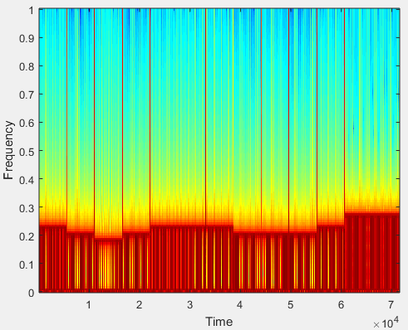

**1.3.3 Bach**

% --------------play_fugue.m-------------- %

load bach_fugue.mat

fs = 44100; % 11025 Hz also works

%theVoices(1).durations = theVoices(1).durations;

sp = 0.125;

xx = zeros(1, ceil(sum(theVoices(1).noteNumbers)*sp*fs));

for i = 1:length(theVoices)

for kk = 1:length(theVoices(i).noteNumbers)

keynum = theVoices(i).noteNumbers(kk);

tone = glottalkey2note(keynum, theVoices(i).durations(kk)*sp);% <------- Fill in this line

strt = theVoices(i).startPulses(kk)*fs*sp;

lend = strt+length(tone)-1;

xx(strt:lend) = xx(strt:lend) + tone;

end

end

soundsc(xx, fs)

**1.5.5**

On the complex plane, the places where either holes or poles will have the strongest influence on the magnitude of the frequency response are near the unit circle. This is because the frequency response is based on the e^jw which is the unit circle.

**1.5.7**

Hole at z = 0

Pole at z = 2

Impulse response:

h[n] = 2^n*u[n]

B_pz = [ 1, 0.594059, 0.164988, 0.470266, 0.647974, 0.482408, 0.708841 ]

A_pz = [ 1 ]

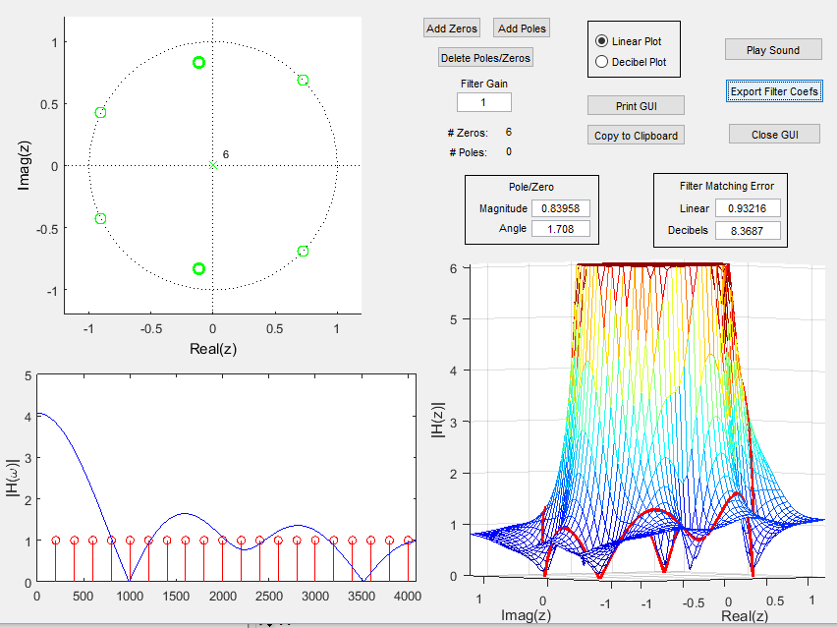

keynum = 44;

dur = 1;

fs = 44100;

tt = 0:1/fs:dur;

A = 1;

f0 = 220*(2^((keynum-49)/12));

xx = 0;

for i = 1:30

xx = xx + A*cos(i*f0*2*pi*tt);

end

%soundsc(xx, fs)

EH = filter(B_pz, A_pz, xx);

soundsc(EH, 44100);

%A and B from pole zero place

[Heh, W] = freqz(B_pz, A_pz, 256);

plot(abs(Heh))

