Dean Fortier

Lab 8 Part 2

6 November 2016

**2.1 Four More**

All of my sounds are in one file named ‘entire_sound.wav’ in order of:

[original (silence) AH EH EE OH OO]

AH

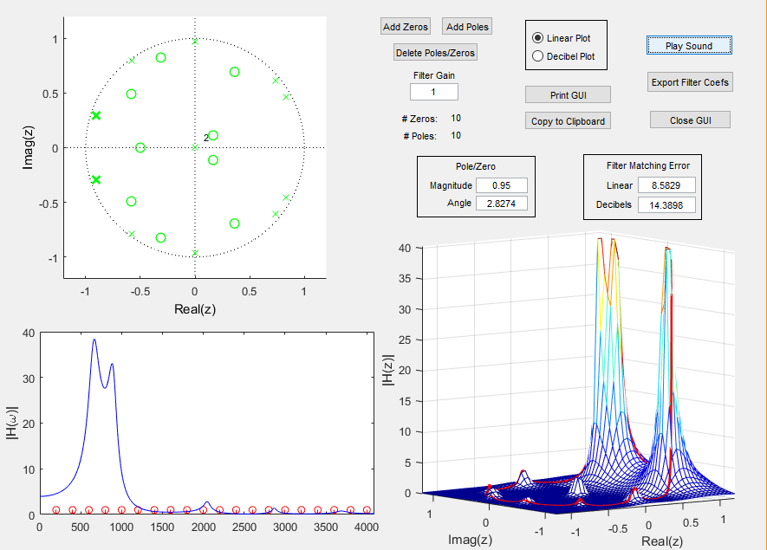

A_ah =

1.0000 -0.1853 -0.1316 0.0140 0.3837 0.4912 0.3438 0.1165 -0.1886 -0.1684 0.6783

B_ah =

0 0 1.0000 1.7366 2.0754 1.7049 1.2857 0.9046 0.5195 0.1398 -0.0223 -0.0073 0.0028

I got all angle by using… Angle = frequencyOfPeak/5000*pi

Sadly, I did not record my pole and zero values, but they are unique if you compare my pole zero plot to anyone else’s.

To get the poles I adjusted all until I got a good looking magnitude of frequency response graph. The reason the left values are many times larger than the right values is because the graph given to us was in decibels and the graph the GUI created is in magnitude.

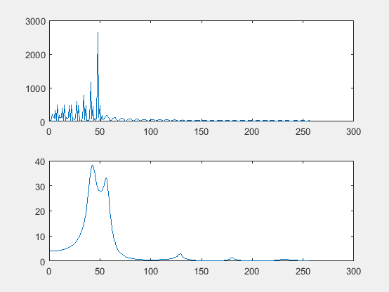

EE

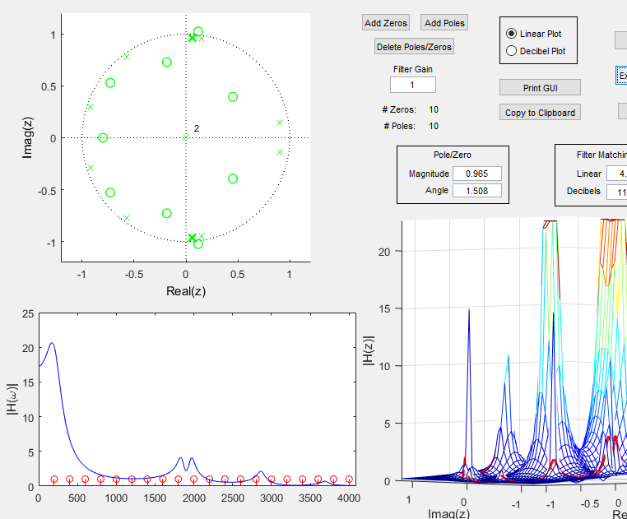

A_ee =

1.0000 0.7161 0.8019 0.1607 -0.7557 -1.2240 -0.9132 -0.1712 0.3728 0.3745 0.6220

B_ee =

0 0 1.0000 2.2856 3.2002 3.6599 3.1227 1.8195 0.8221 0.4489 0.2925 0.2473 0.1114

I got all angle by using… Angle = frequencyOfPeak/5000*pi

Sadly, I did not record my pole and zero values, but they are unique if you compare my pole zero plot to anyone else’s.

To get the poles I adjusted all until I got a good looking magnitude of frequency response graph. The reason the left values are many times larger than the right values is because the graph given to us was in decibels and the graph the GUI created is in magnitude.

This sound turned out relatively well

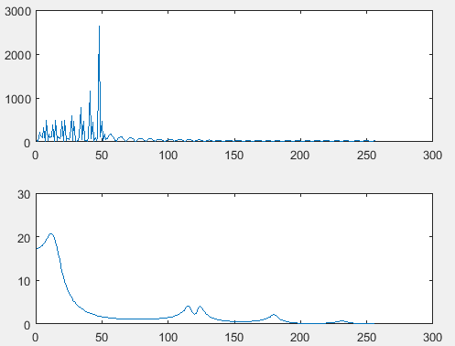

OH

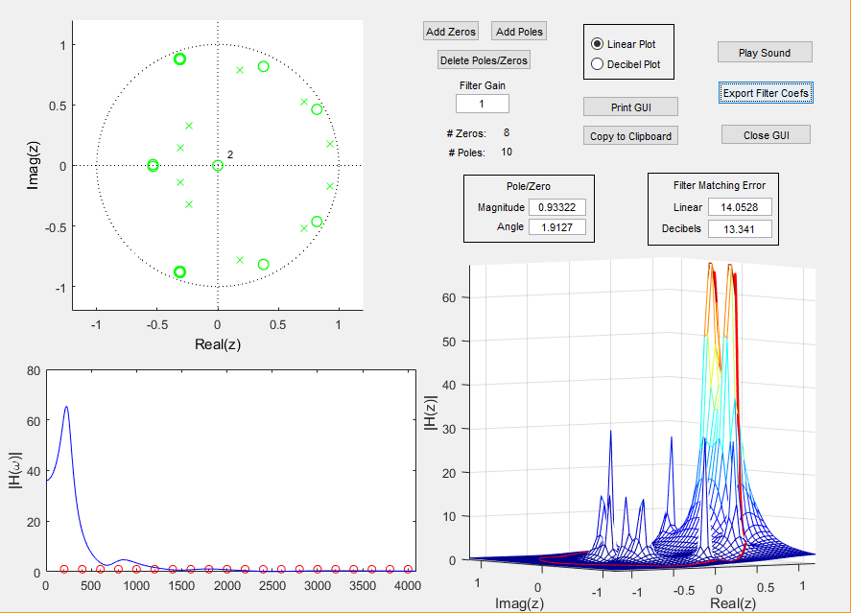

A_oh =

1.0000 -2.6033 2.8516 -1.6958 0.4764 0.0981 -0.0721 -0.0833 0.0304 0.0322 0.0084

B_oh =

1.0000 -0.6950 0.7017 -0.2838 0.2803 0.2314 -0.1751 0.2987 0.1782

**I ended up using the OO vowel for the OH sound. For some reason the OO sounds more like a OH and vice versa.**

I got all angle by using… Angle = frequencyOfPeak/5000*pi

Sadly, I did not record my pole and zero values, but they are unique if you compare my pole zero plot to anyone else’s.

To get the poles I adjusted all until I got a good looking magnitude of frequency response graph. The reason the left values are many times larger than the right values is because the graph given to us was in decibels and the graph the GUI created is in magnitude.

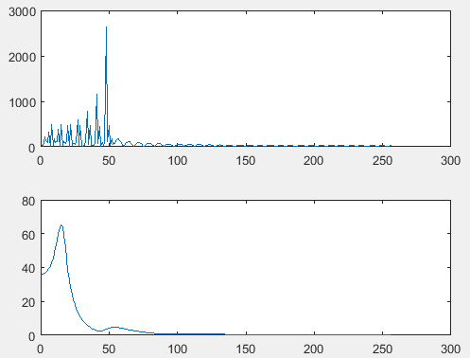

OH

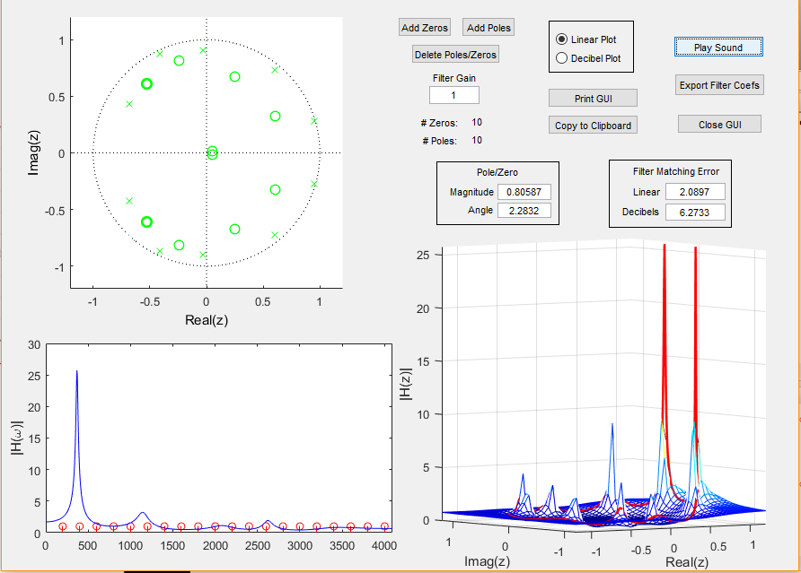

A_oh =

1.0000 -2.6033 2.8516 -1.6958 0.4764 0.0981 -0.0721 -0.0833 0.0304 0.0322 0.0084

B_oh =

1.0000 -0.6950 0.7017 -0.2838 0.2803 0.2314 -0.1751 0.2987 0.1782

**I ended up using the OH vowel for the OO sound. For some reason the OO sounds more like a OH and vice versa.**

I got all angle by using… Angle = frequencyOfPeak(in kHz)/5*pi

Sadly, I did not record my pole and zero values, but they are unique if you compare my pole zero plot to anyone else’s.

To get the poles I adjusted all until I got a good looking magnitude of frequency response graph. The reason the left values are many times larger than the right values is because the graph given to us was in decibels and the graph the GUI created is in magnitude.

**2.2 Whispering Vowels**

% Whisper or Sound order of: [original AH EH EE OH OO]

function total = OneForWhisperTwoForSound(OneForWhisperTwoForSound, keynum)

load('AH A and B.mat')

load('EH A and B.mat')

load('EE A and B.mat')

load('OHa A and B.mat')

load('OOa A and B.mat')

dur = 1;

fs = 44100;

tt = 0:1/fs:dur;

if OneForWhisperTwoForSound == 1

xx = rand(1,length(tt));

%plot(xx)

elseif OneForWhisperTwoForSound == 2

A = 1;

f0 = 220*(2^((keynum-49)/12));

xx = 0;

for i = 1:30

xx = xx + A*cos(i*f0*2*pi*tt);

end

else

disp('please enter 1 for Wisper or 2 for Sound')

end

% plot(xx)

%making sure the amplitudes are the same

xx = xx./max(xx);

AH = filter(B_ah, A_ah, xx);

AH = AH./max(AH);

EH = filter(B_eh, A_eh, xx);

EH = EH./max(EH);

EE = filter(B_ee, A_ee, xx);

EE = EE./max(EE);

OH = filter(B_oo, A_oo, xx);

OH = OH./max(OH);

OO = filter(B_oh, A_oh, xx);

OO = OO./max(OO);

silence = zeros(1,8000);

silencex = [silence silence silence silence silence];

total = [xx silencex AH silence EH silence EE silence OH silence OO];

soundsc(total, fs);

end

I totally would do **2.3** but I have an exam for Physics of EE to study for. Seems pretty cool. If I were to do it, I would write another function that would have for loops and use the information to concatenate many different notes.