Lab Report DDOS

Dean Carmi

Table of Contents
1. Setting up the machines
1.1. Victim
1.2. Monitor
1.3. Attacker
2. Creating the attack
2.1. Using C
2.1.1. After the attack
2.2. Using Python
2.2.1. After the attack
3. Report
3.1. Regarding syns results
3.1.1. Explaination
3.2. Regarding the pings results
3.2.1. Explaination

Setting up the machines
In order to do recreate the conditions of the experiment I included the instructions for each machine.

Victim
The victim should include only a running apache server, listening on port 80 (without firewall)

Monitor
In directory monitorfiles we have all files related to the monitor. Using the makefile in that directory, steps to setup the system:
make hping
install nessecary package.
make python_scapy
installing everything related to the right version of python.

Attacker
In directory attackerfiles we have all files related to the attacker. Using the makefile in that directory, steps to setup the system:
make python_setup
install anything related to python.

Creating the attack

Using C
Instructions:
Victim
Run the apache server.
Attacker
In directory attacker_files run:
    - Compile - make c_ddos
    - Run - sudo ./syn_flood 10.0.2.12 80 (You can replace the IP for any IP that you attack)
Monitor
In directory monitorfiles run:
    - Ping - make start_c . Note: You need to stop manually this process

After the attack
Attacker side
A new file named syns_results_c will be created containing the required info.
Monitor side
A new file named pings_results_c_raw.txt will be created and we need to parse it. Run python3.8 parse_hping.py pings_results_c_raw.txt. The script will ask you in which language the code is, you should reply c for C and p for Python. Note: the RTT is in milliseconds.

Using Python
Instructions:
Victim
Run the apache server.
Attacker
In directory attacker_files run:
    - Run - sudo python3.8 ddos.py 10.0.2.12 80 1000000 (You can replace the IP for any IP that you want to attack, the last nubmer is the amount of packet, a million)
Monitor
In directory monitorfiles run:
    - Ping - make start_py . Note: You need to stop manually this process

After the attack
Attacker side
A new file named syns_results_p will be created containing the required info.
Monitor side
A new file named pings_results_p_raw.txt will be created and we need to parse it. Run python3.8 parse_hping.py pings_results_p_raw.txt. The script will ask you in which language the code is, you should reply c for C and p for Python. Note: the RTT is in milliseconds

Report

Regarding syns results
C code
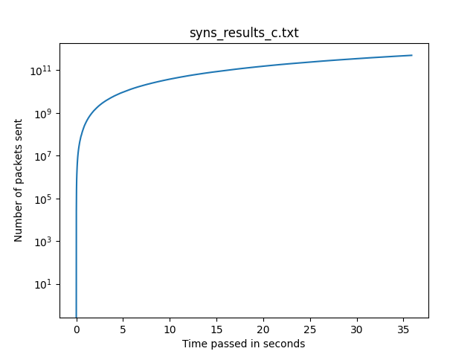 Figure 3.1.1: Results of syn packet sending with C
- Average time for a packet - 0.000036 seconds.
- Total running time - 52.894455 seconds.
- Standard deviation - 0.0000315946680146141
Python code
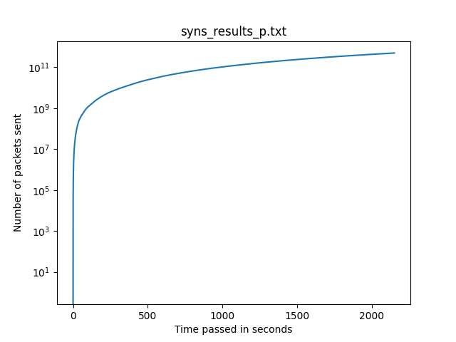 Figure 3.1.2: Results of syn packet sending with Python
Average time for a packet
0.002151517 seconds.
Total running time
2515.619506395 seconds.
Standard deviation
0.0004762834996620782

Explaination
We can observe two differences:
- Attack Time - C took 52 seconds vs Python that took 2515 seconds. C was faster by a factor of 48.
- Average time for a packet - C took 0.000036 seconds vs Python that took 0.00215 seconds. Python was slower by a factor of 59.
We know that because Python is an interpreted language, it amplifies the number of actual CPU instructions required to perform the code given (compared to code in C). In addition, In my case the Python code didn’t run as machine code (like the C code), but it ran in a virtual machine (the bytecode interpreter).

Regarding the pings results
C code
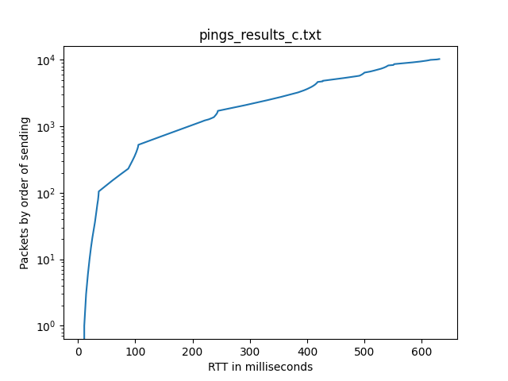 Figure 3.2.1: Results of the pings sending when the C attack took place
Average RTT | 4.378472 milliseconds
Standart deviation | 2.6498208
Python code
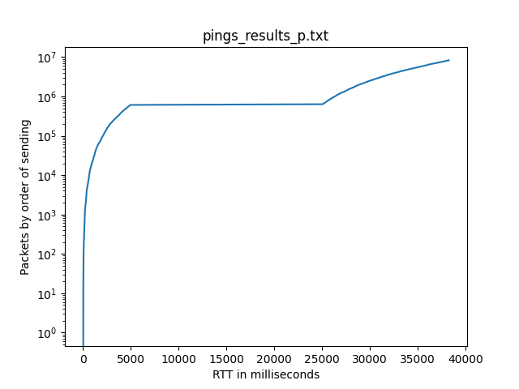 Figure 3.2.2: Results of the pings sending when the Python attack took place
Average RTT | 9.39337423 milliseconds
Standard deviation | 69.80985083

Explaination
- Average RTT

