IMTS Mix Optimization Feasibility
Feasibility Assessment Using Available IMTS Batch and Day-0 Field Data
KEY RESULT: ExtraTrees produced the strongest results, but mean R² remained near 0.40 and errors were roughly 500–800 psi. The current IMTS data supports historical mix-performance screening and engineer review, but not fully automated mix-design optimization.

Study design and validation
Eligible dataset | 13,133 concrete test records with batch data that meet the mix-optimization analysis requirements.
Feature sets | 1) Batch data only; 2) Batch data + Day-0 field slump and air measurements.
Models compared | HistGradientBoosting, ExtraTrees, Random Forest, and DummyMedian.
Validation | 80% training / 20% held-out test split, with 5-fold project-grouped cross-validation used to evaluate model stability and performance.
Why DummyMedian? | A simple baseline that predicts the training-set median for every record. It shows whether the ML models add meaningful predictive value beyond a constant prediction.

Validated model performance
Analysis | Best model | Records | Mean R² | R² range | MAE (psi) | RMSE (psi)
Batch data only | ExtraTrees | 13,133 | 0.405 | 0.263–0.520 | 545 | 811
Batch data + slump and air | ExtraTrees | 11,735 | 0.396 | 0.263–0.449 | 509 | 741

Interpretation: ExtraTrees performed best in both feature sets. Adding Day-0 slump and air reduced MAE from 545 to 509 psi and RMSE from 811 to 741 psi, but mean R² remained near 0.40, indicating only moderate predictive power for mix optimization.

Why current IMTS data limits automated mix optimization
• IMTS purpose: IMTS was designed to record field placement conditions and scheduled strength-test results—especially 28-day strength—not to capture the full detail needed for mix-design optimization.
• Batch-data coverage: More than 85% of concrete records do not contain batch data, which sharply reduces the amount of usable training data.
• Data detail: The available batch records are not detailed or consistent enough to isolate how mix proportions and production variables drive strength with the reliability required for automated mix recommendations.

Recommended Direction
BEST CURRENT USE Use 7-day and 28-day strength history to screen mix performance, identify recurring low-margin/failure patterns or consistent overstrength, and flag mixes for materials-engineer review. Machine learning should support the review—not automatically change a mix design. True optimization will require richer, standardized batch/mix-design data and validation through the approved trial-batch/submittal process.

IMTS Concrete Predictive Quality Analysis
Summary of Regression, Risk Classification, and Model Comparison
Main finding: Day-7 information provides strong prediction of 28-day strength and strong quality-risk screening. The best results come from Day-7 data with Supplier, Plant, and Mix context.

1. Purpose
The goal of this analysis was to determine whether the current large IMTS concrete dataset can be used to predict concrete quality before the final 28-day strength result is available.
The analysis focused on two simple questions:
Can we predict the final 28-day concrete strength?
Can we identify concrete tests that may fall below the required 28-day strength?
The current IMTS concrete data was reviewed, and eligible records were used for modeling and validation. For the Day-7 analysis, 81,509 concrete samples from 4,107 projects were available.

2. Feature Sets
Feature Set | Information Used | Business Meaning
Day 0 - Field | Day-0 field measurements + required 28-day strength | Prediction when concrete is placed
Day 0 - Field + context | Day-0 field measurements + required 28-day strength + Supplier / Plant / Mix
Day 7 - Field | Day-0 field measurements + required 28-day strength + actual Day-7 strength information | Updated prediction after 7 days
Day 7 - Field + context | Day-0 field measurements + required 28-day strength + Day-7 strength + Supplier / Plant / Mix | Most complete prediction

Models were validated using 5-fold project-grouped cross-validation. Tests from the same project were kept together, so the model was evaluated on projects that were not used to train that fold.

3. 28-Day Strength Prediction
Regression models answer the question: “What 28-day strength do we expect?” The output is a strength value in psi.
Feature Set | Best Model | MAE | RMSE | R²
Day 0 - Field | HistGradient Boosting | 699 psi | 955psi | 0.683
Day 0 - Field + context | HistGradient Boosting | 663 psi | 918 psi | 0.707
Day 7 - Field | XGBoost | 344 psi | 492 psi | 0.915
Day 7 - Field + Context | HistGradient Boosting | 320 psi | 465 psi | 0.924

MAE (Mean Absolute Error): Average prediction error. Lower values mean predictions are closer to actual results.
RMSE (Root Mean Squared Error): Measures prediction error with extra emphasis on larger mistakes. Lower values are better.
R² (R-Squared): Indicates how well the model explains the data. Values closer to 1.0 indicate a better fit.
The Day-7 models were much stronger than the Day-0 model. The strongest result was Full Context + Day 7, with an average error of about 320 psi and R² of about 0.924.

4. Failure Risk Classification
Classification models answer a different question: “Is this test at risk of falling below the required 28-day strength?”
For this analysis, Failure = Actual 28-day strength < Required 28-day strength. This is an analytical risk flag, not the final engineering acceptance decision.
Feature Set | Recall | Precision | F1 | FN | FP
Day 0 - Field | 60.9% | 12.9% | 0.212 | 1,901 | 20,055
Day 0 - Field + Context(supplier, plant, mix ) | 63.0% | 14.3% | 0.233 | 1,801 | 18,401
Day 7 - Field | 90.7% | 35.1% | 0.507 | 453 | 8,135
Day 7 - Field + Context (supplier, plant, mix ) | 89.9% | 38.7% | 0.541 | 489 | 6,934

Positive class = Fail. A test is labeled Fail for this analytical screening when its actual 28-day strength is below the applicable required 28-day strength. Pass is the negative class.
Recall means: Of all tests that actually failed, what percentage did the model identify as Fail? For example, recall = 0.90 means the model found about 90% of the actual failures and missed about 10%.
Precision means: Of all tests the model flagged as Fail, what percentage were actually Fail?
The table above uses a classifier threshold of 0.50. Day 0 + Context is better than Day 0 Field alone, but Day-0 precision remains low. Day 7 is much stronger: the models identify about 90% of actual failures at the 0.50 threshold.

5. Regression-Derived Risk vs. Direct Classifier
A regression prediction can also be converted into a risk flag by comparing predicted 28-day strength with the required 28-day strength. I compared that approach with a separate classifier.
Feature Set | Regression Recall | Regression Precision | Classifier Recall | Classifier Precision
Day 0 - Field | 2.0% | 53.7% | 60.9% | 12.9%
Day 0 - Field + Context | 3.4% | 49.8% | 63.0% | 14.3%
Day 7 - Field | 49.4% | 66.7% | 90.7% | 35.1%
Day 7 - Field + Context | 51.5% | 68.4% | 89.9% | 38.7%

At a strict regression margin of 0 psi, regression has higher precision but much lower recall. In other words, it creates fewer alerts, but it misses many actual failures. This is especially clear at Day 0 and still important at Day 7.

6. Precision-Recall trade-off for the Direct Classifier
Each point on the curve represents a different classification threshold
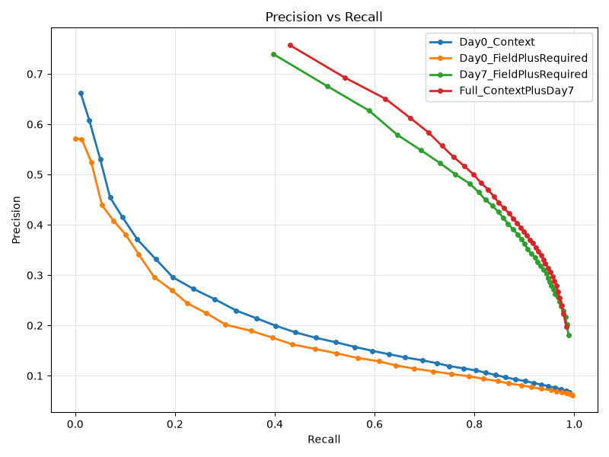

This plot shows the trade-off between recall and precision as we change the classification threshold. As recall increases, precision decreases because the model generates more false alarms. The Day 7 models perform significantly better than the Day 0 models, and Full Context plus Day 7 generally provides the best precision at the same recall level.

7. Main Findings
Question | Finding
Can IMTS predict 28-day strength at Day 0? | Partially. Accuracy is limited.
Can IMTS predict 28-day strength at Day 7? | Yes. Strong performance.
Does Supplier / Plant / Mix information help? | Yes, moderately.
Can IMTS identify tests at risk of falling below required strength? | Yes, especially after Day 7.
Does a separate classifier add value? | Yes. It finds failures more efficiently at similar recall.
Is Day 0 ready for strong operational alerts? | No. Better as preliminary screening.
Is Day 7 suitable for predictive quality screening? | Yes. This is the strongest current use case.

8. Recommended Direction
The strongest current use case is:
Day-7 Updated Concrete Quality Risk Screening
A user could see both the strength prediction and the risk result together:
Day-7 Quality Prediction | Example Result
Required 28-Day Strength | 4,000 psi
Predicted 28-Day Strength | 4,480 psi
Predicted Margin | +480 psi
Quality Risk | Elevated
Model Stage | Day 7

The regression model answers: “What strength do we expect?” The classification model answers: “How concerned should we be that this test may fall below the required strength?” These questions are related, but they are not exactly the same.

9. Overall Conclusion
The current large IMTS concrete dataset provides strong predictive value after the 7-day strength result becomes available. Project-grouped cross-validation showed that the Day-7 regression models can predict 28-day strength with an average error of approximately 320–345 psi and R² above 0.91.
The Day-7 classification models also showed strong ability to identify concrete tests that may fall below the required 28-day strength. When regression-based and classification-based risk methods were compared at similar recall levels, the direct classifier consistently produced fewer false alerts.
The results support using both predicted 28-day strength and a separate quality-risk score in a Day-7 predictive quality screening tool. Day-0 predictions may still provide early information, but they are not currently strong enough for reliable failure-risk alerts.

