**Future classrooms featuring AI robots**

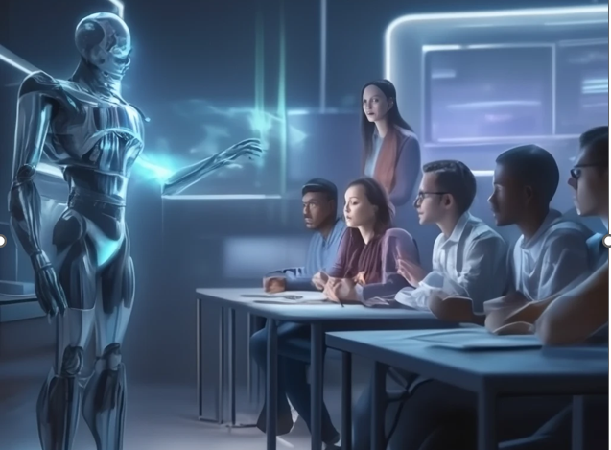

A futuristic classroom featuring AI robots teaching students is a compelling vision of education's future. This concept blends advanced technology with interactive learning environments.

**🧠 Key Features of a Futuristic AI-Integrated Classroom**

* **AI Robot Educators**: Humanoid robots, such as those at Indus International School in Bengaluru, are already assisting in teaching by delivering lessons and answering student queries in subjects like science and mathematics. These robots complement human teachers, enhancing the learning experience without replacing them. ([IndiaPost NewsPaper](https://indiapost.com/robots-turn-teachers-in-bengaluru-school/?utm_source=chatgpt.com" \o "Robots turn teachers in Bengaluru school - IndiaPost NewsPaper))
* **Immersive Learning with AR/VR**: In Tambaram, Chennai, schools are piloting AR/VR classrooms equipped with META VR headsets, tablets, and LED panels. This setup allows students to engage in virtual science experiments and rocket launches, making learning more interactive and engaging. ([The Times of India](https://timesofindia.indiatimes.com/city/chennai/ar/vr-classes-robots-rockets-to-soon-visit-tambaram-schools/articleshow/123752457.cms?utm_source=chatgpt.com))

**🎨 Visual Inspirations**

For a visual representation of this futuristic classroom concept, consider these AI-generated images:

* **Robot Teacher in Action**: A humanoid robot instructing students in a modern classroom setting. ([Craiyon, AI Image Generator](https://www.craiyon.com/image/is-NKz3hR7uh0yiVaOnfFQ?utm_source=chatgpt.com" \o "Futuristic classroom with students and AI robots, colorful atmosphere on Craiyon))
* **Diverse Students Engaging with AI**: Students from various backgrounds interacting with AI technology in a vibrant classroom. ([Easy-Peasy.AI](https://easy-peasy.ai/ai-image-generator/images/futuristic-classroom-students-ai-technology-learning?utm_source=chatgpt.com))
* **Hoverboards and Robotic Professors**: A classroom featuring hoverboards and a robotic professor delivering lessons. ([Easy-Peasy.AI](https://easy-peasy.ai/ai-image-generator/images/futuristic-classroom-hoverboards-robotic-professor-diverse-students?utm_source=chatgpt.com))

These images offer a glimpse into how AI and robotics can transform traditional educational spaces into dynamic, interactive learning environments.