**Classroom featuring AI Robot**

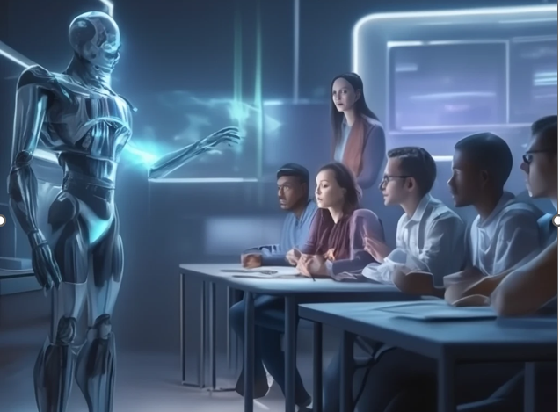

Classroom featuring AI robots teaching students is a compelling vision of education's future which blends advanced technology with interactive learning environments.

**Key Features of a Futuristic AI-Integrated Classroom**

• **AI Robot Educators**:  
Humanoid robots, such as those at Indus International School in Bengaluru, are already assisting in teaching by delivering lessons and answering student queries in subjects like science and mathematics. These robots complement human teachers, enhancing the learning experience without replacing them.  
Link: <https://indiapost.com/robots-turn-teachers-in-bengaluru-school>

• **Learning with Augmented Reality(AR) & Virtual Reality(VR)**:  
In Tambaram, Chennai, schools are piloting AR/VR classrooms equipped with META VR headsets, tablets, and LED panels. This setup allows students to engage in virtual science experiments and rocket launches, making learning more interactive and engaging.  
Link: <https://timesofindia.indiatimes.com/city/chennai/ar/vr-classes-robots-rockets-to-soon-visit-tambaram-schools/articleshow/123752457.cms>