3/30/2021

Just before making serializers, I was wondering if I need to make a separate API for the ingredients. Because you should be able to populate them from a big list of ingredients and they shouldn’t delete on cascade.

I now realized it should be many-to-many. So I’ll change that.

It’s too complicated with the day also. So I am going to get rid of that.

3/31/2021

Today I managed to change the serializers and work on testing. First thing is that testing via admin page works great. However using Postman, I can’t post a recipe without an array of ingredients. It’s suggested I make a custom serializer overriding the create method. I’ll try that.

Potential solutions: https://stackoverflow.com/questions/50048851/django-rest-m2m-nested-serializer-create-update-nested-objects
https://stackoverflow.com/questions/41394761/the-create-method-does-not-support-writable-nested-fields-by-default
https://www.django-rest-framework.org/api-guide/serializers/#dealing-with-nested-objects

Next issue is I’m trying to update git over https but it’s not working. I have a personal access token but that’s no good either and I need to change to updating over ssh.

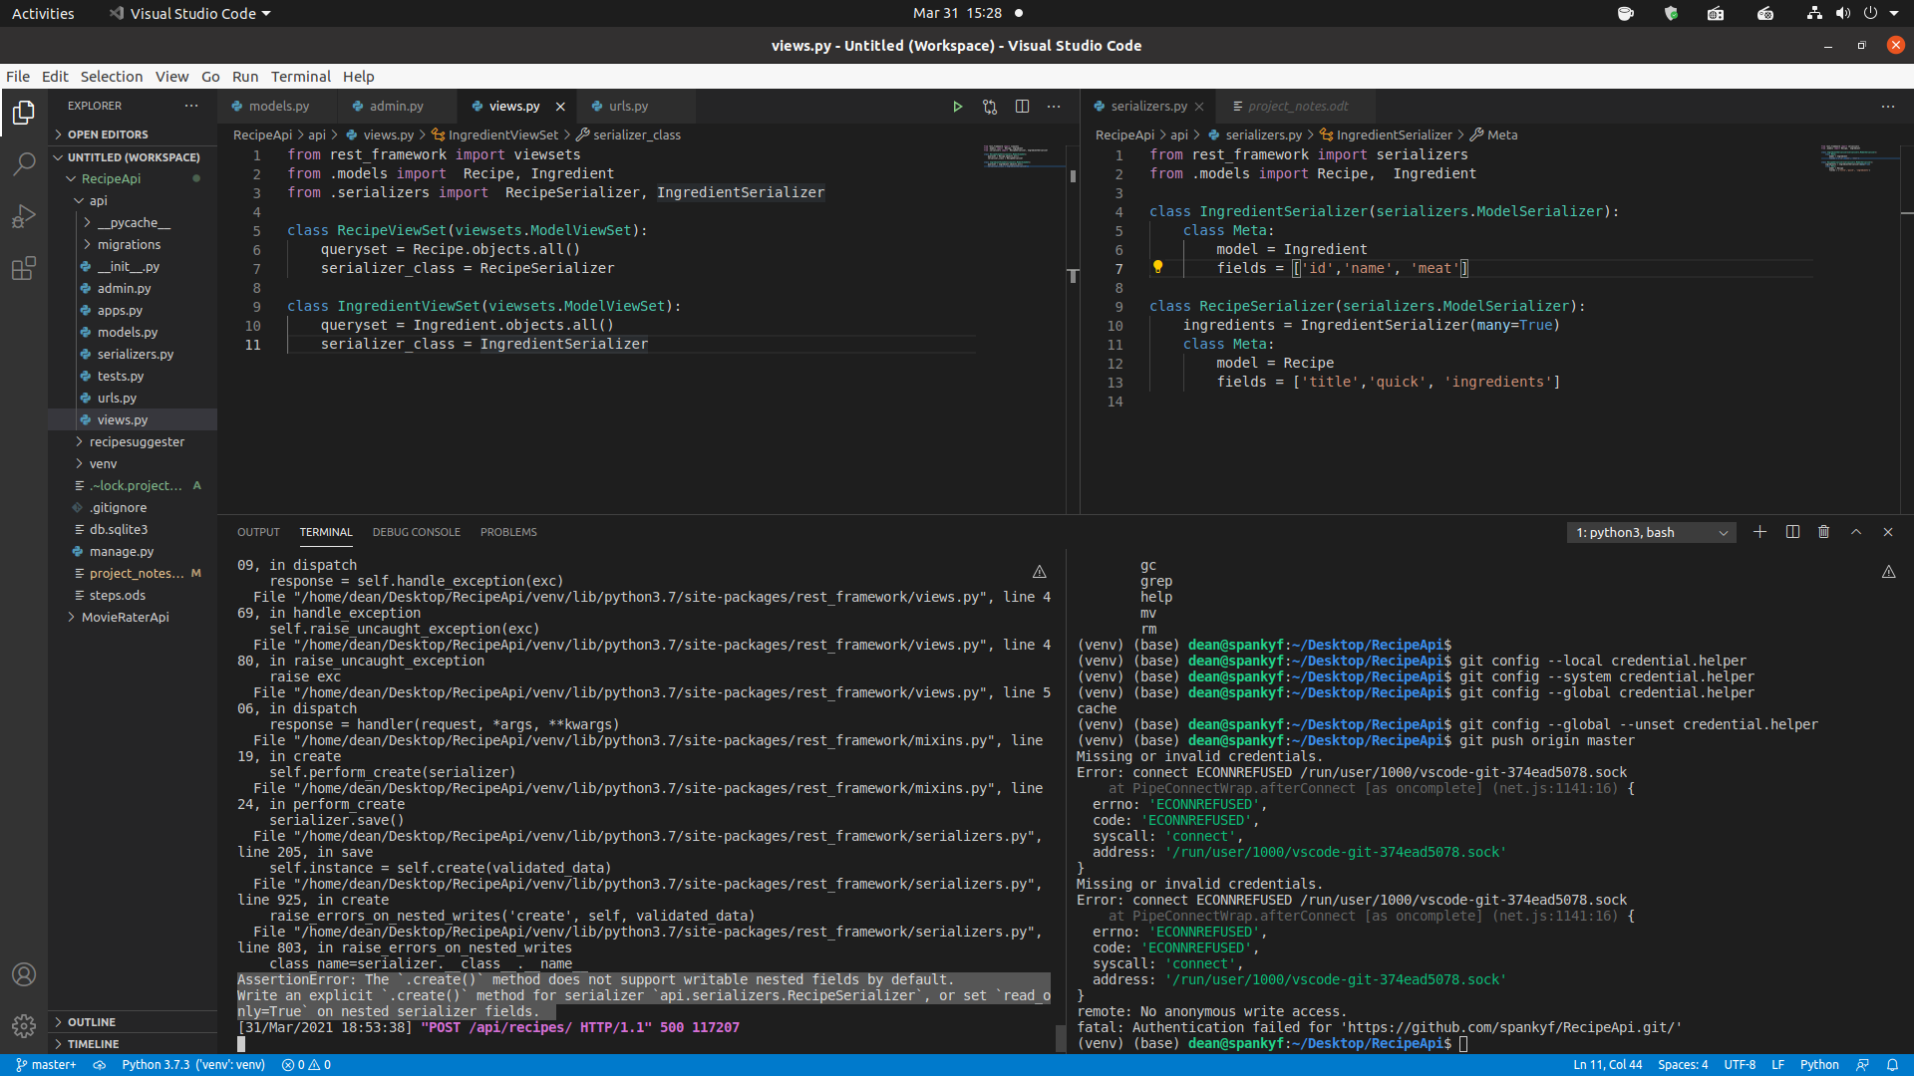

Also just trying git in a normal terminal as per: https://stackoverflow.com/questions/62860280/git-push-missing-or-invalid-credentials-fatal-authentication-failed-for-http

Fixed.

4/1/2021

Migrated to windows and the below error.

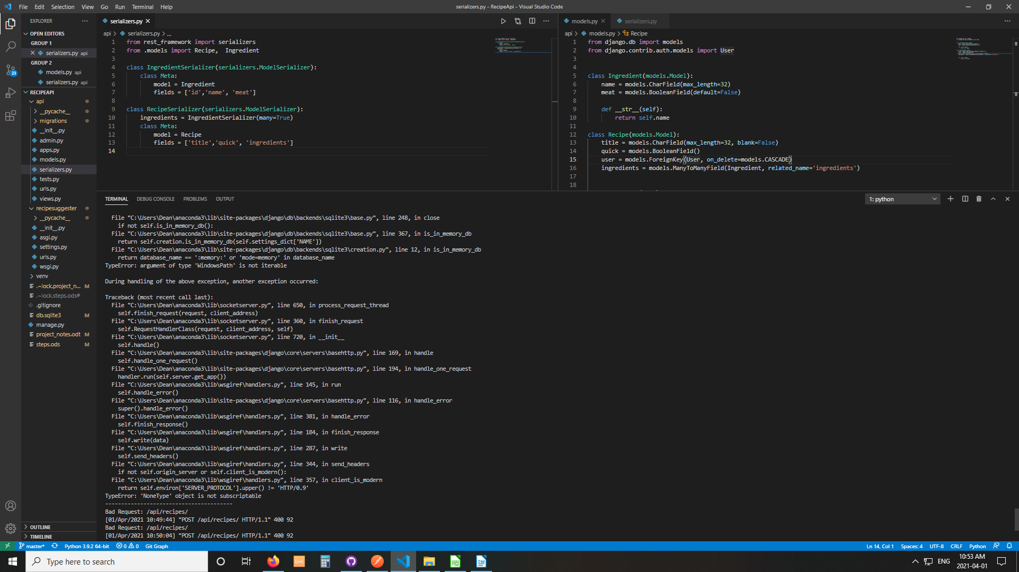
I solved the second by: https://javaatpoint.com/solved-argument-of-type-windowspath-is-not-iterable-nonetype-object-is-not-subscriptable-in-django/

The 10053 is still there.

Need to add new decorated function to views for that create and update thing made in serializers.

Posting is working now and I understand it better but will need to be able to insert an array of new ingredients in a loop perhaps? Beginning to regain the flow of problem – try things – solution, rinse and repeat.

4/3/2021

Beginning to get how I might make a custom create object for ingredients added along with a new recipe. See screenshot below:

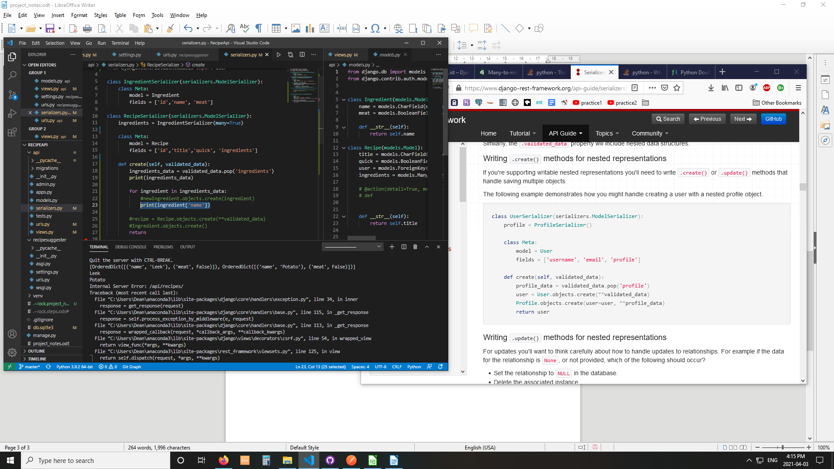
Now its working for adding new ingredients with a new recipe, if any. However I have to add a user with it and I’m working out how to do that.

I am going to send to git and then try moving the create new recepe in views instead of serializers.

There was no need. The view and serializers both get access to a request object and I got the user from it. The SO answer was here: https://stackoverflow.com/questions/29524826/how-to-get-authenticated-user-on-serializer-class-for-validation.

Last problem to solve today: TypeError: Direct assignment to the forward side of a many-to-many set is prohibited. Use ingredients.set() instead.

4/4/2021

Today try to get that assignment done. Start with making the recipe then add to it.

Done it!

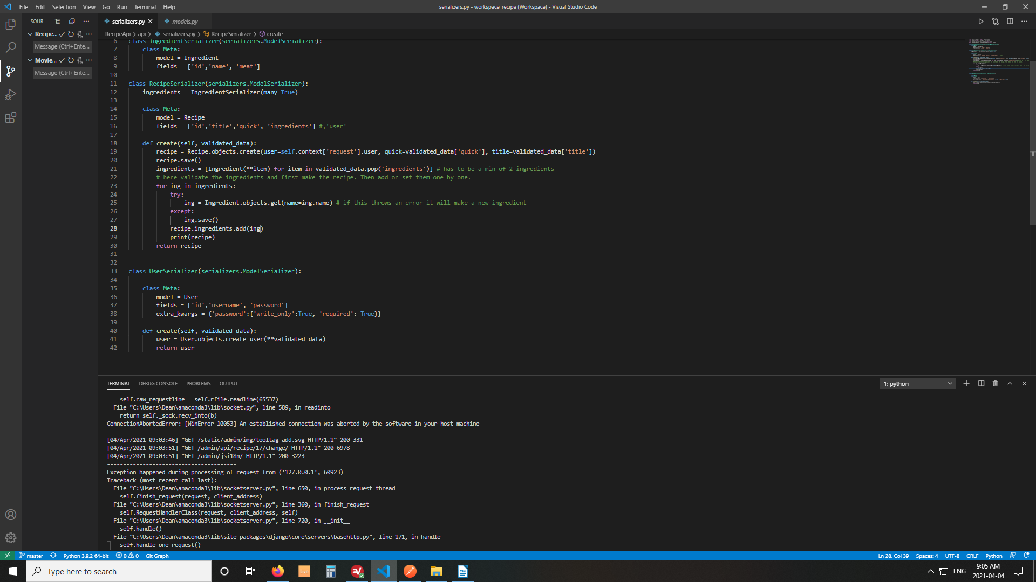

Feeling delighted, it’s only after 9am and I did it.

Now need to automatically add a token for new users.

4/6/2021

New architecture decided upon.
1. Will populate ingredients from searchable API at edamam.com. First get setup and make API calls with key and postman. This is our new ingredients format.
2. First try to make simple calls to the API with python and then incorporate the functionality into your existing REST framework.
3. Then add the days M2M layer on top.
4. Start by making API to search that on front end → separate React project!

1. Accessed the site easily through postman.

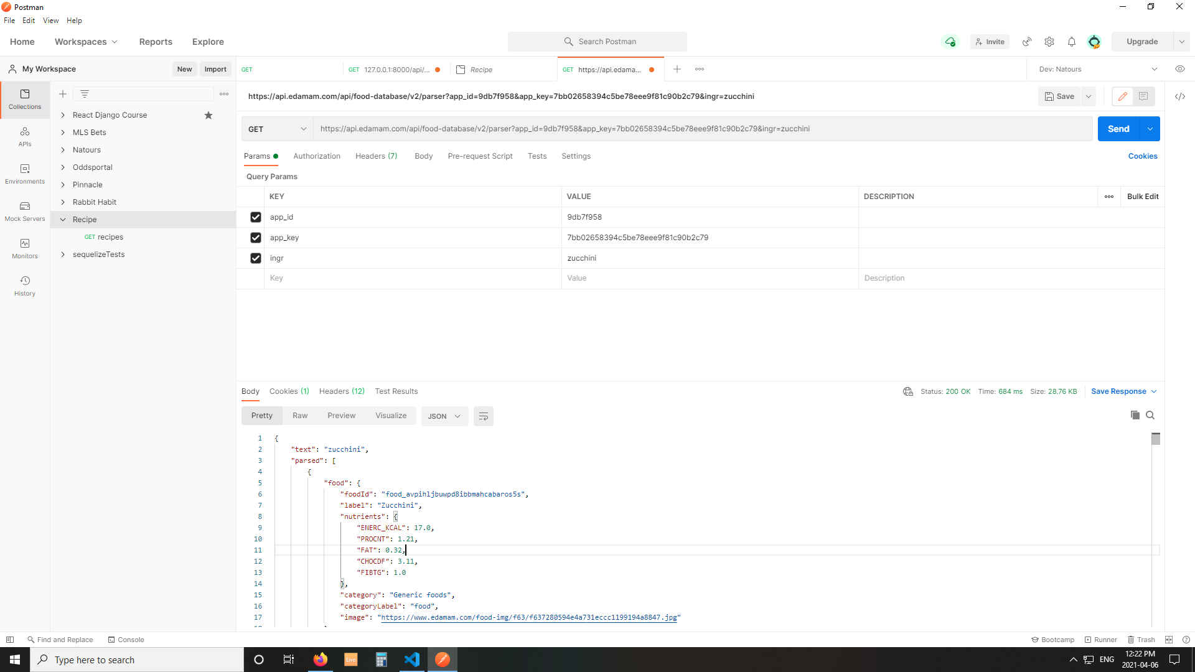

Now I will make a new route or url in my Django Rest API to access these get requests. I will have to do:

2a. GET request to the edamam API to get an ingredient.
2b. Remodel ingredients db to fit the ingredient in and
2c. POST the ingredient into the db.

Changed my mind. Make the front end first. Then make a new route to add ingredients from that API and post them.

