**The more money we are able to collect with Direct Donation, the less fundraising we will have to do the rest of the year!!**

**The best and easiest way to help Holly Avenue PTA is with a direct donation!**

Direct donation also eliminates the hassles of traditional fundraising programs, gets more money to our school, and allows your money to work harder for our students. 100% of your donation goes directly to the school and is 100% tax deductible! Other fundraising sources only give Holly Avenue a portion of the money raised.

**No amount is too small or too big!** We are asking every family to give as much as they can to support the school but are suggesting a minimum donation of $25.00 per student to help us towards our fundraising goal for the year.

Each student who participates will get a **Free Dress Coupon**, which entitles them to have one uniform-free day of their choice!

**Every single dollar you give stays at Holly Avenue to help your children throughout the school year!**

**Your support and generosity are greatly appreciated!**

**Thank you so much if you have already donated during Dolphin Days!**

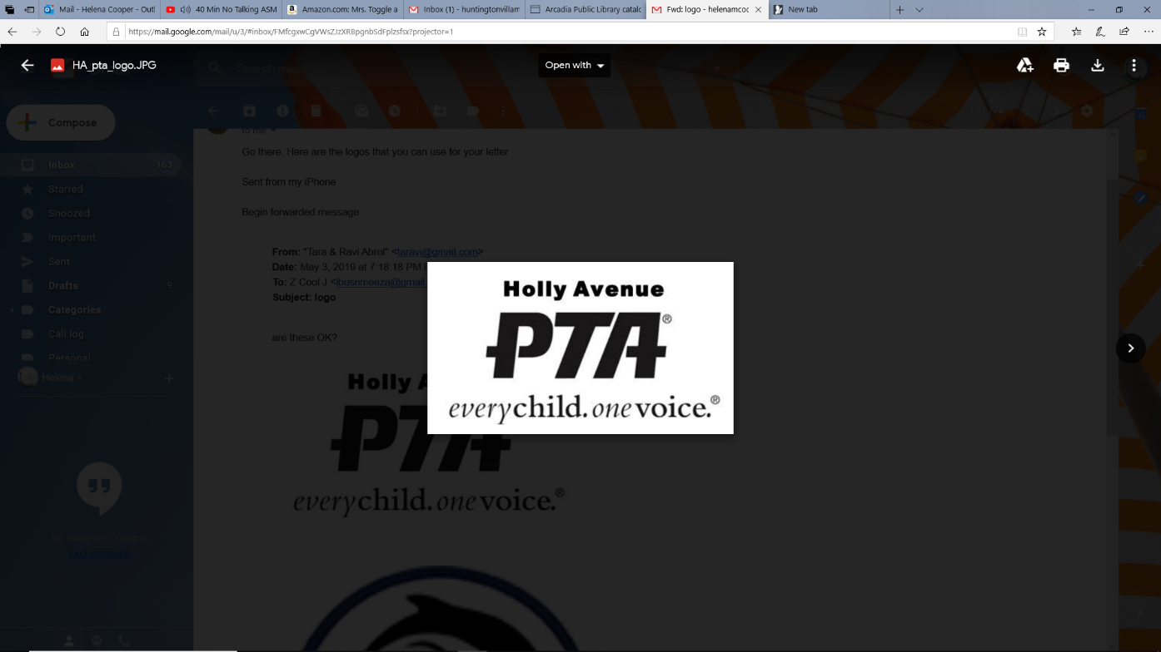 **Holly Avenue Direct Donation**

All donations are tax deductible (Tax ID: 95-6206368)

**___$25 Donation ____$50 Donation ___$100 Donation ___$200 Donation ____Other amount $______**

**Student full name: ____________________________________________ Teacher: __________________________**

*Please check with your employer to see if they will match your donation (i.e. Benevity Community, Coca Cola, Nuveen, Time Warner, Toyota, Walt Disney, Western Asset, Wells Fargo, Yahoo)

Please include this bottom portion along with cash or checks payable to Holly Ave PTA to school with your child in the enclosed envelope.