**FTS experiments:**

Bid = True

Features = All + remove head

No attention, normalize, augmentation

Data is balanced (simple sub sample)

Test accuracy ~ 0.74 – can use high early stop patience…

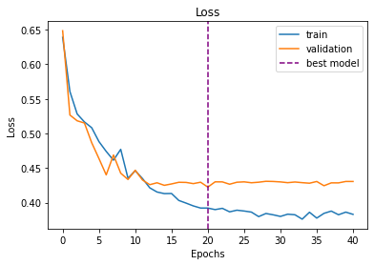all features

|  |  |
| --- | --- |
| **model** | Test accuracy |
| b4_lr0.002_sz3_g0.5_h64_nl2_no_head.pt (56 features) | 0.74 |
| b4_lr0.002_sz3_g0.5_h64_nl2_allfeatures.pt | 0.759 |
|  |  |
|  |  |
|  |  |